Course: MMDS

Tutorial 03

MapReduce

Simple WordCount MapReduce Job

Prepare data for the MapReduce job
- Create a folder for the job

bin/hdfs dfs -mkdir /user/haian

- Create a input folder

bin/hdfs dfs -mkdir user/hadooop/input

- Copy one text files to folder input

bin/hdfs dfs -put ~/Desktop/data/baskets.csv /user/hadoop/input

- Verify copied data

bin/hdfs dfs -ls /user/hadoop/input

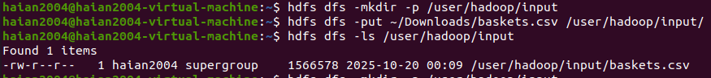

- Show the content of a text file

bin/hdfs dfs -cat /user/hadoop/input/baskets.csv



Create a Java Program for the job
Pass1.java

import java.io.IOException;
import org.apache.hadoop.conf.Configuration;
import org.apache.hadoop.fs.Path;
import org.apache.hadoop.io.IntWritable;
import org.apache.hadoop.io.Text;
import org.apache.hadoop.io.LongWritable;
import org.apache.hadoop.mapreduce.Job;
import org.apache.hadoop.mapreduce.Mapper;
import org.apache.hadoop.mapreduce.Reducer;
import org.apache.hadoop.mapreduce.lib.input.FileInputFormat;
import org.apache.hadoop.mapreduce.lib.output.FileOutputFormat;

public class FirstPass {
// Mapper: Đếm số lần xuất hiện của mỗi khách hàng
public static class CustomerMapper
extends Mapper<LongWritable, Text, Text, IntWritable> {

private final static IntWritable one = new IntWritable(1);
private Text customerID = new Text();

public void map(LongWritable key, Text value, Context context)
throws IOException, InterruptedException {
// Bỏ qua header
if (key.get() == 0) return;

String[] fields = value.toString().split(",");
customerID.set(fields[0]); // Member_number
context.write(customerID, one);
}
}

// Reducer: Tổng hợp và lọc theo ngưỡng min_support
public static class CustomerReducer
extends Reducer<Text, IntWritable, Text, IntWritable> {

private static final int MIN_SUPPORT = 3;
private IntWritable result = new IntWritable();

public void reduce(Text key, Iterable<IntWritable> values, Context context)
throws IOException, InterruptedException {
int sum = 0;
for (IntWritable val : values) {
sum += val.get();
}

if (sum >= MIN_SUPPORT) {
result.set(sum);
context.write(key, result);
}
}
}
public static void main(String[] args) throws Exception {
Configuration conf = new Configuration();
Job job = Job.getInstance(conf, "First Pass - Customer Count");

job.setJarByClass(FirstPass.class);
job.setMapperClass(CustomerMapper.class);
job.setReducerClass(CustomerReducer.class);

job.setOutputKeyClass(Text.class);
job.setOutputValueClass(IntWritable.class);

FileInputFormat.addInputPath(job, new Path(args[0]));
FileOutputFormat.setOutputPath(job, new Path(args[1]));

System.exit(job.waitForCompletion(true) ? 0 : 1);
}
}
Pass2.java
import java.io.*;
import java.util.*;
import org.apache.hadoop.conf.Configuration;
import org.apache.hadoop.fs.Path;
import org.apache.hadoop.fs.FileSystem;
import org.apache.hadoop.io.IntWritable;
import org.apache.hadoop.io.Text;
import org.apache.hadoop.io.LongWritable;
import org.apache.hadoop.mapreduce.Job;
import org.apache.hadoop.mapreduce.Mapper;
import org.apache.hadoop.mapreduce.Reducer;
import org.apache.hadoop.mapreduce.lib.input.FileInputFormat;
import org.apache.hadoop.mapreduce.lib.output.FileOutputFormat;

public class SecondPass {
public class Constants {
// File paths
public static final String OUTPUT1_PATH = "/user/letri/output1/part-r-00000";
public static final String HEADER_LINE = "Member_number";

// Support thresholds
public static final int MIN_SUPPORT = 10;
public static final int MIN_PAIR_SUPPORT = 5;

// Delimiters
public static final String TAB_DELIMITER = "\t";
public static final String COMMA_DELIMITER = ",";

// Job configurations
public static final String JOB_NAME = "Second Pass - Frequent Customer Pairs";
}

public static class PairMapper
extends Mapper<LongWritable, Text, Text, Text> {

private Set<String> frequentCustomers = new HashSet<>();

@Override
protected void setup(Context context) throws IOException {
Configuration conf = context.getConfiguration();
Path output1Path = new Path(Constants.OUTPUT1_PATH);
FileSystem fs = FileSystem.get(conf);

try (BufferedReader br = new BufferedReader(
new InputStreamReader(fs.open(output1Path)))) {
String line;
while ((line = br.readLine()) != null) {
String[] parts = line.split(Constants.TAB_DELIMITER);
if (parts.length == 2) {
String customerID = parts[0].trim();
int frequency = Integer.parseInt(parts[1].trim());
if (frequency >= Constants.MIN_SUPPORT) {
frequentCustomers.add(customerID);
}
}
}
}
}

@Override
public void map(LongWritable key, Text value, Context context)
throws IOException, InterruptedException {
String line = value.toString().trim();
if (line.startsWith(Constants.HEADER_LINE)) return;

String[] fields = line.split(Constants.COMMA_DELIMITER);
if (fields.length >= 2) {
String customerID = fields[0].trim();
String date = fields[1].trim();

if (frequentCustomers.contains(customerID)) {
context.write(new Text(date), new Text(customerID));
}
}
}
}

public static class PairReducer
extends Reducer<Text, Text, Text, IntWritable> {

private Map<String, Integer> pairCounts = new HashMap<>();

@Override
public void reduce(Text key, Iterable<Text> values, Context context)
throws IOException, InterruptedException {
List<String> customersInDay = new ArrayList<>();
for (Text val : values) {
customersInDay.add(val.toString());
}

for (int i = 0; i < customersInDay.size() - 1; i++) {
for (int j = i + 1; j < customersInDay.size(); j++) {
String customer1 = customersInDay.get(i);
String customer2 = customersInDay.get(j);
String pair = customer1.compareTo(customer2) < 0 ?
customer1 + Constants.COMMA_DELIMITER + customer2 :
customer2 + Constants.COMMA_DELIMITER + customer1;

pairCounts.merge(pair, 1, Integer::sum);
}
}
}

@Override
protected void cleanup(Context context)
throws IOException, InterruptedException {
for (Map.Entry<String, Integer> entry : pairCounts.entrySet()) {
if (entry.getValue() >= Constants.MIN_PAIR_SUPPORT) {
context.write(
new Text(entry.getKey()),
new IntWritable(entry.getValue())
);
}
}
}
}

public static void main(String[] args) throws Exception {
Configuration conf = new Configuration();
Job job = Job.getInstance(conf, Constants.JOB_NAME);

job.setJarByClass(SecondPass.class);
job.setMapperClass(PairMapper.class);
job.setReducerClass(PairReducer.class);

job.setMapOutputKeyClass(Text.class);
job.setMapOutputValueClass(Text.class);
job.setOutputKeyClass(Text.class);
job.setOutputValueClass(IntWritable.class);

FileInputFormat.addInputPath(job, new Path(args[0]));
FileOutputFormat.setOutputPath(job, new Path(args[1]));

System.exit(job.waitForCompletion(true) ? 0 : 1);
}
}

Compile and Execute the job
- Declare environment variables (skipped as needed)

nano etc/hadoop/hadoop-env.sh

- Compile the Pass1.java ( Pass 1)

bin/hadoop com.sun.tools.javac.Main ~/Desktop/A-priori/FirstPass.java
jar cf wc.jar FirstPass*.class

- Run the application ( Pass 1)

bin/hadoop jar fp.jar FirstPass /user/hadoop/input /user/hadoop/output1

- Verify the result (Pass1)

bin/hdfs dfs -ls /user/hadoop/output1

bin/hdfs dfs -cat /user/hadoop/output1/part-r-00000

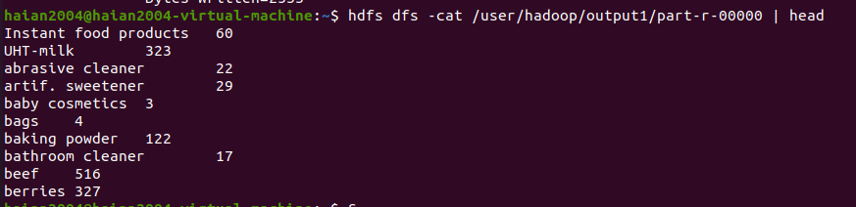
- Compile the Second.java ( Pass 2)
bin/hadoop com.sun.tools.javac.Main ~/Desktop/A-priori/SecondPass.java
jar cf wc.jar SecondPass*.class

- Run the application ( Pass 2)
bin/hadoop jar sp.jar SecondPass /user/hadoop/input /user/hadoop/output1

- Verify the result (Pass2)
bin/hdfs dfs -ls /user/hadoop/output2

bin/hdfs dfs -cat /user/hadoop/output2/part-r-00000

