Pseudo code:

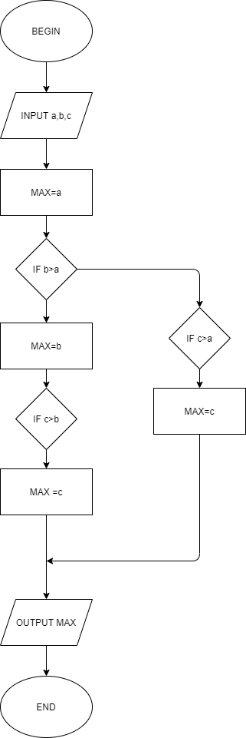

Begin

Input a,b,c

Max=a

If b>a

MAX=b

If c>b

MAX=c

Endif

Else

If c>a

MAX=c

endif

Output MAX

End