Pseudo code:

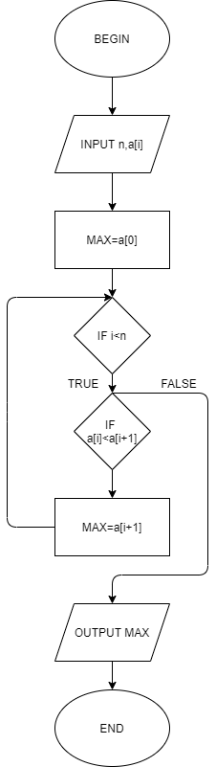

Begin

Input n,a[]

MAX=a[0]

If i<n

If a[i]<a[i+1]

MAX=a[i+1]

Else

Output MAX

End