Pseudo code:

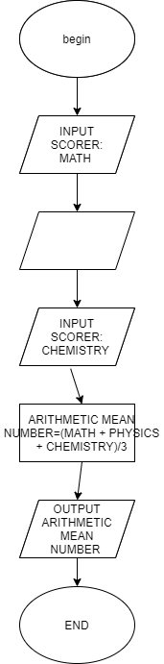

Begin

Input math

Input physic

Input chemistry

Average=(math+physic+chemistry)/3

Output average

End