

**SOFTWARE REQUIREMENT SPECIFICATION**

**Coffee Chain (Code)**

– Hanoi, Sep 2025 –

**Table of Contents**

I. Record of Changes. …………………………………………………………………………………………………………………3

II. Software Requirement Specification. ………………………………………………………………………………………4

1. Overall Requirements. ……………………………………………………………………………………………………………4

1.1 Context Diagram.. ………………………………………………………………………………………………………………..4

1.2 External Entities……………………………………………………………………………………………………………………. 4

1.3 Business Processes………………………………………………………………………………………………………………… 5

1.4 User Requirements………………………………………………………………………………………………………………… 5

1.5 System Functionalities……………………………………………………………………………………………………………. 6

1.6 Entity Relationship Diagram……………………………………………………………………………………………………. 7

3. Functional Requirements…………………………………………………………………………………………………………… 7

3.1 Feature Name1. ……………………………………………………………………………………………………………………….8

3.2 User Authentication. ………………………………………………………………………………………………………………..8

3.3 System Administration…………………………………………………………………………………………………………….. 8

4. Non-Functional Requirements. …………………………………………………………………………………………………..10

3.1 External Interfaces…………………………………………………………………………………………………………………… 10

3.2 Quality Attributes…………………………………………………………………………………………………………………….. 10

5. Requirement Appendix. ………………………………………………………………………………………………………………10

5.1 Business Rules. ………………………………………………………………………………………………………………………….10

5.2 System Messages……………………………………………………………………………………………………………………… 11

5.3 Other Requirements….. ……………………………………………………………………………………………………………11

# I. Record of Changes

| **Date** | **A* M, D** | **In charge** | **Change Description** |
| --- | --- | --- | --- |
|  |  |  |  |
|  |  |  |  |
|  |  |  |  |
|  |  |  |  |
|  |  |  |  |
|  |  |  |  |
|  |  |  |  |
|  |  |  |  |
|  |  |  |  |
|  |  |  |  |
|  |  |  |  |
|  |  |  |  |
|  |  |  |  |

*A - Added M - Modified D - Deleted

# II. Software Requirement Specification

## 1. Overall Requirements

### 1.1 Context Diagram

*[Gives the overall description about the product with some introduction and the context diagram. The context diagram presents the boundary and connections between the system you’re developing and everything else in the universe. This identifies external entities (or terminators – software, hardware, human components, and other systems) outside the system that interface to it in some way, as well as data, control, and material flows between the terminators and the system.]*

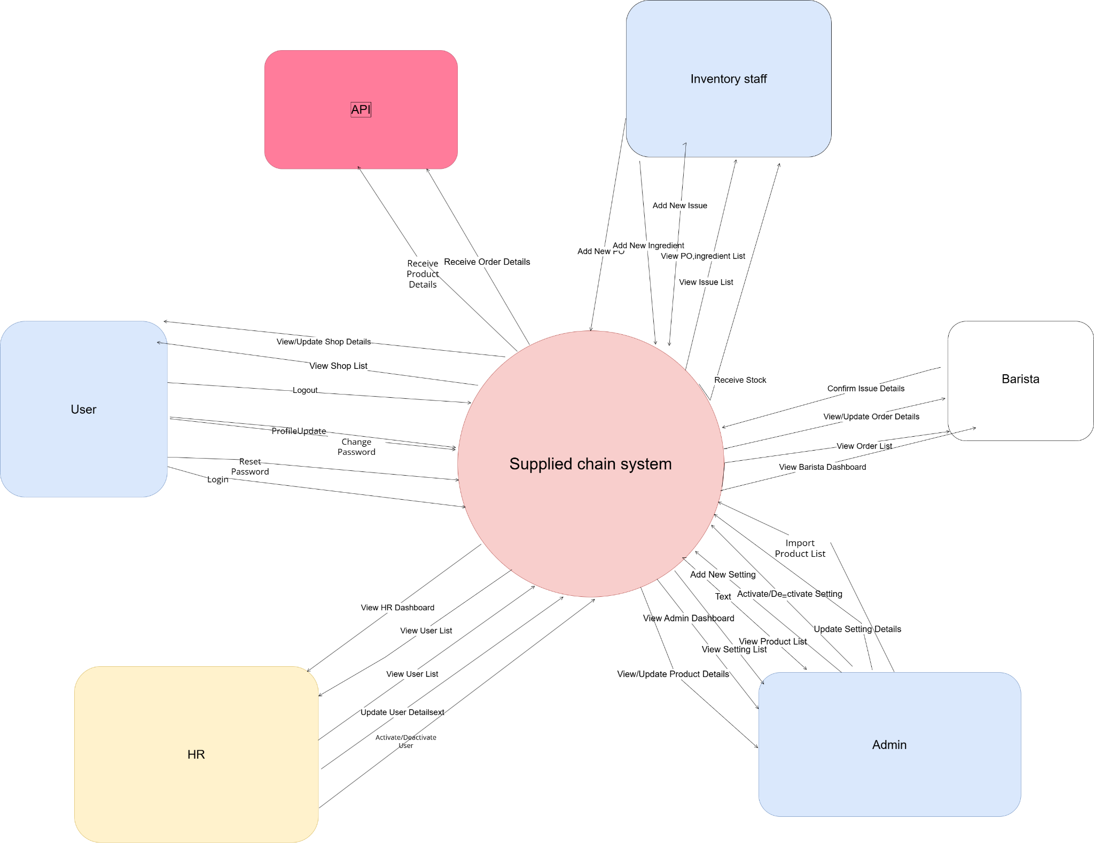

### 1.2 Main Business Processes

[LINK](https://app.diagrams.net/?page-id=ZfsavSA1llmZc2iX2SrH&client=1#G1yTodudRM3O-dUjGJ0hhxq7YLsMMujaEe#%7B%22pageId%22%3A%22IF6Lyqnbwy6KW_27Ea-T%22%7D)

#### 1.2.1 Inventory Management & Replenishment

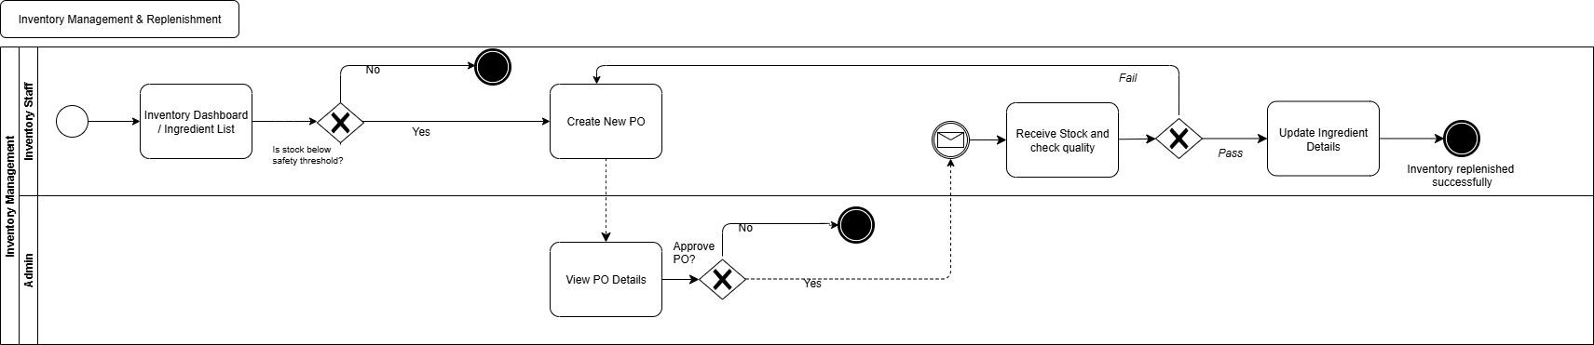

#### 1.2.2 Production Orders from External System

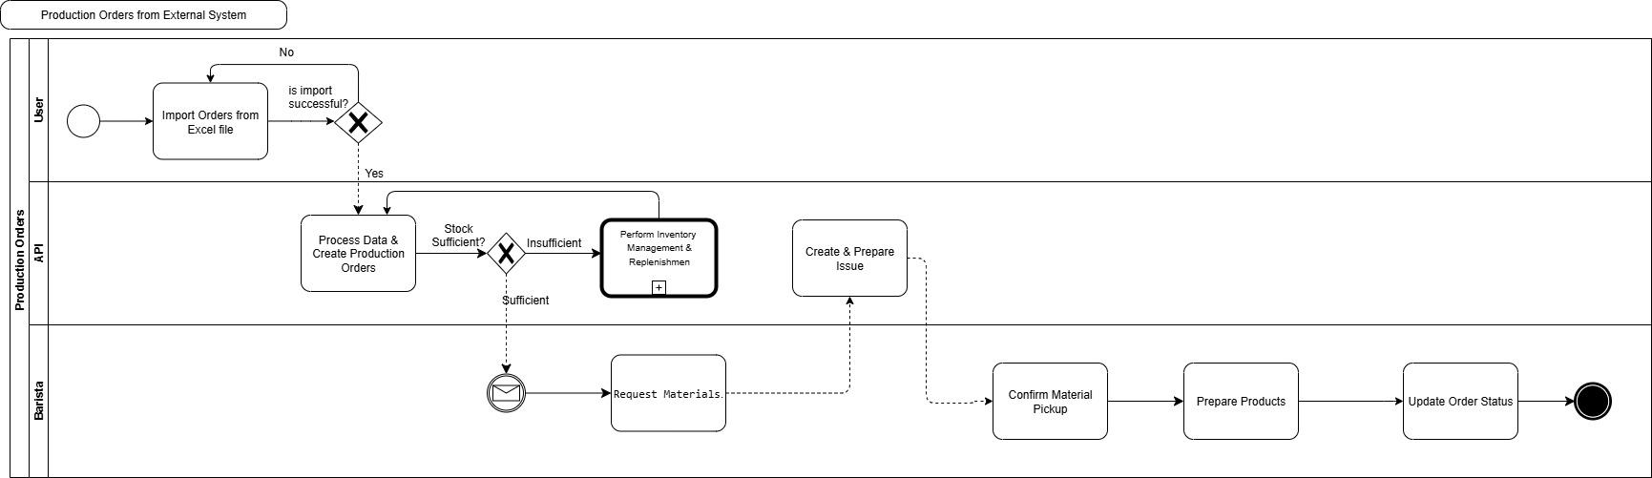

#### 1.2.3 Partner Onboarding & Management

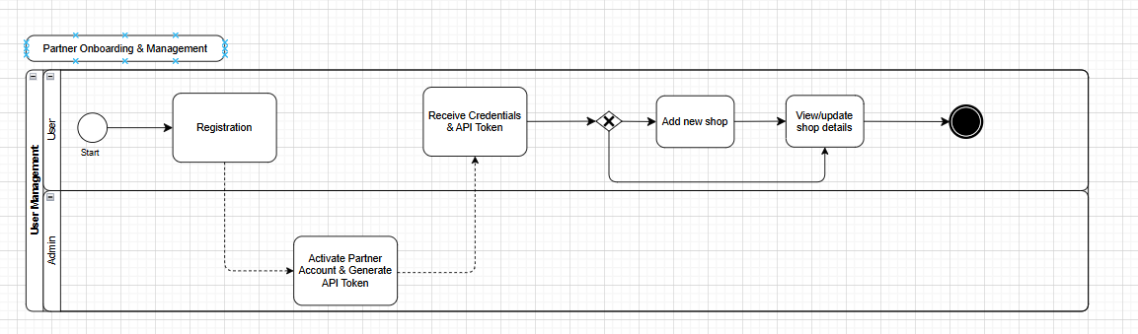

#### 1.2.4 Internal Staff Management

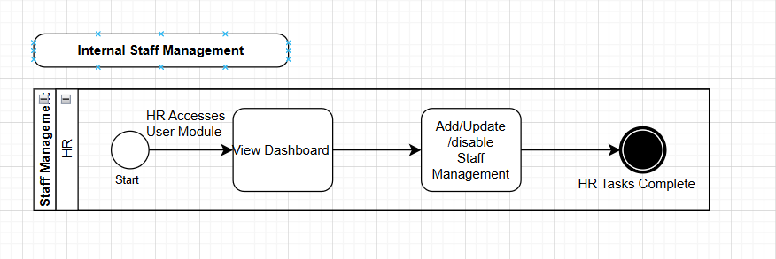

#### 1.2.5 System & Partner Administration

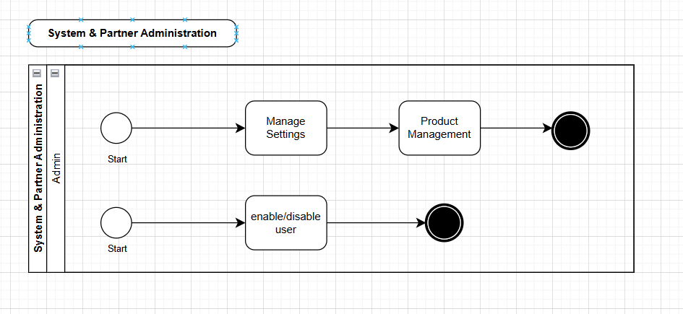

### 1.3 User Requirements

#### 1.3.1 Actors

| **ID** | **Actor** | **Description** |
| --- | --- | --- |
| **1** | **Admin** | Oversees the system: manages users, approves partner applications, configures policies, fees, and payment settings, manages product catalog, confirms purchase orders, handles promotions, sends notifications, and reviews reports for decision-making. |
| **2** | **HR** | Manages employee records, user accounts, and leave requests. Handles customer complaints and FAQs, ensuring service quality and customer satisfaction. |
| **3** | **Inventory Staff** | Manages the full lifecycle of raw materials: creates purchase orders, performs quality checks, records stock receipts, maintains ingredient data, and issues materials to baristas. |
| **4** | **Barista** | Responsible for preparing products: confirms received ingredients, views and updates order details, prepares coffee and related products, and hands over completed orders to delivery or customers. |
| **5** | **Guest** | Unregistered users can access the website to view the homepage, browse products, check basic price quotes, track public orders, submit FAQs, subscribe to newsletters, and perform pre-signup checks before becoming a customer. |
|  | **API** | Exchanges data with external systems. Receives product details and order details from third-party services and returns synchronization acknowledgments. |

#### 1.3.2 Use Cases (UC)

*[A use case (UC) describes a sequence of interactions between a system and an external actor that results in the actor being able to achieve some outcome of value. The names of use cases are always written in the form of a verb followed by an object. Select strong, descriptive names to make it evident from the name that the use case will deliver something valuable for some user.*

*Following are some questions you might ask to help user representatives identify use cases*

* *What will the actor use the system for?*
* *Will the actor create, store, change, remove, or read data in the system?*
* *Will the actor need to inform the system about external events or changes?*
* *Will the actor need to be informed about certain occurrences in the system?*

*This part describes the use cases you could define, you can follow the table form as below]*

| **ID** | **Use Case** | **Feature** | **Use Case Description** |
| --- | --- | --- | --- |
| 01 | View Menu | Feature Name1 |  |
| 02 | Order a Meal | Feature Name2 |  |
| 03 | … |  |  |

…

#### 1.3.2 Use Case Diagrams

*In this section, you need to provide the UC diagram(s) to show the actor-UCs and UC-UC relationships like the sample below. You can have multiple UC diagrams for the system, each diagram is for one actor or one workflow]*

##### 1.3.2.1 UCs for Admin

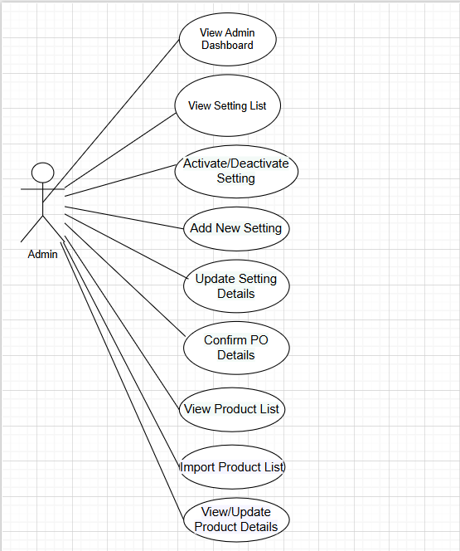

##### 1.3.2.2 UCs for HR / Staff

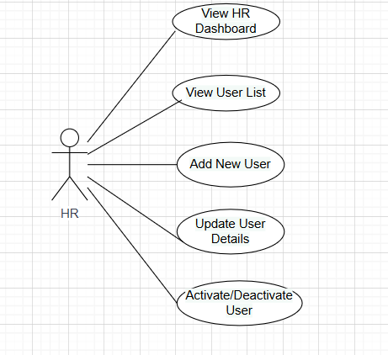

##### 1.3.2.3 UCs for user

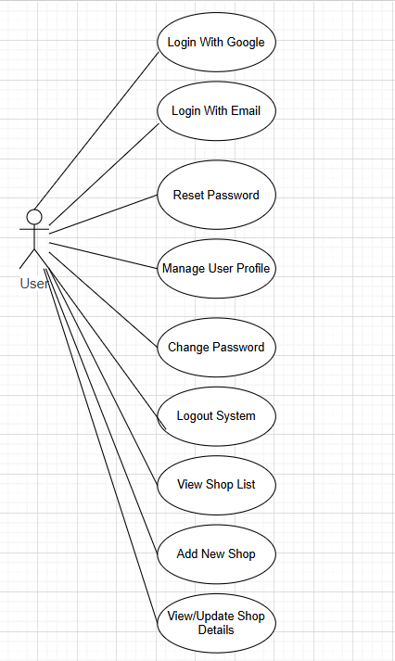

##### 1.3.2.4 UCs for Barista

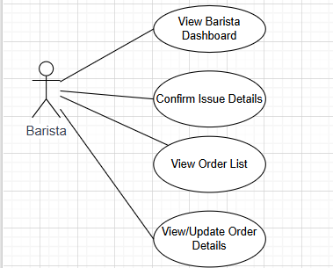

**1.3.2.4 UCs for API**

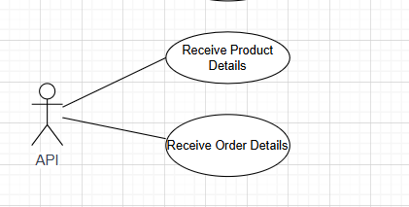

### 1.4 System Functionalities

#### 1.4.1 Screens Flow

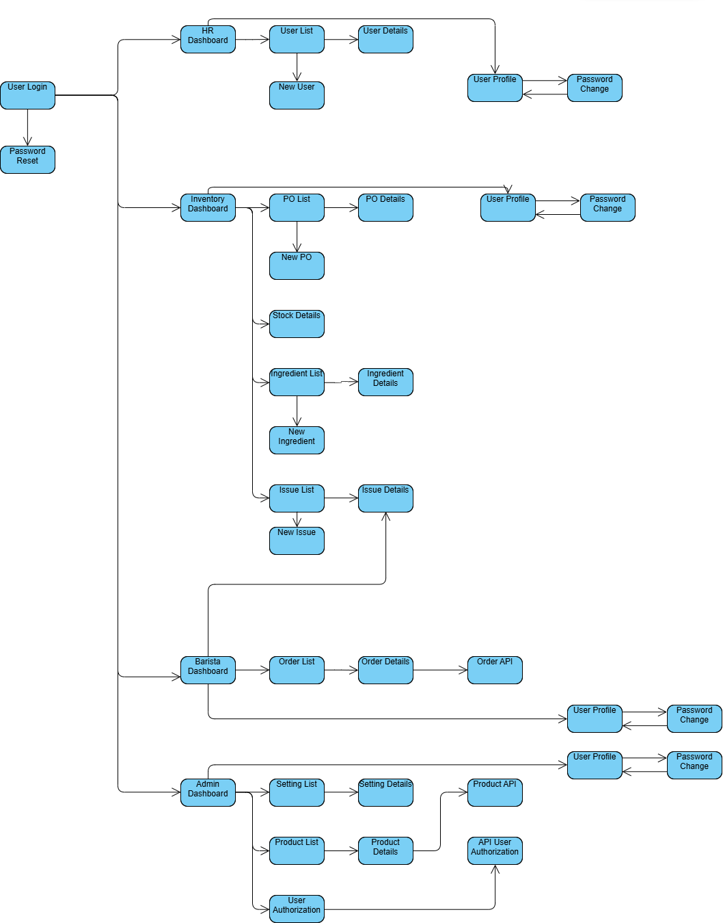

#### 1.4.2 Screen Authorization

| **Screen** | **Admin** | **HR** | **Inventory Staff** | **Barista** | **User** | **API** |
| --- | --- | --- | --- | --- | --- | --- |
| User Login | X | X | X | X | X |  |
| Password Reset | X | X | X | X | X |  |
| User Profile | X | X | X | X | X |  |
| Password Change | X | X | X | X | X |  |
| HR Dashboard |  | X |  |  |  |  |
| User List |  | X |  |  |  |  |
| New User |  | X |  |  |  |  |
| User Details |  | X |  |  |  |  |
| Inventory Dashboard |  |  | X |  |  |  |
| PO List |  |  | X |  |  |  |
| New PO |  |  | X |  |  |  |
| PO Details |  |  | X |  |  |  |
| Stock Details |  |  | X |  |  |  |
| Ingredient List |  |  | X |  |  |  |
| New Ingredient |  |  | X |  |  |  |
| Ingredient Details |  |  | X |  |  |  |
| Issue List |  |  | X |  |  |  |
| New Issue |  |  | X |  |  |  |
| Issue Details |  |  | X | X |  |  |
| Barista Dashboard |  |  |  | X |  |  |
| Order List |  |  |  | X |  |  |
| Order Details |  |  |  | X |  |  |
| Admin Dashboard | X |  |  |  |  |  |
| Setting List | X |  |  |  |  |  |
| Setting Details | X |  |  |  |  |  |
| Product List | X |  |  |  |  |  |
| Product Details | X |  |  |  |  |  |
| User Authorization | X |  |  |  |  |  |
| Product API |  |  |  |  |  | X |
| Order API |  |  |  |  |  | X |
| User Authorization API |  |  |  |  |  | X |
|  |  |  |  |  |  |  |
|  |  |  |  |  |  |  |
|  |  |  |  |  |  |  |

#### 1.4.3 Non-UI Functions

| **#** | **Feature** | **System Function** | **Description** |
| --- | --- | --- | --- |
| 1 | <<Feature Name>> | <<Function Name1>> | <<Function Name1 Description>> |
| 2 | … |  |  |

### 1.5 Entity Relationship Diagram

**Entities Description**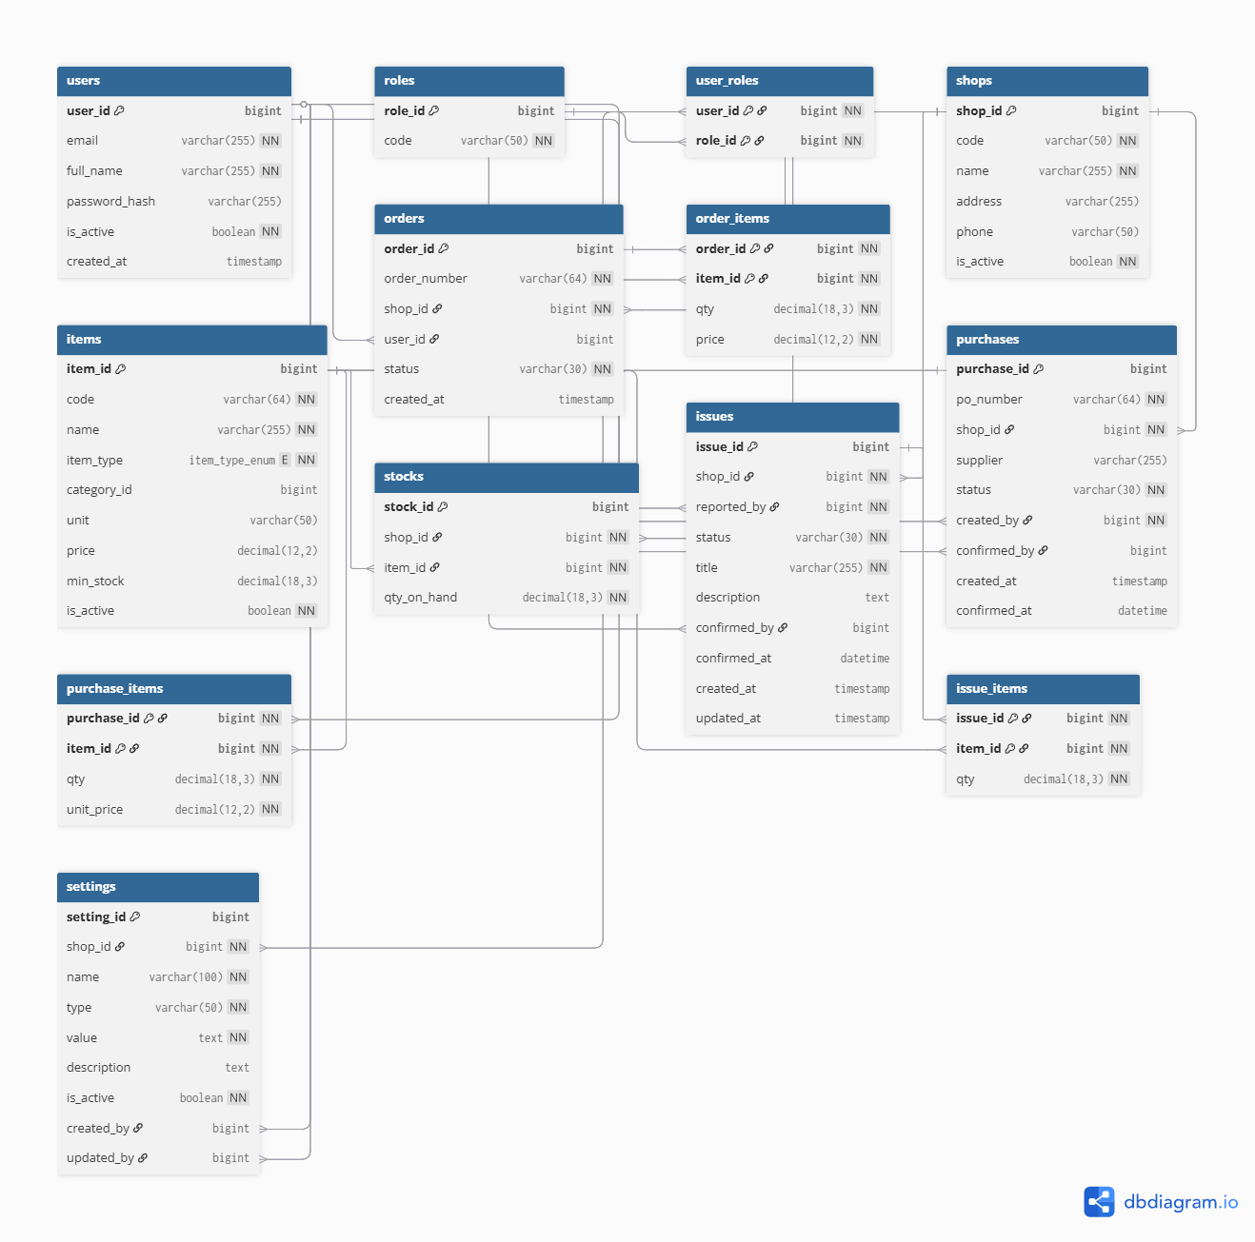

| **#** | **Entity** | **Description** |
| --- | --- | --- |
| 1 | Patrol | Cafeteria’s customer information |
| 2 | Meal | … |
| 3 | … |  |

## 2. Use Case Specifications

### 2.1 <<Feature Name1>>

#### 2.1.1 UC Name1

| Primary Actors |  | Secondary Actors |  |
| --- | --- | --- | --- |
| Description |  | | |
| Preconditions |  | | |
| Postconditions |  | | |
| Normal Sequence/Flow |  | | |
| Alternative Sequences/Flows |  | | |

***Primary and Secondary Actors***

An actor is a person or other entity external to the software system being specified who interacts with the system and performs use cases to accomplish tasks. Name the primary actor that will be initiating this UC and any other secondary actors who will participate in completing execution of the UC.

***Description***

Provide a brief description of the reason for and outcome of this use case, or a high-level description of the sequence of actions and the outcome of executing the use case. The description can be in the form of a user story (As a **<type of user>**, I want **<some goal>** so that **<some reasons>**)

***Preconditions***

List any activities that must take place, or any conditions that must be true, before the use case can be started.

***Postconditions***

Describe the state of the system at the successful conclusion of the use case execution.

***Normal Flow***

Provide a description of the user actions and corresponding system responses that will take place during execution of the use case under normal, expected conditions.

***Alternative Flows***

Describe below two information if any:

* Other successful usage scenarios that can take place within this use case. State the alternative flow, and describe any differences in the sequence of steps that take place.
* Any anticipated error conditions that could occur during execution of the use case and how the system is to respond to those conditions.

#### 2.1.2 Login System

| Primary Actors | Customer | Secondary Actors | None |
| --- | --- | --- | --- |
| Description | As a user, I want to be able to log into the system so that I can use the system’s authenticated features and access my personalized account. | | |
| Preconditions | User account has been created & authorized | | |
| Postconditions | * User logs in the system successfully * The system tracked successful login into the Activity Log | | |
| Normal Sequence/Flow | ***Login System***   1. User clicks Login button from the page header or accesses an authenticated feature (from a link or type the page URL directly into the address bar) 2. System show the User Login screen 3. User types in the login details (email, password) 4. User clicks the Login button 5. System validates the login details (BR-01, BR-02) 6. System allows user to access 7. System tracks user’s success login to the Activity Log 8. System directs user to the Home Page (or the previous calling page if any) | | |
| Alternative Sequences/Flows | ***Step 2.1_Google Login***   1. User clicks Google Login button to login system using Google account 2. System redirects the user to the Google’s Login screen 3. User types in the Google account details and chooses to login 4. Google validates user’s login information successfully and redirect him/her back to the system 5. Return to step 5 of normal flow.   ***Step 4_System can’t authenticate the user***  User can’t be authenticated & get relevant error message in one of below cases   1. He/she leaves the Email and/or Password field blank (MSG10) 2. Input Email or Password are incorrect (MSG09) 3. Input Email/Password are correct but email has not been verified (MSG11) 4. The user account is blocked / inactive (MSG12)   If user inputs wrong logging-in details 5 times continuously, system will lock his/her account in 30 minutes (with relevant warning message - MSG13) | | |

#### 2.1.3 UC Name2

…

### 2.2 Xyz Feature

…

## 3. Functional Requirements

### 3.1 User Authentication

#### 3.1.1 Login Screen

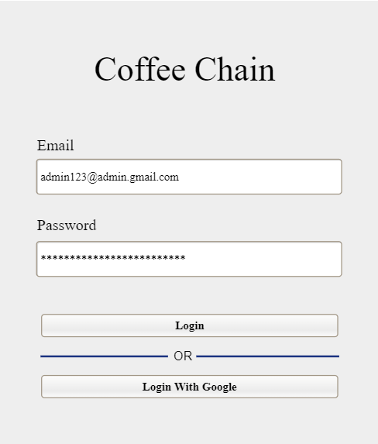

This screen allows all internal users (Admin, HR, Inventory Staff, Barista) to securely access the system. Users can log in using their registered email and password or via their Google account for faster access.

**Field Description**

| **Field Name** | **Description** |
| --- | --- |
| **Email** | Data type: Text. Required. Must be a valid email format. |
| **Password** | Data type: Password. Required. Input is masked. |
| **Login Button** | Action: Submits the credentials for authentication. |
| **Forgot Password?** | Action: Navigates the user to the password reset flow. |

#### 3.1.2 Password Reset Screen

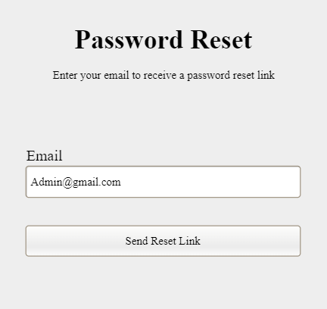

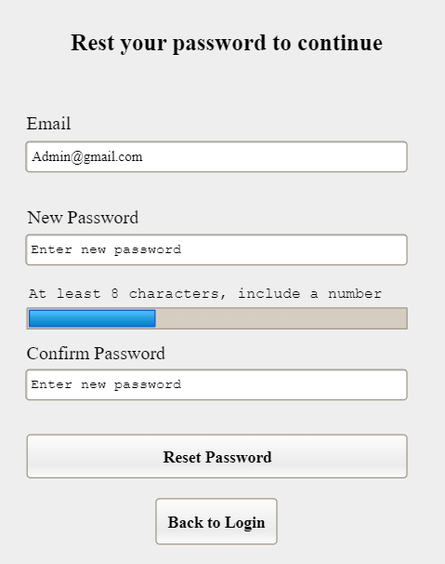

#### 3.1.3 User Profile Screen

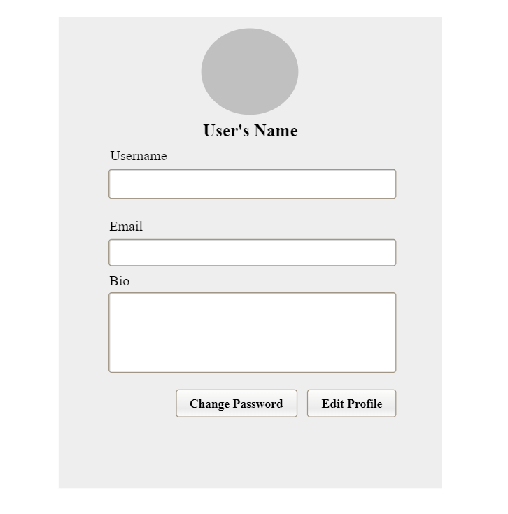

#### 3.1.4 Password Change Screen



### 3.2 System Administration

#### 3.2.1 Admin Dashboard

#### 3.2.6 Confirm PO

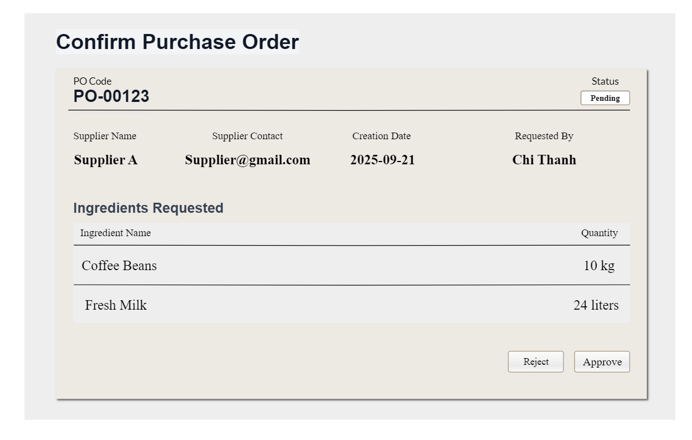

### 3.3 HR Administration

#### 3.3.1 HR Dashboard

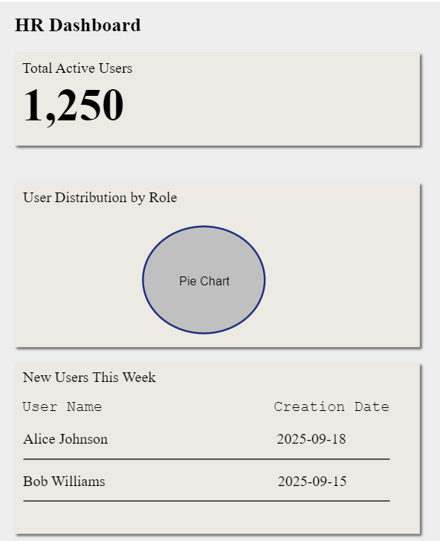

#### 3.3.2 View User List

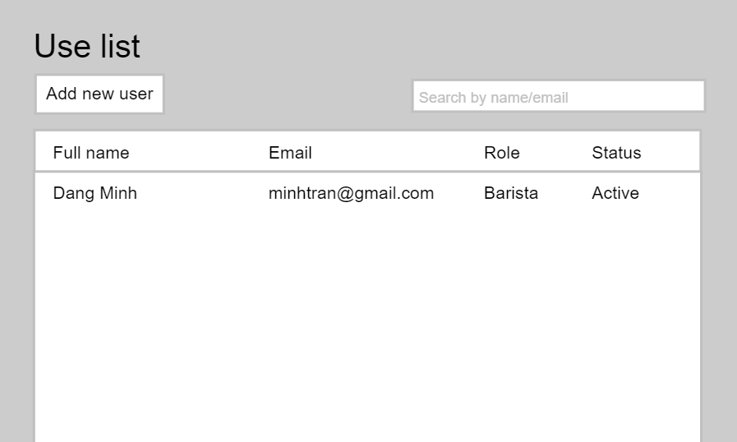

#### 3.3.3Update User Details

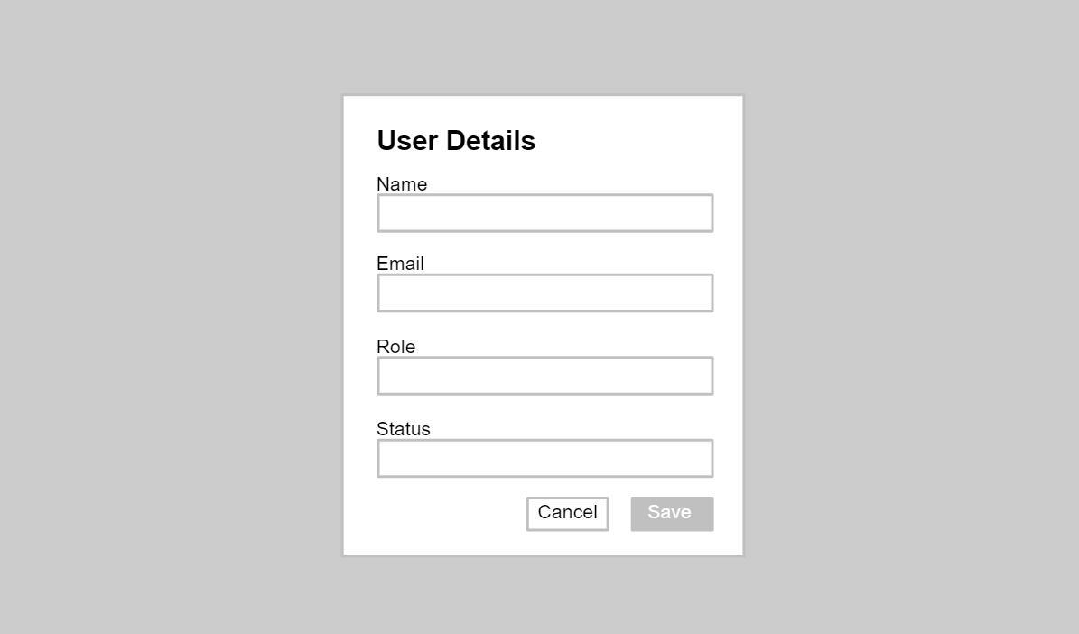

|  |
| --- |

#### 

### 

### 3.4 Inventory Management

#### 3.4.1 Inventory Dashboard

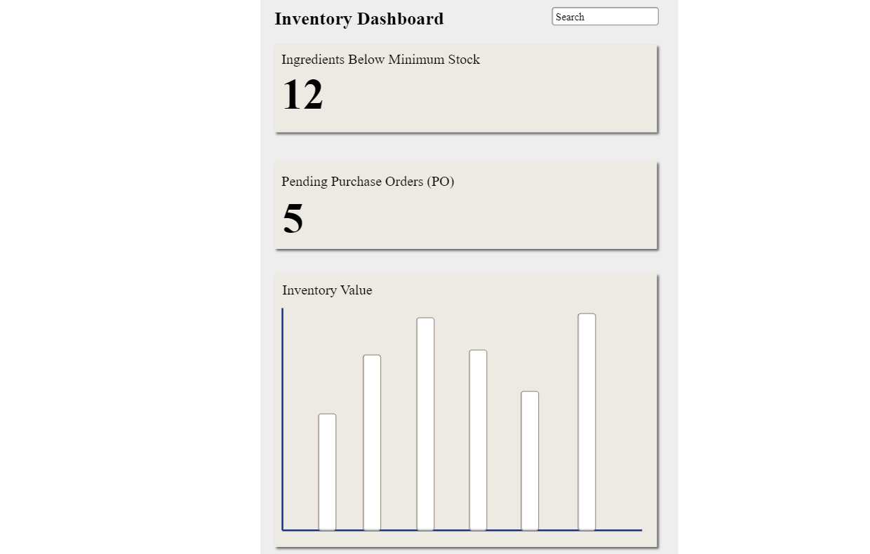

This screen allows the Inventory Staff and Admin to:

* View the number of ingredients currently below minimum stock.
* Track the number of pending purchase orders (PO).
* Monitor the overall inventory value with a visual chart.
* Quickly identify potential issues that require attention.

**Field Description**

| Field Name | Description |
| --- | --- |
| Name | Dashboard Title |
| Description | Type: Header Text Value: "Inventory Dashboard"  Priority: 1  Description: The main title of the screen. |
| Name | Low Stock Widget |
| Description | Type: Metric Value: An integer representing the count of ingredients below minimum stock.  Priority: 2  Description: Displays the number of ingredients under the safety threshold. Clickable to navigate to a filtered list. |
| Name | Pending POs Widget |
| Description | Type: Metric Value: An integer representing the count of pending purchase orders.  Priority: 3  Description: Displays the total number of purchase orders awaiting approval. Clickable. |
| Name | Inventory Value Chart |
| Description | Type: Chart Value: A series of numeric data representing inventory value over time.  Priority: 4 Description: A bar chart showing the current inventory value by shop or by month. |

#### 3.4.2 PO List

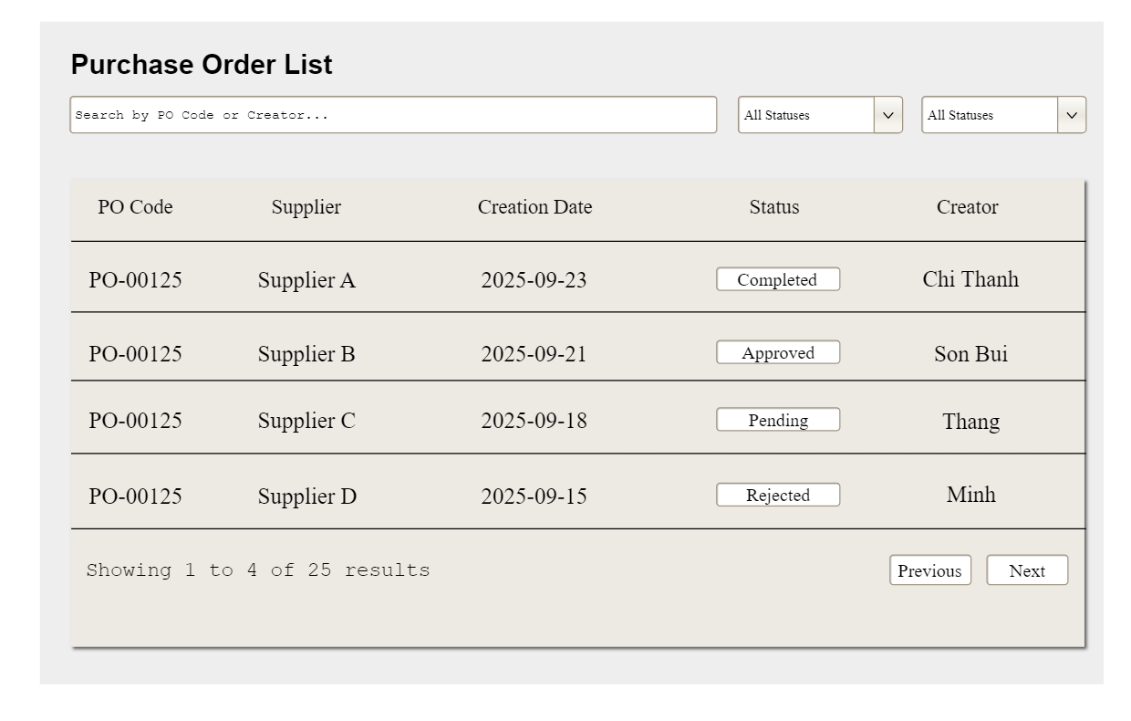

This screen allows the Inventory Staff and Admin to:

* View all purchase orders (PO) in a tabular format.
* Filter and search purchase orders by status, creator, or PO code.
* Navigate through paginated results.
* Access detailed PO information by clicking on a row.

**Field Description**

| Field Name | Description |
| --- | --- |
| Name | Screen Title |
| Description | Type: Header Text  Value: "Purchase Order List"  Priority: 1  Description: The main title of the screen. |
| Name | Search Bar |
| Description | Type: Input Field  Value: User-entered text  Priority: 2  Description: Allows users to search by keywords like PO Code or Supplier name. |
| Name | Status Filter |
| Description | Type: Dropdown  Value: [All, Pending, Approved, etc.]  Priority: 3  Description: Filters the list based on PO status. |
| Name | PO List Table |
| Description | Type: Table  Value: A list of purchase orders.  Priority: 4  Description: The main display area. Contains columns: PO Code (clickable), Supplier, Creation Date, Status (with badge), Creator. |
| Name | Pagination |
| Description | Type: Navigation Control  Value: Previous / Next buttons, page numbers  Priority: 5  Description: Allows users to navigate through pages of the PO list. |

#### 3.4.3 New PO

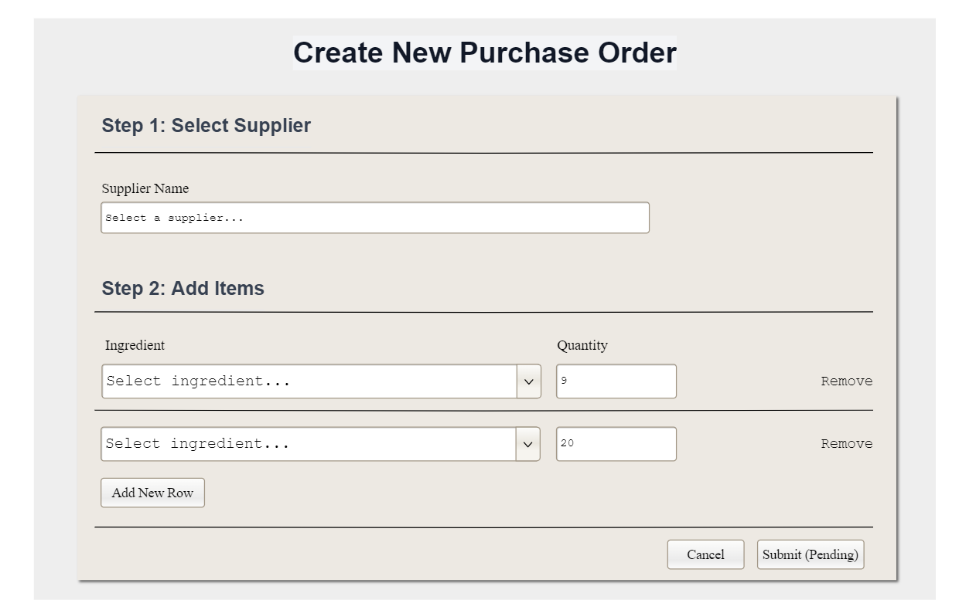

This screen allows the Inventory Staff to:

* Create a new Purchase Order (PO) by selecting a supplier and adding one or more ingredient items.
* Specify quantities for each ingredient and dynamically add or remove item rows.
* Submit the PO into the system with status Pending or cancel the operation.

**Field Description**

| **Field Name** | **Description** |
| --- | --- |
| **Name** | Screen Title |
| **Description** | Type: Header Text Value: "Create New Purchase Order"  Priority: 1  Description: The main title of the screen. |
| **Name** | Supplier Name |
| **Description** | Type: Input Field (Dropdown / Searchable)  Value: Supplier options from database  Priority: 2  Description: Allows user to select the supplier for the new purchase order. |
| **Name** | Items Table |
| **Description** | Type: Dynamic Table Value: A list of ingredients with quantities  Priority: 3  Description: Main area to build the PO. Includes controls for ingredient selection, quantity input, and add/remove item rows. |
| **Name** | Form Actions |
| **Description** | Type: Action Buttons Value: [Cancel, Submit (Pending)]  Priority: 4  Description: Buttons to either discard the form or submit it for approval with "Pending" status. |

#### 3.4.4 Details - Pending

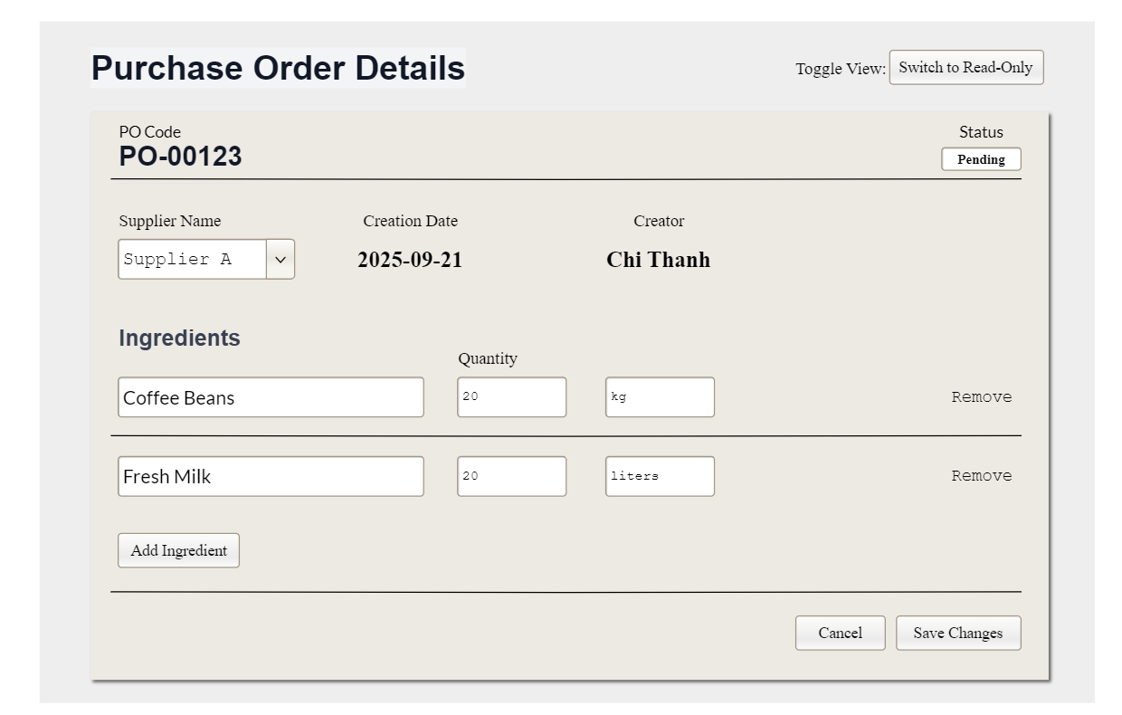

This screen allows the Inventory Staff to:

* View and update details of a specific purchase order that is still in Pending status.
* Modify supplier information, ingredient items, and quantities before the PO is approved.
* Add or remove ingredients from the order.
* Save the changes or cancel the update.
* Toggle between editable and read-only views.

**Field Description**

| **Field Name** | **Description** |
| --- | --- |
| **Name** | Screen Title |
| **Description** | Type: Header Text Value: "Purchase Order Details"  Priority: 1  Description: The main title of the screen. |
| **Name** | PO General Info |
| **Description** | Type: Information Group Value: N/A  Priority: 2  Description: Displays key details of the PO. Includes read-only fields for PO Code, Creation Date, Creator, Status (Badge), and an editable dropdown for Supplier Name. |
| **Name** | Ingredients Section |
| **Description** | Type: Editable Table Value: A list of ingredients with quantities.  Priority: 3  Description: The main area for editing items in the PO. Users can change ingredients, update quantities, and remove items. Includes an "Add Ingredient" button. |
| **Name** | Form Actions |
| **Description** | Type: Action Buttons Value: ["Cancel", "Save Changes"]  Priority: 4  Description: Buttons to either discard the edits or save the updated PO details. |

#### 3.4.5 Details - Approved

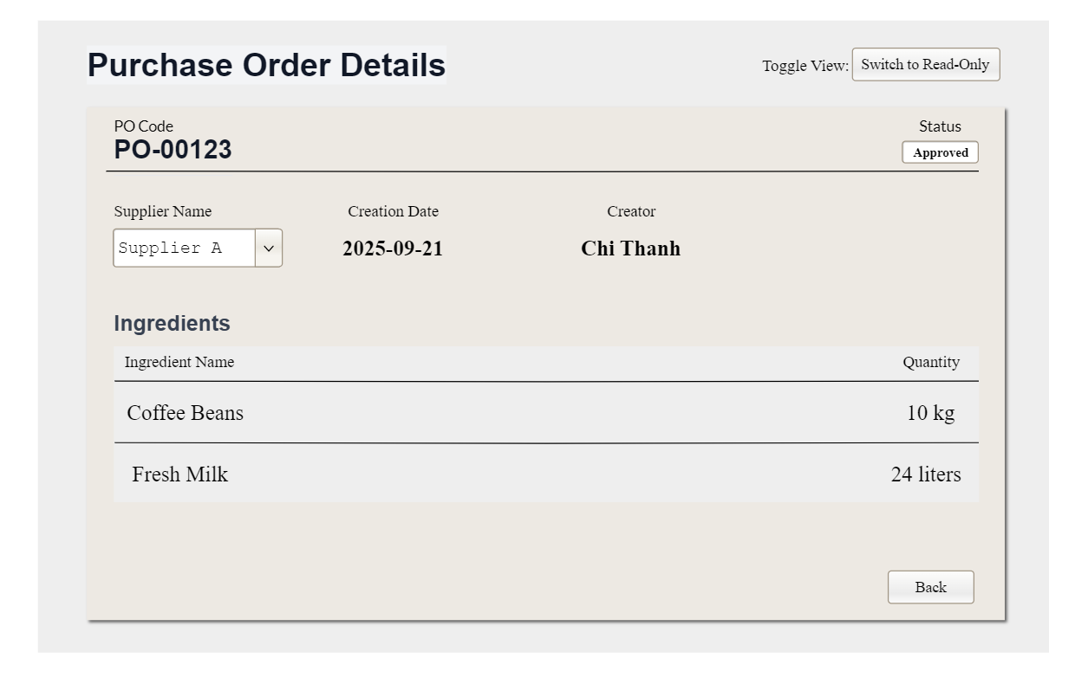

This screen allows the Inventory Staff to:

* View the details of a purchase order that has already been Approved.
* Check supplier information, creation date, creator, and the list of ingredients with confirmed quantities.
* Switch the view mode (if allowed) but cannot edit details.
* Navigate back to the Purchase Order List.

**Field Description**

| **Field Name** | **Description** |
| --- | --- |
| **Name** | Screen Title |
| **Description** | Type: Header Text Value: "Purchase Order Details"  Priority: 1  Description: The main title of the screen. |
| **Name** | PO General Info |
| **Description** | Type: Information Group (Read-only) Value: N/A  Priority: 2  Description: Displays all key details of the approved PO. Includes read-only fields for PO Code, Supplier Name, Creation Date, Creator, and Status (Approved Badge). |
| **Name** | Ingredients List |
| **Description** | Type: Table (Read-only) Value: A static list of ingredients and confirmed quantities.  Priority: 3  Description: The finalized list of items for the PO. Cannot be modified. |
| **Name** | Navigation Action |
| **Description** | Type: Button Value: "Back"  Priority: 4  Description: A single button to navigate the user back to the Purchase Order List screen. |

#### 3.4.6 Receive Stock

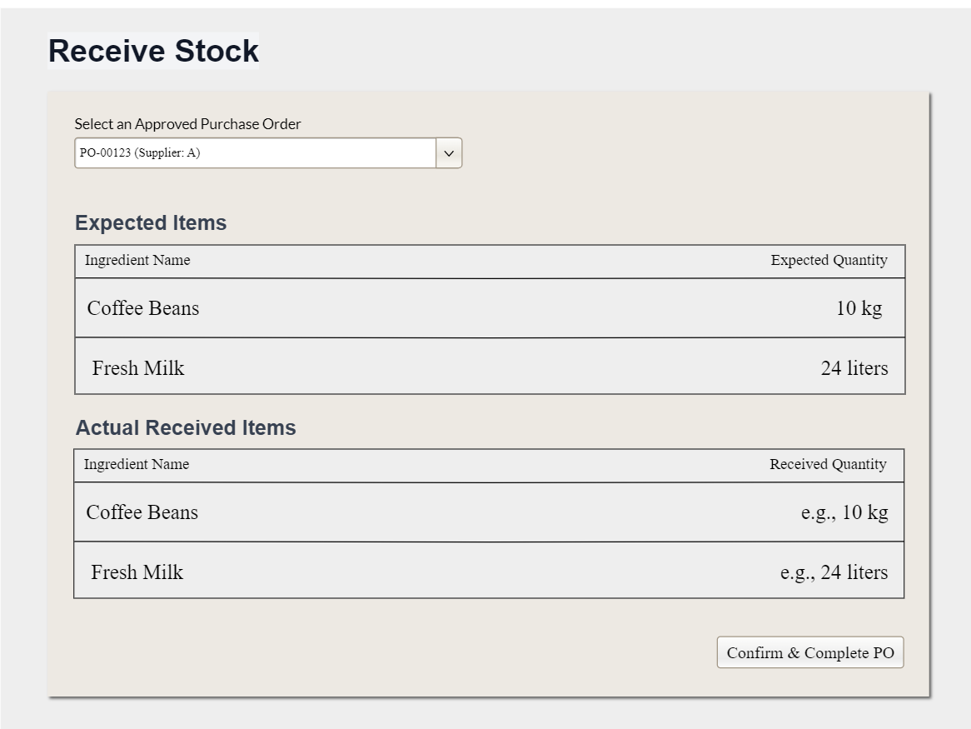

#### 3.4.7 Ingredient Stock Details

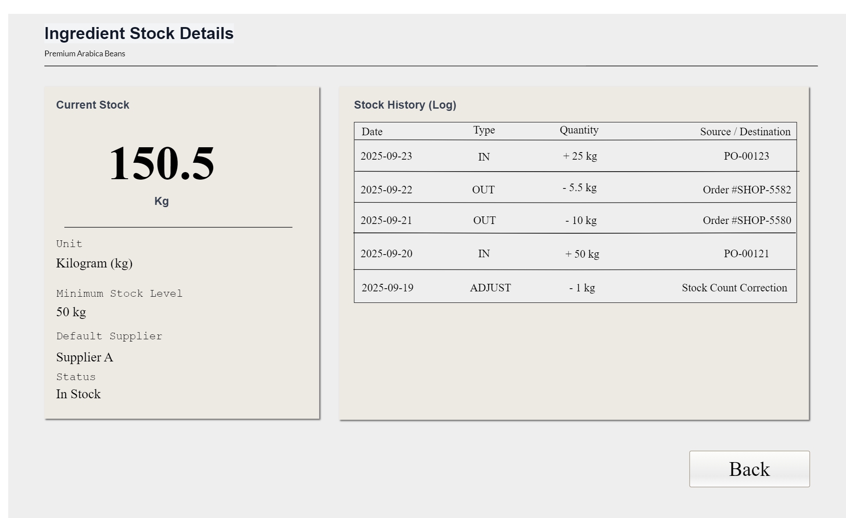

### 3.4 Production Management

##### 3.4.1 Barista Production Dashboard

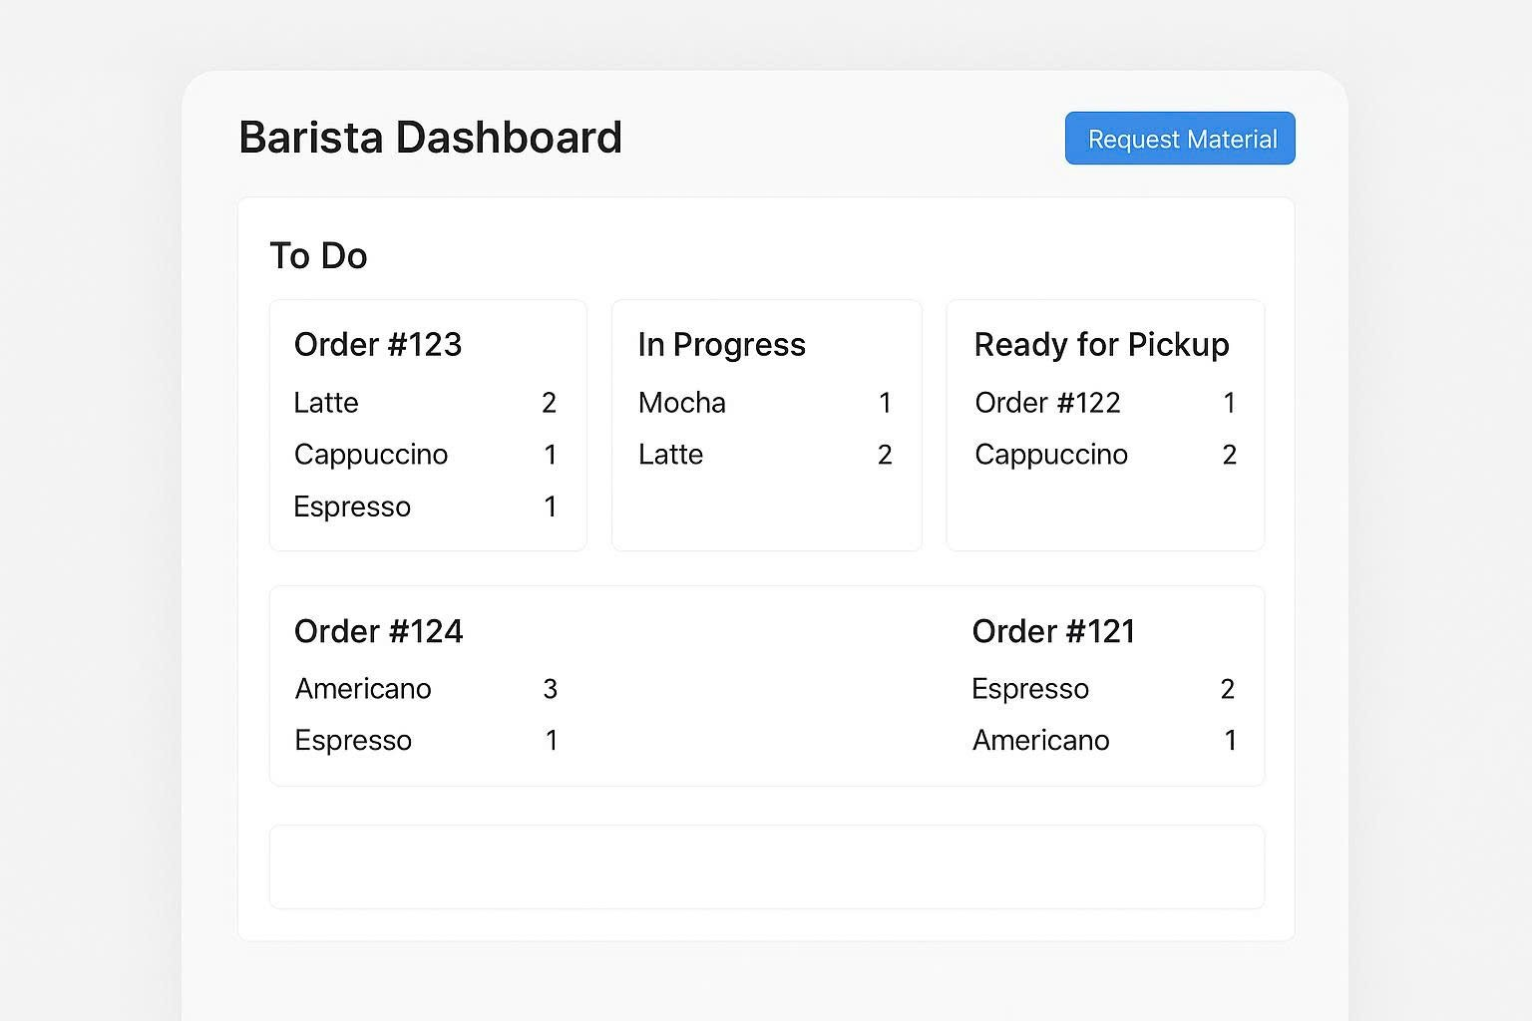

This screen is designed as a highly visual and interactive Kanban board to help Baristas manage their workflow efficiently. It allows them to track production orders through different stages of preparation in real-time.

##### 3.4.2 Material Issue Details

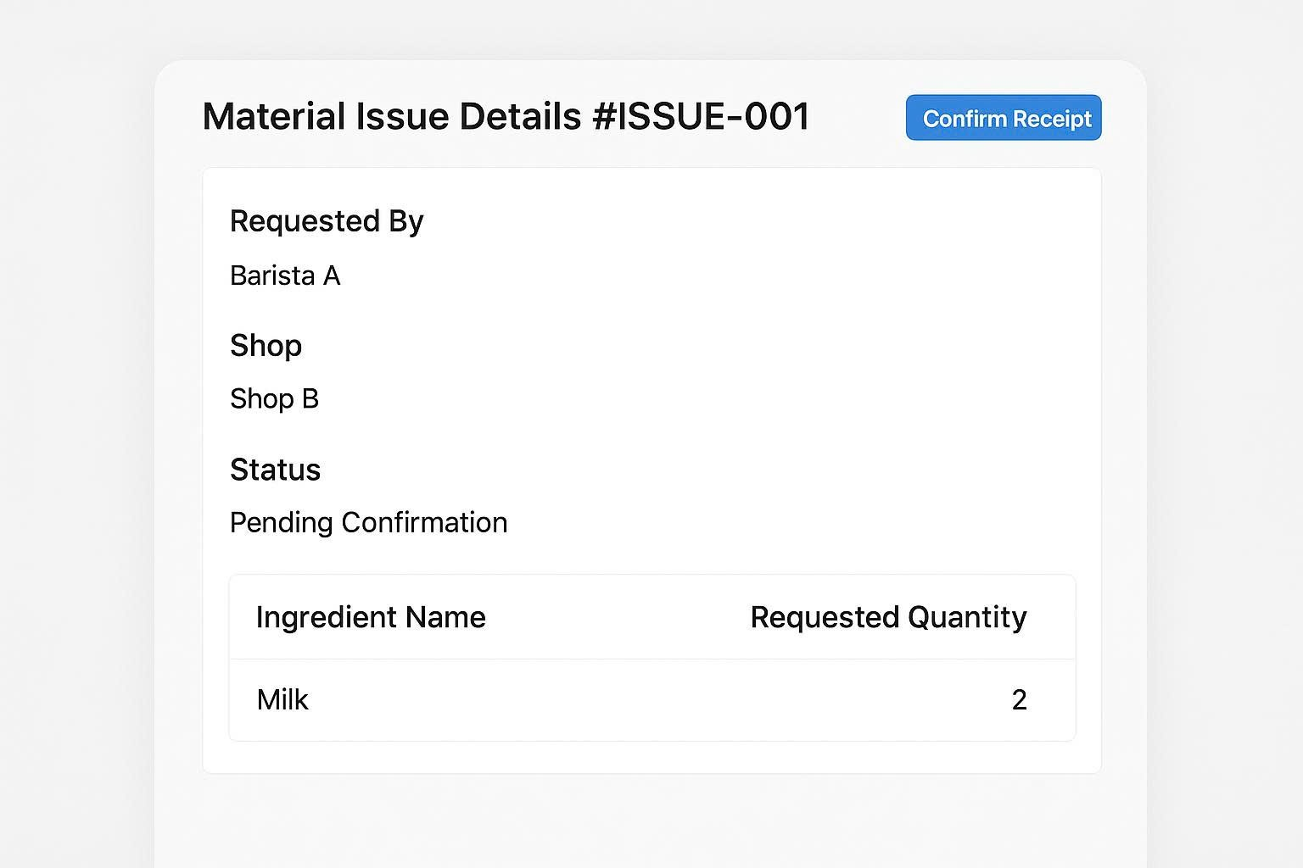

This screen acts as a digital ticket or request form to formalize the process of transferring ingredients from the inventory to the production area. It ensures accurate tracking of all materials used.

**Field Description**

| **Field Name** | **Description** |
| --- | --- |
| **Ticket Header** | Displays the unique ticket ID (e.g., #ISSUE-001). |
| **Requester Info** | Requested By: Name or role of the Barista who created the request.<br>Shop: The shop location.<br>Status: The current status of the request (e.g., "Pending Confirmation"). |
| **Ingredient List** | A simple table listing the Ingredient Name and the Requested Quantity. |
| **Main Action** | Confirm Receipt Button |

## 4. Non-Functional Requirements

### 3.1 External Interfaces

*[This section provides information to ensure that the system will communicate properly with users and with external hardware or software/system elements.]*

### 3.2 Quality Attributes

*[List all the required system characteristics (quality attributes) specification. Some of the possible attributes are provided with the guide/descriptions are mentioned here]*

#### 3.2.1 Usability

*[This section includes all those requirements that affect usability. For example, specify the required training time for a normal user and a power user to become productive at particular operations specify measurable task times for typical tasks or base the new system’s usability requirements on other systems that the users know and like specify requirement to conform to common usability standards, such as IBM’s CUA standards Microsoft’s GUI standards]*

#### 3.2.2 Performance

*[The system’s performance characteristics are outlined in this section. Include specific response times. Where applicable, reference related Use Cases by name.*

*Response time for a transaction (average, maximum)*

*Throughput, for example, transactions per second*

*Capacity, for example, the number of customers or transactions the system can accommodate*

*Resource utilization, such as memory, disk, communications, and so forth.]*

#### 3.2.3 …

## 5. Requirement Appendix

*[Provide business rules, common requirements, or other extra requirements information here]*

### 5.1 Business Rules

*[Provide common business rules that you must follow. The information can be provided in the table format as the sample below]*

| **ID** | **Rule Definition** |
| --- | --- |
| BR-01 | Delivery time windows are 15 minutes, beginning on each quarter hour. |
| BR-02 | Deliveries must be completed between 10:00 A.M. and 2:00 P.M. local time, inclusive. |
| BR-03 | All meals in a single order must be delivered to the same location. |
| BR-04 | All meals in a single order must be paid for by using the same payment method. |
| BR-11 | If an order is to be delivered, the patron must pay by payroll deduction. |
| BR-12 | Order price is calculated as the sum of each food item price times the quantity of that food item ordered, plus applicable sales tax, plus a delivery charge if a meal is delivered outside the free delivery zone. |
| BR-24 | Only cafeteria employees who are designated as Menu Managers by the Cafeteria Manager can create, modify, or delete cafeteria menus. |
| BR-33 | Network transmissions that involve financial information or personally identifiable information require 256-bit encryption. |
| BR-86 | Only regular employees can register for payroll deduction for any company purchase. |
| BR-88 | An employee can register for payroll deduction payment of cafeteria meals if no more than 40 percent of his gross pay is currently being deducted for other reasons. |

### 5.2 System Messages

| **#** | **Message code** | **Message Type** | **Context** | **Content** |
| --- | --- | --- | --- | --- |
| 1 | MSG01 | In line | There is not any search result | *No search results.* |
| 2 | MSG02 | In red, under the text box | Input-required fields are empty | *The * field is required.* |
| 3 | MSG03 | Toast message | Updating asset(s) information successfully | *Update asset(s) successfully.* |
| 4 | MSG04 | Toast message | Adding new asset successfully | *Add assets successfully.* |
| 5 | MSG05 | Toast message | Confirming email of asset hand-over is sent successfully | *A confirmation email has been sent to {email_address}.* |
| 6 | MSG06 | Toast message | Resetting asset information successfully | *Return asset(s) successfully.* |
| 7 | MSG07 | Toast message | Deleting asset information successfully | *Delete asset(s) successfully.* |
| 8 | MSG08 | In red, under the text box | Input value length > max length | *Exceed max length of {max_length}.* |
| 9 | MSG09 | In line | Username or password is not correct when clicking sign-in | *Incorrect user name or password. Please check again.* |
| 10 | .. |  |  |  |

### 5.3 Other Requirements…