Huỳnh Trường Phong-2033223668

LAB 11

TASK 1:

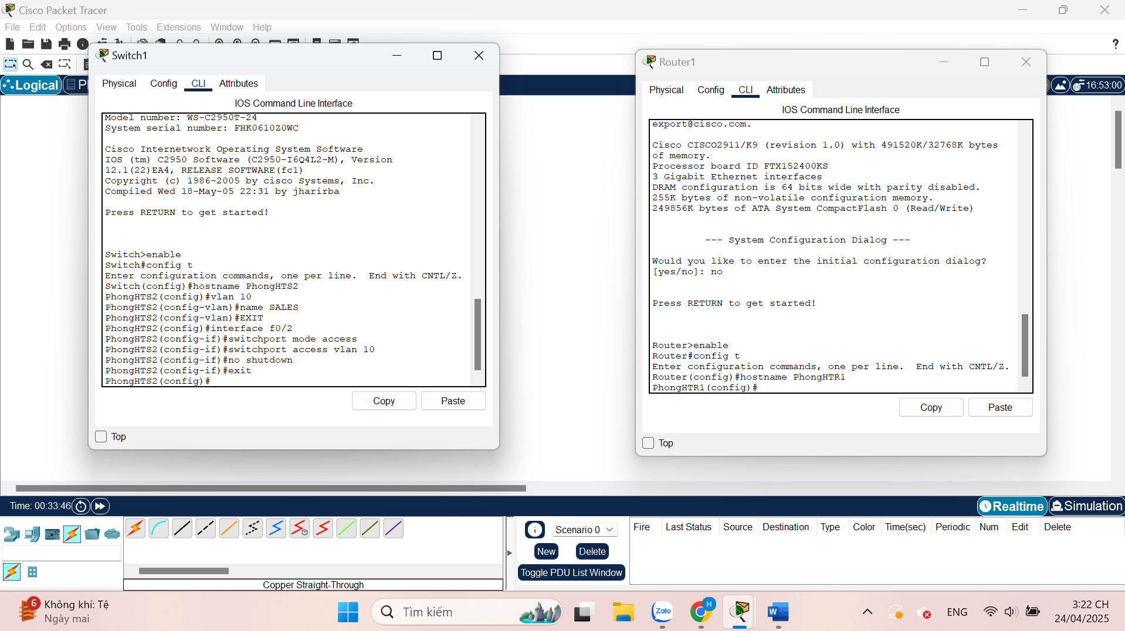

TASK 2:

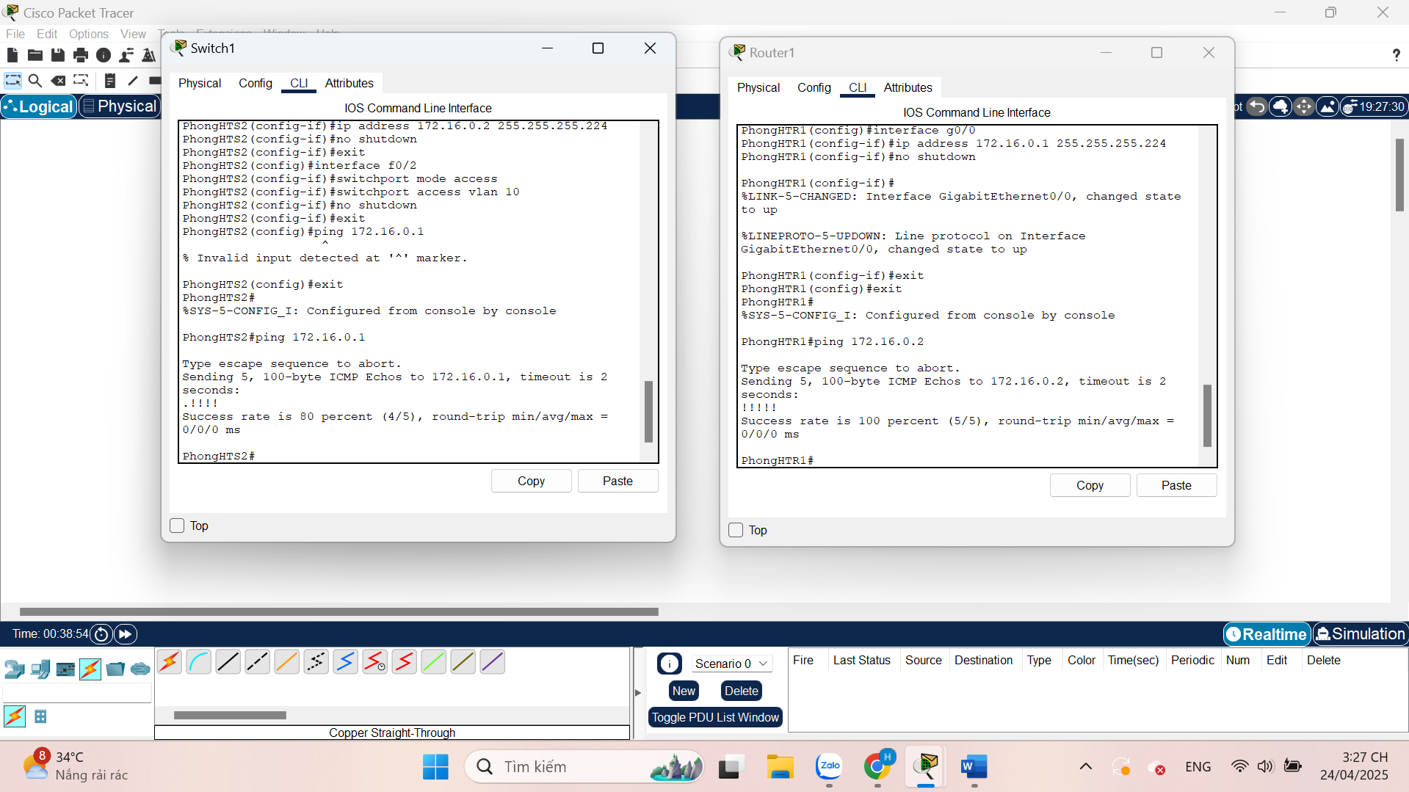

TASK 3:

