Huỳnh Trường Phong-2033223668

LAB 21

TASK 1:

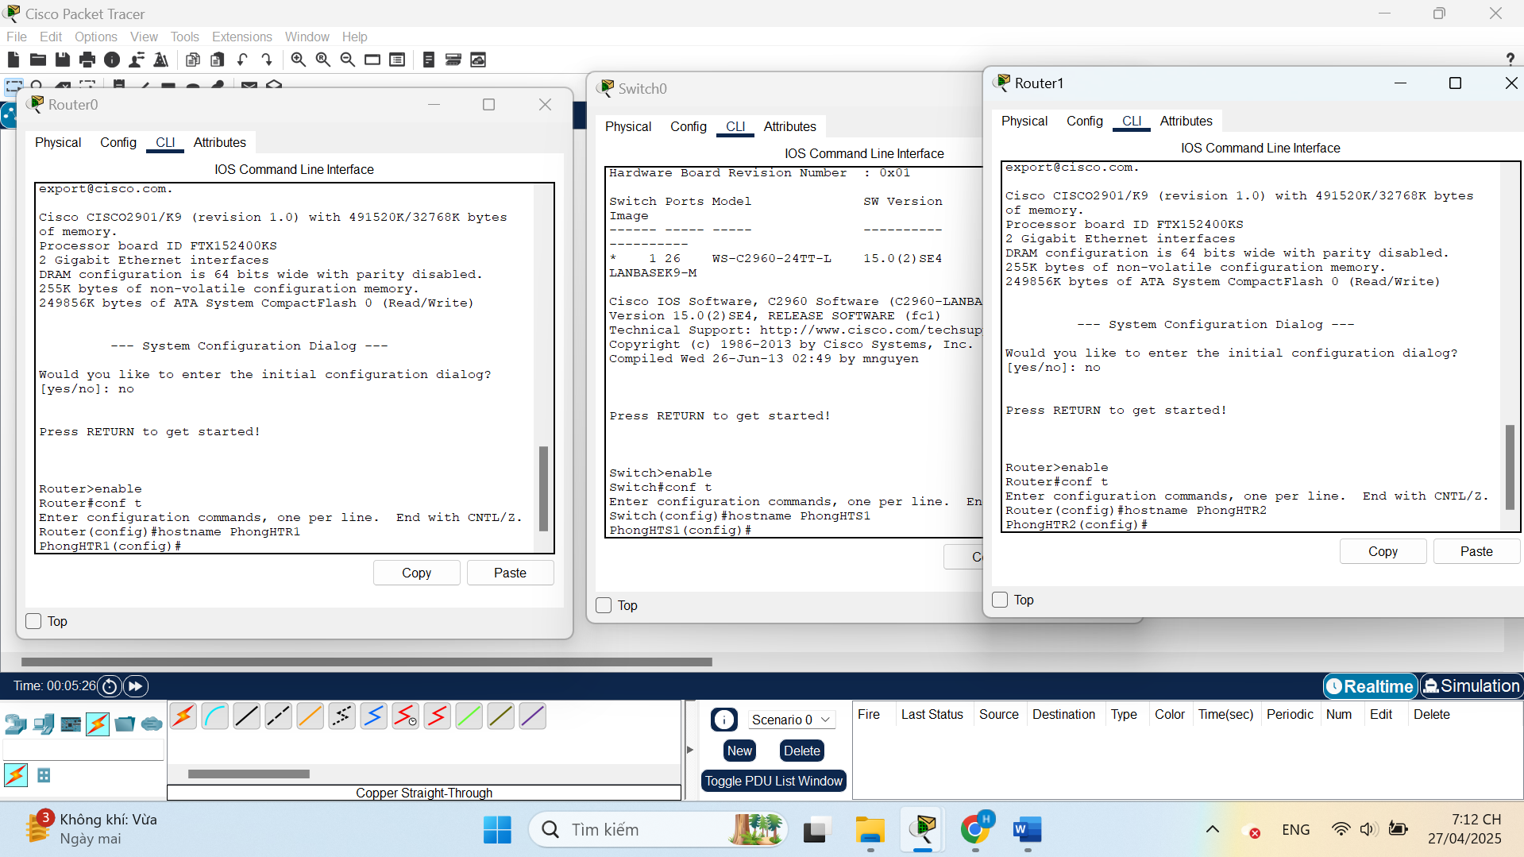

TASK 2:

TASK 3:

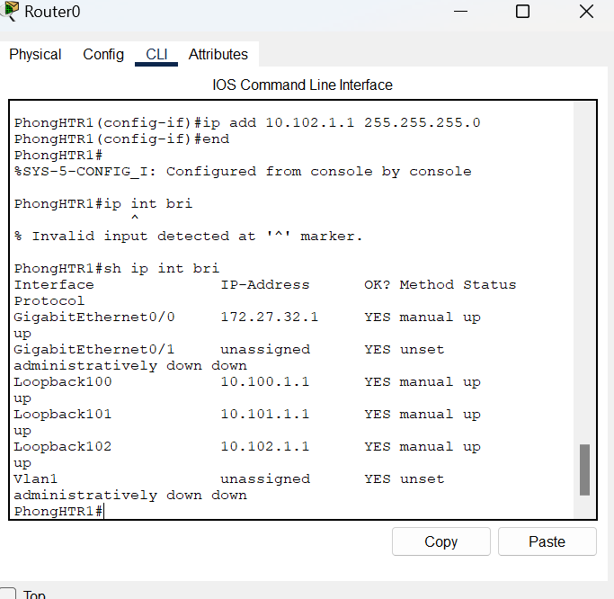

TASK 4:

