Huỳnh Trường Phong-2033223668

LAB 23

TASK 1:

TASK 2:

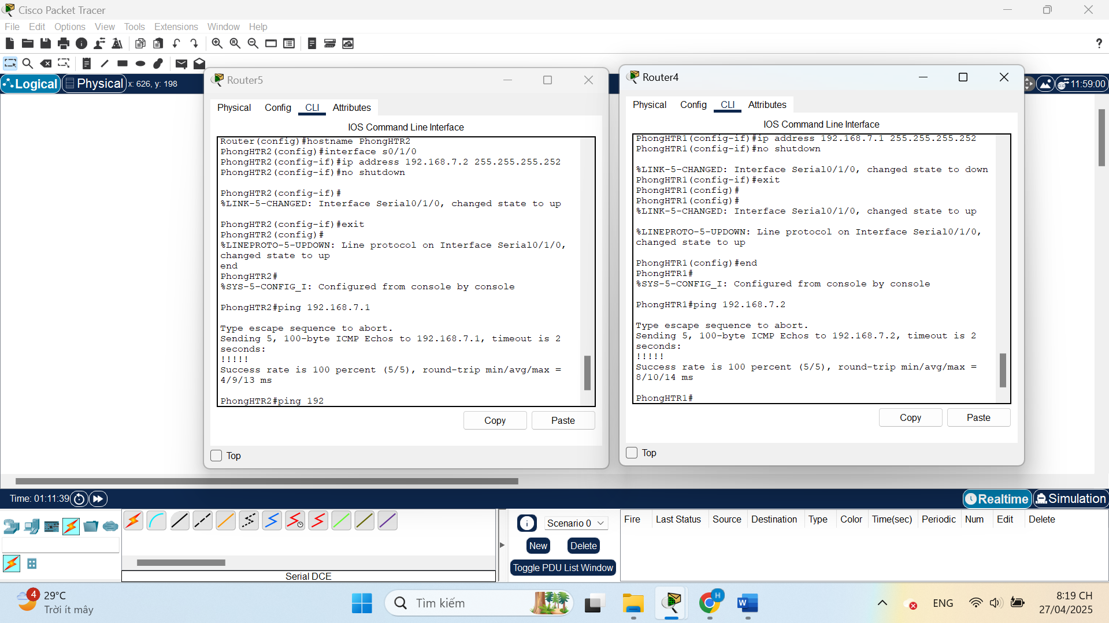

TASK 3:

TASK 4:

