Huỳnh Trường Phong-2033223668

LAB 25

TASK 1:

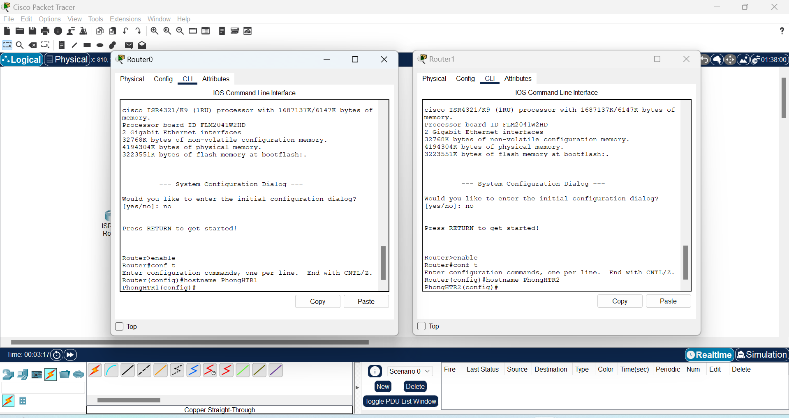

TASK 2:

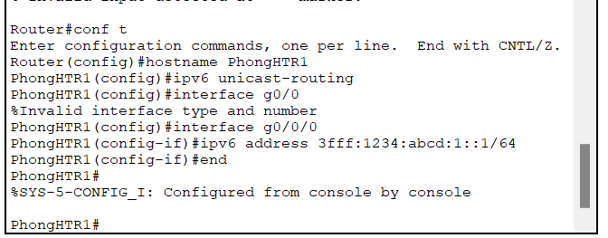

TASK 3:

TASK 4:

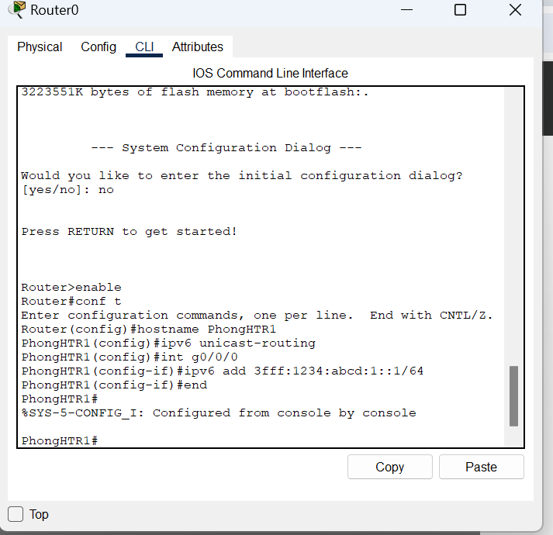

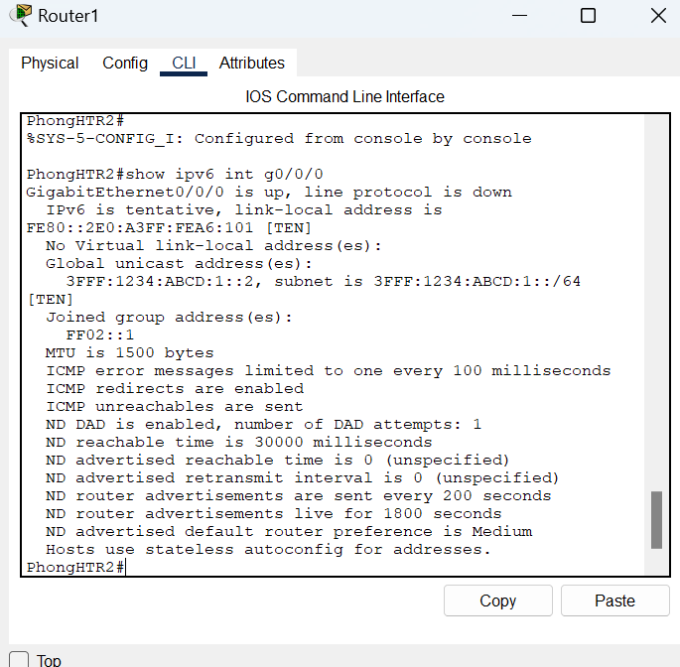

TASK 3:

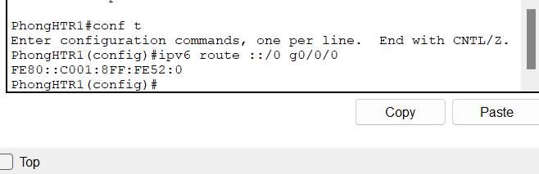

TASK 4: