Huỳnh Trường Phong-2033223668

LAB 26

TASK 1:

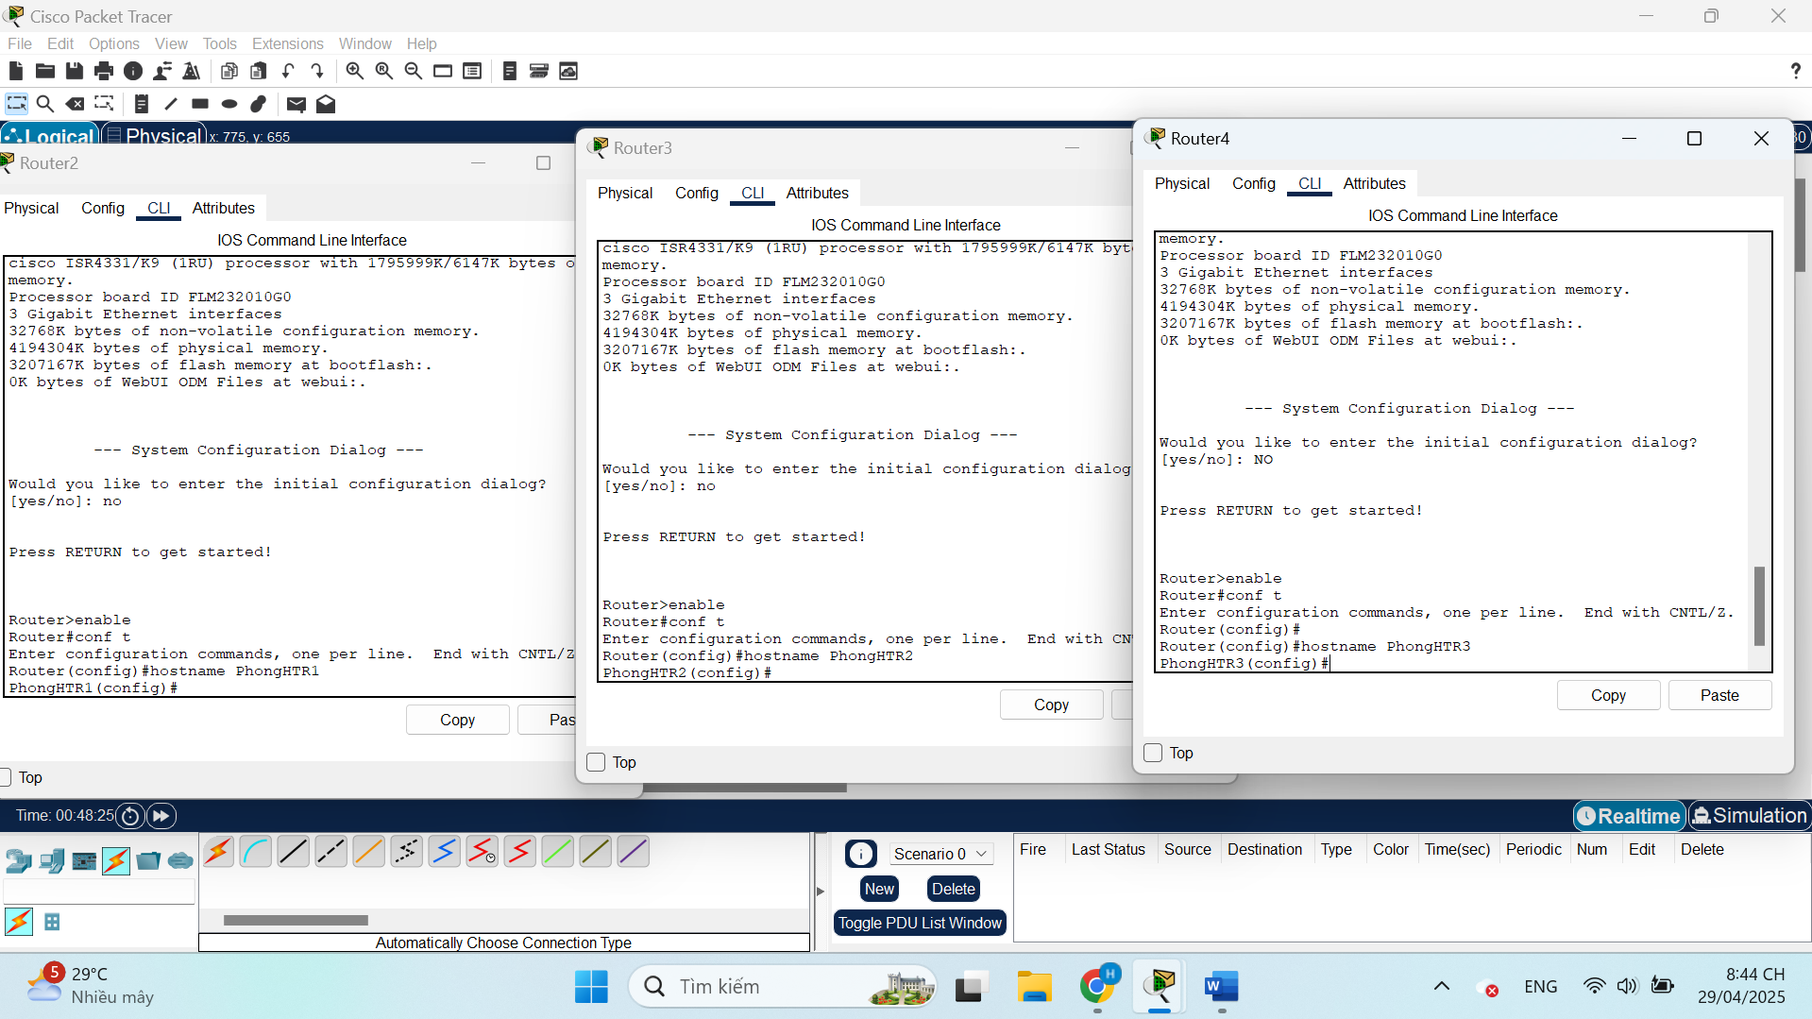

TASK 2:

TASK 3:

TASK 4:

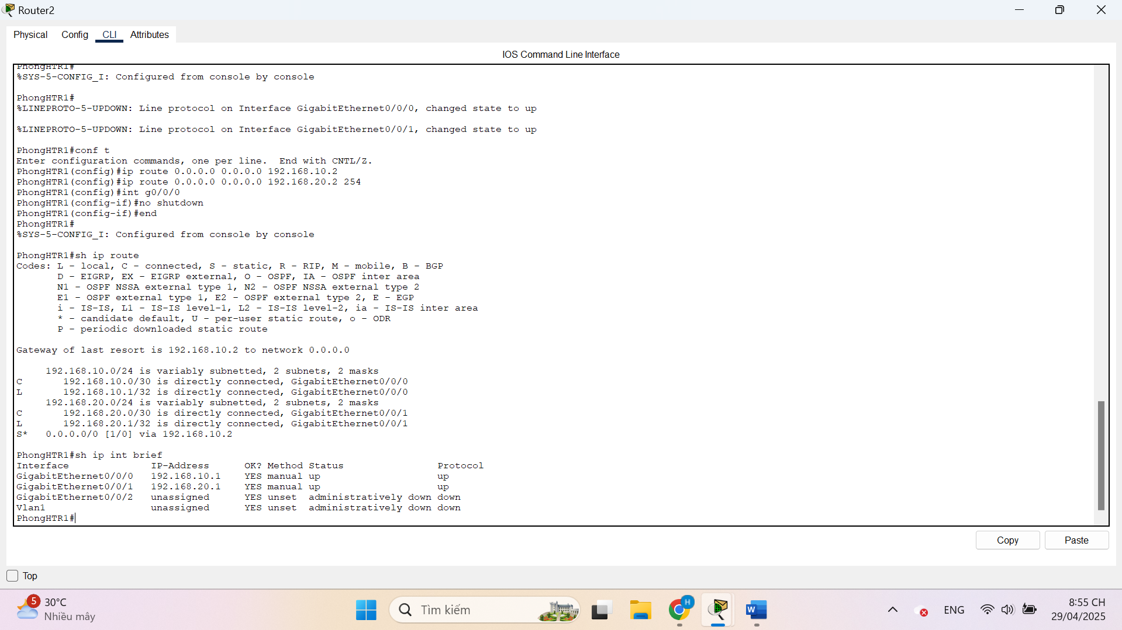

TASK 5:

