Huỳnh Trường Phong-2033223668

LAB 27

TASK 1:

TASK 2:

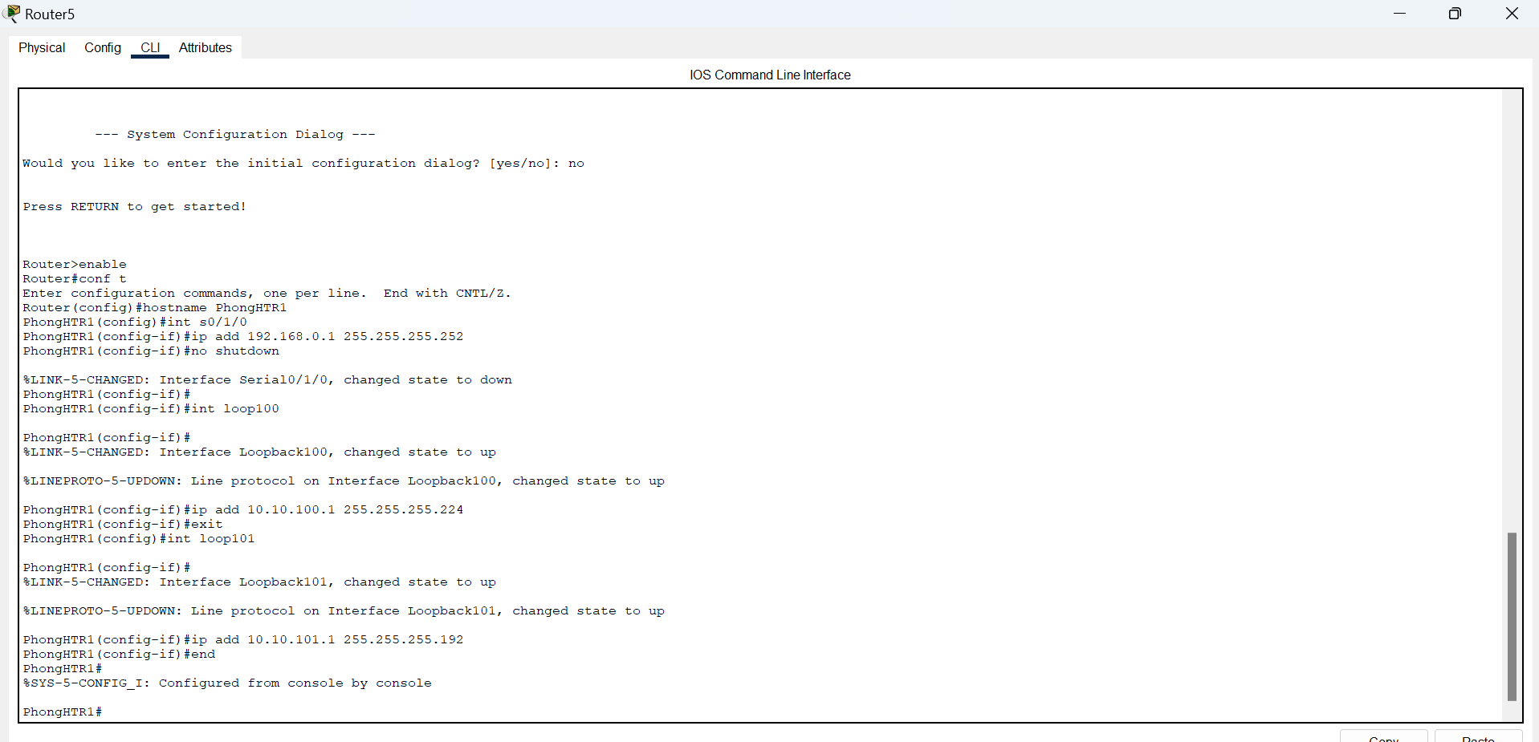

TASK 3:

