

Project Human Resource Plan Template
This Project Human Resource Plan Template is free for you to copy and use on your project
and within your organization. We hope that you find this template useful and
welcome your comments. Public distribution of this document is only permitted
from the Project Management Docs official website at:
www.ProjectManagementDocs.com

Human Resource Plan
<Project Name>

Company Name
Street Address
City, State Zip Code

Date

Table of Contents
Introduction 2
Roles and Responsibilities 2
Project Organizational Charts 3
Staffing Management 4

Introduction
This section explains the purpose and importance of having a human resources management plan. It should provide a general description of what the plan includes and explain how the project manager and project team can use the plan to help them manage the project effectively.

Human resources management is an important part of the Software Upgrade Project. The human resources management plan is a tool which will aid in the management of this project’s human resource activities throughout the project until closure. The human resources management plan includes:
- Roles and responsibilities of team members throughout the project
- Project organization charts
- Staffing management plan to include:
  - How resources will be acquired
  - Timeline for resources/skill sets
  - Training required to develop skills
  - How performance reviews will be conducted
  - Recognition and rewards system

The purpose of the human resources management plan is to achieve project success by ensuring the appropriate human resources are acquired with the necessary skills, resources are trained if any gaps in skills are identified, team building strategies are clearly defines, and team activities are effectively managed.

Roles and Responsibilities
Roles and responsibilities of team members and stakeholders must be clearly defined in any project. Depending on the organizational structure, project team members may represent many different groups/departments and act in the interest of different functional managers. Additionally, team members may have varying degrees of authority and responsibility. When listing roles and responsibilities the following should be included:
- Role – description of the portion of the project for which the member is accountable
- Authority – the level at which the member may make decisions, apply project resources, or make approvals
- Responsibility – the work a team member must perform to complete assigned work activities
- Competency – the skill(s) required to complete assigned project activities

The roles and responsibilities for the Software Upgrade Project are essential to project success. All team members must clearly understand their roles and responsibilities in order to successfully perform their portion of the project. For the Software Upgrade Project the following project team roles and responsibilities have been established:

Project Manager (PM), (1 position): responsible for the overall success of the Software Upgrade Project. The PM must authorize and approve all project expenditures. The PM is also responsible for approving that work activities meet established acceptability criteria and fall within acceptable variances. The PM will be responsible for reporting project status in accordance with the communications management plan. The PM will evaluate the performance of all project team members and communicate their performance to functional managers. The PM is also responsible for acquiring human resources for the project through coordination with functional managers. The PM must possess the following skills: leadership/management, budgeting, scheduling, and effective communication.

Design Engineer (DE) (2 positions): responsible for gathering coding requirements for the Software Upgrade Project. The DEs are responsible for all upgrade design, coding, and testing of the upgraded software. The DEs will assist the implementation lead in the distribution and monitoring of the software upgrades throughout the network infrastructure. The DEs will be responsible for timely status reporting to the PM as required by the communications management plan. The DEs may not authorize any project expenditures nor allocate any resources without PM approval. DE’s performance will be managed by the PM and communicated to the Design Technology Group Manager (DE’s Functional Manager). DEs must be proficient in programming html, C++, and Java programming languages.

Implementation Manager (IM) (1 position): The IM is responsible for the distribution, implementation, and monitoring of the new software upgrade. The IM is responsible for working with the DEs to ensure all coding on new software conforms with organizational security regulations. The IM is responsible for coordination outage windows with each department to facilitate the rollout of the software upgrades with minimal/no disturbance to operations. The IM will report status to the PM in accordance with the project’s communications management plan. The IM’s performance will be evaluated by the PM and communicated to the IM’s functional manager (Network Manager). The IM must be proficient in managing network architecture.

Training Lead (TL) (1 position): The TL is responsible for training all network users on the features provided by the upgrades to the existing software. The TL will coordinate training times/locations with each department’s training advocate. The TL will provide training status to the PM in accordance with the project communications management plan.

Functional Managers (FM) (2 positions): While not part of the project team, functional managers are responsible for providing resources for the project in accordance with the project staffing plan. Functional managers are responsible for working with the PM to determine skill sets required and approving resource assignments. Functional managers are also responsible for conducting performance appraisals of assigned resources based, in part, on the PM’s feedback regarding project performance.

Project Organizational Charts
This section provides a graphic display of the project tasks and team members. The purpose of this is to illustrate the responsibilities of team members as they relate to the project tasks. Tools such as responsible, accountable, consult, inform (RACI) or responsibility assignment matrix (RAM) may be used to aid in communicating roles and responsibilities for the project team. Additionally, organizational or resource breakdown structures may be used to show how responsibilities are assigned by department or by type of resource respectively. It should be noted that the level of detail may vary depending on project complexity.

The following RACI chart shows the relationship between project tasks and team members. Any proposed changes to project responsibilities must be reviewed and approved by the project manager. Changes will be proposed in accordance with the project’s change control process. As changes are made all project documents will be updated and redistributed accordingly.
 | Project Manager | Design Engineers | Implementation Manager | Training Leads | Functional Managers | Department Managers
Requirements Gathering | A | R | R | C | C | I
Coding Design | A | R | C |  | C | I
Coding Input | A | R
Software Testing | A | R | C |  | I | I
Network Preparation | A | C | R |  | I | I
Implementation | A | C | R | C | C | C
Conduct Training | A |  |  | R | C | C

Key:
R – Responsible for completing the work
A – Accountable for ensuring task completion/sign off
C – Consulted before any decisions are made
I – Informed of when an action/decision has been made

Staffing Management
This section contains information on several areas including: when and how human resource requirements will be acquired, the timeline for when resources are needed and may be released, training for any resources with identified gaps in skills required, how performance reviews will be performed, and the rewards and recognition system to be used. It is important to note that depending on the scope of the project there may be other items included in staffing management (government and/or regulatory compliance, organizational health and safety, etc).

Staff Acquisition:
For the Software Upgrade Project the project staff will consist entirely of internal resources. There will be no outsourcing/contracting performed within the scope of this project. The Project Manager will negotiate with functional and department managers in order to identify and assign resources in accordance with the project organizational structure. All resources must be approved by the appropriate functional/department manager before the resource may begin any project work. The project team will not be co-located for this project and all resources will remain in their current workspace.

Resource Calendars:
The Software Upgrade Project will last for five weeks. All resources are required before the project can begin. The resource histogram below illustrates that design engineers are required to perform 40 hours per week per engineer for the first three weeks of the project. Their requirements are then scaled back to 5 hours per engineer in the fourth week. After the fourth week the design engineers will be released from the project. The implementation manager will also be released from the project after week 4. The training lead will be required to perform 15 hours of work in the first week and a full 40 hours of training during week 5.

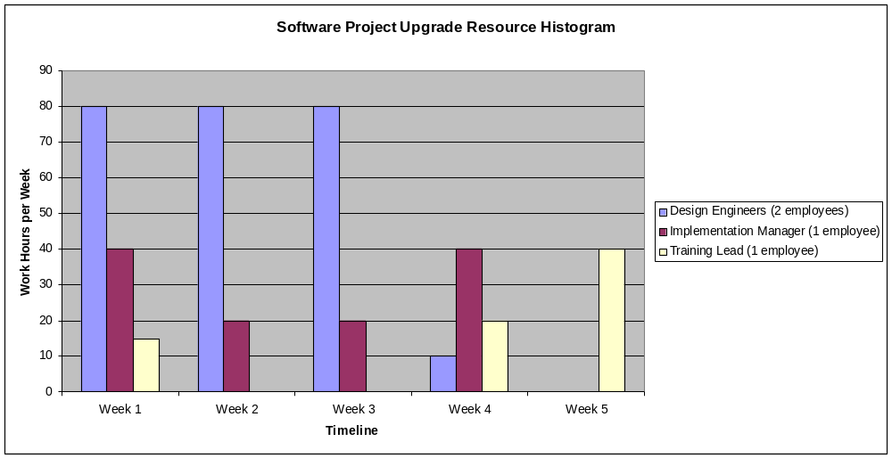

Training:
There is currently no training scheduled with regards to the Software Upgrade Project since the organization has adequate staff with required skill sets. However, if training requirements are identified, funding will be provided from the project reserve.

Performance Reviews:
The project manager will review each team member’s assigned work activities at the onset of the project and communicate all expectations of work to be performed. The project manager will then evaluate each team member throughout the project to evaluate their performance and how effectively they are completing their assigned work. Prior to releasing project resources, the project manager will meet with the appropriate functional manager and provide feedback on employee project performance. The functional managers will then perform a formal performance review on each team member.

Recognition and Rewards:
Although the scope of this project does not allow for ample time to provide cross-training or potential for monetary rewards there are several planned recognition and reward items for project team members.
- Upon successful completion of the Software Upgrade Project, a party will be held to celebrate the success of each team member with the team members’ families present.
- Upon successful completion of the project, any team member who satisfactorily completed all assigned work packages on time will receive a certificate of thanks from the CEO.
- Team members who successfully complete all of their assigned tasks will have their photo taken for inclusion in the company newsletter.
- The company will provide free family movie tickets for the top two performers on each project.
Sponsor Acceptance

Approved by the Project Sponsor:

Date:
<Project Sponsor>
<Project Sponsor Title>

This free Project Human Resource Plan Template is brought to you by www.ProjectManagementDocs.com

