
USER GUIDE FOR THE TASK MANAGEMENT SYSTEM

Team Members | Truong Thi Hong Hoa
 | Nguyen Thi Thu Trang
 | Pham Thi Cam Tien

Internship Company | TMA Solutions Binh Dinh

Quy Nhon, 08/2026
TABLE OF CONTENTS
INTRODUCTION 2
I. Features: 3
1. General Features 3
2. List of Super Admin Functions 3
3. List of User Functions 3
II. Event Flows and User Guide 4
1. General Event Flows 4
1.1. User Registration 4
1.2. Login 7
1.3. Logout 9
1.4. Forgot Password 10
1.5. Change Password 13
1.6. Change Language 15
1.7. Update Personal Information (Profile) 17
1.8. General Search 17
1.9. User Help Center 19
1.10. Space Summary Dashboard 20
2. For Super Admin 23
2.1. User Account Management 23
2.2. View System-Wide Dashboard 25
2.3. View All Spaces, Sprints, and Tasks 26
2.4. View Audit Logs 28
2.5. Assignment History 28
2.6. System Notification Settings 30
2.7. Receive Notifications 33
3. For Users 36
3.1. Space Management 36
3.2. Sprint Management 40
3.3. Task Management 41
3.4. Notification Settings 48
3.5. Receive Notifications 50

INTRODUCTION
In the context of organizations and enterprises increasingly emphasizing effective management and collaboration, the ability to monitor and control workloads in a systematic, centralized, and efficient manner has become an essential requirement. Traditional management methods or the use of multiple separate tools often lead to errors, information loss, and difficulties in task assignment, progress tracking, and team coordination.
To address these challenges, the Task Management System was developed to digitalize and centralize the task management process, from task creation and assignment to progress monitoring, updating, and completion. The system enables users to manage tasks more effectively through an intuitive interface, enhances collaboration among team members, and contributes to improving organizational productivity and work efficiency.
In addition to its practical value, this project provided an opportunity for the team to apply specialized knowledge in developing a complete software product. The development process included requirements analysis, system design, application development, database management, system testing, and deployment in a real business environment.
This document has been prepared to provide users with a comprehensive guide to using the Task Management System. It aims to help users quickly become familiar with the system and effectively utilize the features and functionalities provided.

- Features:
- General Features
- Authentication and Account Management:
  - User Registration
  - Email OTP Verification
  - Login & Logout
  - Forgot Password & Password Reset
- Personal Profile Managemen (View and Update Personal Profile
- System-Wide Search
- System Language Settings
- General Search and Summary
  - Global Search
  - Space Summary
  - Help Center
- List of Super Admin Functions
- User Account Management
- View System-Wide Dashboard
- View All Spaces, Sprints, Tasks, etc.
- View Audit Logs
- Assignment History
- Receive Notifications & Configure System-Wide Notifications
- List of User Functions
- Space Management
  - Create New Space
  - View Space List
  - Space Management (for Space Owner)
    - Update Space Information (Name, Description, etc.)
    - Change Space Status
    - Manage Space Trash
  - Member and Invitation Management
    - View the List of Members in the Space
    - Add, Invite, or Remove Other Members from the Space
    - Approve Join Requests
- Sprint Management
  - Create Sprint
  - Monitor & Update Sprint
  - Change Sprint Status
- Task Management
  - Create Task
  - View Tasks & Kanban Board
  - Update & Delete Task
- Task Assignment
  - Assign Assignee
  - Reassign Task
  - Unassign Task
  - View Assignment History
- Tệp đính kèm Attachments
  - Upload Files (Images, Documents, etc.)
  - Manage Attachments
- Comments & Discussions
  - Create Comments
  - Edit and Delete Comments
- Receive and Configure Personal Notifications
- Event Flows and User Guide
- General Event Flows
  - User Registration
- Flow Description
  - The user registers an account by providing an email address, full name, password, and other required information.
  - The user activates or verifies the account through an OTP code sent to the registered email address.
  - After successful verification, the user completes the registration information.
  - The system validates the registration information and creates a new account.
  - If the registration is successful, the system automatically logs the user in.
  - The system redirects the user directly to the main Task interface screen.
  - The user begins using the task management features accordingly.
- User Guide
Step 1: The user accesses the system and selects the User Registration function.
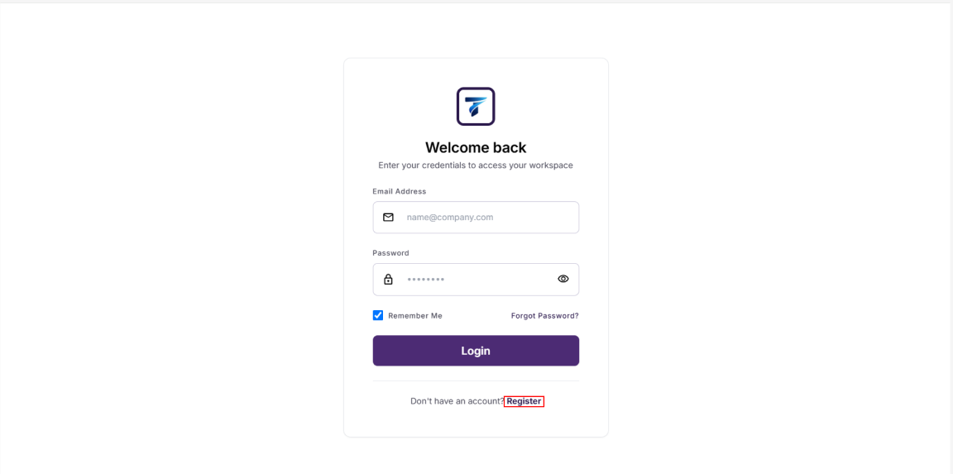
Step 2: The user enters the registration email address and then clicks Continue to submit the registration request.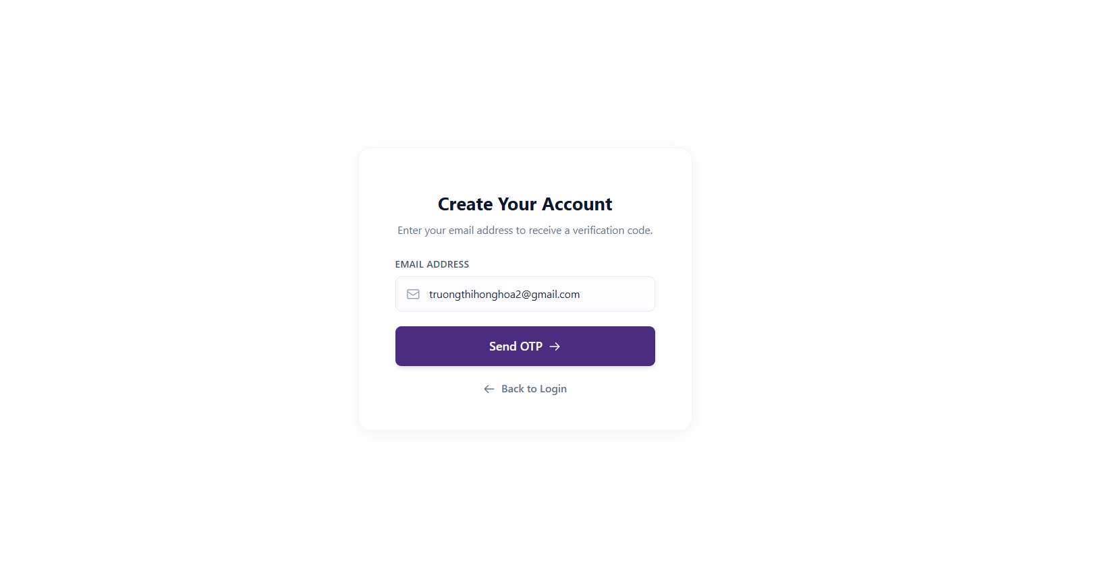
Step 3: The system verifies the registration email, including checking the email format and whether the email already exists in the system.

Step 4: If the email is invalid or already exists, the system displays an appropriate error message. If the email is valid, the system sends an OTP verification code to the user's registered email address.
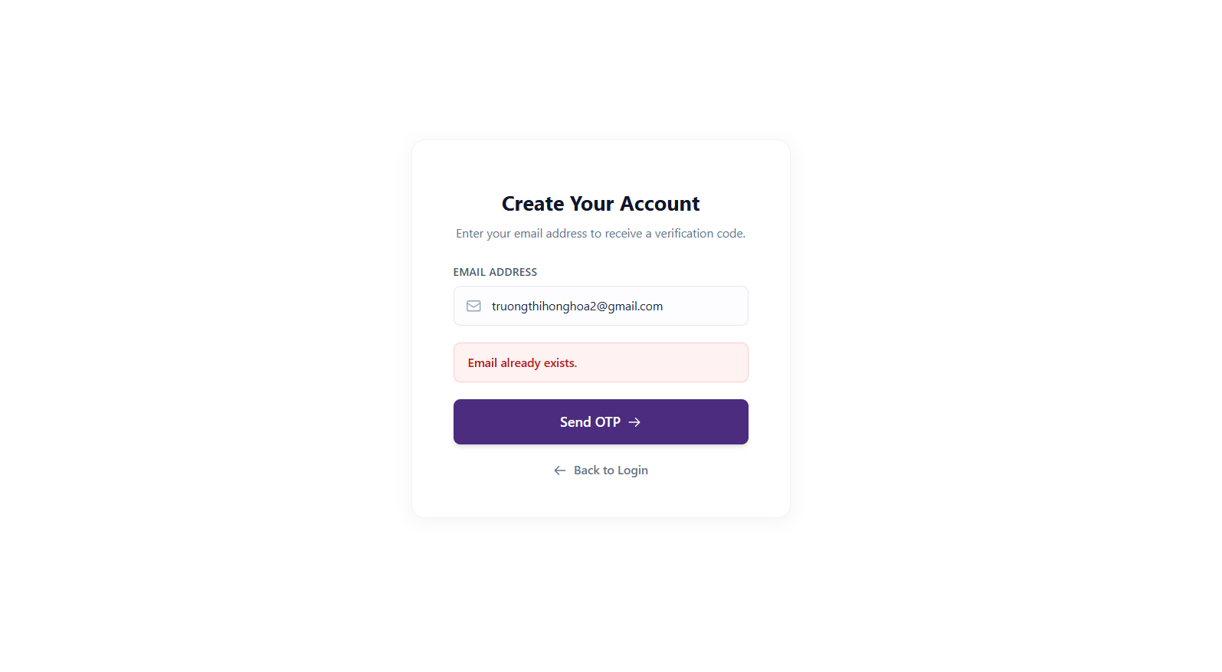
Step 5: The user opens the registered email, retrieves the OTP code, and enters it on the Email Verification screen.
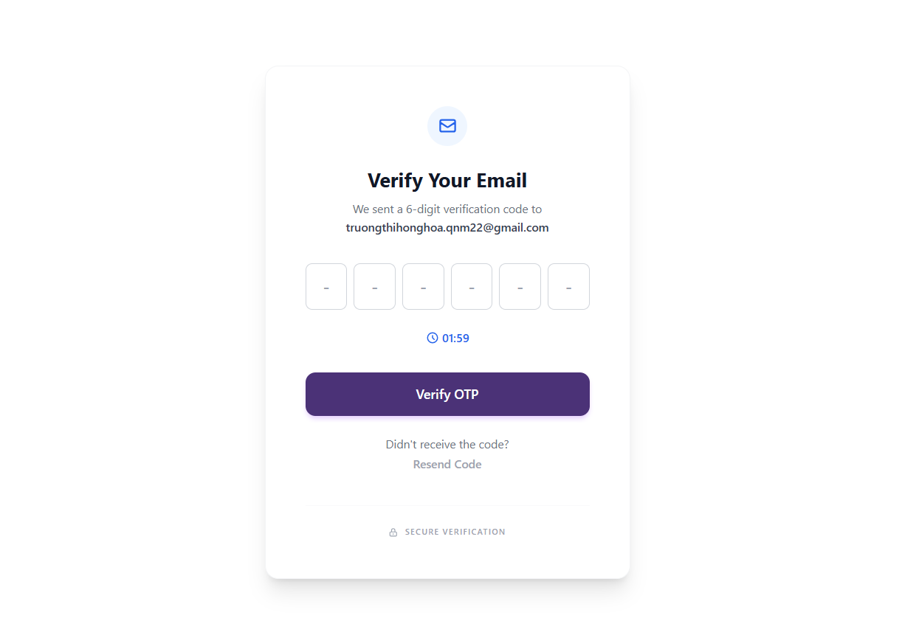
Step 6: The system validates the OTP code. If the OTP code is incorrect, expired, or has already been used, the system displays an error message. If the OTP code is valid, the system allows the user to continue entering account information.
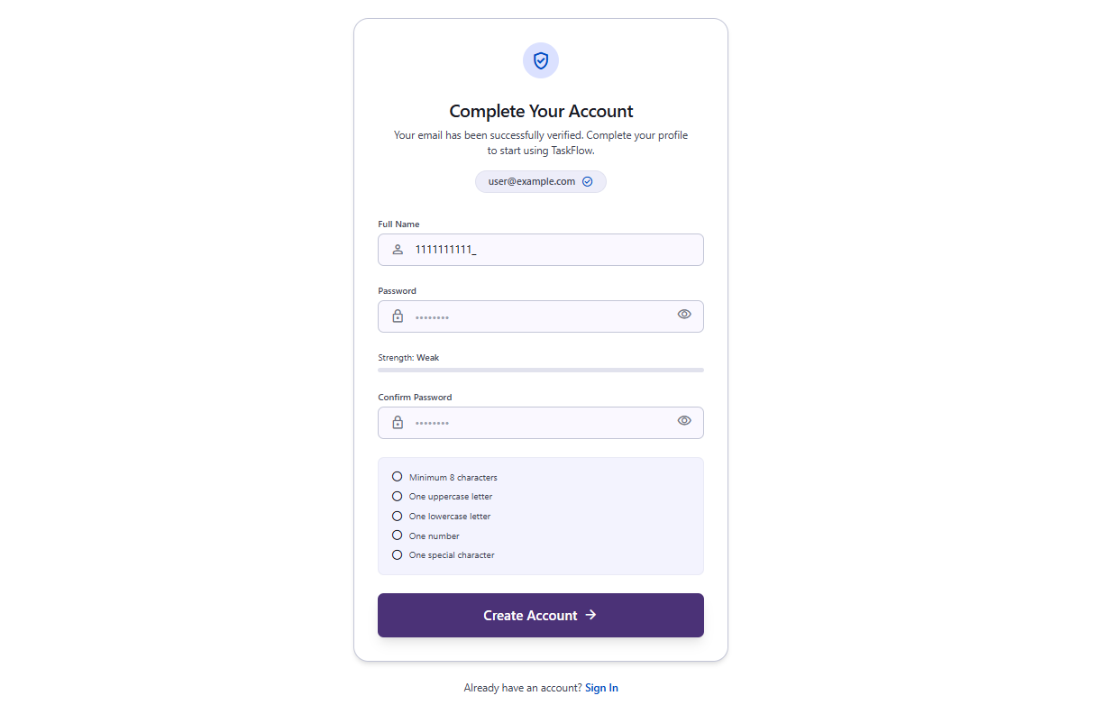
Step 7: The user enters all required registration information, including full name, password, and password confirmation, and then submits the registration form.
Step 8: The system validates the registration information. If any information is invalid, the system displays the corresponding error message. If the information is valid, the system creates a new account with the default role of USER, marks the account as Active, and confirms that the email address has been verified.
Step 9: After successful registration, the system automatically creates a login session for the user and redirects the user to the main Task interface screen.
  - Login
- Flow Description
  - The user accesses the system and opens the login screen.
  - The user enters the registered email address and password.
  - The system verifies the email address, password, and account status.
  - If the information is invalid, the system displays the corresponding error message.
  - If the information is valid, the system creates a login session for the user.
  - The system determines the user's role.
  - If the role is USER, the system redirects the user to the Task screen.
  - If the role is SUPER ADMIN, the system redirects the user to the administrative Dashboard screen.
- User Guide
Step 1: The user accesses the system.
Step 2: On the login screen, the user enters the registered email address and password.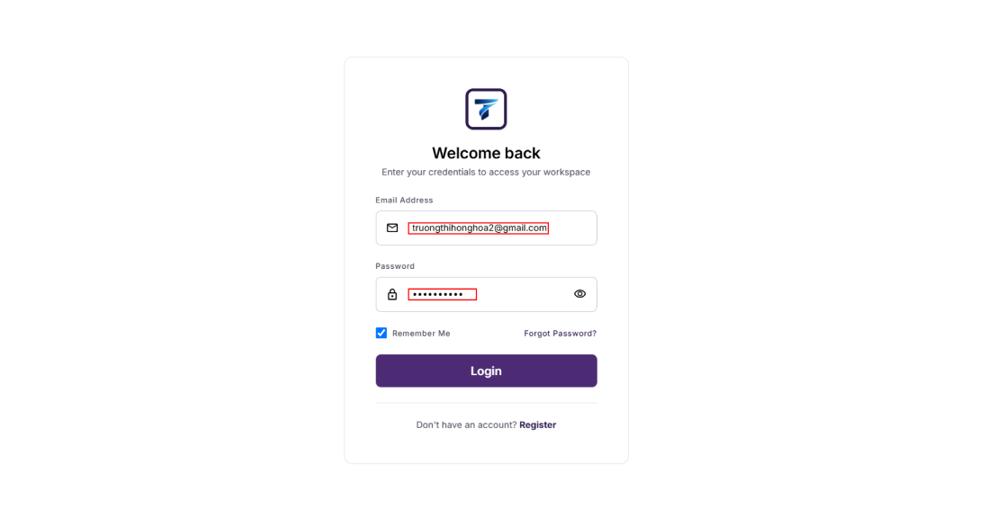
Step 3: The user clicks the Login button to sign in to the system.
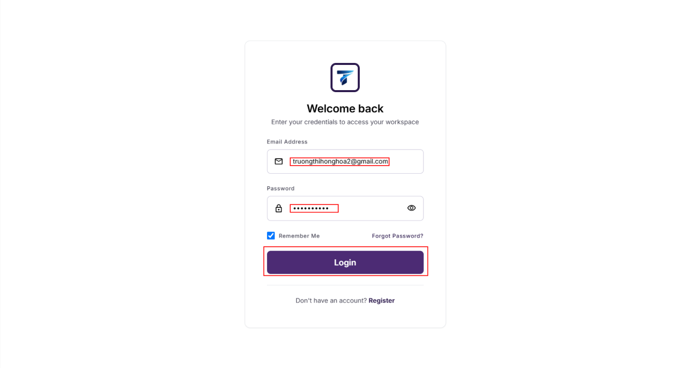
Step 4: If the login is successful, the system automatically redirects the user to the appropriate screen based on the account role.
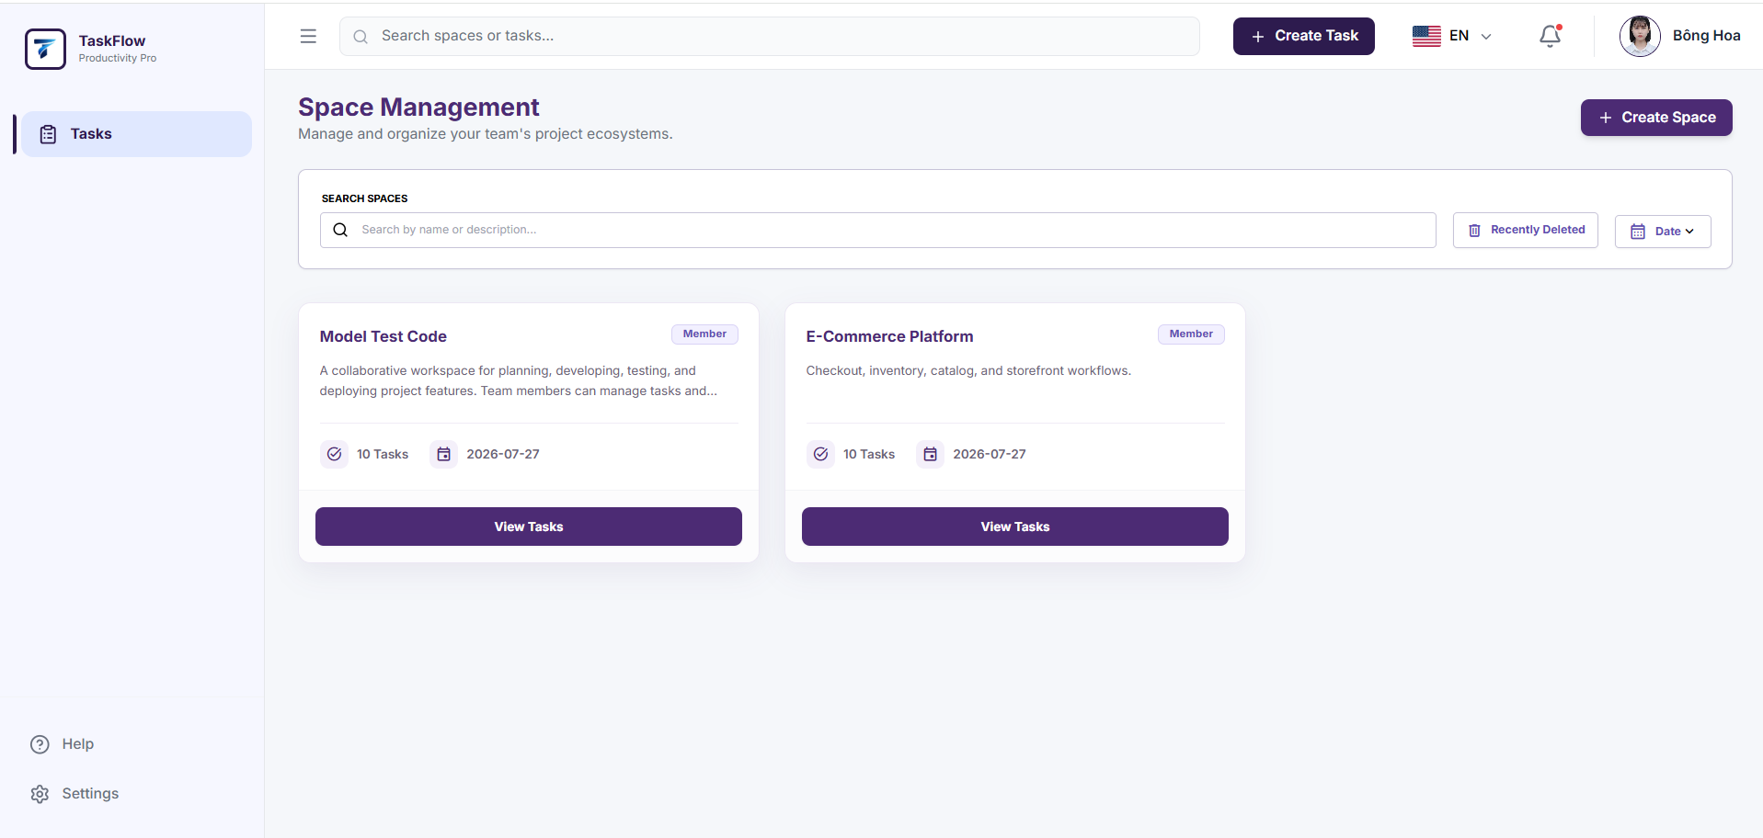
Step 5: If the login fails, the user checks the email address, password, or account status and attempts to log in again.
* Note: If incorrect login credentials are entered more than 5 times, the account will be locked.
  - Logout
- Flow Description
  - The user selects the Logout function to sign out of the system.
  - The system sends a logout request along with the current login session.
  - The system verifies the user's login session.
  - The system invalidates or revokes the current login session.
  - The system removes the stored login information on the client side.
  - After a successful logout, the system redirects the user to the login screen.
  - If the login session is invalid or has expired, the system still removes the local login information and redirects the user to the login screen.
- User Guide
Step 1: The user clicks on the account icon located at the top-right corner of the screen.
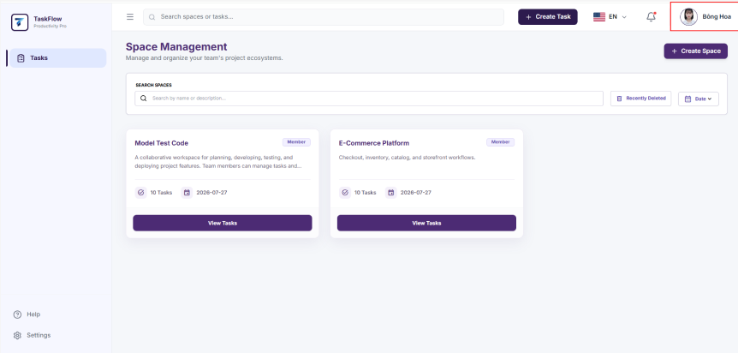
Step 2: The user selects the Logout function.
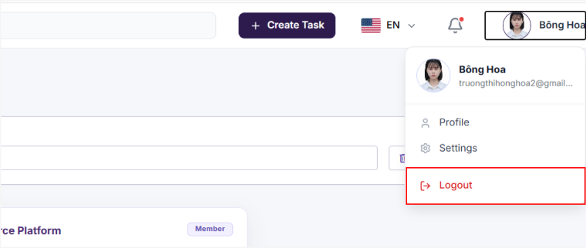
Step 3: The system logs the user out of the current account.
Step 4: After a successful logout, the system redirects the user to the login screen.
Step 5: The user can log in with another account if needed.
  - Forgot Password
- Flow Description
  - The user selects the Forgot Password function on the login screen.
  - The user enters the email address associated with the account.
  - The system verifies the email address and sends a password reset link/code to the email.
  - The user opens the email and accesses the reset link or enters the verification code.
  - The user enters a new password and confirms the password.
  - The system validates the password reset information.
  - If the information is valid, the system updates the account with the new password.
  - After successfully changing the password, the user returns to the login screen.
- User Guide
Step 1: The user accesses the login screen.
Step 2: The user selects the Forgot Password? function
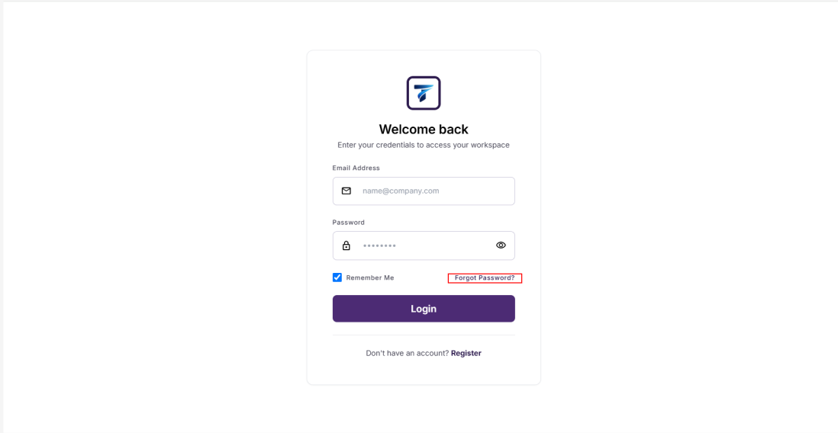
Step 3: The user enters the email address associated with the account and submits a password reset request.
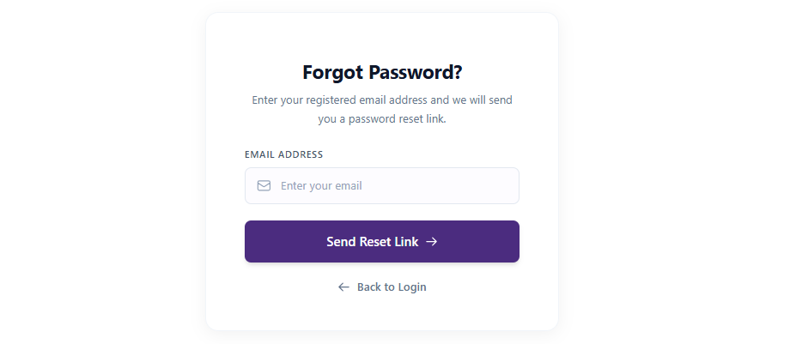
Step 4: The user opens the email and accesses the password reset link sent by the system.
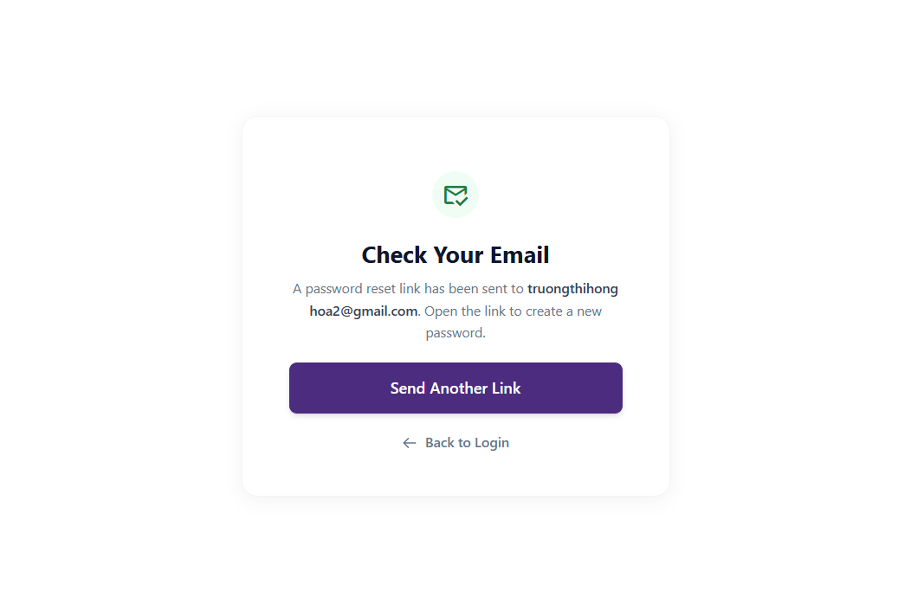
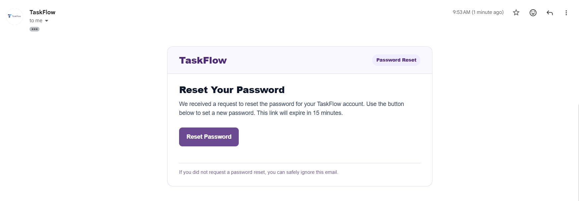
Step 5: On the password reset screen, the user enters a new password and confirms the password.
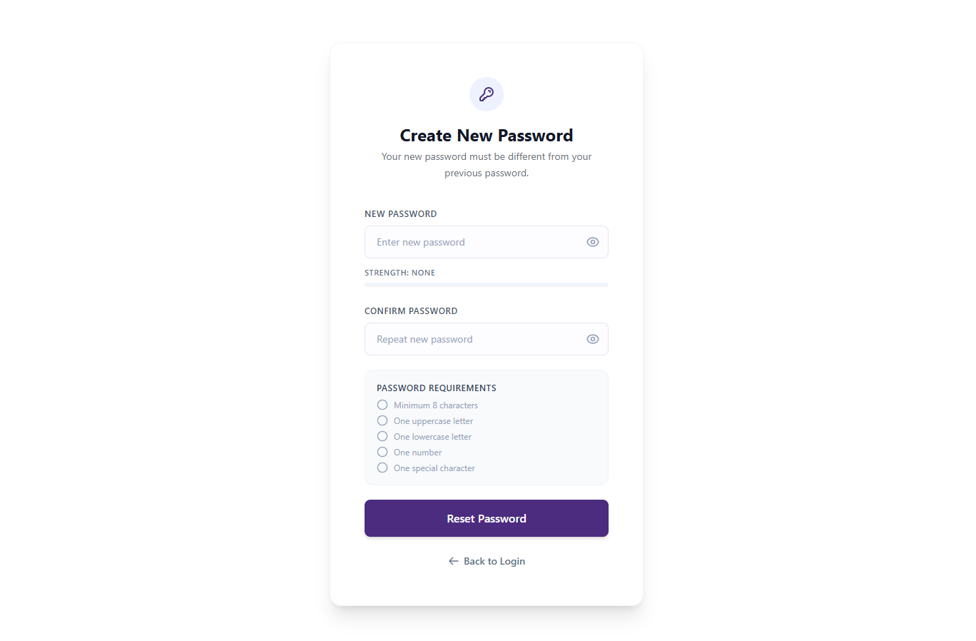
Step 6: The user clicks Reset Password to update the new password.
Step 7: If the password reset is successful, the system redirects the user to the login screen so that the user can sign in again using the new password.
  - Change Password
- Flow Description
  - The user accesses the Change Password function in the personal account settings.
  - The user enters the current password, the new password, and the new password confirmation.
  - The system validates the password information.
  - If the information is invalid, the system displays an error message.
  - If the information is valid, the system updates the password with the new one.
  - After successfully changing the password, the user logs in again using the new password.
- User Guide
Step 1: The user logs in to the system.
Step 2: The user clicks on the account icon located at the top-right corner of the screen.

Step 3: The user selects the Profile option.
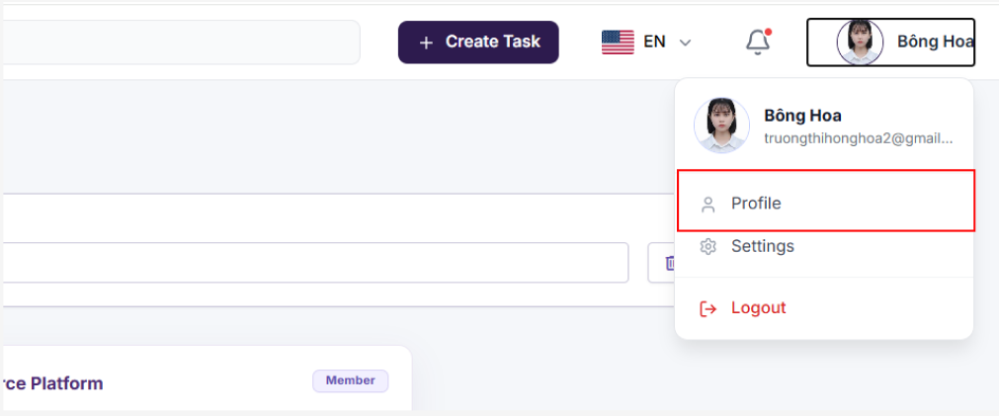
Step 4: The user clicks Edit Profile to change the password.
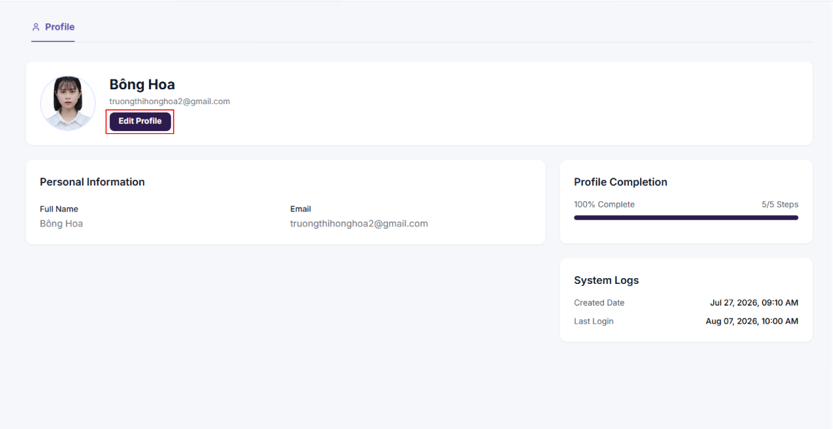
Step 5: The user enters the current password.
Step 6: The user enters a new password.
Step 7: The user re-enters the new password for confirmation.
Step 8: The user clicks the Change Password button to update the password.
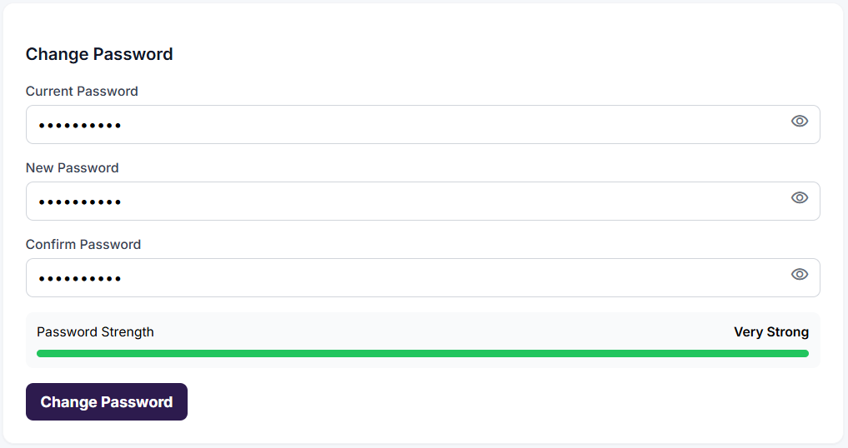
Step 9: If the password is changed successfully, the system displays a success message and requires the user to log in again using the new password.
  - Change Language
- Flow Description
  - The user is logged in to the system.
  - The user selects the Change Language function on the interface.
  - The system displays a list of supported languages.
  - The user selects the language they want to use.
  - The system updates the interface language according to the user's selection.
  - All content on the system is displayed in the selected language.
- User Guide
Step 1: The user logs in to the system.
Step 2: On the top navigation bar, the user clicks on the language icon or the currently selected language.

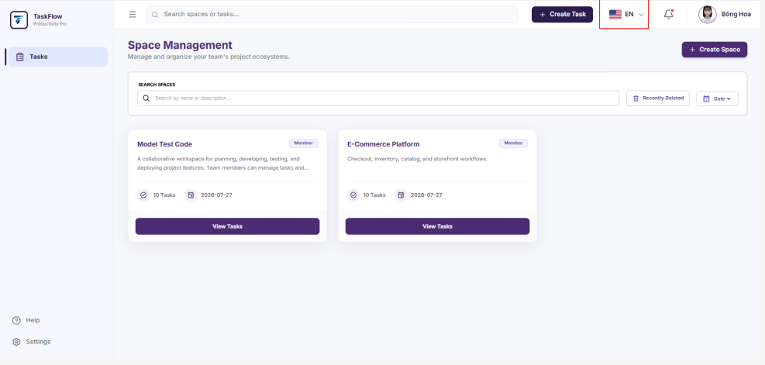
Step 3: The system displays a list of supported languages.
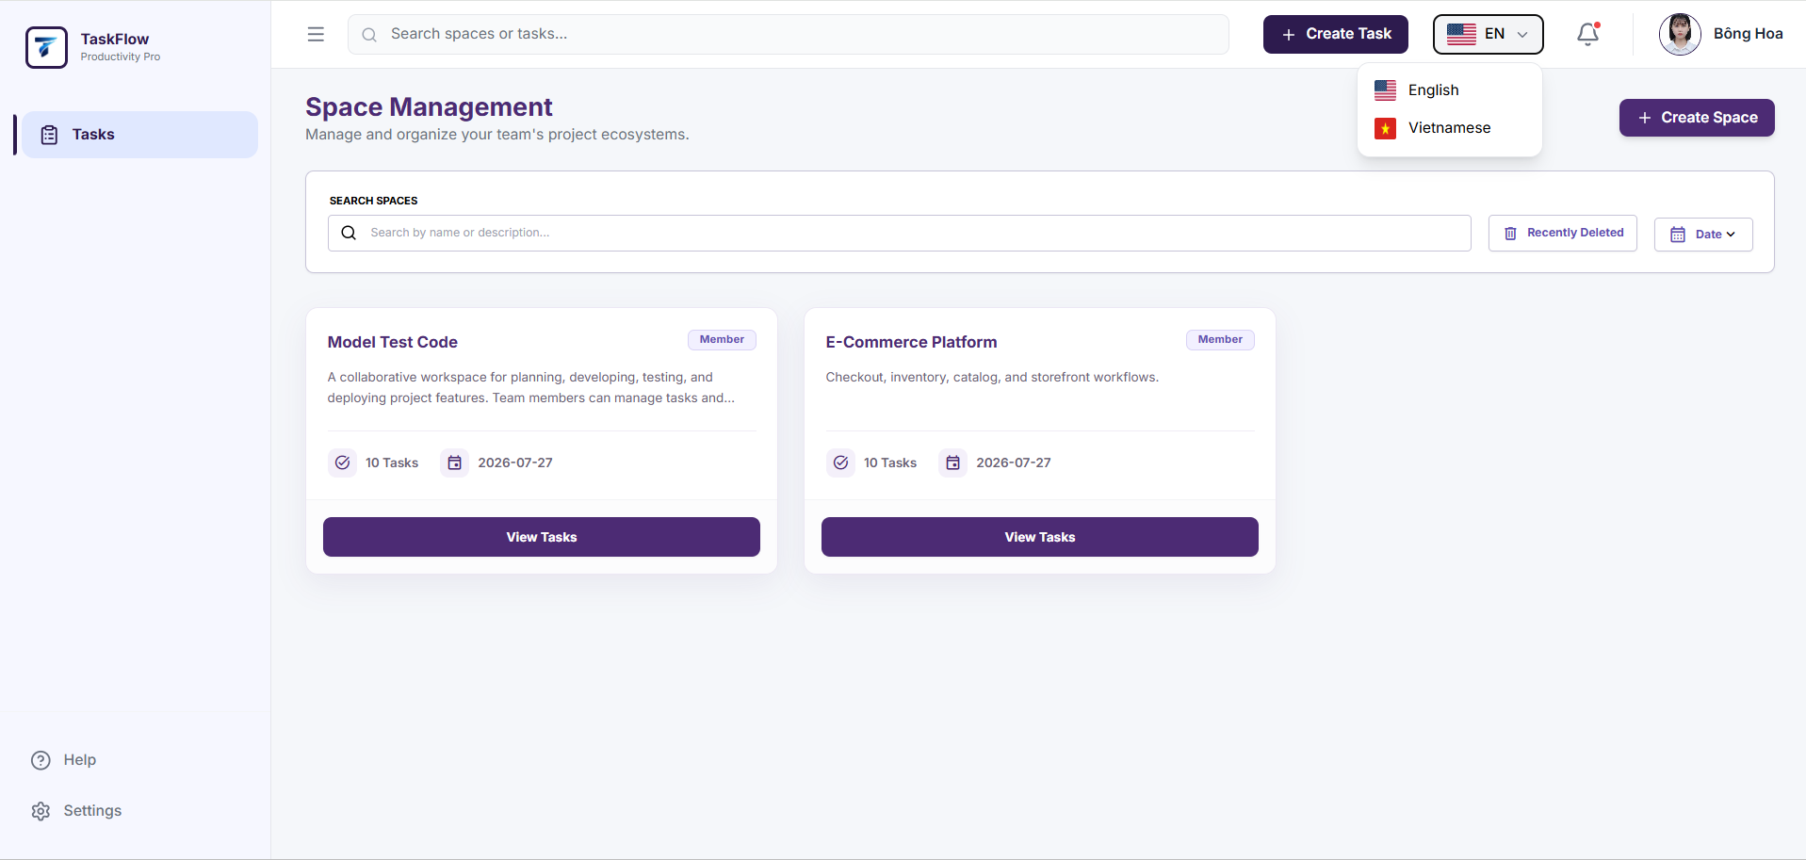
Step 4: The user selects the desired language, for example, English or Vietnamese.
Step 5: The system automatically updates the interface to the selected language.
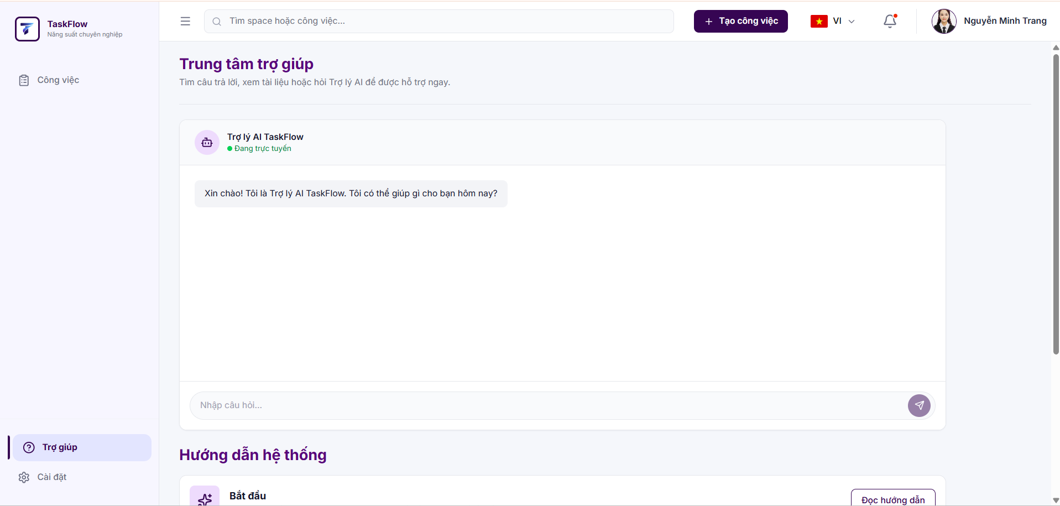
  - Update Personal Information (Profile)
- Flow Description
  - The user opens the Profile page.
  - The system displays the user's personal information.
  - The user edits the information if necessary.
  - The system saves and updates the new information.
- User Guide
Step 1: The user logs in to the system.
Step 2: Similar to Steps 2, 3, and 4 of the Change Password function.
Step 3: The user edits the permitted information, including Full Name and Profile Picture.
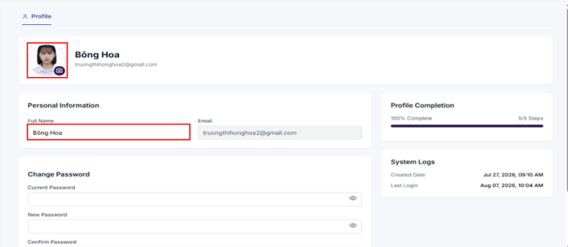
Step 4: The user clicks "Save Changes" to save the information.
Step 5: If the update is successful, the system displays the new information on the Profile page.
  - General Search
- Flow Description
  - The user enters a keyword into the search box on the top navigation bar.
  - The system searches for matching data based on the user's permissions.
  - For Users, the system returns Spaces and Tasks that the user has permission to access.
  - For Super Admins, the system returns Spaces, Tasks, and Users across the entire system.
  - The system stores the user's recent search history.
  - The user can view the search history.
  - The user can delete a search history entry.
  - The user selects a search result to quickly open the corresponding screen.
- User Guide
Step 1: The user logs in to the system.
Step 2: On the top navigation bar, the user enters a keyword into the search box.
Step 3: The system displays a list of matching results.
Step 4: The results are displayed according to the user's role and permissions:
User: Displays related Spaces and Tasks.
Super Admin: Displays Spaces, Tasks, and Users across the system.
Step 5: The user clicks on the desired result.
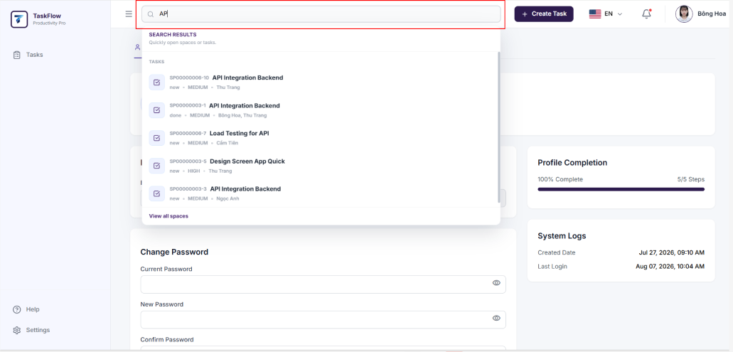
Step 6: The system navigates to the corresponding detail screen.
- User Guide: View and Delete Search History
Step 1: The user logs in to the system.
Step 2: The user clicks on the search box on the top navigation bar.
Step 3: If the search box is empty, the system displays the Recently Viewed list.
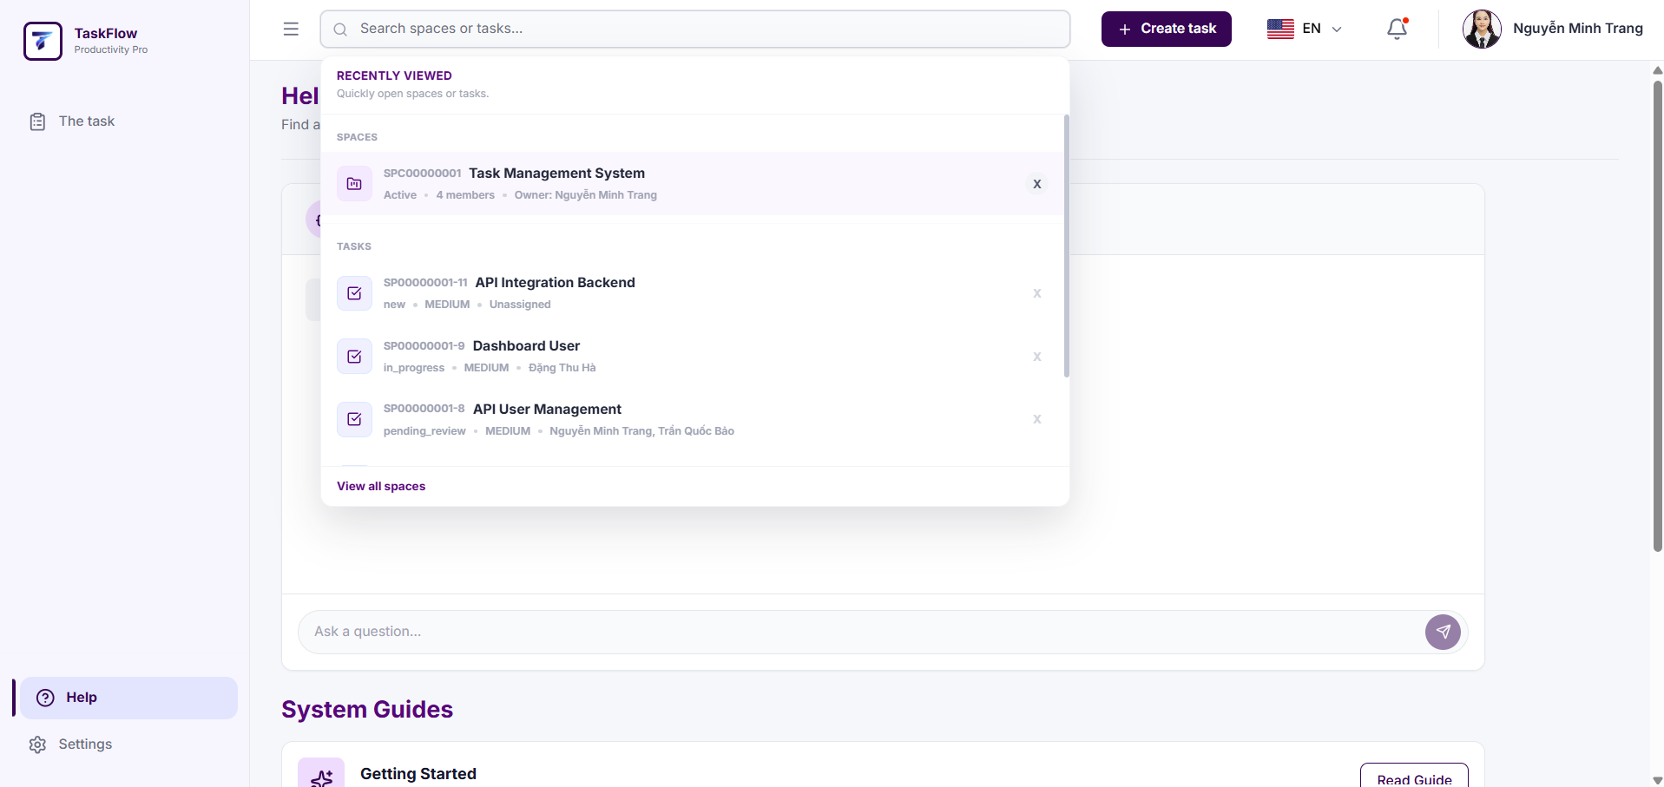
Step 4: The user clicks on an item in the list to quickly open the corresponding screen.
Step 5: If the user wants to remove an item from the history, they click the X button on the right side of that item.
Step 6: The system removes the selected item from the Recently Viewed list.
  - User Help Center
- Flow Description
  - The user logs in to the system and selects Help from the left-side menu.
  - The system displays a list of user guides and an AI Assistant chatbox.
  - The user can search for information in the Guide System or enter questions for the AI Assistant to answer.
- User Guide
Step 1: The user logs in to the system and selects Help from the left-side menu.
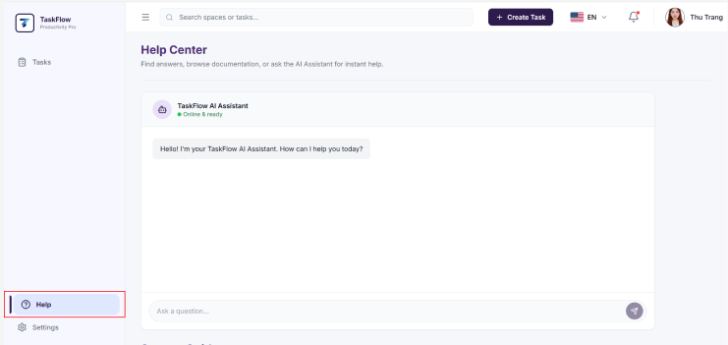
Step 2: The user scrolls through the page to read the information in the Read Guide section or enters a question in the chatbox for the AI Assistant to answer.
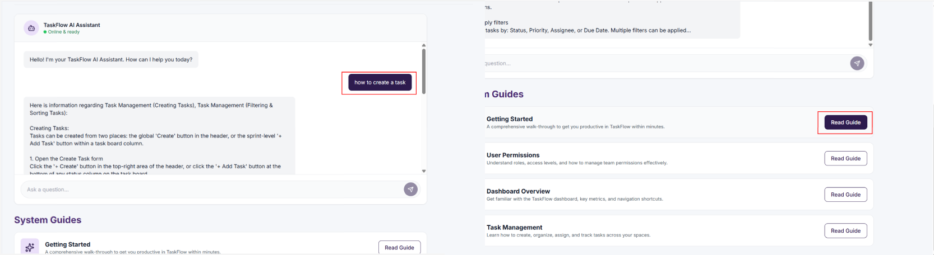
  - Space Summary Dashboard
- Flow Description
  - The user logs in, selects a Space, and opens the Summary tab.
  - The system checks the user's permission to access the Space Summary.
  - The Owner can view the overall data of the entire Space and can filter data by individual members.
  - A Member can only view data related to themselves and does not have access to the member filter.
  - The system displays statistics such as the total number of Tasks, completed Tasks, in-progress Tasks, overdue Tasks, and progress by status.
  - For the Owner, the system additionally displays the total number of members and the Space User Overview.
  - The user can view sections including Status Overview, Recent Activity, Priority Breakdown, and Recent Tasks.
  - For the Owner, Recent Tasks includes the tabs Work On, View History, and Assignment History.
  - For a Member, Recent Tasks includes the tabs Work On, View History, and Assigned to Me.
  - When the user clicks View All in the Status Overview section, the system navigates to the Space List screen.
  - When the user clicks the expand icon in the Recent Activity section, the system opens the detailed recent activity screen.
- User Guide
Step 1: Log in to the system using a valid account.
Step 2: Access the Space that you want to view.
Step 3: Select the Summary tab on the Space navigation bar.
Step 4: The system displays the Space Summary Dashboard.
Step 5: If the user is an Owner, the system displays metrics including Total Users, Total Tasks, Completed Tasks, In Progress, and Overdue Tasks.
Step 6: If the user is a Member, the system displays metrics related to the user's own tasks and does not display the member filter.
Step 7: If the user is an Owner, they can select All Members or choose an individual member from the dropdown list to filter the data.
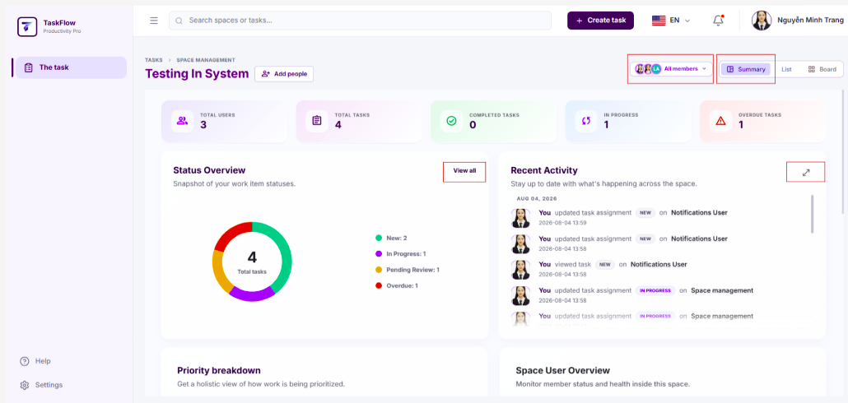
Step 8: The user reviews the Status Overview, Recent Activity, Priority Breakdown, and Recent Tasks sections.
Step 9: For an Owner, the system additionally displays the Space User Overview section.
Step 10: The user hovers over a chart or statistic bar in Status Overview, Priority Breakdown, or Space User Overview to view detailed tooltips.
Step 11: The user clicks View All in the Status Overview section to navigate to the Space List screen and view the detailed status of each task.
Step 12: The user clicks the expand icon in the Recent Activity section to view detailed recent activities.
Step 13: In the Recent Tasks section, the system displays tabs based on the user's role:
For Owner: Work On, View History, and Assignment History.
For Member: Work On, View History, and Assigned to Me.
Step 14: The user selects each tab in Recent Tasks to view the corresponding task list or history.

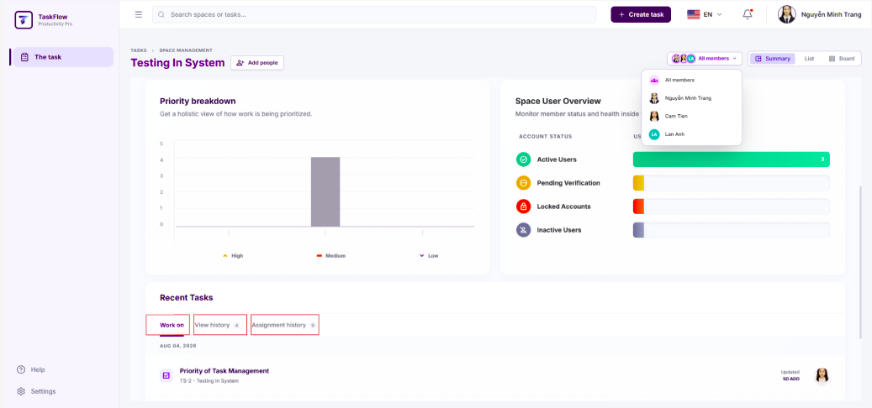
Step 15: After completing the review, the user can switch to the List tab, Board tab, or return to the previous screen.
- For Super Admin
  - User Account Management
- Flow Description
  - The Super Admin accesses the User Management function.
  - The system displays the list of users in the system.
  - The Super Admin searches, filters, or views user information.
  - The Super Admin updates the user status or locks/unlocks user accounts.
  - The system verifies Super Admin permissions and saves the changes.
- User Guide
Step 1: Log in to the system using a Super Admin account.
Step 2: On the left-side menu, select "Users".

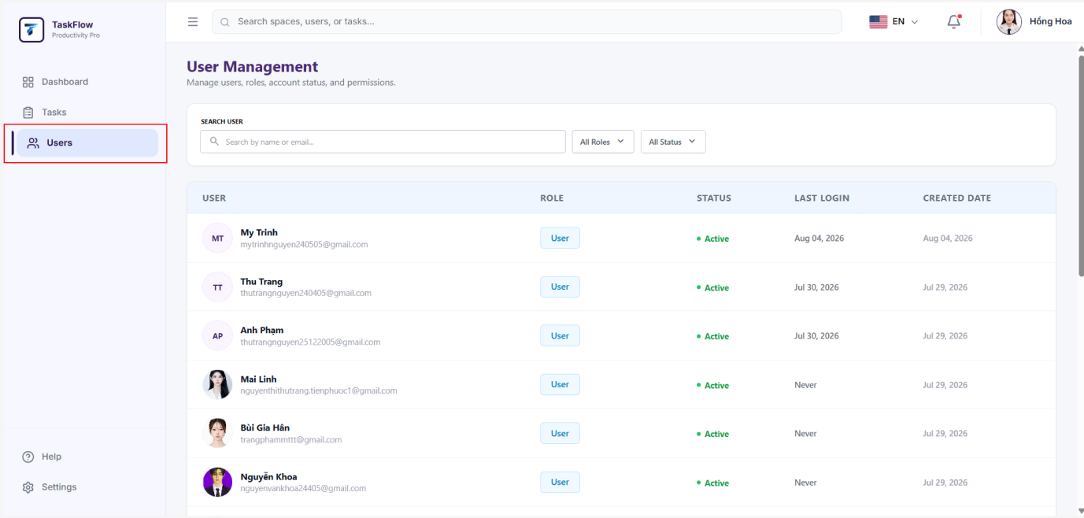
Step 3: The system displays the list of users.
Step 4: The Super Admin can search for users by name or email address.
Step 5: The Super Admin can filter the list by role or account status.
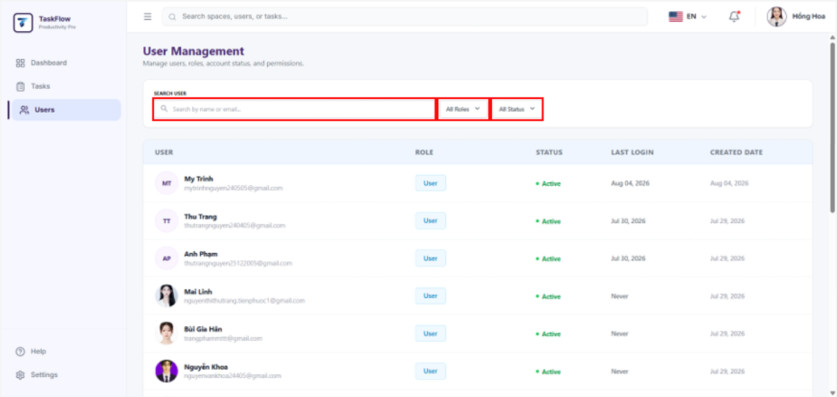
Step 6: The Super Admin selects the user account to manage.
Step 7: On the edit screen, the Super Admin can View User Information and Update Account Status (Lock or Unlock Account).
Step 8: Click "Save Changes" to apply the changes.

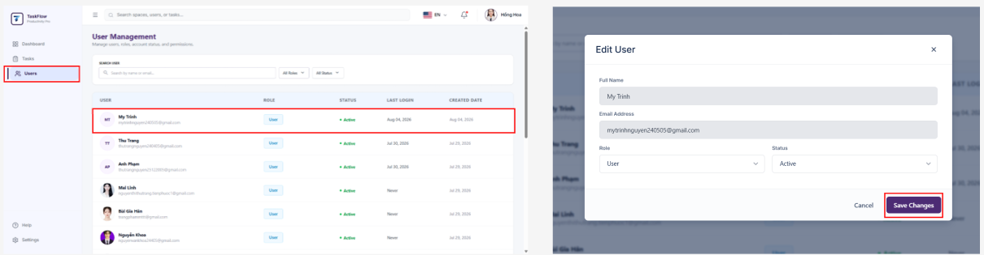
Step 9: The system verifies Super Admin permissions and updates the user information.
  - View System-Wide Dashboard
- Flow Description
  - The Super Admin logs in and accesses the Dashboard function.
  - The system verifies Super Admin permissions.
  - The system displays the system-wide overview dashboard.
  - The Super Admin views statistical data related to users, tasks, task statuses, priority levels, user account statuses, and audit logs.
  - The Super Admin can view Status Overview, Audit Logs, Priority Breakdown, User Account Overview, and Recent Activities.
  - The Super Admin can filter Recent Activities by Space, status, and time.
  - The Super Admin can expand Audit Logs to view the detailed list, search, filter, and refresh the data.
- User Guide
Step 1: Log in to the system using a Super Admin account.
Step 2: On the left-side menu, select Dashboard.
Step 3: The system displays the system-wide Dashboard screen.
Step 4: The Super Admin reviews the overview metrics, including Total Users, Total Tasks, Completed Tasks, In Progress, and Overdue Tasks.
Step 5: The Super Admin views the Status Overview chart to monitor the number of tasks by status.
Step 6: The Super Admin clicks View All in the Status Overview section to navigate to the Space List screen.
Step 7: The Super Admin reviews the Audit Logs section to quickly monitor actions, security events, and system changes.
Step 8: The Super Admin clicks the expand icon in Audit Logs to open the detailed Audit Logs table.
Step 9: In the detailed Audit Logs table, the Super Admin can search, filter by Date Range, Event Type, Label Title, and Sort Order, and click Refresh to reload the data.
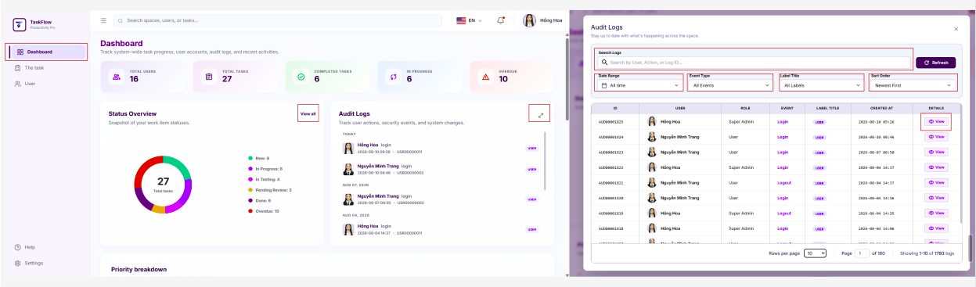
Step 10: The Super Admin reviews the Priority Breakdown section to monitor the number of tasks by priority level (High, Medium, and Low).
Step 11: The Super Admin reviews the User Account Overview section to monitor user account statuses.
Step 12: The Super Admin reviews the Recent Activities section.
Step 13: In Recent Activities, the Super Admin can filter activities by Space, Status, and Date.
Step 14: The Super Admin selects the Work On, View History, or Assignment History tabs to view the corresponding activities.
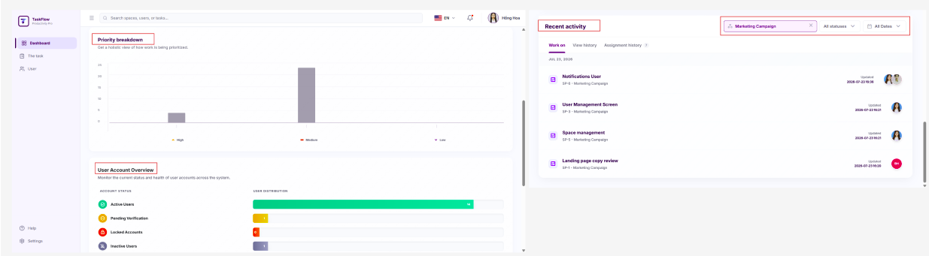
  - View All Spaces, Sprints, and Tasks
- Flow Description
  - The user accesses the task management function.
  - The system displays the list of Spaces that the user has permission to view.
  - The user selects a Space to view its details.
  - The system displays the list of Sprints and Tasks belonging to that Space.
  - The user can view detailed information for each Sprint and Task according to their assigned permissions.
- User Guide
Step 1: The user logs in to the system.
Step 2: On the left-side menu, select Tasks.
Step 3: The system displays the list of Spaces that the user has permission to access.
Step 4: The user selects the Space they want to view.
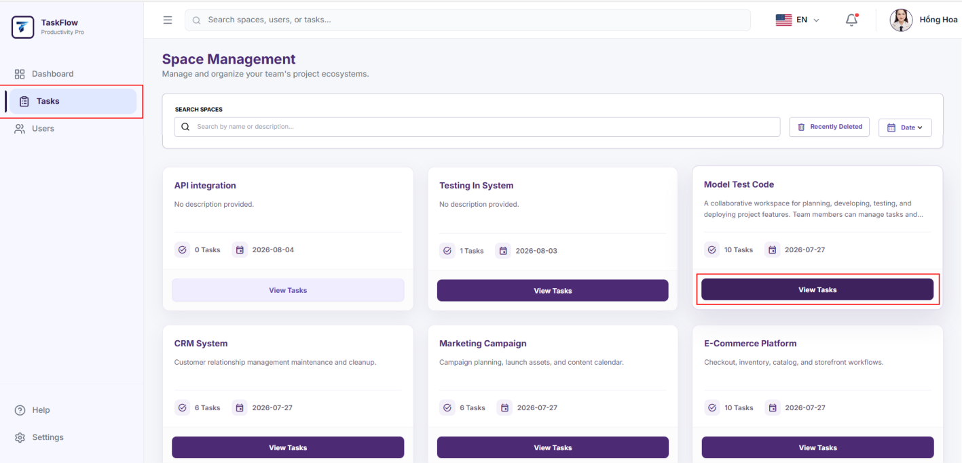
Step 5: The system displays the Sprints and Tasks belonging to the selected Space.
Step 6: The user selects a Sprint or Task to view detailed information.
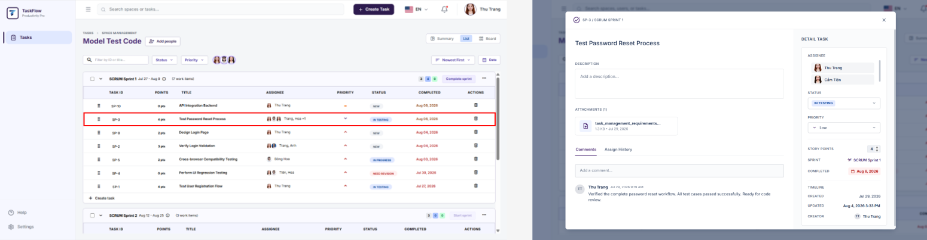
Step 7: If the user is a Super Admin, they can view all Spaces, Sprints, and Tasks in the system. If the user is a User, they can only view the Spaces, Sprints, and Tasks in which they participate.
  - View Audit Logs
- Flow Description
  - The Super Admin accesses the system-wide Dashboard.
  - The system verifies Super Admin permissions.
  - The system displays the list of system audit logs.
  - The Super Admin views the user who performed the action, the timestamp, the action taken, and the details of the changes.
  - The Super Admin can search, filter, or view detailed log record
- User Guide
Step 1: Log in to the system using a Super Admin account.
Step 2: On the left-side menu, select Dashboard.
Step 3: Navigate to the Audit Logs section.
Step 4: View the list of system audit logs.
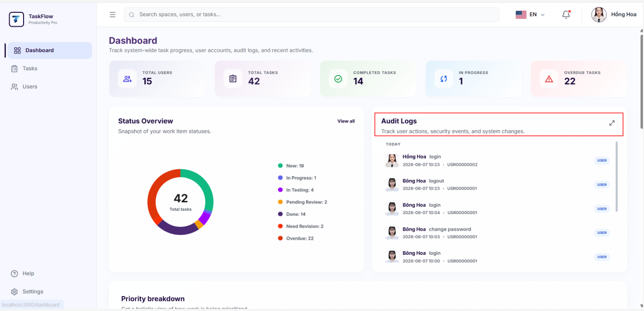
Step 5: Use the search function or filters if needed.
Step 6: Select a log record to view its detailed information.
  - Assignment History
- Flow Description
  - The Super Admin accesses the system-wide Dashboard.
  - The system verifies Super Admin permissions.
  - The system displays the system-wide overview Dashboard.
  - The Super Admin views the task assignment history in the Recent Activities section under the Assignment History tab.
  - The Super Admin can view the Task, Space, previous assignee, new assignee, user who made the change, timestamp, and change status.
  - The Super Admin can filter assignment history by Space, status, and time.
  - In addition to the Dashboard, assignment history can also be viewed in the details of each Task and in the Summary of each Space.
- User Guide
Step 1: Log in to the system using a Super Admin account.
Step 2: On the left-side menu, select Dashboard.
Step 3: Navigate to the Recent Activities section.
Step 4: Select a specific Space or All Spaces if you want to view activity data across all spaces.
Step 5: Select the Assignment History tab.
Step 6: The system displays the list of task assignment history records.
Step 7: The Super Admin can view information including Task, Space, assignee changes, user who made the change, timestamp, and status.
Step 8: Use the Space, Status, or Date filters if needed.
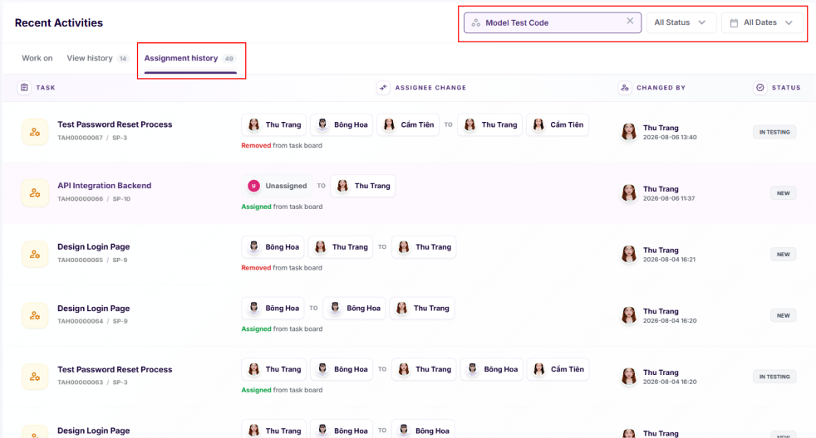
Step 9: In addition to the Dashboard, the Super Admin can view assignment history for an individual Task by opening the Task Details screen and selecting the History tab.
Step 10: The Super Admin can also view assignment history within a Space by opening the Space, selecting the Summary tab, and then selecting the Assignment History tab in the Recent Tasks section.
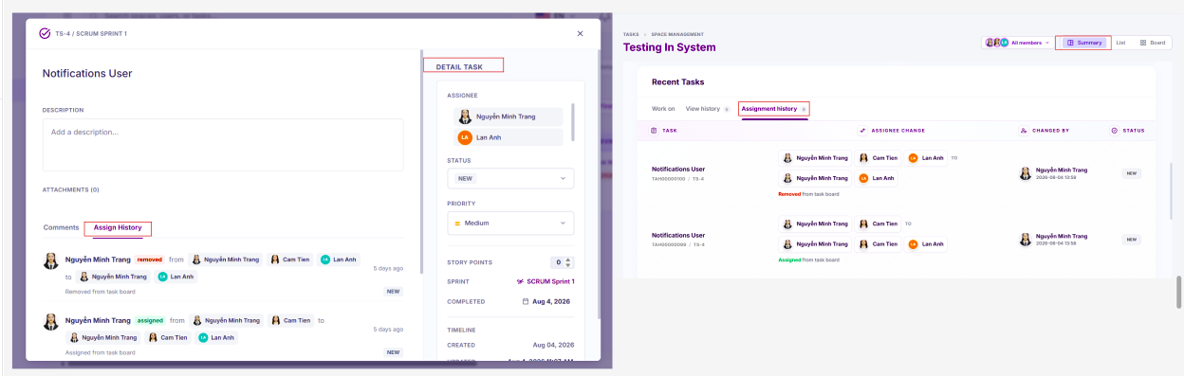
  - System Notification Settings
- Flow Description
  - The Super Admin accesses the Notification Settings function.
  - The system verifies Super Admin permissions.
  - If the account is not a Super Admin, the system does not allow access to notification settings within the SUPER_ADMIN scope.
  - The system displays the system notification settings available exclusively for Super Admins.
  - The Super Admin can configure notifications through two channels: In-Product and Email.
  - The Super Admin can enable or disable system alert emails.
  - The Super Admin can choose the email delivery frequency as Instant or Off.
  - The system displays system notification groups, including Account Lifecycle and Security and Permissions.
  - The Super Admin can enable or disable an entire notification group or individual notification types.
  - The Super Admin can restore the default configuration using the Reset Defaults button.
  - After the Super Admin clicks Save Changes, the system saves the notification settings for the Super Admin account.
  - Subsequent system notifications will be sent or displayed according to the saved configuration.
- User Guide
Step 1: Log in to the system using a Super Admin account.
Step 2: On the left-side menu, select Settings, or click the profile picture and select Settings.
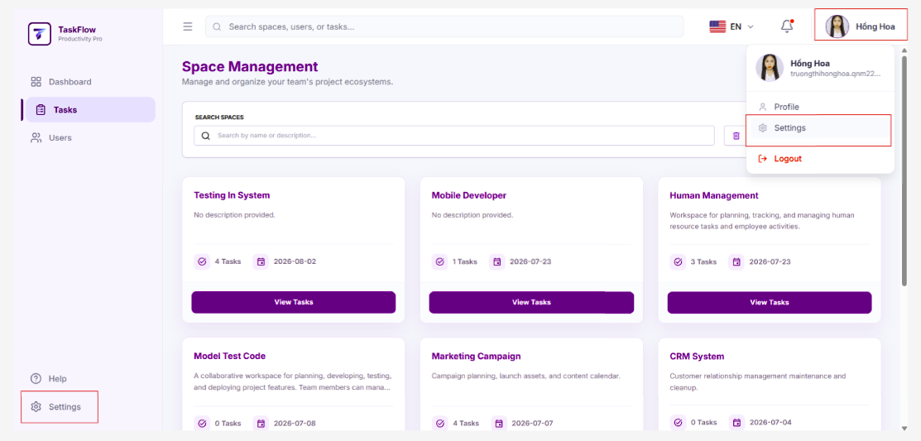
Step 3: The system opens the Notification Settings screen for Super Admin.
Step 4: In the Email Preferences section, the Super Admin enables or disables the Send me system email alerts option.
Step 5: The Super Admin selects the Email Frequency:
- Instant: Receive system alert emails immediately when an event occurs.
- Off: Disable system alert emails.
Note: If Email Preferences is disabled or Email Frequency is set to Off, the checkboxes in the Email column will be disabled.
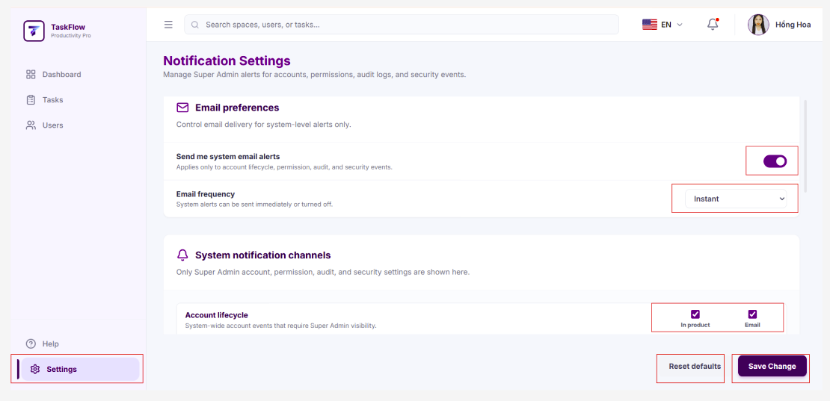
Step 6: In the System Notification Channels section, the system displays the available system notification groups.
Step 7: For the Account Lifecycle group, the Super Admin configures the following notification types:
- New User Registered
- Account Locked
- User Verified
- User Deactivated/Reactivated
- Role Changed
Step 8: For the Security and Permissions group, the Super Admin configures the following notification types:
- Important Permission Changes
- System Audit/Security Events
- System Alert
Step 9: For each notification type, the Super Admin selects the notification channel:
- In Product: Receive notifications within the system.
- Email: Receive notifications via email.
Step 10: The Super Admin can select the checkbox in the group header row to quickly enable or disable all notifications within that group.
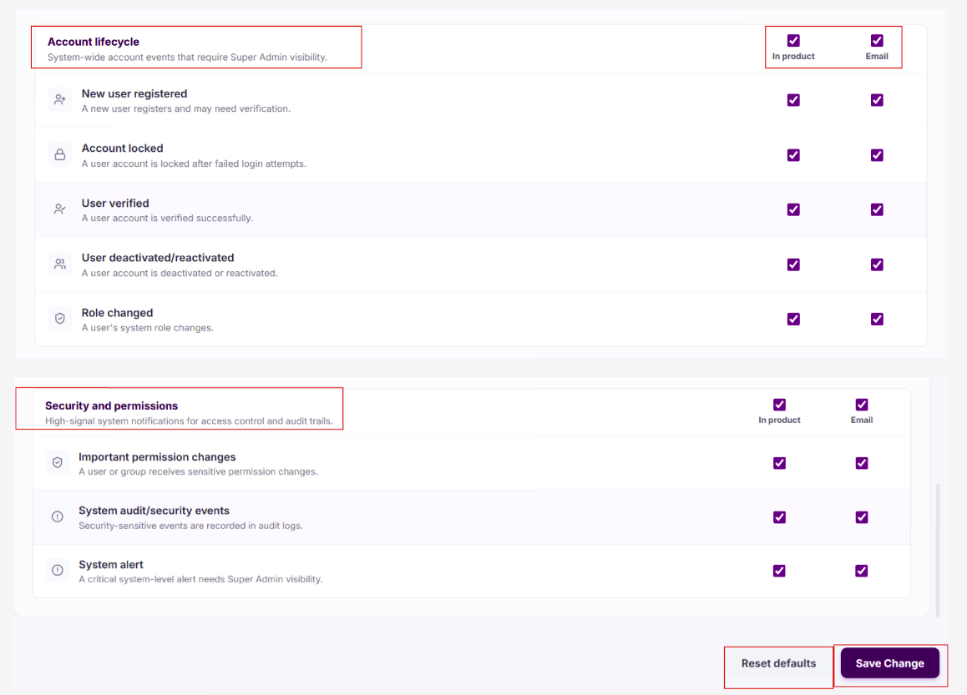
Step 11: The Super Admin clicks Save Changes to save the configuration.
Step 12: The system displays a success message and applies the new configuration to the Super Admin account.
Step 13: If the Super Admin wants to restore the default settings, they click Reset Defaults.
  - Receive Notifications
- Flow Description
  - The Super Admin logs in to the system.
  - The system sends notifications when events related to the account occur.
  - The notification bell icon on the top navigation bar indicates when there are unread notifications.
  - The user clicks the notification bell icon to view the list of recent notifications.
  - For a Super Admin, the system displays administrative notifications such as account events, permission changes, audit/security events, and system alerts.
  - The Super Admin can quickly view notifications in the dropdown menu or select View All / See All Notifications to open the full notification list.
  - The Super Admin can filter notifications by All, Unread, or Read, and can search for notifications.
  - When the Super Admin selects a notification, the system marks it as Read and navigates to the related screen if applicable.
  - The Super Admin can mark all notifications as read using Mark All as Read.
  - The Super Admin can delete individual notifications through the notification action menu.
  - The system only displays notifications from the most recent 30 days. Notifications older than 30 days will not be displayed in the dropdown menu or the notification list.
- User Guide
Step 1: The Super Admin logs in to the system.
Step 2: When a new notification is received, the notification bell icon on the top navigation bar indicates the notification status.
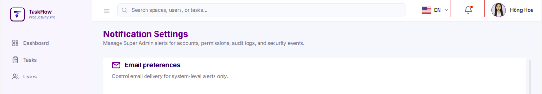
Step 3: The Super Admin clicks the notification bell icon.
Step 4: The system displays the Notifications dropdown.
Step 5: The system only displays notifications from the most recent 30 days and shows the message "That's all your notifications from the last 30 days." at the bottom of the list.
Step 6: The Super Admin can quickly view the title, content, timestamp, and read/unread status of each notification.
Step 7: The Super Admin clicks a notification to open the related screen.
Step 8: After the Super Admin clicks a notification, the system marks that notification as Read.
Step 9: The Super Admin clicks Mark All as Read to mark all existing notifications as read.
Step 10: The Super Admin clicks View All or See All Notifications to open the full notification list screen.
Step 11: On the notification list screen, the Super Admin can filter notifications by All, Unread, or Read.
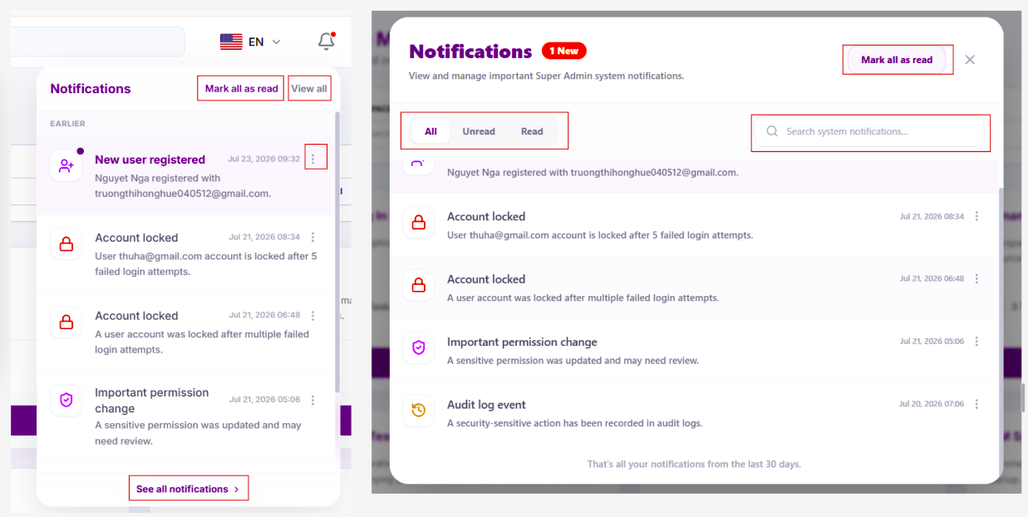
Step 12: The Super Admin can enter keywords in the search box to search notifications by content, notification type, Task, Space, or related users.
Step 13: To delete a notification, the Super Admin clicks the three-dot menu on that notification and selects Delete This Notification.
Step 14: The system removes the selected notification from the list.
Thông báo qua Email
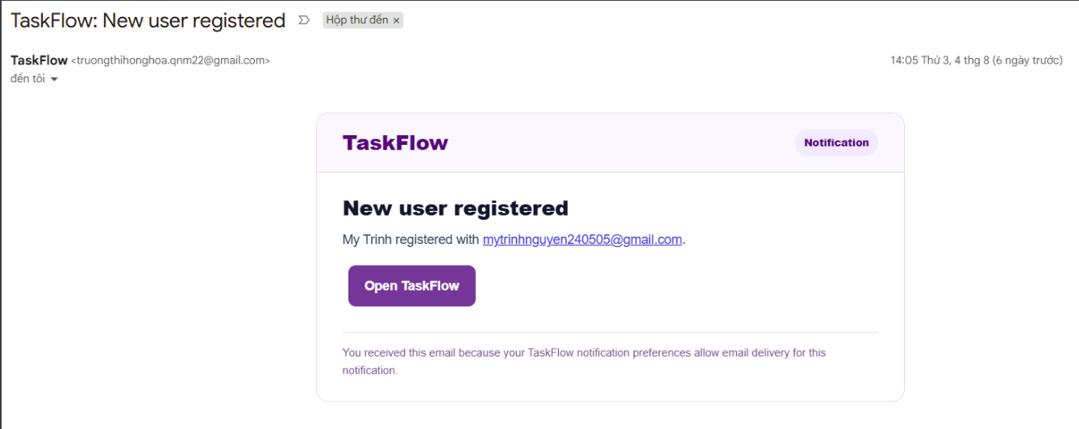
Step 1: If the Super Admin has enabled email notifications in Notification Settings, the system sends an email when a relevant event occurs.
Step 2: The Super Admin opens the notification email from TaskFlow to view the event details.
Step 3: The Super Admin clicks Open TaskFlow in the email to quickly access the system.
Step 4: If the Super Admin no longer wants to receive email notifications, they can go to Settings → Notification Settings, disable Email Preferences, or set Email Frequency to Off.
- For Users
  - Space Management
- Flow Description
  - The user accesses the Space Management feature to view their accessible Spaces.
  - The system filters and displays Spaces based on the user's role and permissions (Owner/Member).
  - The user can create a new Space and automatically becomes the Space Owner.
  - The Space Owner can manage Space details, change its lifecycle status (Active, Completed/Archived), or move it to the Recycle Bin (Soft Delete).
  - When a Space is Completed/Archived, the system grants a 7-day Reopen Window (`reopen_until`). During this window, the Space Owner can Reopen (Unarchive) the Space.
  - The Space Owner can restore soft-deleted Spaces from the Recycle Bin before permanent deletion.
  - An automated System Cron Job periodically executes background cleanup tasks:
- Expires the Reopen Window for Archived Spaces after 7 days, making the completion permanent.
- Hard-deletes expired soft-deleted Spaces from the Recycle Bin to free up system resources.
  - The Space Owner can manage team members, send email invitations, track pending invites, and remove members.
  - The system validates all business constraints and updates the Space information accordingly.
- User Guide
Step 1: The user logs in to the system.
Step 2: The system displays the list of Spaces that the user has permission to access.
Step 3: If the user wants to create a new Space, they click Create Space.
Step 4: The user enters the Space information, including Space Name and Space Description.
Step 5: The user clicks Create to create a new Space.
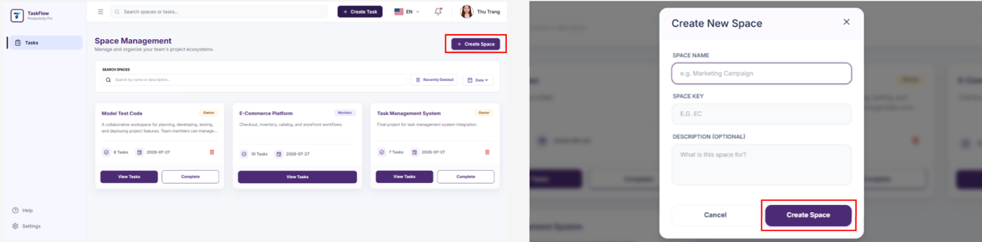
Step 6: To view or manage a Space, the user selects a Space from the list.
Step 7: The system displays the detailed information of the selected Space.
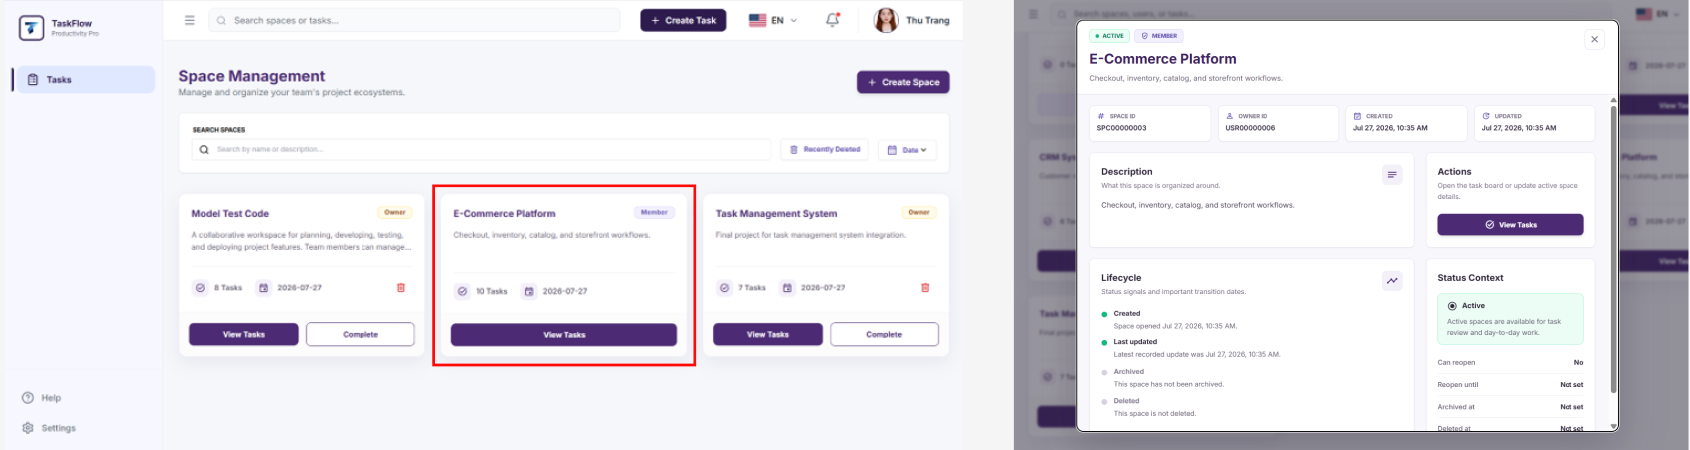
Step 8: If the user is the Space Owner, they can select "Edit Space" to update the Space Name and Space Description.
Step 9: The user clicks "Save Changes" to save the updated Space information.
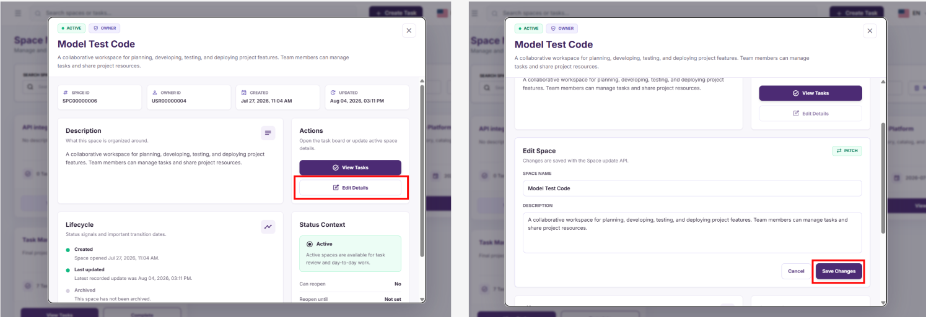
Step 10: To change the Space status, the Space Owner opens the status function and selects a new status such as Active, Archived, or Deleted.
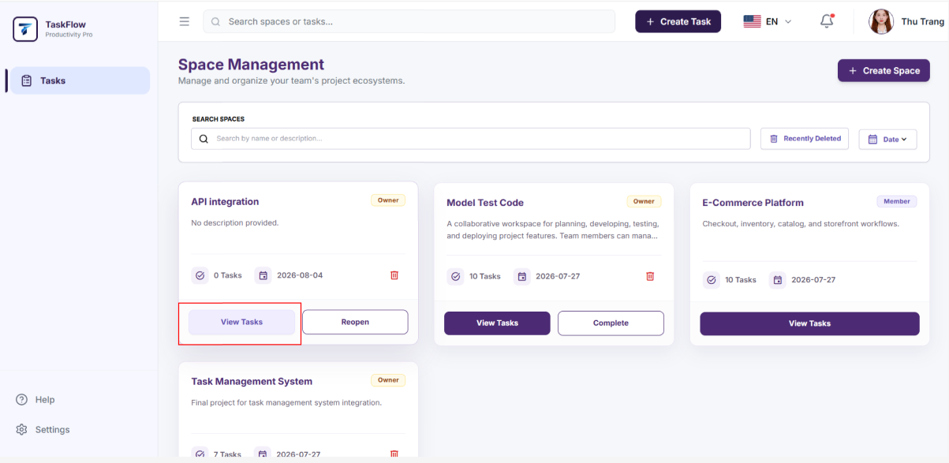
Step 11: The user confirms the action to update the Space status.
Step 12: To manage the Space recycle bin, the Space Owner opens the recycle bin section.
Step 13: The system displays the Spaces that have been deleted or moved to the recycle bin.
Step 14: The Space Owner selects the Space to process and performs a restore or permanent delete action if supported by the system.
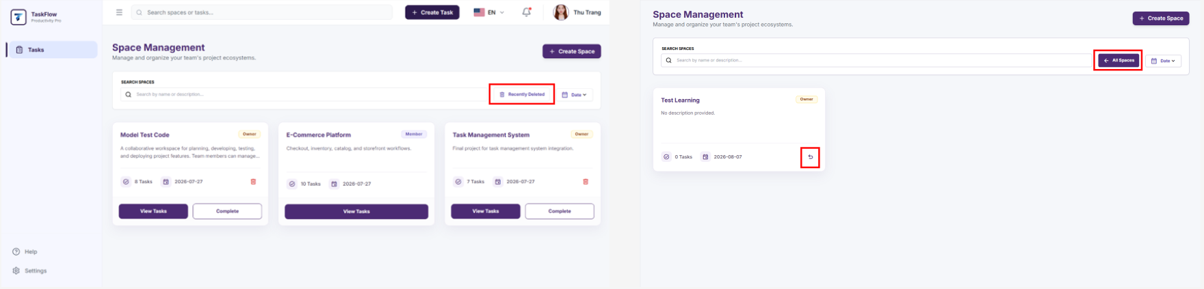
Step 15: To manage members, the Space Owner selects the Members section within the Space.
Step 16: The system displays the list of Space members, including name, email, role, and status.
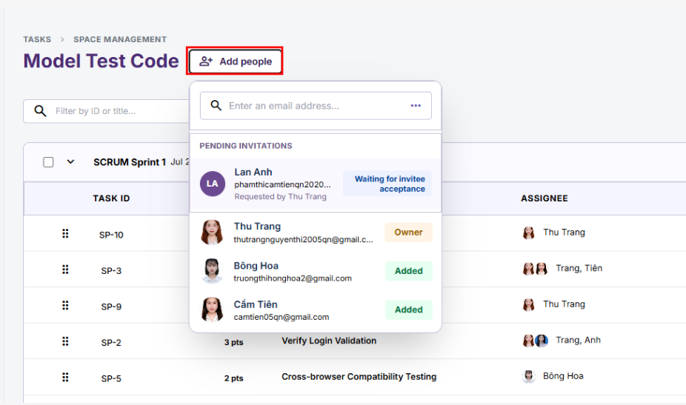
Step 17: To add or invite members, the Space Owner clicks "Add People".
Step 18: The Space Owner enters the email address or user information of the person to invite.
Step 19: Click "Invite" to send the invitation or add the member.
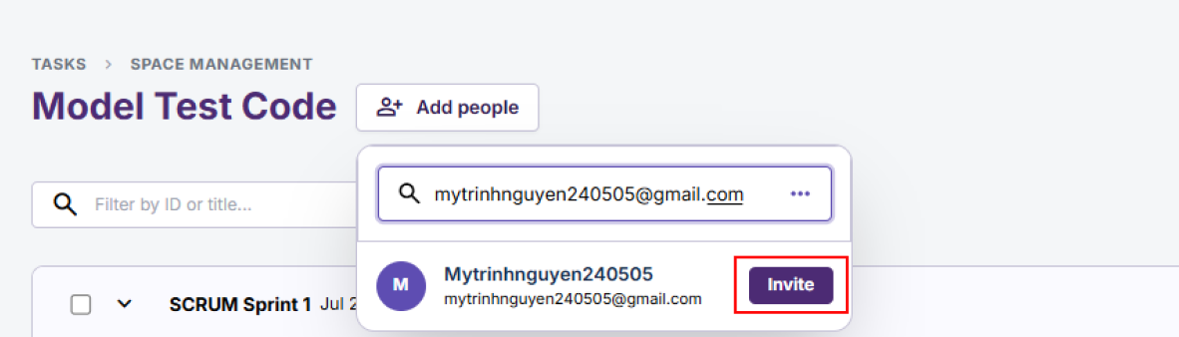
Step 20: The system displays the list of requests to join the Space.
Step 21: The Space Owner approves the join request.
Step 22: The system updates the Space information, member list, invitations, and join requests according to the actions performed.
  - Sprint Management
- Flow Description
  - The user accesses the Space where they want to manage Sprints.
  - The system displays the list of Sprints within the selected Space.
  - Users with the appropriate permissions can create new Sprints.
  - The user monitors Sprint information and the list of Tasks belonging to the Sprint.
  - Users with the appropriate permissions can update Sprint information or change the Sprint status.
  - The system saves the changes and updates the Sprint data.
- User Guide
Step 1: The user logs in to the system.
Step 2: The system displays the list of Spaces that the user has permission to access.
Step 3: Select the Space where the user wants to manage Sprints.
Step 4: The system displays the list of Sprints belonging to the selected Space.
Step 5: If the user wants to create a new Sprint, click "Create Sprint".
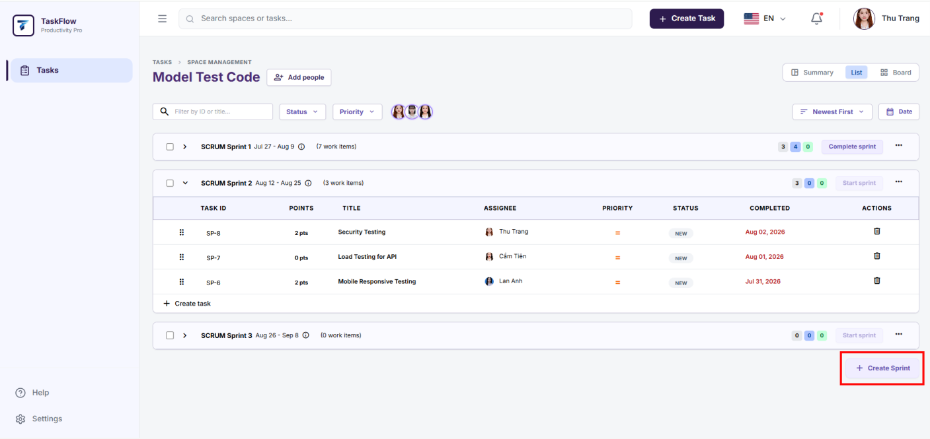
Step 6: The system displays the Sprint information and the Tasks belonging to the Sprint.
Step 7: If the user wants to update a Sprint, click "Edit Sprint".
Step 8: The user edits the following information: "Sprint Name", "Sprint Description", "Start Date", and "End Date".
Step 9: Click "Update Sprint" to save the changes.
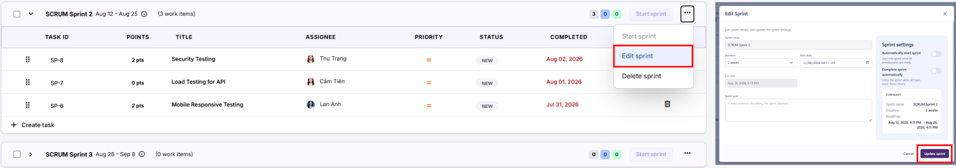
Step 10: If the Sprint has been completed, click "Complete Sprint".
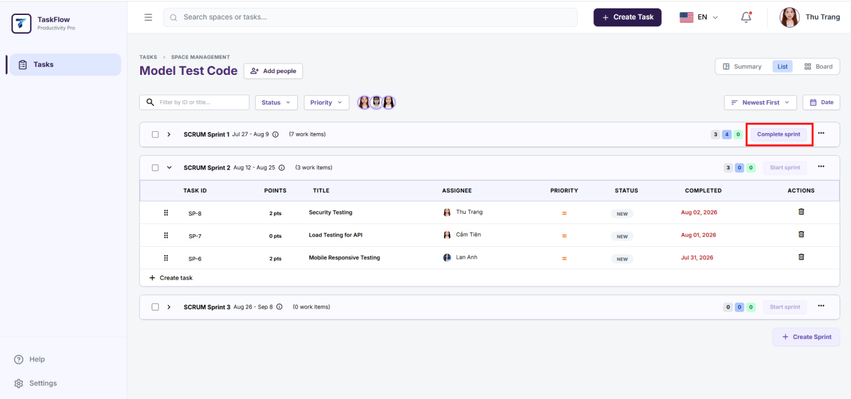
  - Task Management
- Flow Description
  - The user accesses the Tasks function to view the list of Tasks.
  - The system displays the Tasks that the user has permission to access (in List View or Kanban Board View).
  - The user can create new Tasks and change the Task status (New, In Progress, etc.).
  - The user can manage attachments and comments (upload, view, download, and manage files related to the Task).
- User Guide
Step 1: The user logs in to the system.
Step 2: The system displays the list of Spaces that the user participates in.
Step 3: The user selects the Space where they want to view Tasks.
Step 4: The system displays the list of Tasks in List View or Kanban Board View.
Step 5: If the user wants to create a new Task, they click Create Task in the desired Sprint or click "Create Task" on the header bar.
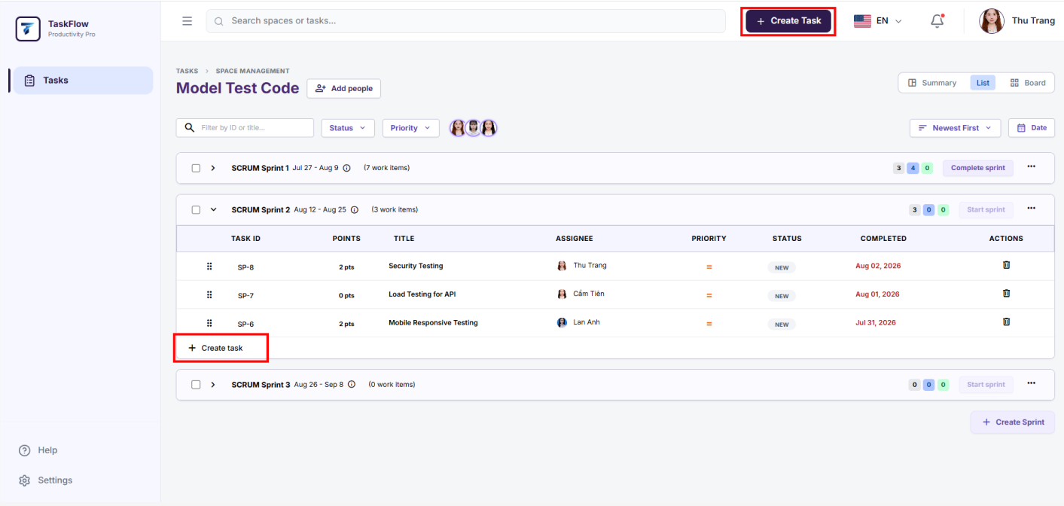
Step 6: The user enters the Task information, including Task Title, Task Description, Due Date, Tags/Labels, Description, and other details.
Step 7: The user clicks "Create" to create a new Task.
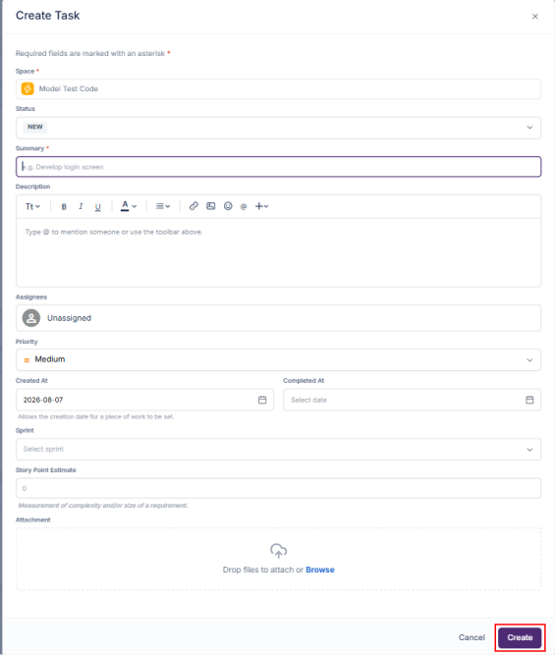
* Note: Fields marked with a red asterisk (*) are required.
Step 8: To view or manage a Task, the user selects a Task from the list or Kanban board.
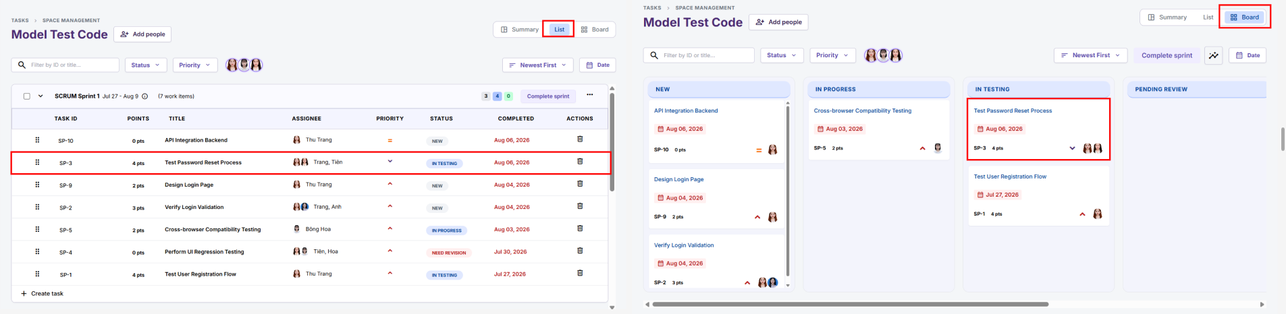
Step 9: The system displays the detailed information of the Task, including title, description, labels, status, attachments, and other related information.
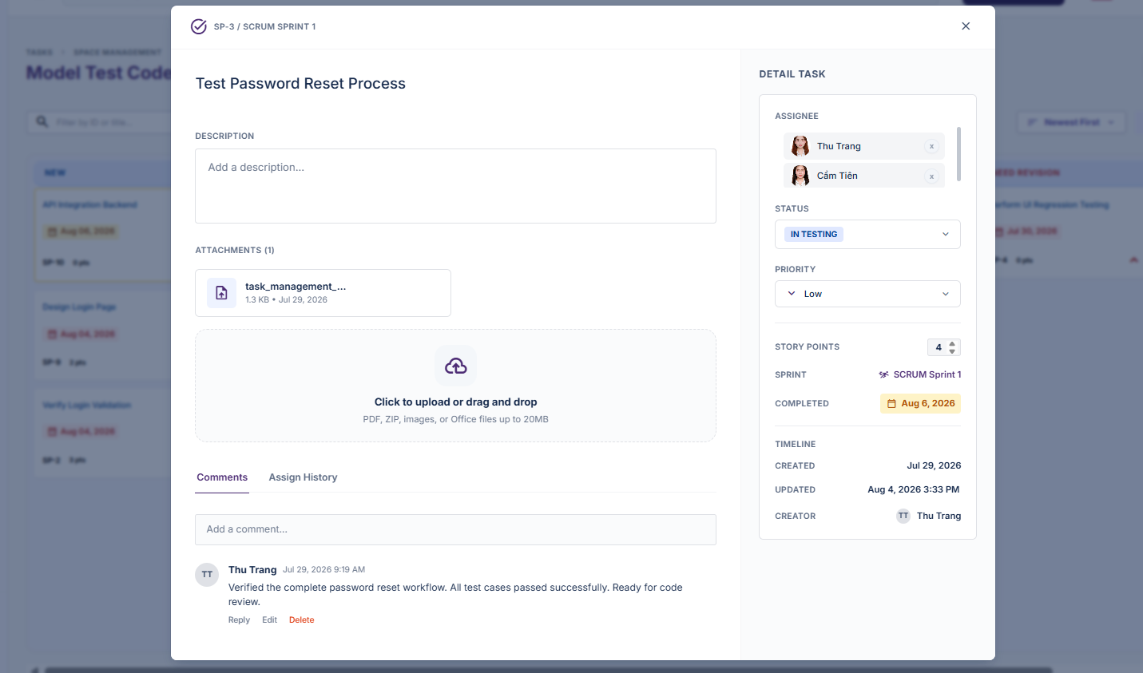
Step 10: To edit a Task, the user selects the Task and updates fields such as Title, Description, Due Date, and other information.
Step 11: To change the Task status, the user can drag and drop the Task from its current status column to the desired status column, or click the Status label in the Edit Task screen.
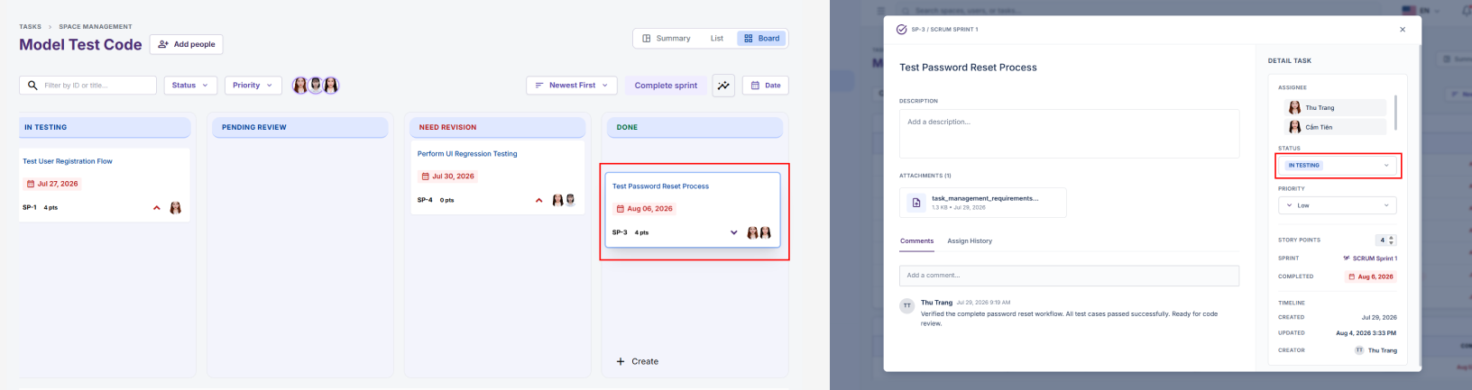
Step 12: Only the Task Owner has permission to delete a Task.
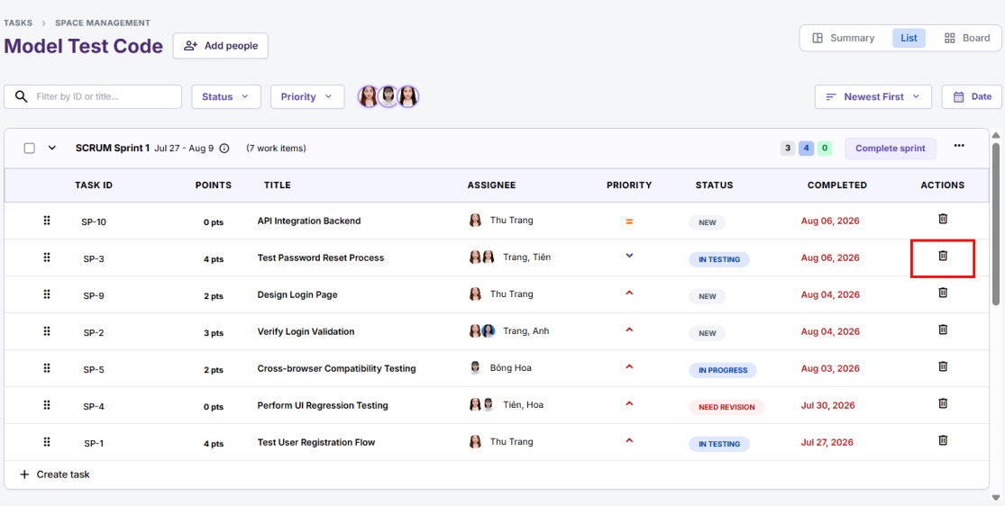
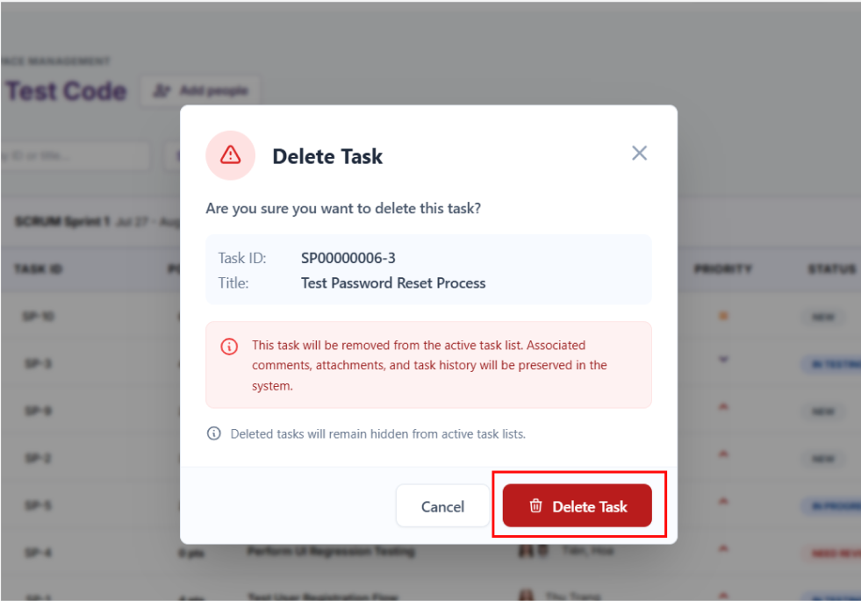
Attachment Management
Step 13: To manage attachments, the Task Owner opens the Attachments tab in the Task Details screen.
Step 14: The system displays the list of attached files, including file name, file type, and file size.
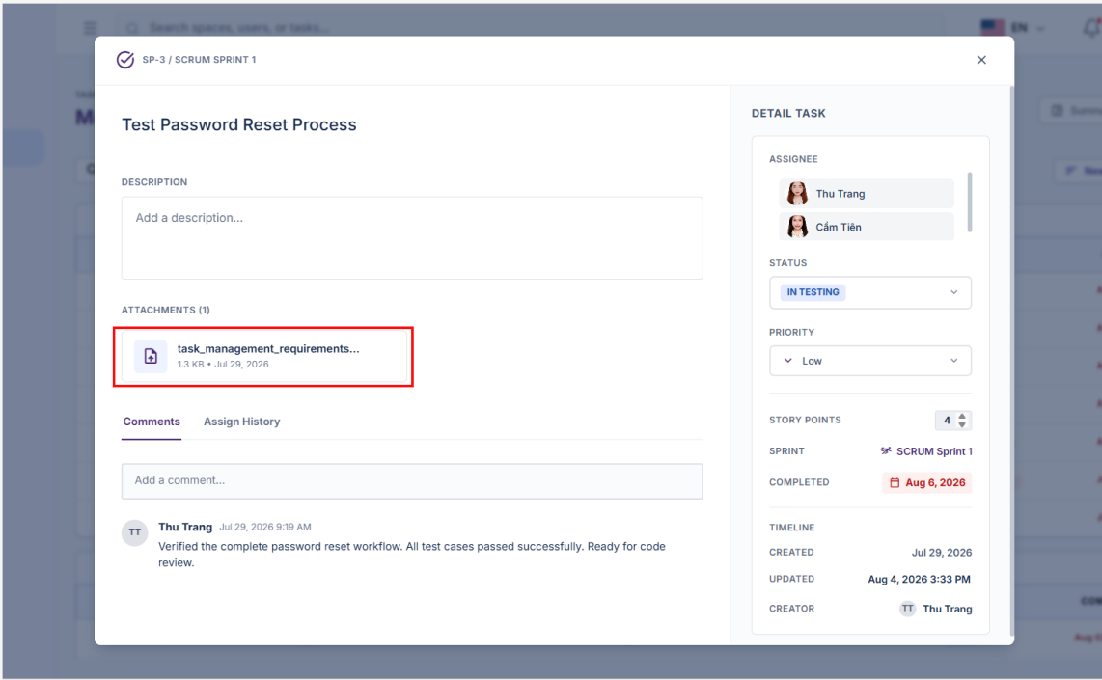
Step 15: To add an attachment, the user clicks "Click to Upload..." and selects a file (image, PDF, DOCX, etc.).
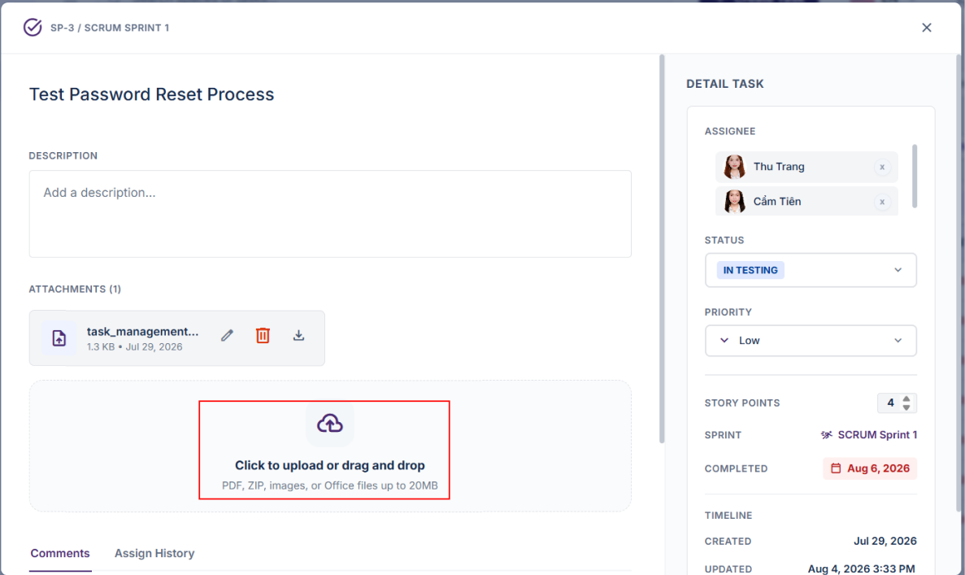
Step 16: To view or download a file, the user clicks View or Download accordingly.
Step 17: To delete a file, the user clicks the Trash icon.
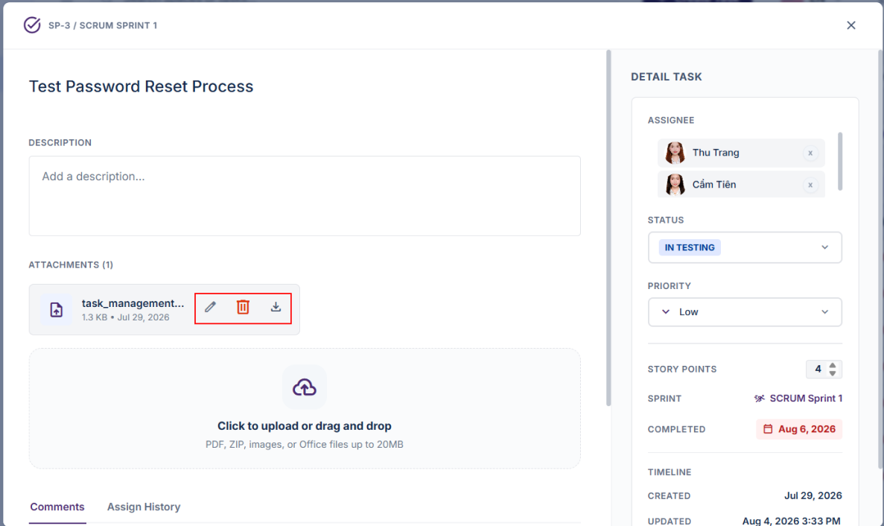
* Note: Only the user who uploaded the attachment has permission to edit or delete that file.
Comment Management
Step 18: To manage comments, the user scrolls down to the Comments section in the Task Details screen.
Step 19: To create a comment, enter the content in the "Write a comment..." field and click "Comment".
Step 20: To edit their own comment, click "Edit", modify the content, and click "Comment" to save the changes.
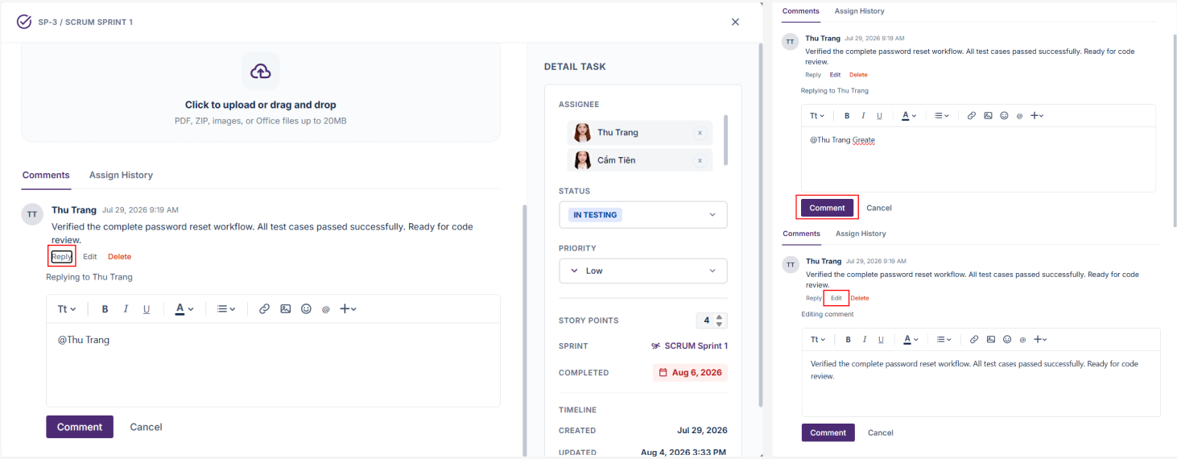
* Note: Only the comment creator has permission to edit or delete their comments.
Step 21: To delete a comment, click "Delete".
Step 22: The system saves all changes and automatically updates the Task information on the interface.
  - Notification Settings
- Flow Description
  - The User accesses the Notification Settings function.
  - The system verifies the logged-in account.
  - The system displays the personal notification settings of the User.
  - The User can configure notifications through two channels: In-Product and Email.
  - The User can enable or disable email notifications for activities related to Tasks and Spaces.
  - The User can choose the email delivery frequency as Instant or Off.
  - The system displays personal notification groups, including Task Activity and Space Activity.
  - The User can enable or disable an entire notification group or individual notification types.
  - The User can restore the default configuration using the Reset Defaults button.
  - After the User clicks Save Changes, the system saves the notification settings for the User account.
  - Subsequent notifications will be sent or displayed according to the saved configuration.
- User Guide
Step 1: Log in to the system using a User account.
Step 2: On the left-side menu, select Settings, or click the profile picture and select Settings.
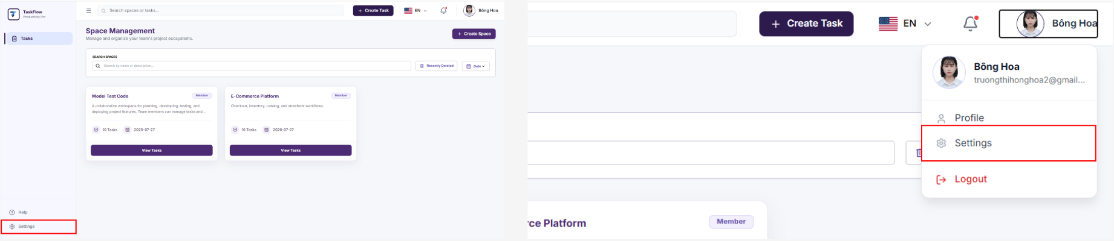
Step 3: The system opens the Notification Settings screen for User.
Step 4: In the Email Preferences section, the User enables or disables the Send me emails for space and task activity option.
Step 5: The User selects the Email Frequency:
- Instant: Receive email notifications immediately when an event occurs.
- Off: Disable email notifications.
* Note: If Email Preferences is disabled or Email Frequency is set to Off, the checkboxes in the Email column will be disabled.
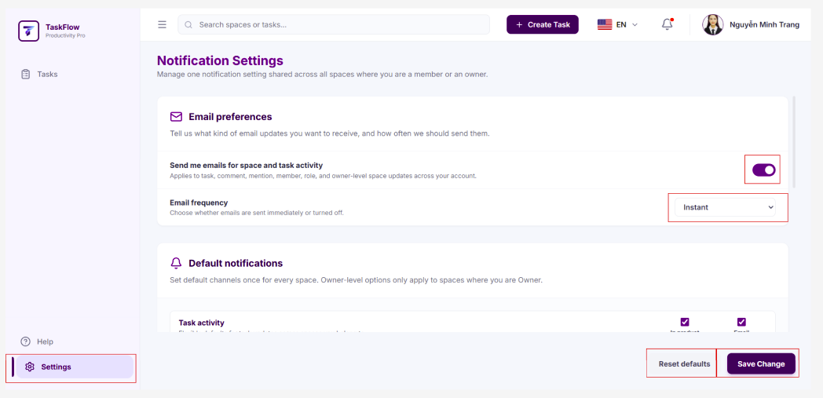
Step 6: In the Default Notifications section, the system displays personal notification groups.
Step 7: For the Task Activity group, the User configures the following notification types:
- Task Assigned to Me
- Task Status Changed
- Comment Added
- Due Date Changed
- Mentioned in Comment
Step 8: For the Space Activity group, the User configures the following notification types:
- Space Member Added
- Space Role Changed
- Owner-Level Space Updates
Step 9: For each notification type, the User selects the notification channel:
- In Product: Receive notifications within the system.
- Email: Receive notifications via email.
Step 10: The User can select the checkbox in the group header row to quickly enable or disable all notifications within that group.
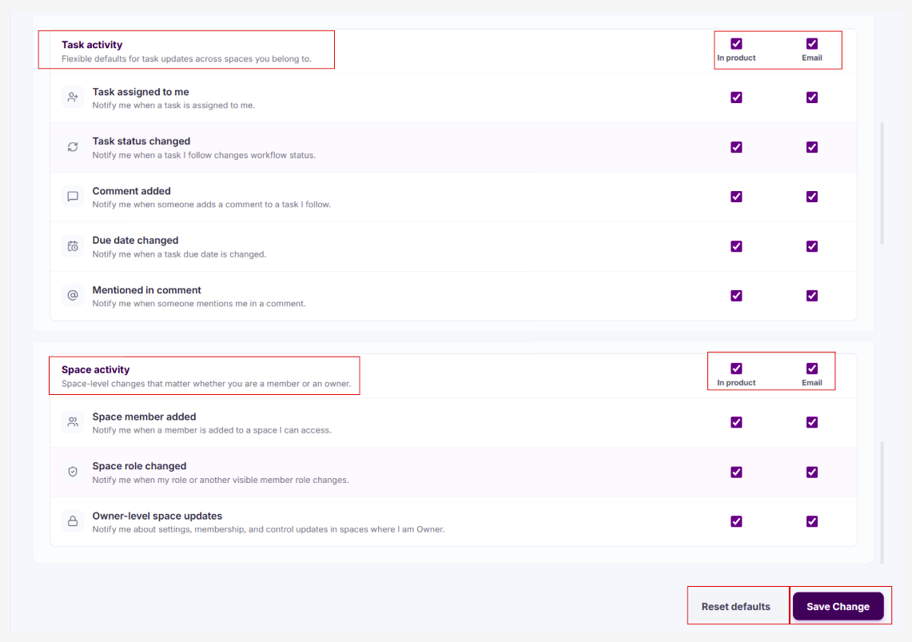
Step 11: The User clicks Save Changes to save the configuration.
Step 12: The system displays a success message and applies the new configuration to the User account.
Step 13: If the User wants to restore the default settings, they click Reset Defaults.
  - Receive Notifications
- Flow Description
  - The user logs in to the system.
  - The system sends notifications when there are events related to the account, tasks, spaces, comments, attachments, permissions, or system events.
  - The notification bell icon on the top bar displays an indicator when there are unread notifications.
  - The user clicks the notification bell icon to view the list of recent notifications.
  - The system displays notifications appropriate to the user's role.
  - For User, the system displays notifications related to tasks, spaces, owner-level updates, or activities within the account's access permissions.
  - The user can quickly view notifications in the dropdown or select View all/See all notifications to open the full notification list.
  - The user can filter notifications by All, Unread, Read and search for notifications.
  - When the user selects a notification, the system marks the notification as read and navigates to the related screen, if available.
  - The user can mark all notifications as read by selecting Mark all as read.
  - The user can delete individual notifications using the notification's action menu.
  - The system only displays notifications from the most recent 30 days. Notifications older than 30 days will not be displayed in the dropdown or notification list.
- User Guide
Step 1: The user logs in to the system.
Step 2: When there is a new notification, the notification bell icon on the top bar displays the notification status.
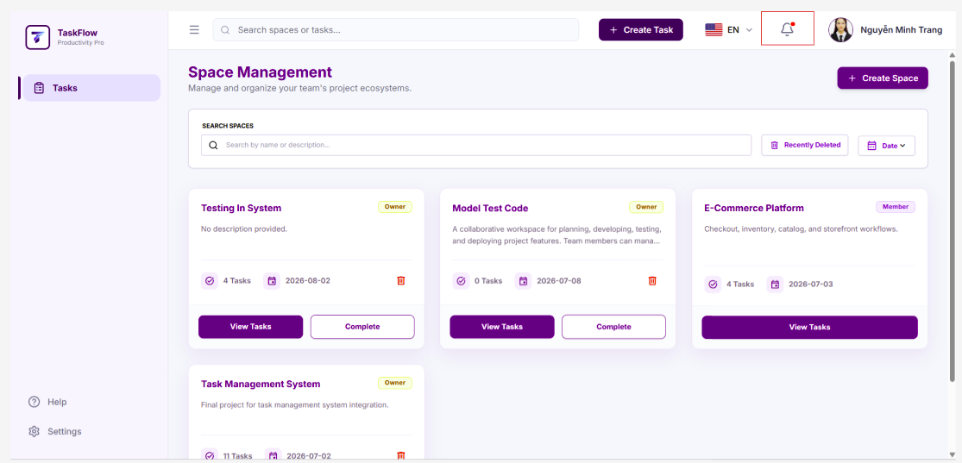
Step 3: The user clicks the notification bell icon.
Step 4: The system displays the Notifications dropdown.
Step 5: The system only displays notifications from the most recent 30 days and displays the message “That's all your notifications from the last 30 days.” at the bottom of the list.
Step 6: The user can quickly view the title, content, time, and read/unread status of each notification.
Step 7: The user clicks a notification to open the related screen.
Step 8: After the user clicks the notification, the system marks the notification as read.
Step 9: The user clicks Mark all as read to mark all existing notifications as read.
Step 10: The user clicks View all or See all notifications to open the full notification list.
Step 11: On the notification list screen, the user can filter notifications by All, Unread, or Read.
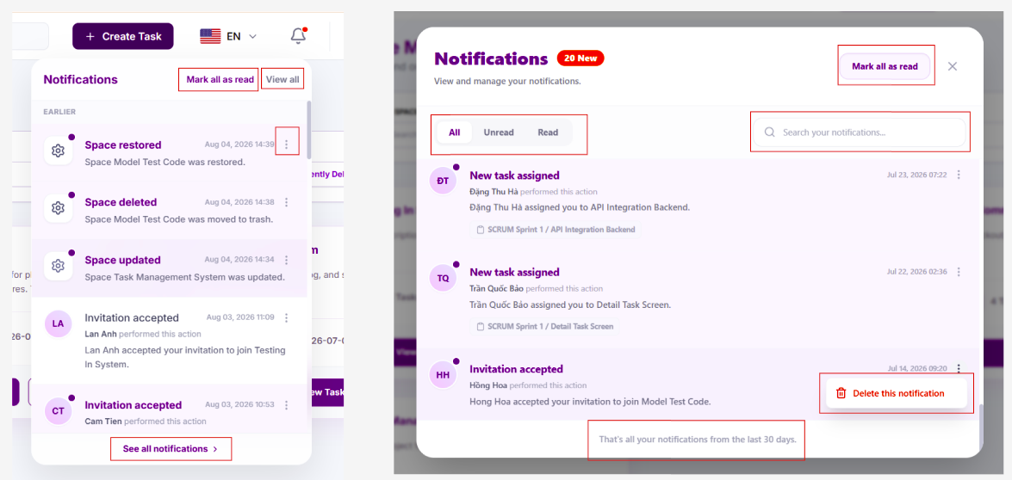
Step 12: The user can enter keywords in the search box to search for notifications by content, notification type, task, space, or related user.
Step 13: If the user wants to delete a notification, the user clicks the three-dot button on that notification and selects Delete this notification.
Step 14: The system removes the selected notification from the list.
Email Notifications
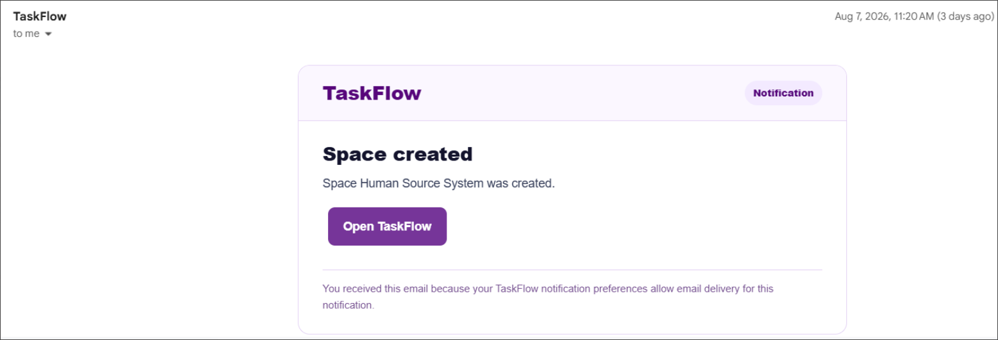
Step 1: If the user has enabled email notifications in Notification Settings, the system sends an email when a relevant event occurs.
Step 2: The user opens the notification email from TaskFlow to view the event details.
Step 3: The user clicks Open TaskFlow in the email to quickly access the system.
Step 4: If the user does not want to receive email notifications, the user goes to Settings → Notification Settings, disables Email preferences, or sets Email frequency to Off.

