

TEST PLAN
BUS TICKET BOOKING WEBSITE (FBUS)

Class: SE1817 | Mentor:
Group: 1 | Ngo Giang Thanh
1. Le Dang Khoa
2. Nguyen Thanh Truong
3. Pham Van Hoai
4. Tran Thanh Huy
5. Mai Quach Kim Tuyen
6. Nguyen Quynh Nhu

– Cantho, May 2025 –

VERSION HISTORY

I. INTRODUCTION
This Test Plan is developed as part of our group assignment for the course SWT301 – Software Testing. It presents a structured approach to testing the Bus Ticket Booking Website (FBUS), a web-based project that simulates the end-to-end experience of booking intercity bus tickets online.

FBUS allows users to search for available trips, select seats from an interactive seat map, fill in customer details, and proceed with a simulated payment process. While no real financial transactions are made, the system is designed to mimic realistic user flows and behaviors in a typical ticketing platform – including seat locking, validation of input data, countdown timers, and confirmation messages.

Our goal is to apply testing knowledge learned during the course into practice, ensuring that the core features of the system function as intended. Testing is especially important in this project because the booking process involves multiple interconnected steps: if any part fails (e.g., selecting an already-booked seat or skipping required fields), the user experience can be disrupted, and the booking will not complete successfully.

This document outlines the scope of testing, testing techniques, resources, schedule, and expected deliverables. It helps ensure that all team members follow a common plan, align with the course requirements, and gain practical experience with test planning in a real-world-like project scenario.

Team Members

Name | Role | Responsibilities
 | Test Manager | Manage the entire testing process; define the test strategy; coordinate the group; assign tasks; ensure deliverables are completed on time.
 | Tester | Design and write test cases, execute tests, log defects, validate fixes; review the test plan and suggest improvements to testing methods.
 | Developer in Test | Implement unit tests; assist with automation scripts if needed; help integrate tests into the application workflow.
 | Test Administrator | Set up test environment, prepare test data; assist tester in test execution; ensure all assets are ready and working.
 | SQA Member | Ensure test activities follow quality standards; review test results and verify testing meets the acceptance criteria.
 | SQA Member | Support the QA process by reviewing artifacts; ensure that all planned test coverage is complete and results are valid and reproducible.

II. TEST OBJECTIVE
The primary objective of this Test Plan is to ensure that the core functionalities of the Bus Ticket Booking Website (FBUS) operate correctly, consistently, and in alignment with user expectations. The goal is to verify that users can successfully go through the full booking flow – from searching for a trip, selecting seats, filling in personal information, to completing the simulated payment process – without encountering functional or usability issues.
Since the FBUS project simulates real-world booking scenarios in an academic environment, the testing objectives also include:
- Ensuring data correctness and flow consistency between each step of the booking process. For example, selected seats must remain locked during payment countdown and released properly if timeout occurs.
- Validating user interactions, such as:
  - Proper form validation for name, phone, email
  - Prevention of booking submission without accepting terms
  - Display of error messages when conditions are not met
- Simulating payment logic: Although the payment is not connected to a real gateway, the system must mimic realistic behavior such as:
  - Displaying total cost based on seats selected
  - Handling countdown timer (20 minutes) before expiration
  - Showing success/failure notification based on simulation
- Ensuring UI consistency and responsiveness across devices, especially on the booking and payment pages.
- Identifying and logging defects early, helping improve code quality and user experience before submission.
In summary, this testing effort aims to not only detect bugs or broken flows but also to evaluate the stability and usability of the FBUS application as a complete and functional academic software product. It gives the team an opportunity to apply theoretical knowledge of software testing into a practical scenario, aligned with the learning outcomes of the SWT301 course.

III. SCOPE OF TESTING
This section defines the boundaries of what will and will not be tested in this assignment project. As the system is developed in an academic setting, with simulated features (such as mock payment), the scope of testing focuses primarily on functional correctness, UI behavior, and flow validation for the main booking process.

a. Features Not To Be Tested (Out of Scope)
The following features are considered outside the scope of this test plan due to either system limitations, project constraints, or irrelevance to the current academic objectives:
- Admin features: revenue reports, account management, or trip CRUD operations in the admin panel are not tested.
- Real-world payment gateway: the system uses mock payment, so integration with real banking systems or secure transactions is not tested.
- Backend performance or load testing: stress testing with hundreds of users is not feasible in this project.
- Mobile app version: only the web interface is tested.
- Security vulnerabilities: penetration testing, SQL injection, and authentication bypass checks are not in scope.

b. Features To Be Tested (In Scope)
User Interfaces
The testing scope includes all UI components to ensure the interface behaves as expected across different user roles.

Functional Items
All the feature of FBUS which were defined in software requirement specs are need to tested

# | Feature | Role | Description
1 | Trip Search | Guest, Customer | Allows users to search for available bus trips by selecting departure point, destination, and date. Validates input and returns matching trips.
2 | Seat Selection | Customer | Shows bus seat layout by floor (upper/lower), allows selecting/deselecting available seats; handles UI state (booked, locked, selected).
3 | Passenger Info Form | Customer | Validates required input: full name, phone, email. Prevents progress with invalid/missing data.
4 | Terms Acceptance | Customer | Ensures user checks “Agree to Terms & Conditions” before proceeding to payment; shows error if unchecked.
5 | Fare Calculation | Customer | Calculates total fare based on selected seats and displays summary in 3 locations (right info panel, payment footer, confirmation).
6 | Payment Simulation | Customer | Displays 20-minute countdown; simulates “payment” with success/fail feedback via popup; no real transaction.
7 | Seat Lock & Release | Customer | Temporarily locks selected seats during payment process; auto-release after timeout if not confirmed.
8 | Ticket Confirmation Page | Customer | Displays route, passenger info, selected seat codes, total amount, and fake QR code for reference.
9 | Toast + Redirect Behavior | Customer | On successful payment, shows toast and redirects to “view-trips” page after 5 seconds.
10 | Responsive UI | All roles | Ensures layout works properly on laptop, tablet, and mobile (Tailwind responsive grid, 2-column design).

Non-Functional Item:
Security Notes:
- Since FBUS uses mock payment (no real transaction integration), it does not require PCI DSS or HIPAA compliance.
- However, user inputs (name, email, phone) must be validated and not exposed to basic attacks such as XSS or injection.
Responsiveness & Compatibility:
- UI must render correctly on Chrome, Edge, and Safari (latest versions).
- Must be responsive on common screen sizes: mobile (360px), tablet (768px), and desktop (1920px).
Usability:
- The booking flow must be intuitive for first-time users with minimal instruction.
- Tooltips, placeholders, and validation messages must guide users effectively.

IV. TEST STRATEGY

a. Test Types
1. User Interface Testing
Test Objective | Ensure the navigation across the FBUS web application reflects the intended flow of bus ticket booking, with consistent element positioning, alignment, and responsiveness across browsers and screen sizes.
Technique: | - Testers create UI-based scenarios based on wireframes and Figma design.  - Execute each UI flow using valid/invalid/boundary data to verify layout consistency and interaction logic.  - Use developer tools to simulate screen sizes and inspect responsive behavior.
Completion Criteria | - All UI test cases executed and passed.  - UI bugs are logged and resolved before system acceptance.
Special Considerations | Responsive layout must adapt well across mobile (360px), tablet (768px), and desktop (1920px).

2. Function Testing
Test Objective | Verify each FBUS feature (Trip search, seat selection, booking form, payment simulation, etc.) to ensure correct behavior based on user input and business logic.
Technique: | - Testers create test scenarios based on use cases and Black Box techniques (EP, BVA).  - Execute each case with valid, invalid, and boundary data.  - Validate UI/DB sync (e.g. seat lock, fare calculation).  - Ensure user flow behaves correctly across all screens.
Completion Criteria | - All functional test cases passed.  - Critical flows (booking, payment simulation) verified with valid/invalid data.  - No major defect remains unresolved.
Special Considerations | Functional testing will start only when developers finish unit testing of Servlets, DAOs, and helper classes.

3. Load Testing
Test Objective | Verify that the FBUS system performs within acceptable load times under normal and stress conditions, especially during peak seat booking and payment simulation.
Technique: | - Simulate 100+ concurrent users using mock tools (e.g., browser dev tools or simple load scripts).  - Measure page load time under normal (<100 users) and stress (>100 users) conditions.  - Validate response time for key actions (search trips, select seat, confirm booking).
Completion Criteria | - Under normal load (<100 users): page loads in ≤3s.  - Under stress (>100 users): page loads in ≤6s.  - All key user flows respond within acceptable thresholds.
Special Considerations | Actual load testing is limited in academic setting. Results are simulated or theoretical, not performed with full-scale infrastructure.

b. Test Levels
Types of Test | Stages of Test
Types of Test | Unit | Integration | System | Acceptance
Function Test | X | X | X | X
User Interface Test |  | X | X | X
Load Test |  |  | X

c. Supporting Tools
Purpose | Tool | Vendor/In-house | Version
Defect log | Excel | Internal
Collect test effort | Timesheet (manual) | Internal
Documenting | MS Word, Excel | Microsoft | Office 365
Unit Testing | JUnit | Open Source | 5
Development IDE | NetBeans | Apache | 13
Function Testing | Manual | Internal
Load Testing | Simulated via Dev Tools | Manual
Security Testing | Code Review (basic level) | Manual
Database | SQL Server | Microsoft | 2022

V. RISK
Risks | Mitigation Strategies
Lack of testing skills or unfamiliarity with JSP/Servlet (MVC pattern) | - Organize internal knowledge-sharing sessions on testing process and tools.  - Assign tasks based on team members’ strengths.
Time constraints, hard to meet deadlines | - Create a clear timeline for each phase: Unit Test, Integration Test, System Test.  - Prioritize testing for core functionalities first.
Difficulty using testing tools due to limited experience or resources | - Learn basic tools like JUnit and browser DevTools through hands-on examples in the project.  - Seek quick tutorials and team guidance.
Disagreements in the team on test approaches or decisions | - Hold regular meetings to align on test cases.  - Assign a team leader to make final calls when needed.
Underestimated workload or unexpected increase in testing scope | - Estimate number of test cases per feature/module early.  - Track progress daily to adjust tasks accordingly.

VI. TEST CRITERIA

a. Entry Criteria
- Unit Testing
- The planning phase has been completed.
- Functional requirements and specifications are available and reviewed.
- Developers must complete at least 80% of unit tests before moving forward.
- System Testing
- The system test environment (JSP/Servlet + SQL Server on localhost) has been properly set up.
- All test cases and test data are prepared and reviewed.
- Internet connection is available (for testing simulation features like countdown timer, QR code, etc.).
- Acceptance Testing
- The environment for acceptance testing is stable and ready.
- All key features of FBUS are fully implemented.
- End-users (student testers) are invited for final testing round.
- Test scripts are prepared and walkthrough is scheduled.
- Internet access is ensured for complete end-to-end booking simulation.

b. Suspension Criteria
If the test team reports that 40% or more of test cases fail during a specific test phase, testing will be suspended until all major defects are fixed and retested by the development team.

c. Exit Criteria
To move to the next test phase or declare success, the following criteria must be met:
- Run rate: 100% of planned test cases must be executed, unless a valid reason for skipping is documented.
- Pass rate: Minimum 95% pass rate is required for the test phase to be considered successful.

VII. RESOURCE PLANNING

a. System Resources
No | Resource | Description
1 | Server | Localhost setup using NetBeans IDE and SQL Server for database testing.
2 | Test Tool | Manual testing using Excel-based test cases; browser DevTools for inspection.
3 | Network | Stable internet connection (min 5 Mbps) required for simulating user flow.
4 | Computer | Windows 10/11, 8GB RAM, Intel Core i5 or higher; running NetBeans IDE.
5 | Mobile Device | Smartphones running Android or iOS to validate responsive UI layout.

b. Human Resources
No | Role | Task
1 | Test Manager | - Supervise the entire test plan execution.  - Define objectives, scope, schedule.
2 | Programmer in Test | - Develop testable modules and setup dummy logic for seat booking, payment simulation.  - Prepare test data and scripts for unit/system test.
3 | Tester | - Write test cases, execute functional & UI test.  - Validate results, log bugs, retest after fix.  - Use browser tools to test layout and behavior across screen sizes.

VIII. TEST ENVIRONMENT
- Devices Used: Laptop, Desktop, Mobile
- Operating System: Windows 10 / Windows 11
- Browsers for UI Testing:
+ Google Chrome (latest version)
+ Microsoft Edge (latest version)
- Network: Wi-Fi
- Development & Execution Tools:
+ IDE: Apache NetBeans
+ Application Server: Apache Tomcat (embedded in NetBeans)
+ Database Server: Microsoft SQL Server 2022 (CTP2.0) – Version: 16.0.600.9 (X64)

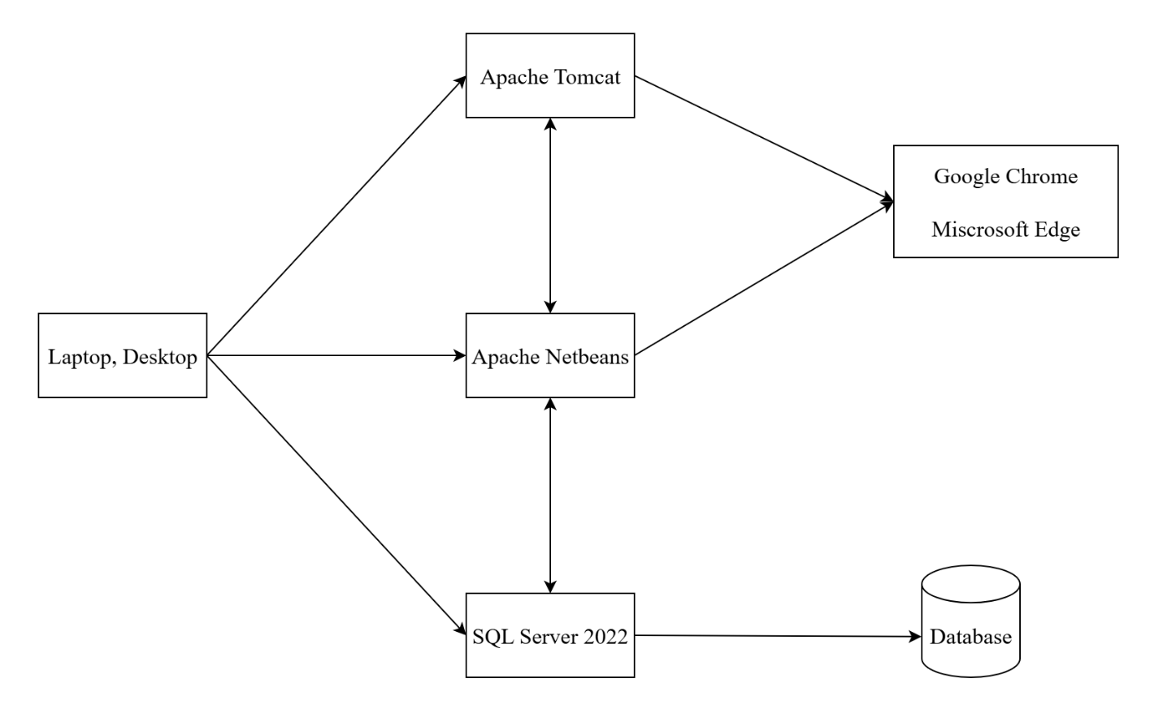

IX. SCHEDULE & ESTIMATION
No | Task | Assigned Member | Estimated Effort
1 | Sign-In / Sign-Up | Developer, Tester | 3 man-hour
2 | Trip Search & Filter | Developer, Tester | 5 man-hour
3 | Seat Selection UI + Logic | Developer, Tester | 8 man-hour
4 | Passenger Info Form | Tester | 6 man-hour
5 | Terms Acceptance Validation | Tester | 3 man-hour
6 | Fare Calculation | Developer, Tester | 5 man-hour
7 | Payment Countdown + Simulation | Developer, Tester | 9 man-hour
8 | Ticket Confirmation Page | Developer, Tester | 6 man-hour
9 | Responsive UI Testing (Mobile/Web) | Tester | 5 man-hour
10 | Final Acceptance Test & Bug Fixing | All Members | 10 man-hour
 | Total |  | 60 man-hour

X. TEST DELIVERABLES
Throughout the testing lifecycle of the Bus Ticket Booking Website (FBUS), the following deliverables will be prepared and maintained, organized by phase:

a. Before testing
- Test plan document
- Test case documentation
- Specific requirements for test design

b. During testing
- Test tool
- Simulation
- Test data
- Log errors and execute log

c. After the test
- Test results/reports
- Error report
- Install/guide the test procedure
- Release notes

