## Some Connection Diagrams

## +01: Xinje HMI-Siemens only S7200 PLC Communication cable diagram

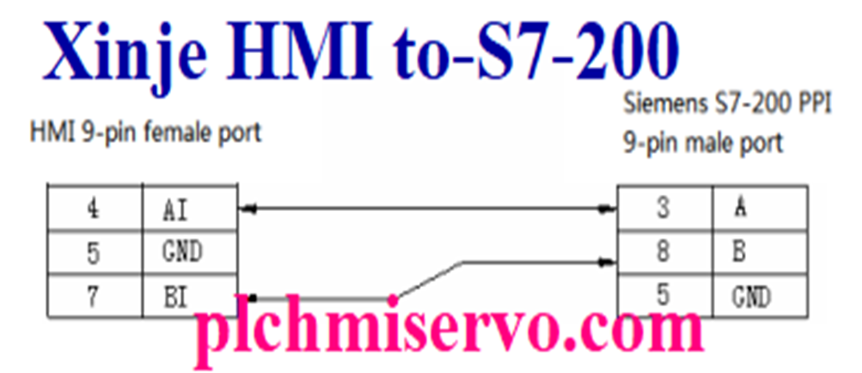

## +02: Xinje-Delta DVP Series PLC Interface Cables Diagram

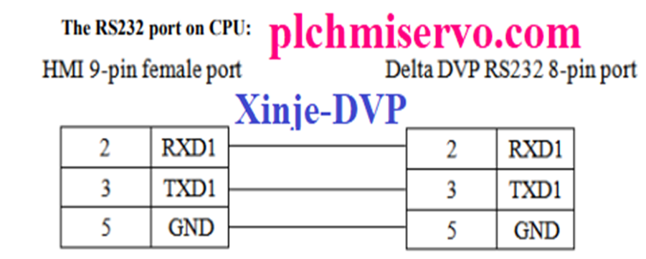

## +03: Allen-Bradley Micrologix Series PLC  to Xinje HMI Diagram

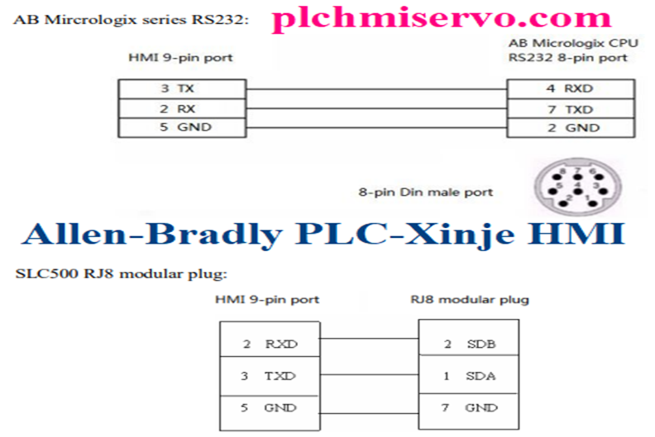

## +04: Fatek FB Series PLC> “Xinje” HMI

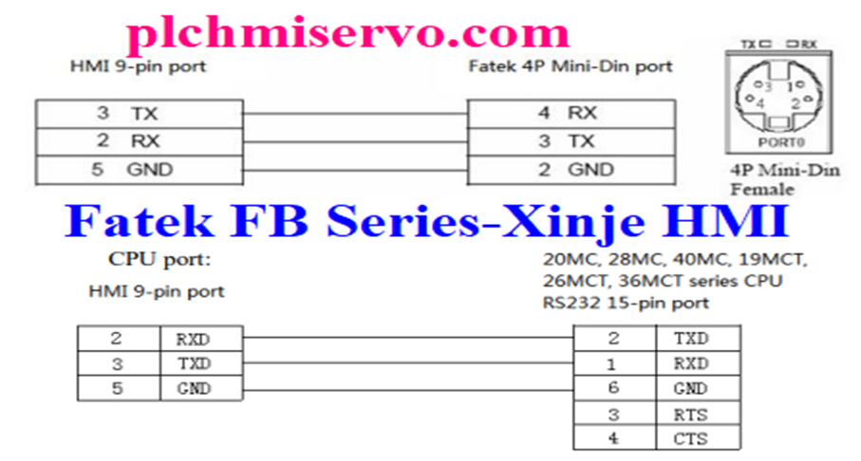

## +05: RS232 Communication Xinje HMI –IDEC Micro3c PLCs

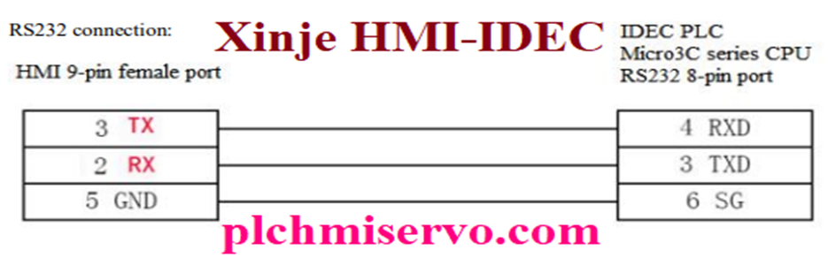

## +06: LS/LG Master K PLC>Xinje

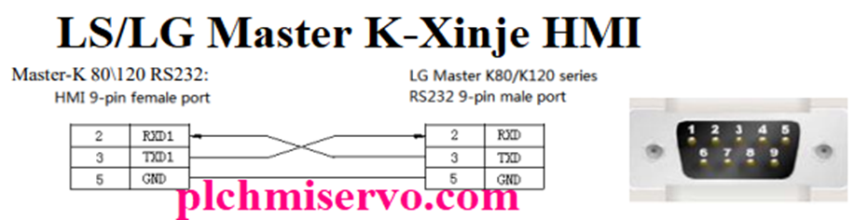

## +07: Siemens S7-300/400/200>Xinje RS485 Communication

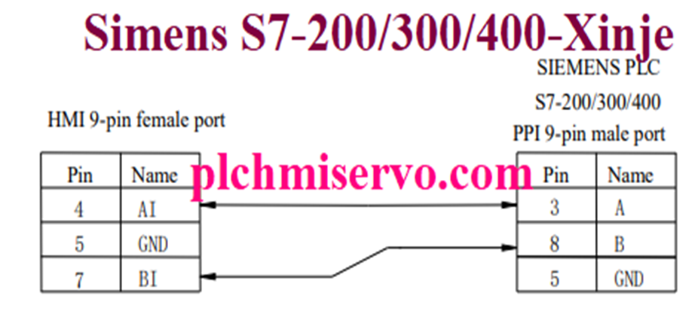

## +08: Mitsubishi RS422 Connection FX>Xinje “HMI”

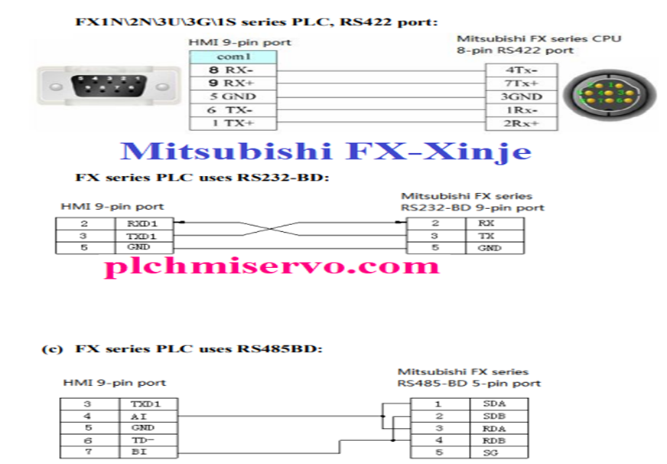

## +09: Omron RS232 -Xinje

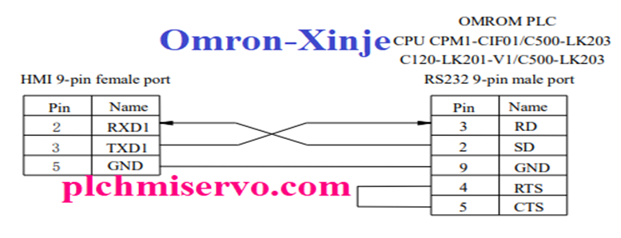

## +10: Xinje HMI to Vigor PLC “RS232” Communication

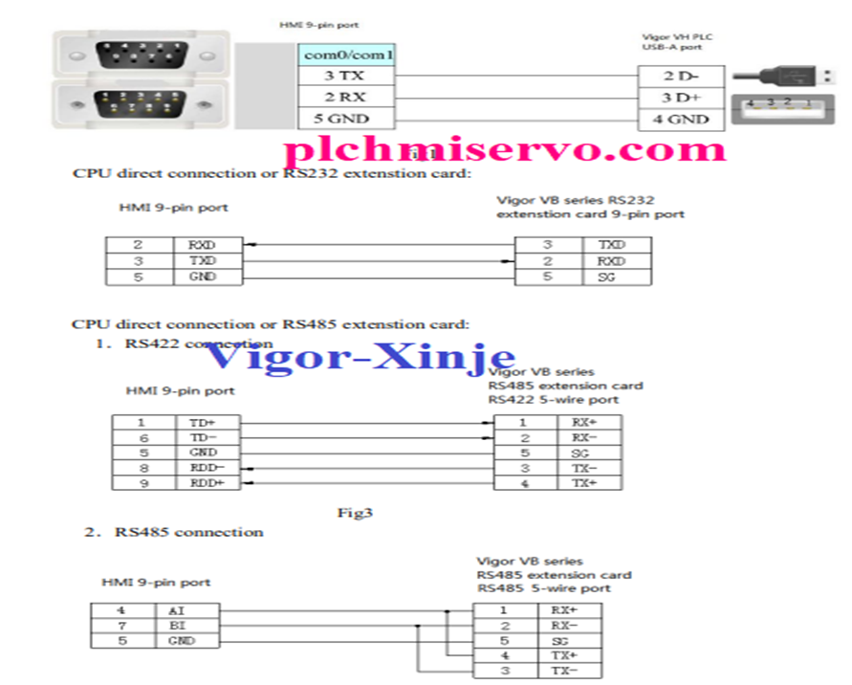

## +11: Xinje PLC -HMI

- PLC Xinje sử dụng cổng COM 2

