Download Eclipse

Link <https://www.eclipse.org/downloads/>

Click on button download then redirect to download page

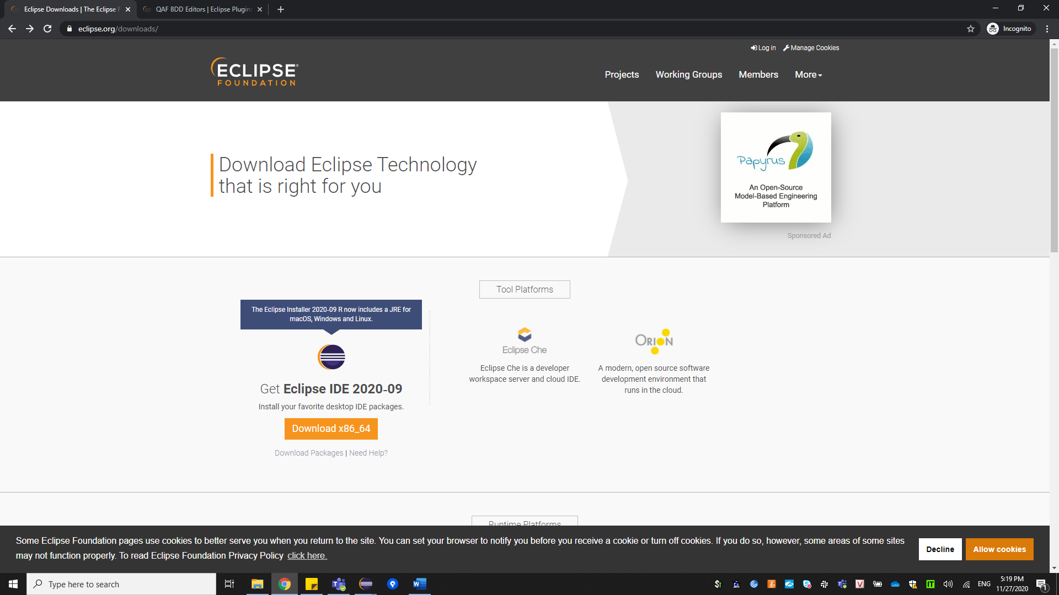

Click on button download and waiting for download complete

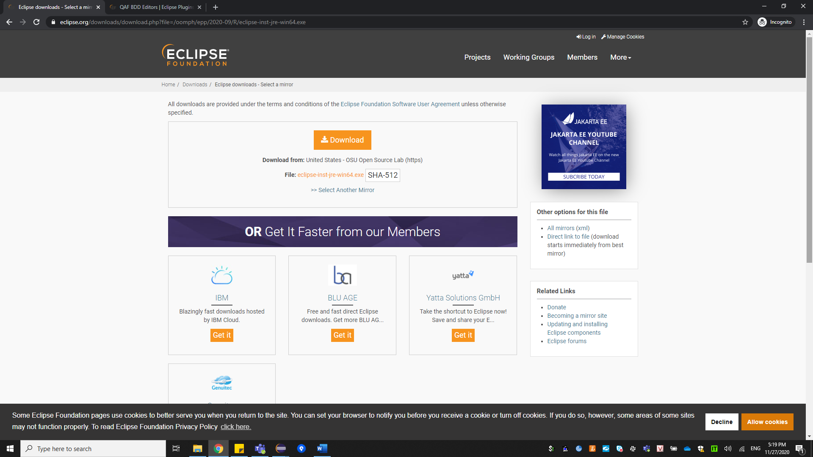

Install Eclipse

Select option **Eclipse IDE for java Developers**

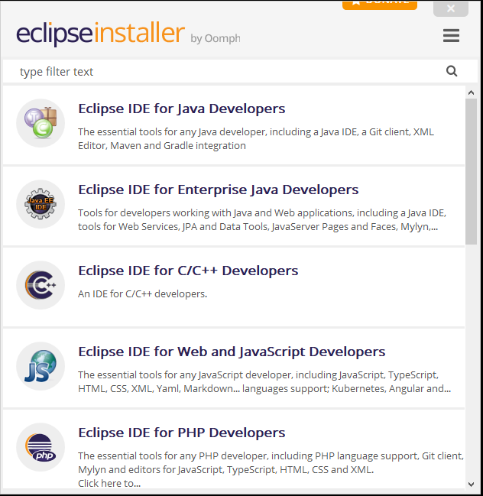

Click on button **Install**

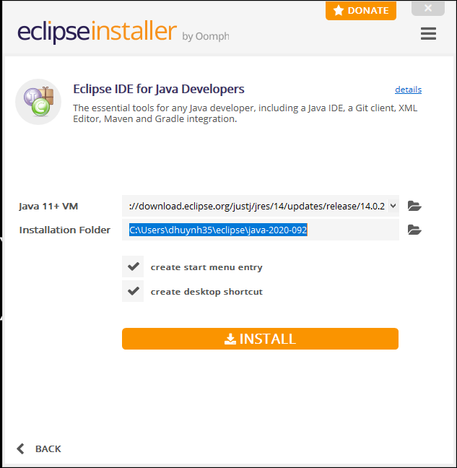

Install BDD QAF

Link <https://marketplace.eclipse.org/content/qaf-bdd-editors>

Move mouse to button install

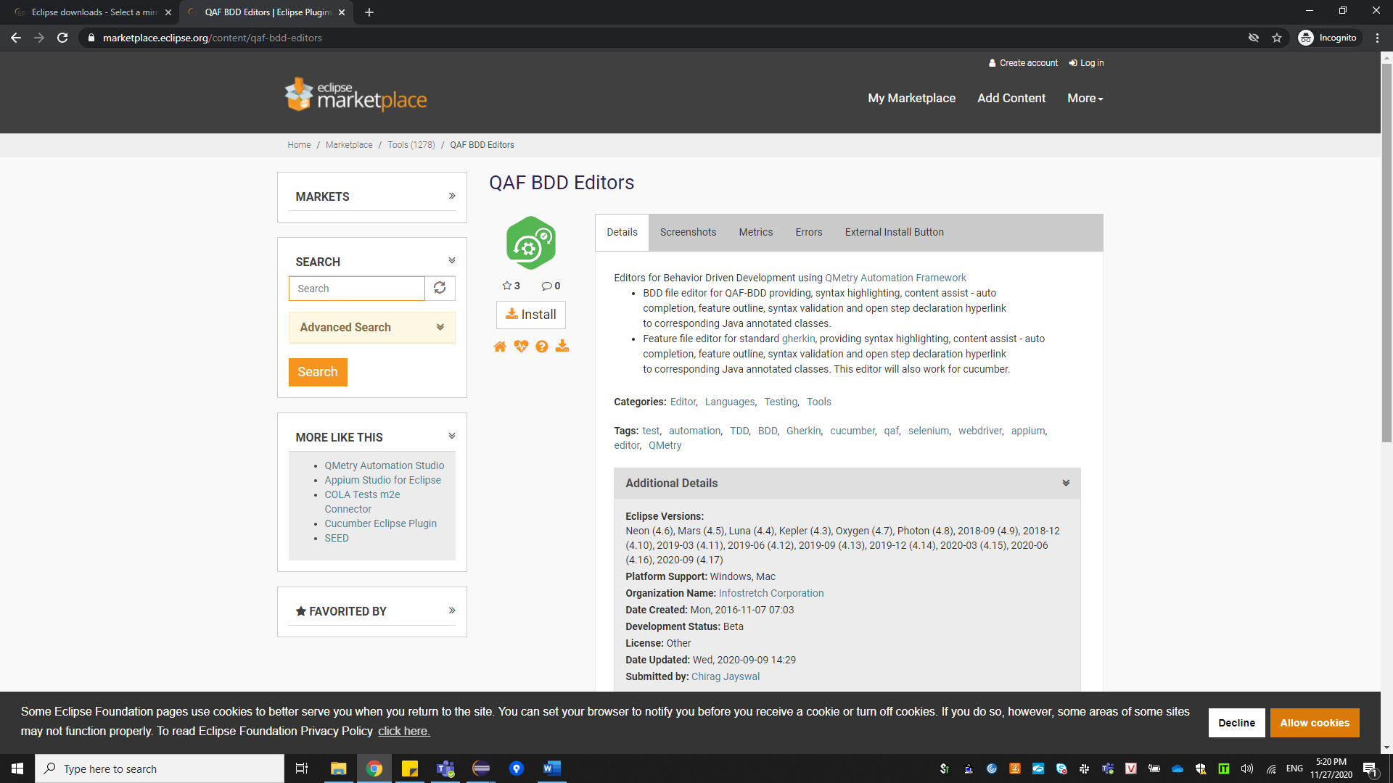

Drag this into eclipse workspace

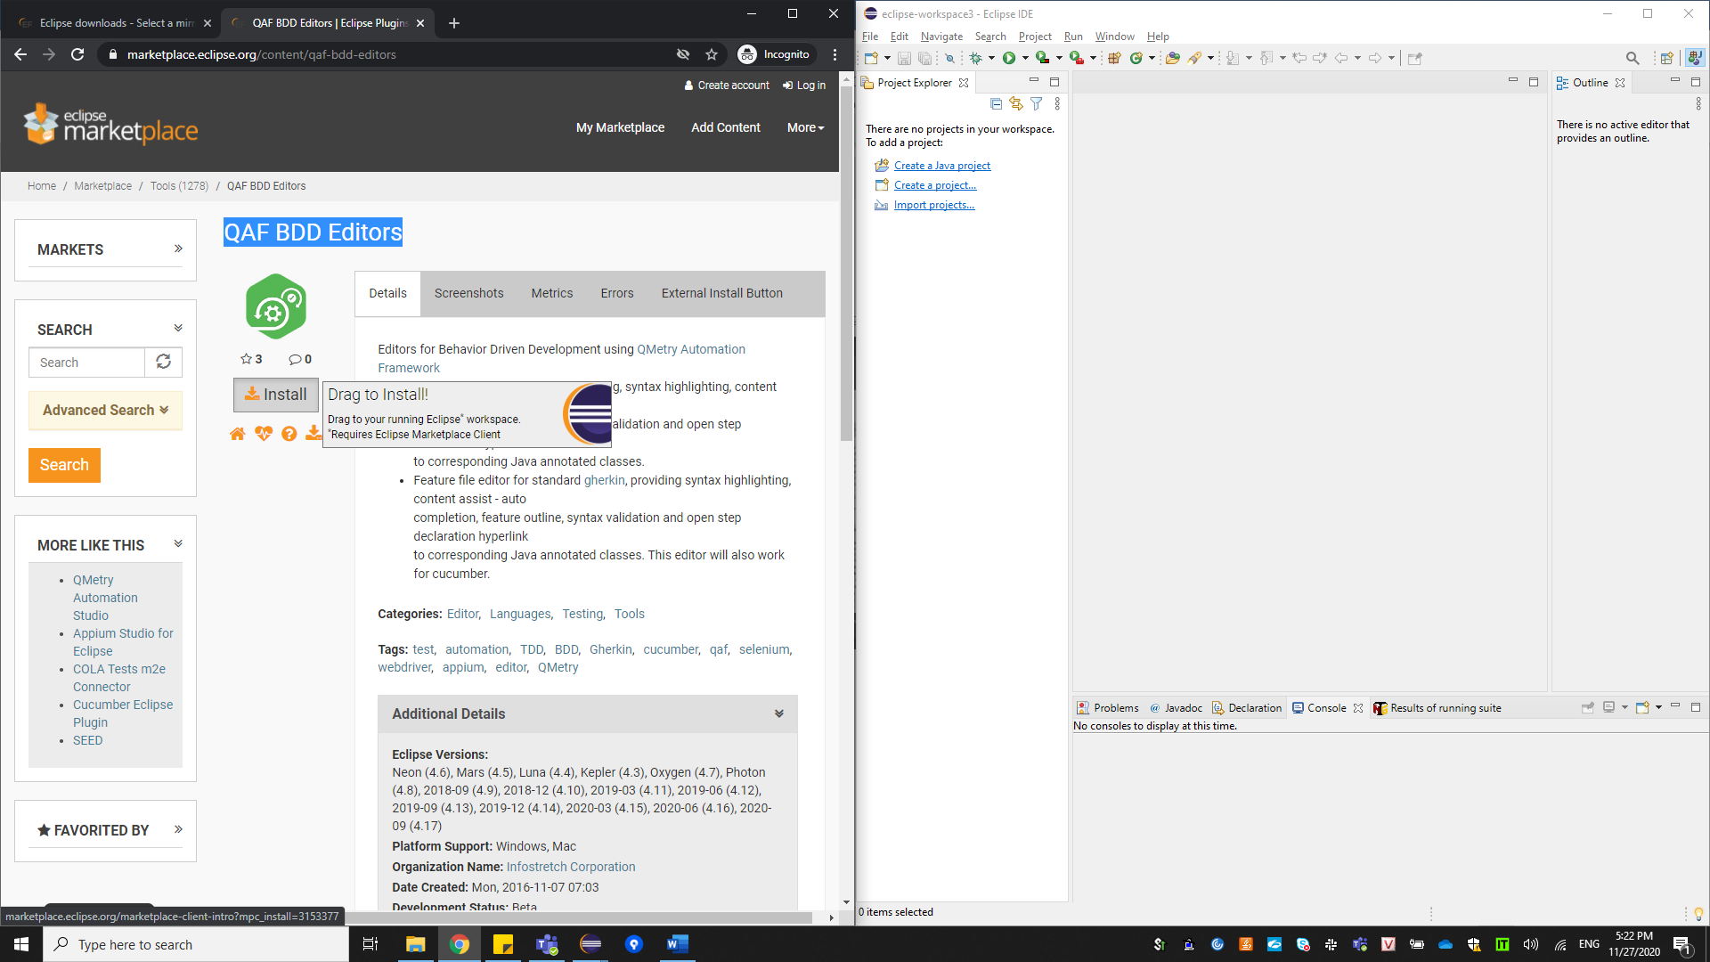

Drag to here

Click confirm for setup

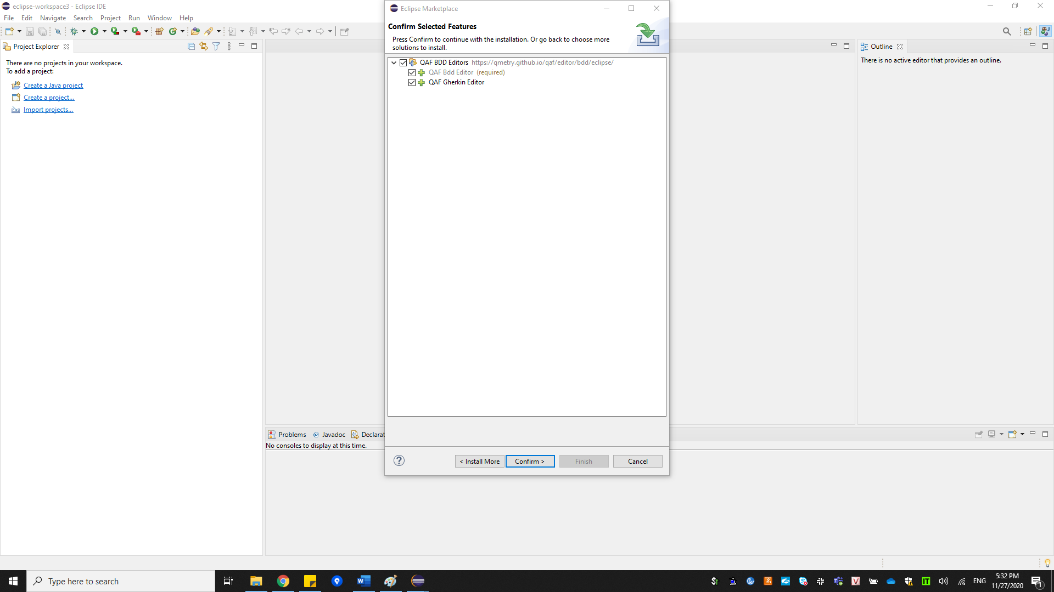

Select the radio button I accept the terms of the license agreement and click on finish

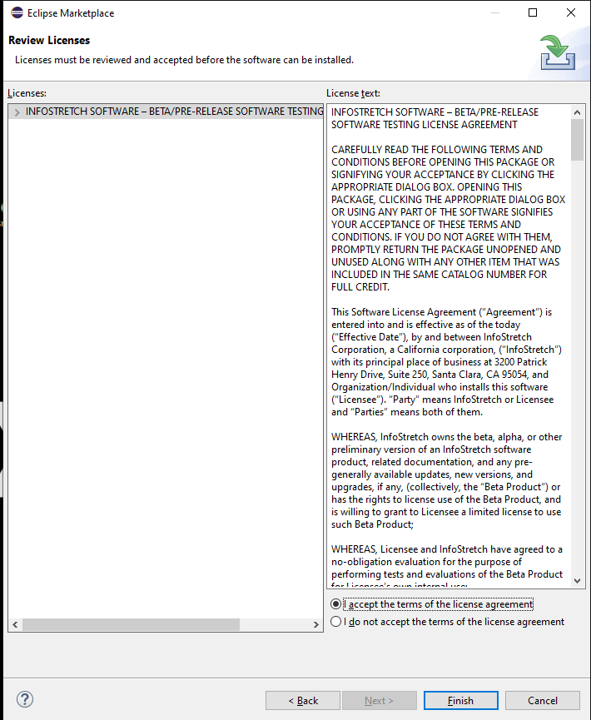

Click on Install anyway

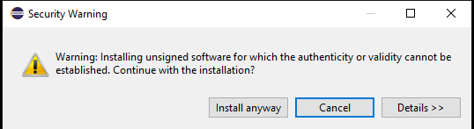

Click on Restart now

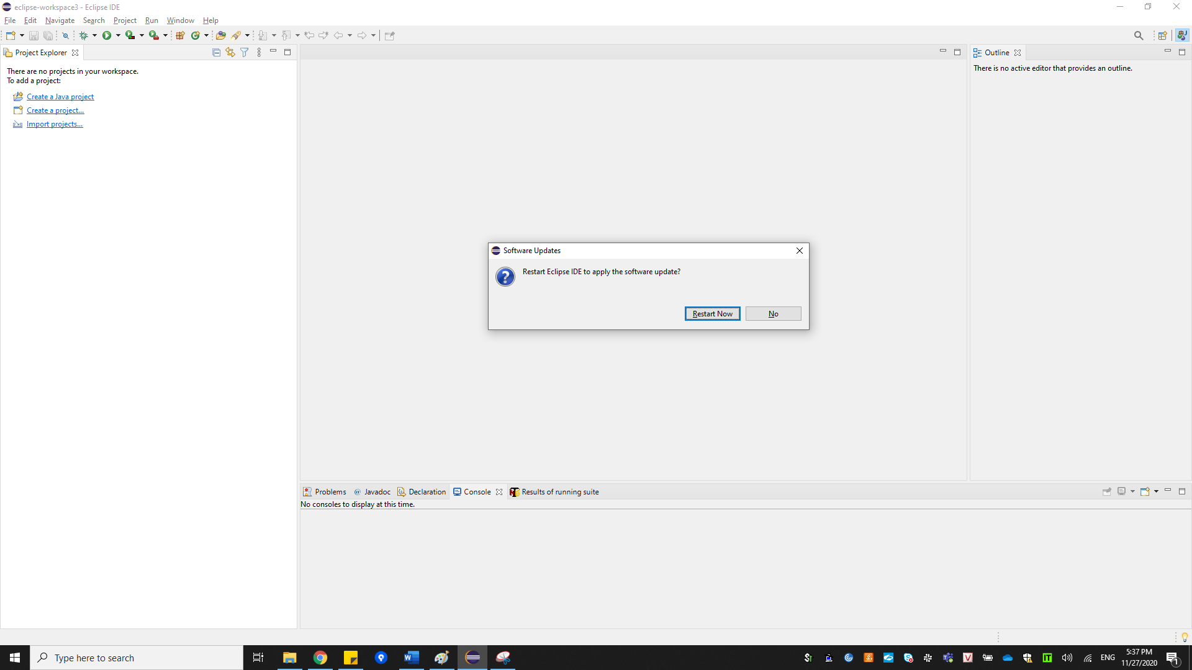

Install TestNG

On the menu bar, click help

Choose **Install new software** option

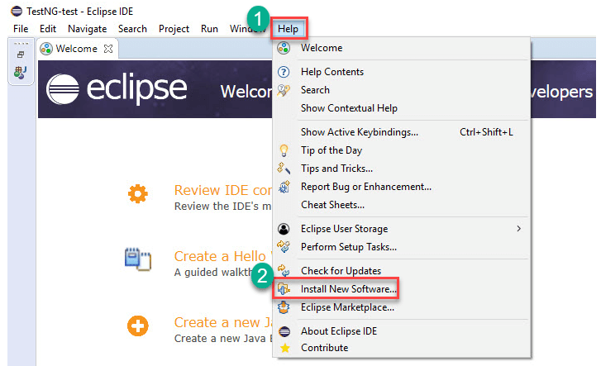

Enter <https://dl.bintray.com/testng-team/testng-eclipse-release/6.10.0/> in the Work with box

Click the **Add button**

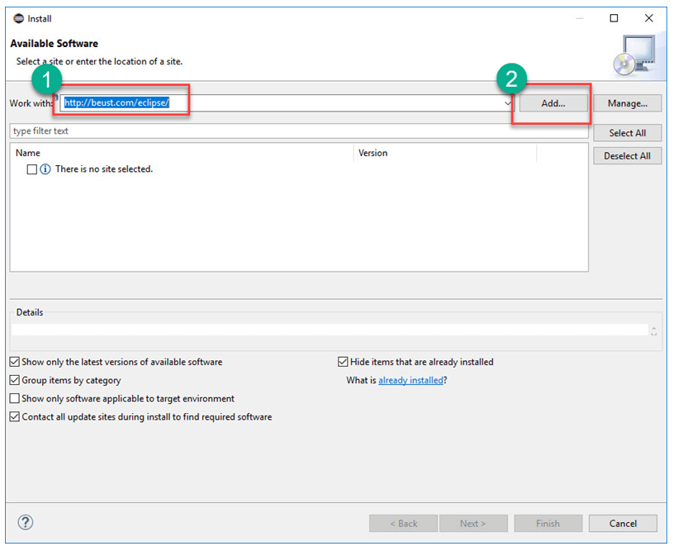

Enter **TestNG** in Name Text Filed

Click on Add button

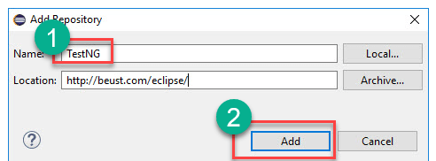

Select the **TestNG** checkbox

Click on button Next

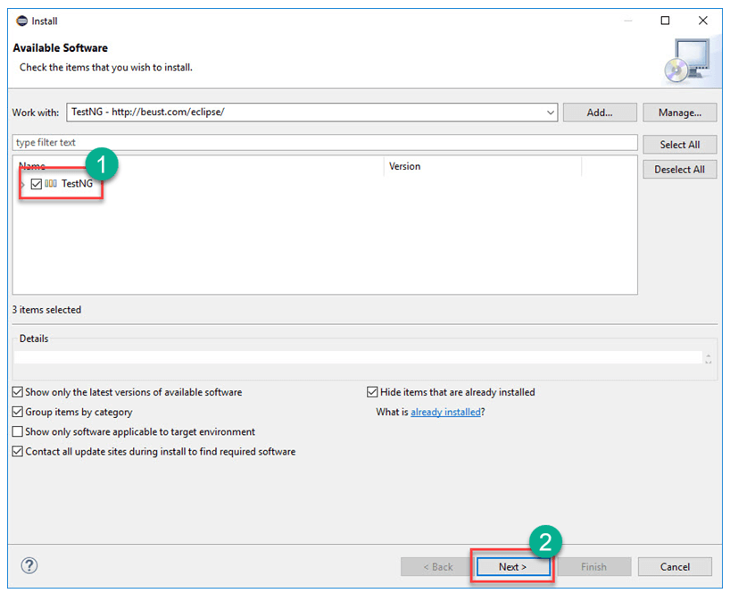

It will give you review of items to be installed

Click on button Next

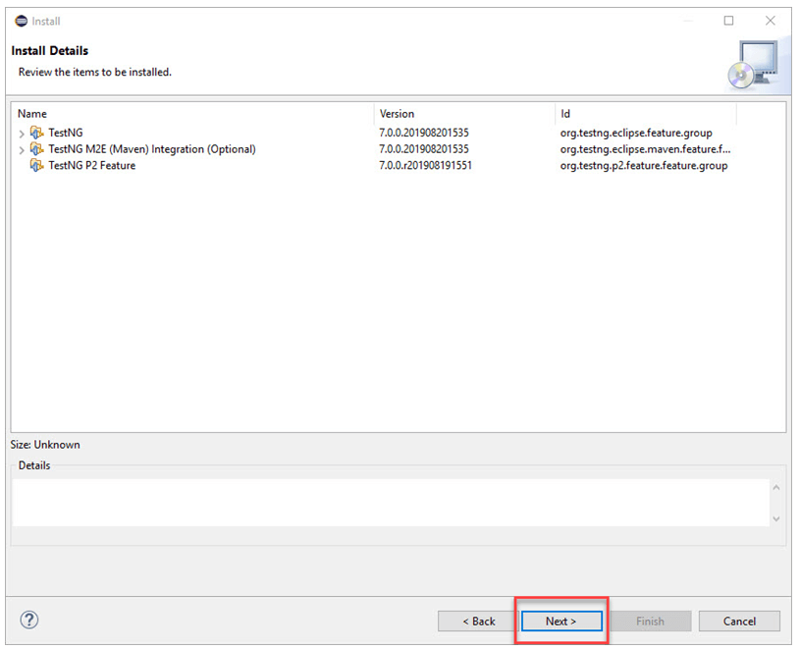

Select the radio button I accept the terms of the license agreement and click on finish 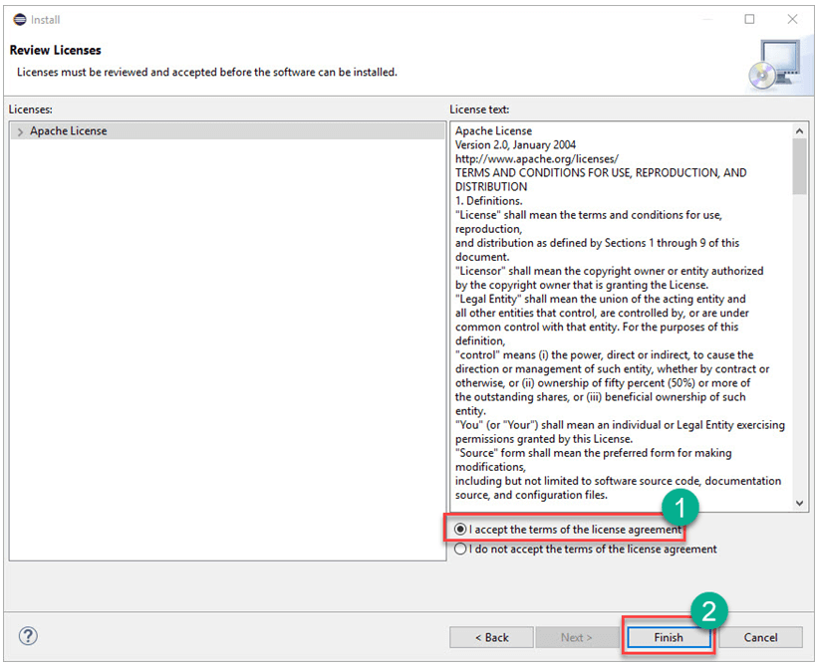

Click on Install anyway



Click on Restart Now 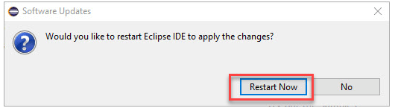

  After the restart, verify if TestNG was indeed successfully installed. Click Window > Show View > Other.

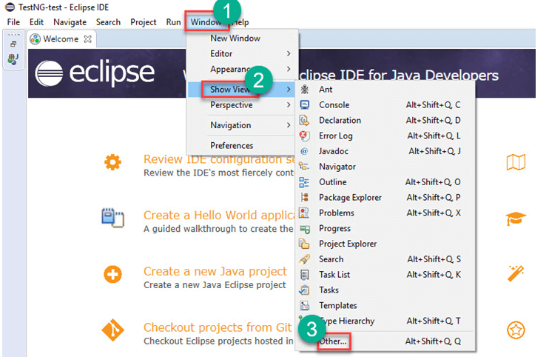

Then open the Java directory and see if TestNG is included.

