INSTRUCTIONS
Please read the instructions carefully before doing the questions.
- You can use materials in your computer, notebook and text book.
- You are NOT allowed to use any device to share data with others.
Beside the above conditions, students must follow the following requirements:
- The work must complete by using Visual Studio 2022++
- The Framework must be .NET 6.0
- THIS PART IS VERY IMPORTANT, PLEASE READ IT CAREFULLY AND FOLLOW THE INSTRUCTIONS.
- You are given a database script (.sql file) in Zip file. Execute the script before doing questions.
- You must use the given solution.
- You are not allowed to add any libraries via NuGet Package Manager during the exam.
- Just one of above requirements is violated, your work will be considered as invalid.
On completion, submit the whole solution folder.
Before submitting, you can delete the folder [bin] in each project to reduce the size of the solution, to fit the requirements of PEA_Client.

Use the following database diagram for doing this exam.
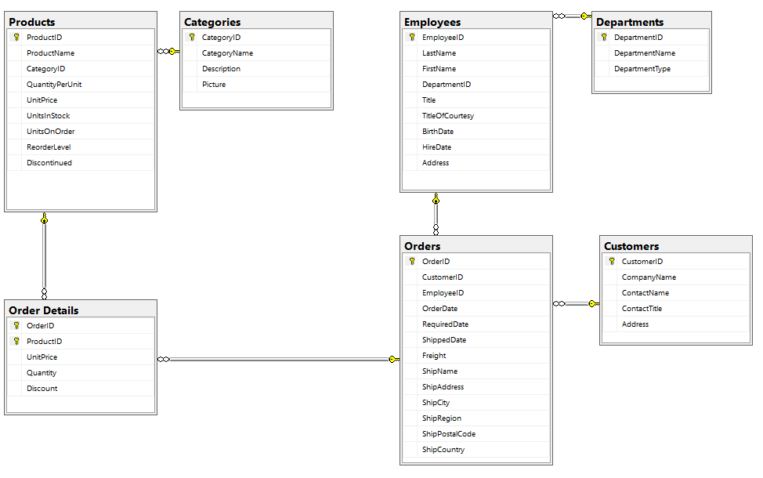
Question 1. (5 points)
In this question, you are asked to write an application that provide some API to manage orders and customers.
Note: 0 will be given to the work that
- not using database connection string in the file appsettings.json
- do not config for testing by Swagger using the root path http://localhost:5000

You are asked to build three APIs, as following:
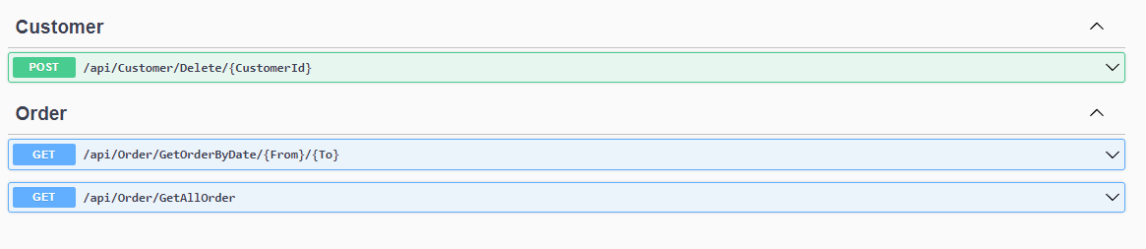
Figure 1 - Required APIs.
1.1 (1.5 point)
The API at url /api/order/getallorder return information of all orders in database, using GET method. Each order requires the information shown in Figure 2. Note that:
- [CustomerName] is attribute [CompanyName] in table [Customer]
- [EmployeeName] is the concatenation of attributes [FirstName] and [LastName] in table [Employee])
- [EmployeeDepartmentId] is the DepartmentId of the department of employee.
- [EmployeeDepartmentName] is the DepartmentName of the department of employee.
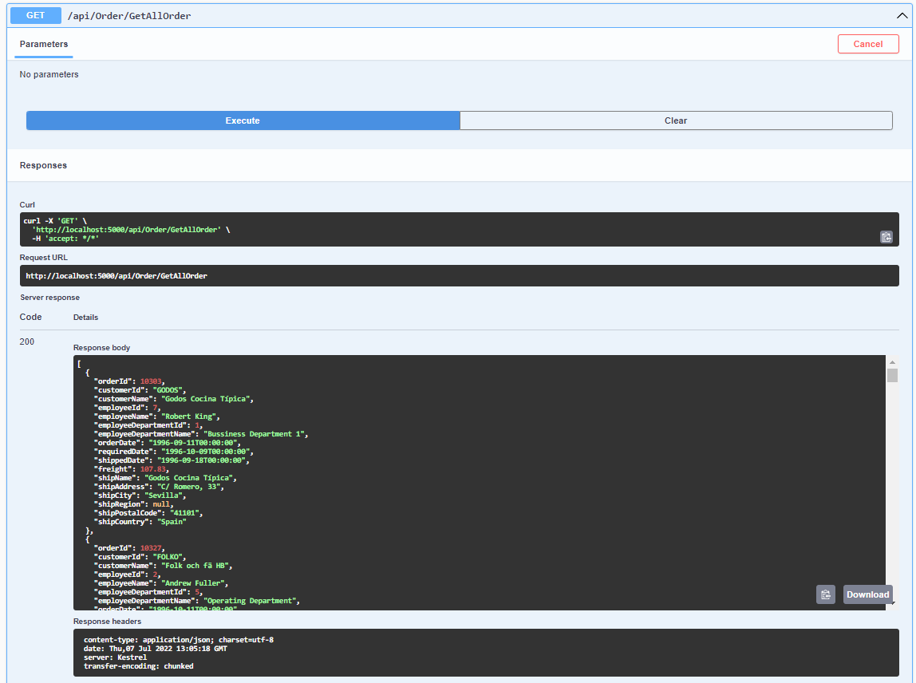
Figure 2 – The result of API at /api/order/getallorder (using method GET)

1.2 (1.5 point)
The API at url /api/order/getorderbydate/{From}/{To}:
- Receives two date strings {From} and {To}.
- using GET method.
- Returns all orders with OrderDate between {From} and {To}. The information of each order is the same as in the question part 1.1. See Figure 3 for more detail.
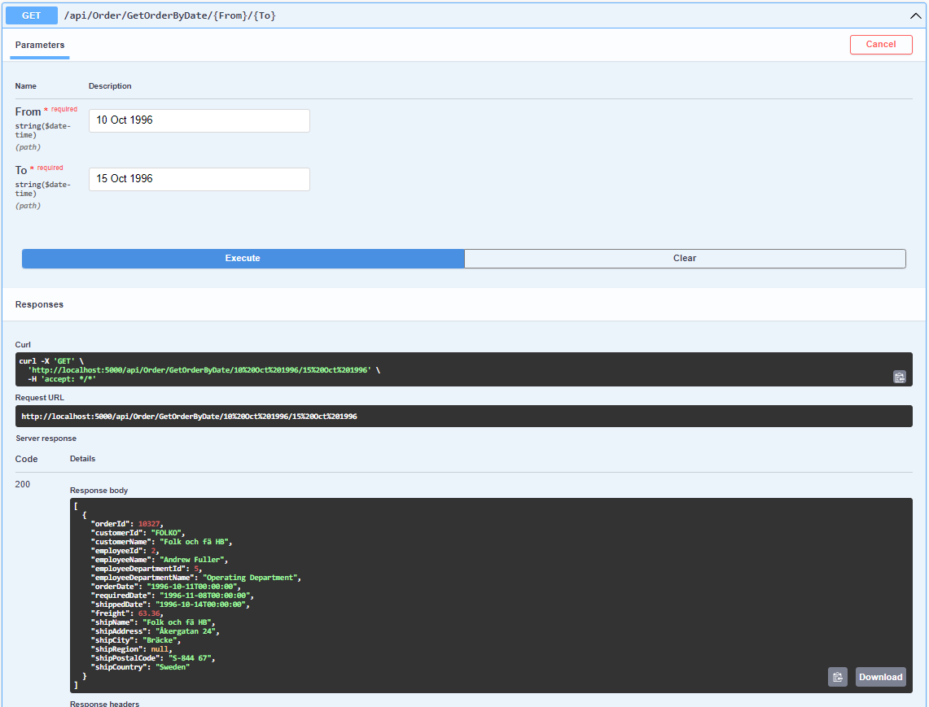
Figure 3 - The result of API at /api/order/getorderbydate/{From}/{To} (using method GET)
1.3 (2 point)
The API at url /api/customer/delete/{CustomerId}:
- Receives the string that is {CustomerId}.
- using POST method.
- This API deletes the customer that has {CustomerId} and all related information in the database and returns:
  - NotFound() if no customer has {CustomerId}.
  - The number of customers, orders, order details are deleted. Note that, between tables Customer, Order, Order Details have foreign key constraint.
  - Conflict() with message “There was an unknown error when performing data deletion.” if any exception occurs during data deletion.
See Figure 4, 5, 6 for more detail.
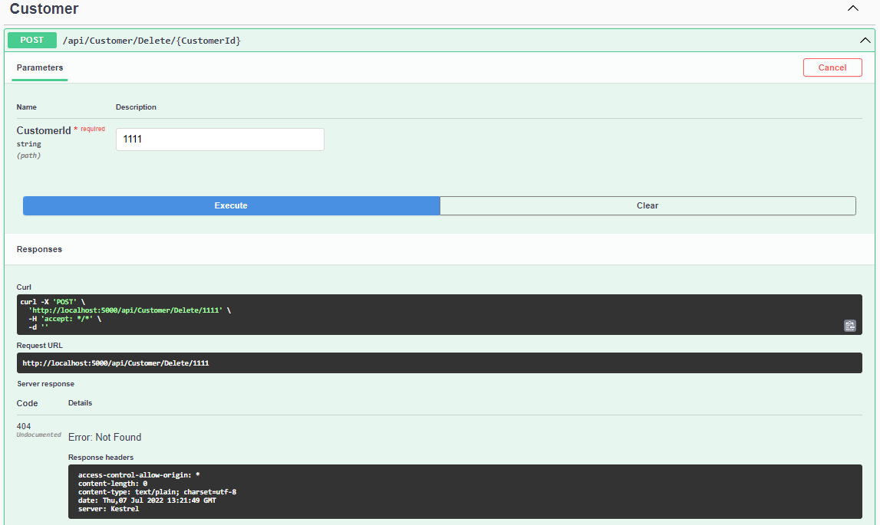
Figure 4 – The result of api at /api/customer/delete/{CustomerId} when customer not found by request CustomerId.
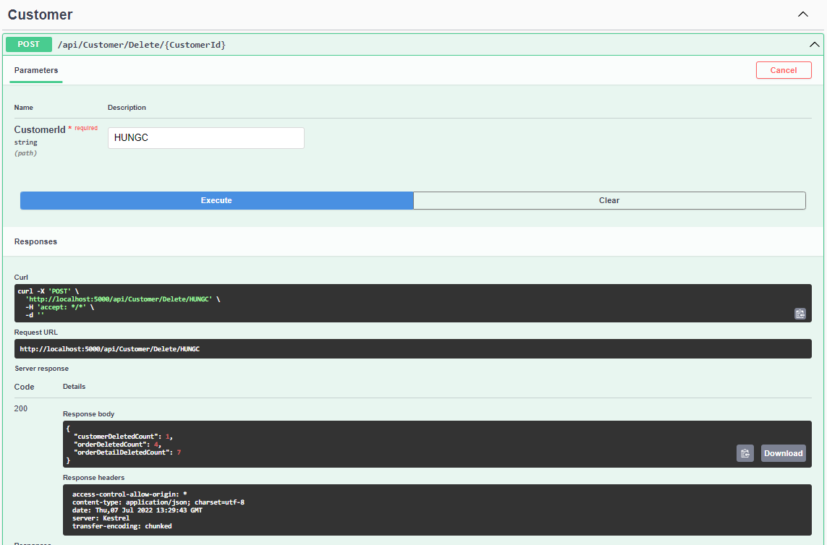
Figure 5 – The result of api at /api/customer/delete/{CustomerId} in normal case.
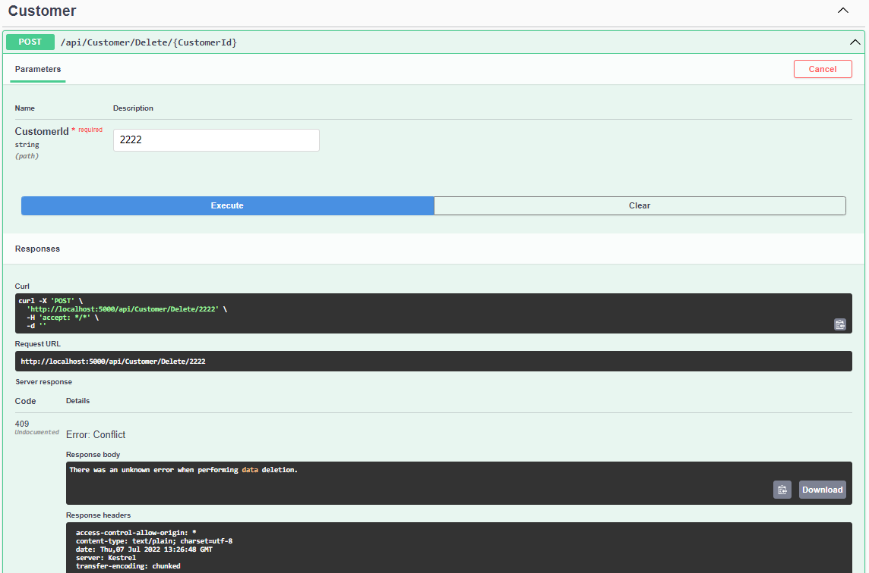
Figure 6 – The result of api at /api/customer/delete/{CustomerId} when the database server is in stopped state.

Question 2. (5 points)
In this question, you are asked to write a web site that using APIs of Question 1 to manage orders and customers.
Note that: using the root path http://localhost:5000 to call APIs.
You are asked to create the file orders.html in folder Pages of the given project, using bootstrap, jquery and ajax to display all orders, search orders by order’s date and delete customer of the order.
(Do not worry about the context path of this html file, the grader will open this file directly from Windows Explorer.)
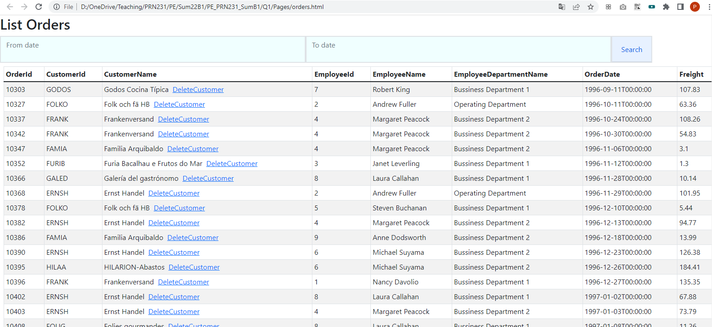
Figure 1 – The page orders.html when first loaded.
2.1 (1.5 points) when user open orders.html for the first time, load all orders from database like Figure 1.
2.2 (1.5 points) user can use two inputs [From date] and [To date] and button Search, to search orders that has OrderDate between [From date] and [To date]. List of orders will be reloaded.
2.3 (2 points) if user click on the link [DeleteCustomer], delete the corresponding customer and all related information. After that, show the message to notify and reload list of orders (all remaining orders in the database). See Figure 2.
Figure 2 – The page after the customer “Godos Cocina Típica” is deleted.

