UART

Khung truyền

9 bits word length, 1 start bit, 1 stop bit

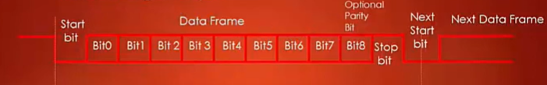

8 bits word length, 1 start bit, 1 stop bit (thường sử dụng)

