Department of Computer Technology

Vision of the Department
To be a well-known centre for pursuing computer education through innovative pedagogy, value-based education and industry collaboration.

Mission of the Department
To establish learning ambience for ushering in computer engineering professionals in core and multidisciplinary area by developing Problem- solving skills through emerging technologies.

Session 2025-2026

Vision: Dream of where you want. | Mission: Means to achieve Vision
Program Educational Objectives of the program (PEO): (broad statements that describe the professional and career accomplishments)
PEO1 | Preparation | P: Preparation | Pep-CL abbreviation pronounce as Pep-si-lL easy to recall
PEO2 | Core Competence | E: Environment (Learning Environment) | Pep-CL abbreviation pronounce as Pep-si-lL easy to recall
PEO3 | Breadth | P: Professionalism | Pep-CL abbreviation pronounce as Pep-si-lL easy to recall
PEO4 | Professionalism | C: Core Competence | Pep-CL abbreviation pronounce as Pep-si-lL easy to recall
PEO5 | Learning Environment | L: Breadth (Learning in diverse areas) | Pep-CL abbreviation pronounce as Pep-si-lL easy to recall

Program Outcomes (PO): (statements that describe what a student should be able to do and know by the end of a program)

Keywords of POs:

Engineering knowledge, Problem analysis, Design/development of solutions, Conduct Investigations of Complex Problems, Engineering Tool Usage, The Engineer and The World, Ethics, Individual and Collaborative Team work, Communication, Project Management and Finance, Life-Long Learning
PSO Keywords: Cutting edge technologies, Research

“I am an engineer, and I know how to apply engineering knowledge to investigate, analyse and design solutions to complex problems using tools for entire world following all ethics in a collaborative way with proper management skills throughout my life.” to contribute to the development of cutting-edge technologies and Research.

Integrity: I will adhere to the Laboratory Code of Conduct and ethics in its entirety.

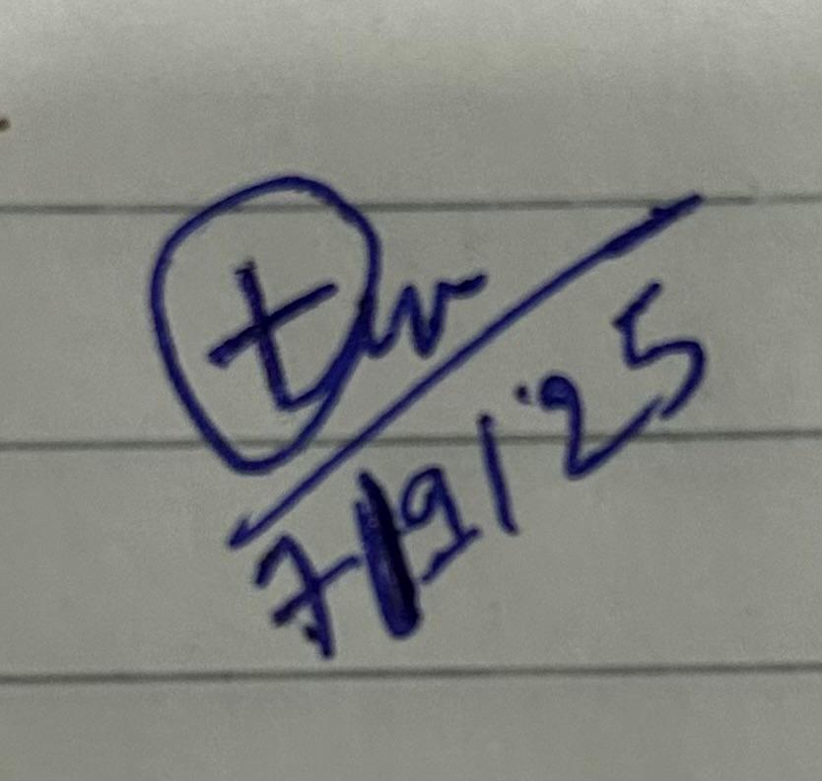

Parth Ubgade

Name and Signature of Student and Date
(Signature and Date in Handwritten)

Department of Computer Technology

Vision of the Department
To be a well-known centre for pursuing computer education through innovative pedagogy, value-based education and industry collaboration.

Mission of the Department
To establish learning ambience for ushering in computer engineering professionals in core and multidisciplinary area by developing Problem- solving skills through emerging technologies.

Session | 2024-25 (ODD) |  | Course Name | Lab: Java stack
Semester | 5 |  | Course Code | 23CT1506
Roll No | 77 |  | Name of Student | Trupal Tagade
Practical Number |  | 1
Course Outcome |  | Develop backend applications using object-oriented programming concepts and implement data persistence using relational databases.
Aim |  | Implement basic Java programs (loops, conditionals, arrays)
Problem Definition |  | - Problem Statement: Lottery  Develop a program to play lottery.the program randomly generates a lottery of a two-digit  number,prompts the user to enter a two-digit number, and determines whether the user wins  according to the following rules:  - If the user input matches the lottery number in the exact order, the award is $10,000.  - If all digits in the user input match all digits in the lottery number, the award is $3,000.  - If one digit in the user input matches a digit in the lottery number ,the award is $1,000.  2.Problem Statement: Computing Body Mass Index  Write a program that promts the user to enter a weight in pounds and height in inches and displays  the BMI.  * One pound is 0.45359237 kilograms, one inch is 0.0254 meters.  - It can be calculated by taking your weight in kilograms and dividing it by the square of your height  in meters.  - The interpretation of BMI for people 20 years or older is as follows:  BMI Interpretation  BMI<18.5 Underweight  18.5<=BMI<25.0 Normal  25.0<=BMI<30.0 Overweight 30.0<=BMI Obese
Theory  (100 words) |  | An array in Java is a fixed-size data structure used to store multiple values of the same data type in a single variable. Each element in an

Department of Computer Technology

Vision of the Department
To be a well-known centre for pursuing computer education through innovative pedagogy, value-based education and industry collaboration.

Mission of the Department
To establish learning ambience for ushering in computer engineering professionals in core and multidisciplinary area by developing Problem- solving skills through emerging technologies.

array is accessed by its index, starting from zero. Arrays are static, meaning their size is set when they are created and cannot be changed later. They provide efficient access and are commonly used to store and process collections of data. Arrays can hold both primitive and object types and are essential for organizing and managing multiple related values.
Loops in Java are control structures that allow repeating a block of code multiple times based on a condition. They help automate repetitive tasks efficiently. Java mainly provides three types of loops: for, while, and do-while. A for loop is used when the number of iterations is known, while while and do-while loops run based on a condition that may depend on dynamic factors. Loops improve code readability and reduce redundancy by handling repetitive operations.
Conditionals in Java control the flow of a program by executing different blocks of code based on boolean conditions. The main conditional statements are if, if-else, and switch. They evaluate expressions that result in true or false, allowing the program to make decisions and respond accordingly. Conditionals are essential for implementing logic, handling different scenarios, and controlling how a
program behaves under various inputs or states.
Procedure and Execution  (100 Words) | Algorithm:  - Problem Statement: Lottery  - Start  - Generate a random two-digit lottery number  - Prompt the user to enter a two-digit number (their lottery choice)  - Read the user's input using Scanner  - Extract digits of both:  - Lottery number → lotteryDigit1, lotteryDigit2  - User's choice → choiceDigit1, choiceDigit2  - Display the generated lottery number  - Compare the user's input with the lottery number:  - If the numbers match exactly  → Print "YOU WIN $10,000"

Department of Computer Technology

Vision of the Department
To be a well-known centre for pursuing computer education through innovative pedagogy, value-based education and industry collaboration.

Mission of the Department
To establish learning ambience for ushering in computer engineering professionals in core and multidisciplinary area by developing Problem- solving skills through emerging technologies.

- Else if the digits match but in reverse order →
Print "YOU WIN $3,000"

- Else if any one digit matches → Print "YOU WIN $1,000"
- Else
→ Print "Sorry no match, Better luck next time!"
- Close the Scanner
- End
- Problem Statement: Computing Body Mass Index
1: Start
2: Create a Scanner object to read input from the user. 3: Prompt the user to enter weight in pounds.
4: Prompt the user to enter height in inches. 5: Convert weight to kilograms
6: Convert height to meters
7: Calculate BMI using the formula:
8: Display the BMI value (rounded to two decimal places) 9: Use conditional logic to interpret the BMI:
  - If BMI < 18.5, print "Underweight"
  - Else if BMI < 25.0, print "Normal"
  - Else if BMI < 30.0, print "Overweight"

Department of Computer Technology

Vision of the Department
To be a well-known centre for pursuing computer education through innovative pedagogy, value-based education and industry collaboration.

Mission of the Department
To establish learning ambience for ushering in computer engineering professionals in core and multidisciplinary area by developing Problem- solving skills through emerging technologies.

- Else, print "Obese"

10: Close the Scanner. 11: End
Code:
1.Problem Statement: Lottery
import java.util.Scanner;

public class Lottery{
public static void main(String[] args) { int lottery=(int)(Math.random()*90+10);
Scanner sc = new Scanner(System.in);
System.out.println("Enter your lucky choice two-digit no. for lottery");
int choice = sc.nextInt();
int lotteryDigit1 = lottery/10; int lotteryDigit2 = lottery%10;
int choiceDigit1 = choice/10; int choiceDigit2 = choice%10;
System.out.println("lottery no. is "+
lottery);

if(choice == lottery){
System.out.println("the lottery number in the exact order(match)!!! \n YOU WIN $10,000");
}
else if(choiceDigit1 == lotteryDigit2 && choiceDigit2 == lotteryDigit1){
System.out.println("Match all Digit!!! \n YOU WIN $3,000");
}
else if(choiceDigit1 == lotteryDigit1 || choiceDigit1 == lotteryDigit2 || choiceDigit2 == lotteryDigit1 || choiceDigit2 == lotteryDigit2){
System.out.println("Match one Digit!!! \n YOU WIN $1,000");
}
else{
System.out.println("Sorry no Match, Better Luck next time!!!");
}
sc.close();

Department of Computer Technology

Vision of the Department
To be a well-known centre for pursuing computer education through innovative pedagogy, value-based education and industry collaboration.

Mission of the Department
To establish learning ambience for ushering in computer engineering professionals in core and multidisciplinary area by developing Problem- solving skills through emerging technologies.

}
}
2.Problem Statement: Computing Body Mass Index
import java.util.Scanner;
public class BMICalculator {
public static void main(String[] args) { Scanner sc = new Scanner(System.in);
System.out.print("Enter your weight in pounds: ");
double weightInPounds = sc.nextDouble();
System.out.print("Enter your height in inches: ");
double heightInInches = sc.nextDouble();
double weightInKg = weightInPounds * 0.45359237;
double heightInMeters = heightInInches *
0.0254;
double bmi = weightInKg / (heightInMeters * heightInMeters);
System.out.printf("Your BMI is: %.2f\n",
bmi);
if (bmi < 18.5) { System.out.println("Interpretation:
Underweight");
} else if (bmi < 25.0) { System.out.println("Interpretation:
Normal");
} else if (bmi < 30.0) { System.out.println("Interpretation:
Overweight");
} else {
System.out.println("Interpretation:
Obese");
}
sc.close();
}
}

Department of Computer Technology

Vision of the Department
To be a well-known centre for pursuing computer education through innovative pedagogy, value-based education and industry collaboration.

Mission of the Department
To establish learning ambience for ushering in computer engineering professionals in core and multidisciplinary area by developing Problem- solving skills through emerging technologies.

Output:
- Problem Statement: Lotter
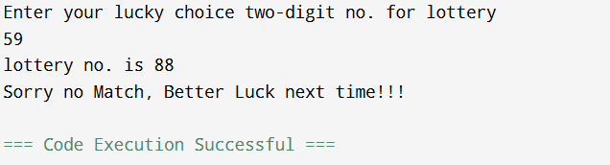

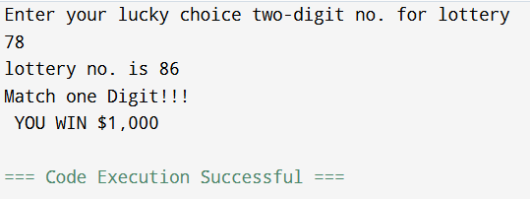
- Problem Statement: Computing Body Mass Index

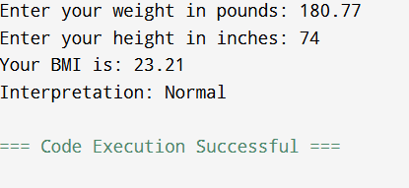

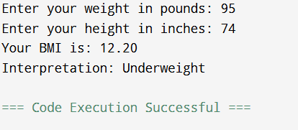

Department of Computer Technology

Vision of the Department
To be a well-known centre for pursuing computer education through innovative pedagogy, value-based education and industry collaboration.

Mission of the Department
To establish learning ambience for ushering in computer engineering professionals in core and multidisciplinary area by developing Problem- solving skills through emerging technologies.

 | 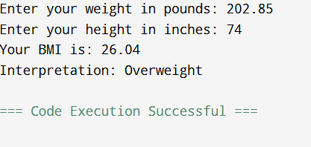
Output Analysis | - Problem Statement: Lotter  Input: User enters a two-digit number.  Output: Compares with a random lottery number.  Possible Outputs:  Exact match → YOU WIN $10,000  All digits match (reverse order) → YOU WIN $3,000  One digit matches → YOU WIN $1,000 No match → Better luck next time  - Problem Statement: Computing Body Mass Index Input: User enters weight (pounds) and height (inches).  Output: Displays BMI and health category.  Possible Outputs:  BMI < 18.5 → Underweight BMI 18.5–24.9 → Normal  BMI 25–29.9 → Overweight BMI ≥ 30 → Obese
Link of student Github profile where lab assignment has been  uploaded | https://github.com/trupaltag2005/JFSD.git
Conclusion | Successfully implemented the both problem statement, learn  about concept of some Java like loops, conditionals, arrays.

Department of Computer Technology

Vision of the Department
To be a well-known centre for pursuing computer education through innovative pedagogy, value-based education and industry collaboration.

Mission of the Department
To establish learning ambience for ushering in computer engineering professionals in core and multidisciplinary area by developing Problem- solving skills through emerging technologies.

Plag Report (Similarity index < 12%) | 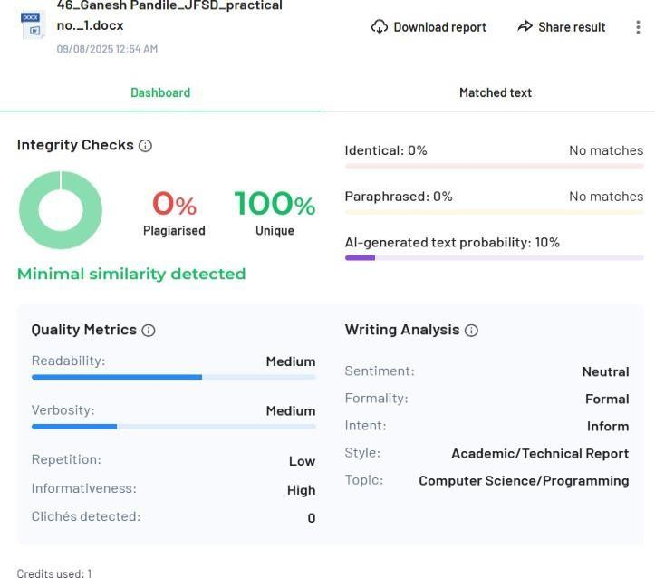
Date | 07/09/2025

