Session 2025-2026

Vision: Dream of where you want. | Mission: Means to achieve Vision

Program Educational Objectives of the program (PEO): (broad statements that describe the professional and career accomplishments)
PEO1 | Preparation | P: Preparation | Pep-CL abbreviation  pronounce as Pep-si-lL easy to recall
PEO2 | Core Competence | E: Environment (Learning Environment) | Pep-CL abbreviation  pronounce as Pep-si-lL easy to recall
PEO3 | Breadth | P: Professionalism | Pep-CL abbreviation  pronounce as Pep-si-lL easy to recall
PEO4 | Professionalism | C: Core Competence | Pep-CL abbreviation  pronounce as Pep-si-lL easy to recall
PEO5 | Learning Environment | L: Breadth (Learning in diverse areas) | Pep-CL abbreviation  pronounce as Pep-si-lL easy to recall

Program Outcomes (PO): (statements that describe what a student should be able to do and know by the end of a program)
Keywords of POs:
Engineering knowledge, Problem analysis, Design/development of solutions, Conduct Investigations of Complex Problems, Engineering Tool Usage, The Engineer and The World, Ethics, Individual and Collaborative Team work, Communication, Project Management and Finance, Life-Long Learning

PSO Keywords: Cutting edge technologies, Research

“I am an engineer, and I know how to apply engineering knowledge to investigate, analyse and design solutions to complex problems using tools for entire world following all ethics in a collaborative way with proper management skills throughout my life.” to contribute to the development of cutting-edge technologies and Research.

Integrity: I will adhere to the Laboratory Code of Conduct and ethics in its entirety.

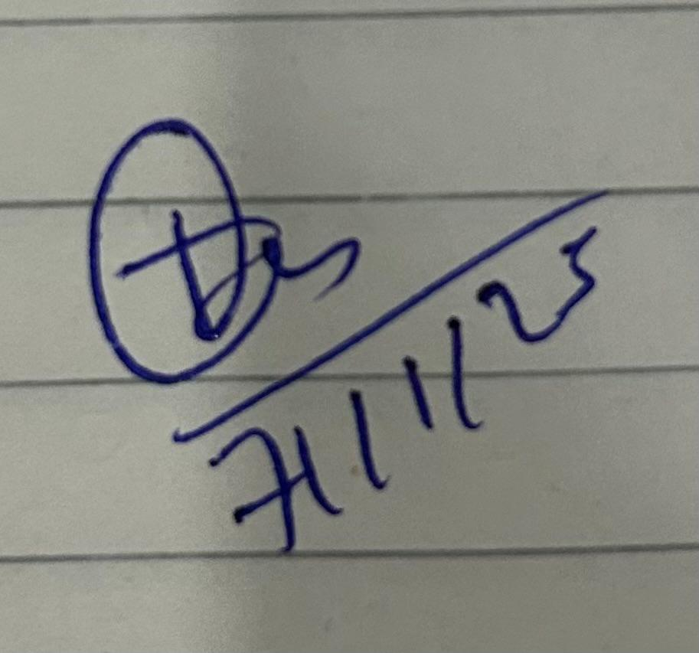
Trupal Sunil Tagade
Name and Signature of Student and Date
(Signature and Date in Handwritten)

Session | 2025-26 (ODD) |  | Course Name | Java Lab
Semester | 5 |  | Course Code | 23CT1506
Roll No | 77 |  | Name of Student | Trupal Tagade
Practical Number |  | 4
Course Outcome |  | Students will be able to apply file handling concepts in Java to read, write, append, and manage data efficiently using different stream classes and collections.
Aim |  | Practical based on file handling.
Problem Definition |  | 1. Write a Java program to append text/ string  in a given file.  2. Write a Java program to determine number  of bytes written to file using DataOutputStream.  3.Write a Java program to read content from one  file and write it into another file.  4. Write a Java program to get the  attributes of file.  5. read this file and transfer its content  in the collection. display the to name of students along with the addition of  marks in the three subjects.
Theory  (100 words) |  | File Handling:  File handling in Java allows programs to store, access, and modify data permanently on disk rather than only in memory. It is an essential concept for data persistence and input/output operations.  Java provides several classes in the java.io package to perform file operations such as reading, writing, and updating files.  Key Concepts:  - File Class: Used to get file information like name, size, path, and permissions.  - FileReader & FileWriter: Handle character-based file reading and writing.  - BufferedReader & BufferedWriter: Improve efficiency by reading/writing data in chunks.  - DataInputStream & DataOutputStream: Used for handling primitive data types in binary format.  - Collections (like ArrayList): Help store and manipulate data read from files in memory for processing.  Overall, Java file handling enables smooth interaction between a program and the file system, allowing creation, modification, and retrieval of data for real-world applications.
Procedure and Execution  (100 Words) |  | Algorithm:  P 1:  - Start the program and import java.io.*.  - Create a FileWriter object with the filename and append mode set to true.  - Define a string message to append.  - Use the write() method to add text to the file.  - Close the writer using close() to save changes.  - Display a success message after completion.  - Handle exceptions using try–catch to avoid runtime errors.  - Stop execution.  P2:  - Begin the program and import necessary classes from java.io.  - Create a FileOutputStream object linked to a target file.  - Wrap it with a DataOutputStream for binary writing.  - Define the data (string) to be written into the file.  - Convert the string into a byte array using getBytes().  - Write bytes using write() and store their count.  - Display the total number of bytes written.  - Close the stream and end the program safely.  P3:  - Start and import java.io.*.  - Open FileInputStream for the source file (input.txt).  - Open FileOutputStream for the destination file (output.txt).  - Read bytes from input file one by one using read().  - Write each byte into the output file using write().  - Continue until the end of the source file (-1 returned).  - Close both streams properly to prevent data loss.  - Print confirmation that the file has been copied.  P4:  - Start the program and import java.io.File.  - Create a File object with the path of the target file.  - Check if the file exists using exists().  - Retrieve file details using methods like getName(), getPath(), and length().  - Display permissions using canRead() and canWrite().  - Get modification time using lastModified().  - Print all gathered details in a readable format.  - End the program gracefully.  P5:  - Start program and import required classes (BufferedReader, FileReader, etc.).  - Create a BufferedReader to read lines from student.csv.  - Skip the first line (header).  - Read each remaining line and split it using the tab or comma delimiter.  - Extract Name, Maths, Physics, and Chemistry values.  - Convert marks to integers and calculate total.  - Store each student’s data in a list or collection.  - After reading all lines, display student names with their total marks.  - Close the file and terminate execution.
Code 1 :
import java.io.*;

public class Pract1 {
public static void main(String[] args) {
String fileName = "output.txt";
String textToAdd = "This line is newly appended to the file.\n";
try (FileWriter fw = new FileWriter(fileName, true);
BufferedWriter bw = new BufferedWriter(fw)) {

bw.write(textToAdd);
System.out.println("Text successfully appended to " + fileName);

} catch (IOException e) {
System.out.println(“ Error: " + e.getMessage());
}
}
}

Code 2:

import java.io.DataOutputStream;
import java.io.FileOutputStream;
import java.io.IOException;

public class ByteCount {
public static void main(String[] args) {
String fileName = "bytes.txt";
String data = "Java File Handling Example";

try (DataOutputStream dos = new DataOutputStream(new FileOutputStream(fileName))) {
byte[] bytes = data.getBytes();
dos.write(bytes);
System.out.println(" " + bytes.length + " bytes written to " + fileName);
} catch (IOException e) {
System.out.println("Error: " + e.getMessage());
}
}
}

Code 3:

import java.io.FileInputStream;
import java.io.FileOutputStream;
import java.io.IOException;

public class pract3 {
public static void main(String[] args) {
try (FileInputStream fin = new FileInputStream("input.txt");
FileOutputStream fout = new FileOutputStream("output.txt")) {

int c;
while ((c = fin.read()) != -1) {
fout.write(c);
}
System.out.println(" File copied successfully!");
} catch (IOException e) {
System.out.println("Error: " + e.getMessage());
}
}
}

Code 4:

import java.io.File;

public class FileAttributes {
public static void main(String[] args) {
File file = new File("sample.txt");

if (file.exists()) {
System.out.println(" File Name: " + file.getName());
System.out.println(" Path: " + file.getAbsolutePath());
System.out.println(" Size: " + file.length() + " bytes");
System.out.println(" Last Modified: " + file.lastModified());
System.out.println(" Writable: " + file.canWrite());
System.out.println(" Readable: " + file.canRead());
} else {
System.out.println("File does not exist!");
}
}
}

Code 5:

import java.io.BufferedReader;
import java.io.FileReader;
import java.io.IOException;
import java.util.ArrayList;

class Student {
String name;
int maths, physics, chemistry;

Student(String name, int maths, int physics, int chemistry) {
this.name = name;
this.maths = maths;
this.physics = physics;
this.chemistry = chemistry;
}

int totalMarks() {
return maths + physics + chemistry;
}
}

public class StudentMarks {
public static void main(String[] args) {
String fileName = "student.csv";
ArrayList<Student> students = new ArrayList<>();

try (BufferedReader br = new BufferedReader(new FileReader(fileName))) {
String line;
br.readLine(); // skip header

while ((line = br.readLine()) != null) {
// Debugging: show each line read
System.out.println("Reading: " + line);

// Use regex that matches comma, tab, or multiple spaces
String[] data = line.trim().split("[,\\t ]+");

// Print column count for debugging
System.out.println("Columns: " + data.length);

if (data.length >= 8) {
String name = data[1];
int maths = Integer.parseInt(data[5]);
int physics = Integer.parseInt(data[6]);
int chemistry = Integer.parseInt(data[7]);
students.add(new Student(name, maths, physics, chemistry));
} else {
System.out.println(" Skipped line (not enough columns)");
}
}
} catch (IOException e) {
System.out.println(" Error reading file: " + e.getMessage());
} catch (NumberFormatException e) {
System.out.println(" Error parsing numbers. Check data format.");
}

System.out.println("\n Student Total Marks:");
for (Student s : students) {
System.out.println(s.name + " → " + s.totalMarks());
}
}
}

Output:

Code 1/output1:

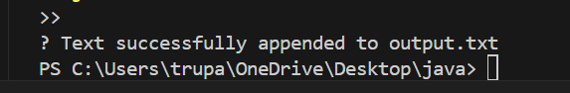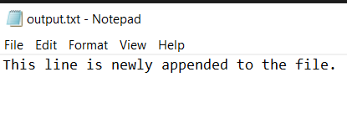

Code 2/Output2:

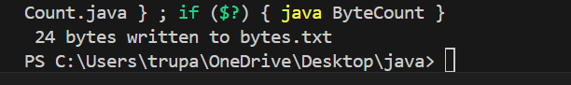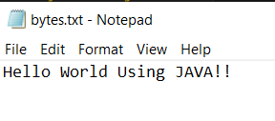

Code3/Output3:

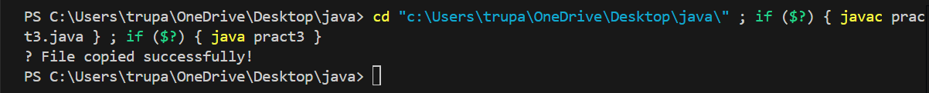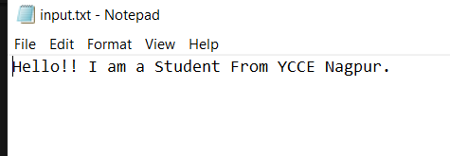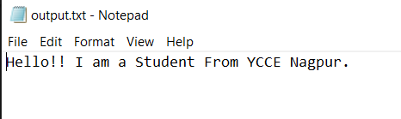

Code 4/output:

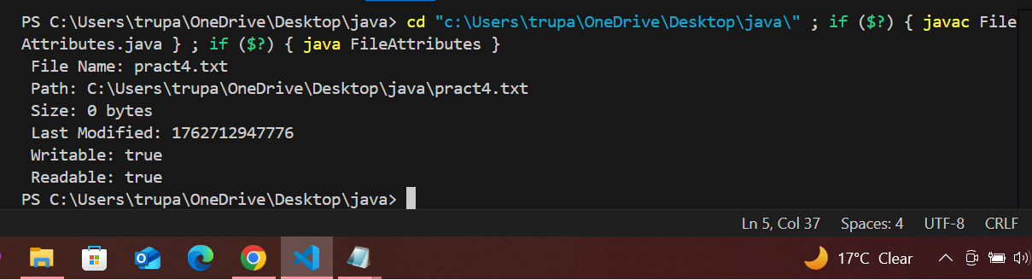

Code 5/output:

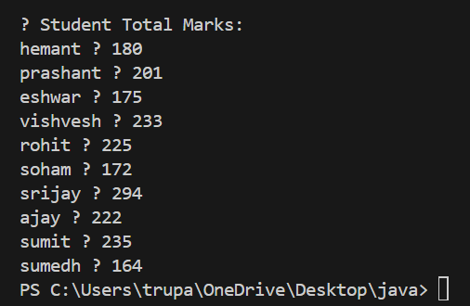

Output Analysis |  | P1:  - The program successfully adds new text at the end of an existing file.  - Confirms the operation by printing a success message.  - If the file doesn’t exist, it creates a new one automatically.  - Demonstrates the use of FileWriter in append mode.  P2:  - Displays the exact number of bytes written to the file.  - Validates data conversion from string to byte format.  - Confirms successful writing operation using console output.  - Helps understand how binary data is handled in file I/O.  P3:  - Copies data from input.txt to output.txt without errors.  - Verifies byte-by-byte reading and writing using streams.  - Output message confirms successful file copy.  - Shows effective use of FileInputStream and FileOutputStream.  P4:  - Displays file details such as name, path, size, and permissions.  - Helps verify if a file exists and is accessible.  - Shows last modified timestamp and file status (read/write).  - Demonstrates the use of File class methods effectively.  P5:  - Reads student data from a .csv file correctly.  - Calculates and displays total marks of each student.  - Handles various separators (tab, space, or comma) safely.  - Demonstrates file reading, data parsing, and collection handling.
Link of student Github profile where lab assignment has been uploaded |  | https://github.com/trupaltag2005/JFSD.git
Conclusion |  | From these programs, we learned how to perform essential file-handling operations such as creating, reading, writing, appending, and retrieving file details using Java I/O classes. These exercises demonstrate the practical use of File, FileWriter, FileInputStream, and DataOutputStream to manage files efficiently and handle data safely.
Plag Report (Similarity index < 12% |  | 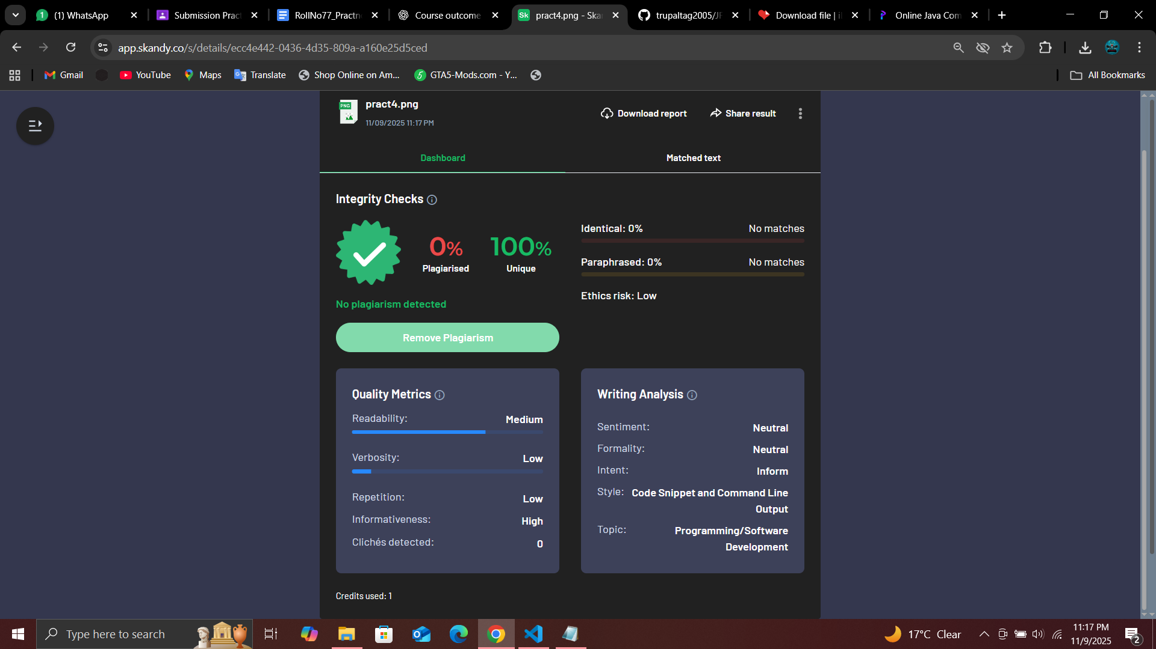
Date |  | 7/11/25

