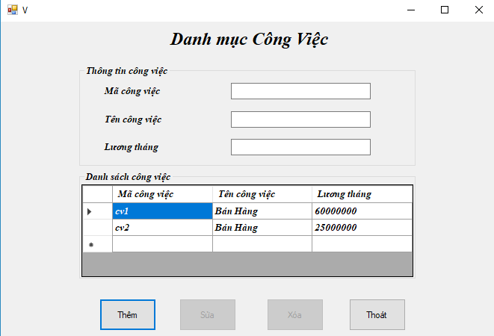**Thêm sửa xóa bình thường**

using System;

using System.Collections.Generic;

using System.ComponentModel;

using System.Data;

using System.Drawing;

using System.Linq;

using System.Text;

using System.Threading.Tasks;

using System.Windows.Forms;

using System.Data.SqlClient;

namespace LTTQ

{

public partial class Form1 : Form

{

public Form1()

{

InitializeComponent();

}

SqlCommand cmd = null;

SqlConnection conn = null;

DataTable dt = null;

SqlDataAdapter da = null;

***************************************************** #region ketnoi

void ketnoi()

{

string s = @"Data Source=VAIO\SQLEXPRESS;Initial Catalog=CongViec;Integrated Security=True";

conn = new SqlConnection(s);

if (conn.State == ConnectionState.Open)

conn.Close();

conn.Open();

}

********************************************************* #endregion

#region loaddata

void loaddata()

{

string s = "select * from CongViec";

cmd = new SqlCommand(s,conn);

da = new SqlDataAdapter(cmd);

dt = new DataTable();

da.Fill(dt);

dataGridView1.DataSource = dt;

}

**\*\*\*\*\*\*\*\*\*\*\*\*\*\*\*\*\*\*\*\*\*\*\*\*\*\*\*\*\*\*\*\*\*\*\*\*\*\*\*\*\*\*\*\*\*\*\*\*\*\*\*\*\*\*\*\*\*\*\*\*** #endregion

#region them

private void button2_Click(object sender, EventArgs e)

{

ketnoi();

if (txtmacong.Text == string.Empty || txttencv.Text == string.Empty || txtluong.Text == string.Empty)

// string.empty cũng giống “ ” kiểm tra chuỗi rỗng null : chưa trỏ đến vùng nhớ nào hết. Con trỏ này chưa được khởi tạo.  
"" : đã trỏ đến 1 vùng nhớ, nhưng vùng nhớ này chưa có giá trị gì hết.  
string.empty : tương tự như "", nhưng để tránh các hardcoded string và để cho "" có 1 cái tên rõ ràng, người ta sử dụng string.empty, về bản chất nó chỉ là chuỗi ""

{

MessageBox.Show("Xin Nhập đầy đủ thông tin!","Thông báo?",MessageBoxButtons.YesNo,MessageBoxIcon.Warning);

}

else

{

string s= "select MaCongViec from CongViec where MaCongViec='"+txtmacong.Text+"'";

cmd = new SqlCommand(s,conn);

SqlDataReader r = cmd.ExecuteReader();

if (r.Read())

{

MessageBox.Show("Đã tồn tại mã này, xin nhập lại!", "Thông báo?", MessageBoxButtons.YesNo, MessageBoxIcon.Warning);

}

else

{

r.Close();

cmd.Dispose();

string sql = "insert into CongViec values('"+txtmacong.Text+"',N'"+txttencv.Text+"','"+txtluong.Text+"' )";

cmd = new SqlCommand(sql,conn);

cmd.ExecuteNonQuery();

loaddata();

txtluong.Text = string.Empty;

txttencv.Text = string.Empty;

txtmacong.Text = string.Empty;

btnthem.Enabled = false;

MessageBox.Show("Thêm thành công", "Thông báo?", MessageBoxButtons.YesNo, MessageBoxIcon.Information);

}

}

}

**************************************** #endregion

#region load_form

private void Form1_Load(object sender, EventArgs e)

{

ketnoi();

loaddata();

btnsua.Enabled = false;

btnxoa.Enabled = false;

}

************************************************* #endregion

#region click_show

private void dataGridView1_CellClick(object sender, DataGridViewCellEventArgs e)

{

if (e.RowIndex >= 0)

{

txtmacong.Text = dataGridView1.Rows[e.RowIndex].Cells[0].Value.ToString();

txttencv.Text = dataGridView1.Rows[e.RowIndex].Cells[1].Value.ToString();

txtluong.Text = dataGridView1.Rows[e.RowIndex].Cells[2].Value.ToString();

btnsua.Enabled = true;

btnxoa.Enabled = true;

}

}

************************************************************ #endregion

#region sua

void sua()

{

ketnoi();

string dele = "update CongViec set TenCongViec=N'" + txttencv.Text + "', LuongThang ='" + txtluong.Text + "' where MaCongViec='" + txtmacong.Text + "'";

cmd = new SqlCommand(dele, conn);

cmd.ExecuteNonQuery();

loaddata();

txtluong.Text = string.Empty;

txttencv.Text = string.Empty;

txtmacong.Text = string.Empty;

btnsua.Enabled = false;

btnxoa.Enabled = false;

btnthem.Enabled = true;

MessageBox.Show("Sửa thành công", "Thông báo?", MessageBoxButtons.YesNo, MessageBoxIcon.Information);

}

private void btnsua_Click(object sender, EventArgs e)

{

sua();

}

************************************** #endregion

private void txtluong_KeyPress(object sender, KeyPressEventArgs e)

{

if(!Char.IsDigit(e.KeyChar)&&!Char.IsControl(e.KeyChar))

{

e.Handled= true;

}

}

*********************************** #region xoa

private void btnxoa_Click(object sender, EventArgs e)

{

ketnoi ();

if((MessageBox.Show("Bạn muốn xóa công việc này không?","Thông báo?",MessageBoxButtons.YesNo,MessageBoxIcon.Warning)==DialogResult.Yes))

{

string dele= "delete from CongViec where MaCongViec='"+txtmacong.Text+"'";

cmd =new SqlCommand (dele,conn);

cmd.ExecuteNonQuery();

loaddata();

txtluong.Text = string.Empty;

txttencv.Text = string.Empty;

txtmacong.Text = string.Empty;

btnsua.Enabled = false;

btnxoa.Enabled = false;

btnthem.Enabled = true;

MessageBox.Show("Xóa thành công", "Thông báo?", MessageBoxButtons.YesNo, MessageBoxIcon.Information);

}

}

*********************************************************** #endregion

private void btnThoat_Click(object sender, EventArgs e)

{

if (MessageBox.Show("Bạn muốn thoát!", "Thông báo?", MessageBoxButtons.YesNo, MessageBoxIcon.Warning) == DialogResult.Yes)

this.Close();

}

}

}

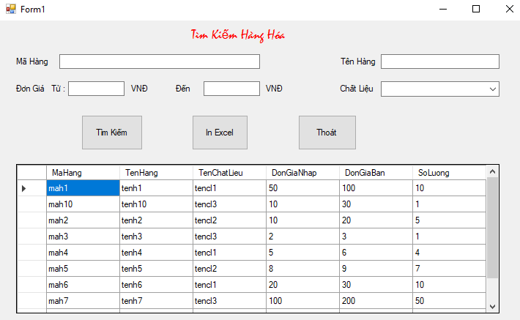**Xuat file excel**

using System;

using System.Collections.Generic;

using System.ComponentModel;

using System.Data;

using System.Data.SqlClient;

using System.Drawing;

using System.Linq;

using System.Text;

using System.Threading.Tasks;

using System.Windows.Forms;

using cExcel = Microsoft.Office.Interop.Excel;

namespace ChatLieu

{

public partial class Form1 : Form

{

//Chuỗi kết nối

string strConnectionString = @"Data Source=vaio\sqlexpress;Initial Catalog=excel;Integrated Security=True";

//Đối tượng kết nối

SqlConnection conn = null;

//Đối tượng đưa dữ liệu vào dtHang

SqlDataAdapter daHangHoa = null,daChatLieu=null;

//Đối tượng dữ lieeuj hiển thị from

DataTable dtHangHoa = null, dtChatLieu = null;

string T = @"SELECT MaHang,TenHang,TenChatLieu,DonGiaNhap,DonGiaBan,SoLuong FROM tblChatLieu,tblHang

WHERE tblChatLieu.MaChatLieu = tblHang.MaChatLieu";

SqlDataAdapter da = null;

SqlCommand comm = null;

//conn = new SqlConnection(strConnect);

%%%%%%%%%%%%%%%%%%%%%%%%%%%%%%%%%%%%%%%%%%%%%%%%%%%%%%%%%%%%%%%%%%%

public DataSet ExecuteQueryDataSet(string strSQL, CommandType ct)

{

comm = conn.CreateCommand();

if (conn.State == ConnectionState.Open)

conn.Close();

conn.Open();

comm.CommandText = strSQL;

comm.CommandType = ct;

da = new SqlDataAdapter(comm);

DataSet ds = new DataSet();

da.Fill(ds);

return ds;

}

%%%%%%%%%%%%%%%%%%%%%%%%%%%%%%%%%%%%%%%%%%%%%%%%%%%%%%%%%%%%%%%%%%%%

public DataSet TimTheoMaHang(string tim)

{

return ExecuteQueryDataSet("select * from tblChatLieu where TenChatLieu like '%"+txtTenHang +"%' ",CommandType.Text);

}

public Form1()

{

InitializeComponent();

}

private void btnTimKiem_Click(object sender, EventArgs e)

{

TimKiem();

}

%%%%%%%%%%%%%%%%%%%%%%%%%%%%%%%%%%%%%%%%%%%%%%%%%%%%%%%%%%%%%%%%%%%%

void KetNoi()

{

try

{

//Khởi động kết nối

conn = new SqlConnection(strConnectionString);

//Vận chuyển dữ liệu

daHangHoa = new SqlDataAdapter(T,conn);

dtHangHoa = new DataTable();

dtHangHoa.Clear();

daHangHoa.Fill(dtHangHoa);

//Dua du lieu len dgv

dgvShow.DataSource = dtHangHoa;

daChatLieu = new SqlDataAdapter("SELECT *FROM tblChatLieu ", conn);

dtChatLieu = new DataTable();

dtChatLieu.Clear();

daChatLieu.Fill(dtChatLieu);

//Len combobox

DataRow a = dtChatLieu.NewRow();

a[0] = "";

dtChatLieu.Rows.InsertAt(a, 0);

cmbChatLieu.DataSource = dtChatLieu;

cmbChatLieu.DisplayMember = "TenChatLieu";

cmbChatLieu.ValueMember = "MaChatLieu";

}

catch (Exception ex)

{

MessageBox.Show("Không lấy được dữ liệu lên ! Làm lại");

}

}

%%%%%%%%%%%%%%%%%%%%%%%%%%%%%%%%%%%%%%%%%%%%%%%%%%%%%%%%%%%%%%%%%%%%%%%%%%%%%%%%

private void btnInExcel_Click(object sender, EventArgs e)

{

cExcel.Application Excel = new cExcel.Application();

cExcel.Workbook wb = Excel.Workbooks.Add(cExcel.XlSheetType.xlWorksheet);

cExcel.Worksheet ws = (cExcel.Worksheet)Excel.ActiveSheet;

Excel.Visible = true;

ws.Cells[1, 1] = "Cửa Hàng Bán Đồ Lưu Niệm Bình An";

ws.Cells[2, 1] = "Địa Chỉ: 37B - TT Đông Anh - Hà Nội";

ws.Cells[3, 1] = "Điện Thoại: 0976967619";

ws.Cells[5, 2] = "Danh Sách Các Mặt Hàng";

ws.Cells[7, 1] = "STT";

ws.Cells[7, 2] = "Mã Hàng";

ws.Cells[7, 3] = "Tên Hàng";

ws.Cells[7, 4] = "Chất Liệu";

ws.Cells[7, 7] = "Số Lượng";

ws.Cells[7, 5] = "Giá Nhập";

ws.Cells[7, 6] = "Giá Bán";

for (int i = 8; i <= dgvShow.Rows.Count + 7; i++)

{

for (int j = 1; j <= 7; j++)

{

if (j == 1)

ws.Cells[i, 1] = i - 7;

else

ws.Cells[i, j] = dgvShow.Rows[i - 8].Cells[j - 2].Value;

}

}

}

%%%%%%%%%%%%%%%%%%%%%%%%%%%%%%%%%%%%%%%%%%%%%%%%%%%%%%%%%%%%%%%%%%%%%%%%%%

private void btnThoat_Click(object sender, EventArgs e)

{

if (MessageBox.Show("Bạn Thật Sự Muốn Thoát!", "Thông Báo!", MessageBoxButtons.YesNo, MessageBoxIcon.Information) == DialogResult.Yes)

{

Application.Exit();

}

}

%%%%%%%%%%%%%%%%%%%%%%%%%%%%%%%%%%%%%%%%%%%%%%%%%%%%%%%%%%%%%%%%%%%%%%%%%%%%

private void Form1_Load(object sender, EventArgs e)

{

KetNoi();

}

%%%%%%%%%%%%%%%%%%%%%%%%%%%%%%%%%%%%%%%%%%%%%%%%%%%%%%%%%%%%%%%%%%%%%%%%%%%%%%%

void TimKiem()

{

try

{

string mahang, tenhang, chatlieu;

int gia1=0, gia2=0;

mahang = txtMaHang.Text;

tenhang = txtTenHang.Text;

chatlieu = cmbChatLieu.Text;

string a;

if (txtGiaBan.Text.Equals(""))

{

gia1 = 0;

a = "Select MaHang, TenHang, TenChatLieu, DonGiaNhap,DonGiaBan, SoLuong from tblHang, tblChatLieu " +

"where tblHang.MaChatLieu = tblChatLieu.MaChatLieu and MaHang like '%" + mahang + "%' and TenHang like '%" + tenhang + "%' and TenChatLieu like N'%" + chatlieu + "%' and DonGiaNhap>=" + gia1;

}

else

{

gia1 = Int32.Parse(txtGiaNhap.Text.ToString());

gia2 = Int32.Parse(txtGiaBan.Text.ToString());

a = "Select MaHang, TenHang, TenChatLieu, DonGiaNhap,DonGiaBan, SoLuong from tblHang, tblChatLieu " +

"where tblHang.MaChatLieu = tblChatLieu.MaChatLieu and MaHang like '%" + mahang + "%' and TenHang like '%" + tenhang + "%' and TenChatLieu like N'%" + chatlieu + "%' and DonGiaNhap>=" + gia1 + "and DonGiaBan<=" + gia2;

//}

}

//Khởi động kết nối

conn = new SqlConnection(strConnectionString);

//Vận chuyển dữ liệu

daChatLieu = new SqlDataAdapter(a, conn);

dtChatLieu = new DataTable();

dtChatLieu.Clear();

daChatLieu.Fill(dtChatLieu);

//Dua du lieu len dgv

dgvShow.DataSource = dtChatLieu;

}

catch (Exception ex)

{

MessageBox.Show("Bạn phải nhập giá nhập và giá bán!");

}

}

}

}

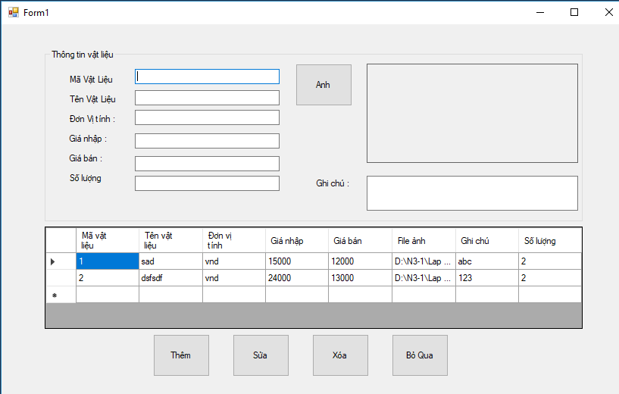

**Them sua xoa có ảnh**

DataConnetion.cs

using System;

using System.Collections.Generic;

using System.Data.SqlClient;

using System.Linq;

using System.Text;

using System.Threading.Tasks;

namespace TSXanh

{

class DataConnetion

{

string a;

public DataConnetion()

{

a = "Data Source=VAIO\\SQLEXPRESS;Initial Catalog=DuLieu1;Integrated Security=True";

}

public SqlConnection GetConnect()

{

return new SqlConnection(a);

}

}

}

XuLi.cs

class XuLi

{

DataConnetion dc;

SqlDataAdapter da;

SqlCommand cmd;

public XuLi()

{

dc = new DataConnetion();

}

public bool XuLiAll(string sql)

{

try

{

SqlConnection con = dc.GetConnect();

cmd = new SqlCommand(sql, con);

con.Open();

cmd.ExecuteNonQuery();

con.Close();

}

catch (Exception ex)

{

return false;

}

return true;

}

//lay du lieu ra bang

public DataTable GetAll(string a)

{

//tạo một kết nối đến sql

SqlConnection con = dc.GetConnect();

//khởi tạo đối tượng của lớp sqldataAdater

da = new SqlDataAdapter(a, con);

con.Open();//mở kết nối

//đổi dl từ sqldaraAdater vào datatable

DataTable dt = new DataTable();

da.Fill(dt);

//đóng kết nối

con.Close();

return dt;

}

}

Form1.cs

using System;

using System.Collections.Generic;

using System.ComponentModel;

using System.Data;

using System.Drawing;

using System.Linq;

using System.Text;

using System.Threading.Tasks;

using System.Windows.Forms;

namespace TSXanh

{

public partial class Form1 : Form

{

string fileimage = "";

XuLi a;

public Form1()

{

a = new XuLi();

InitializeComponent();

}

#region load Form

private void Form1_Load(object sender, EventArgs e)

{

Load_data();

}

#endregion

#region load data

public void Load_data()

{

string sql = "SELECT * FROM VatLieu";

DataTable dt = a.GetAll(sql);

dtgv.DataSource = dt;

}

#endregion

#region return null

public void TextReturnNull()

{

txtMa.Text = "";

txtTen.Text = "";

txtDonvi.Text = "";

txtGiaNhap.Text = "";

txtGiaBan.Text = "";

txtSoLuong.Text = "";

txtGhichu.Text = "";

}

#endregion

#region click show

private void dtgv_CellClick(object sender, DataGridViewCellEventArgs e)

{

int i = e.RowIndex;

if (i >= 0)

{

txtMa.Text = dtgv.Rows[i].Cells["MaVLD"].Value.ToString();

txtTen.Text = dtgv.Rows[i].Cells["TenVLD"].Value.ToString();

txtDonvi.Text = dtgv.Rows[i].Cells["DonViD"].Value.ToString();

txtGiaNhap.Text = dtgv.Rows[i].Cells["GiaNhapD"].Value.ToString();

txtGiaBan.Text = dtgv.Rows[i].Cells["GiaBanD"].Value.ToString();

txtSoLuong.Text = dtgv.Rows[i].Cells["SoLuongD"].Value.ToString();

txtGhichu.Text = dtgv.Rows[i].Cells["GhiChuD"].Value.ToString();

}

}

#endregion

#region chọn ảnh

private void btnAnh_Click(object sender, EventArgs e)

{

OpenFileDialog openDiaLog = new OpenFileDialog();

if (DialogResult.OK == openDiaLog.ShowDialog())

{

openDiaLog.Filter = "insert image(*)|*";

fileimage = openDiaLog.FileName;

}

}

#endregion

#region Them

private void btnThem_Click(object sender, EventArgs e)

{

int i = int.Parse(txtSoLuong.Text);

string sql = "INSERT INTO VatLieu VALUES ('" + txtMa.Text + "','" + txtTen.Text + "','" + txtDonvi.Text + "',N'" + txtGiaNhap.Text + "',N'" + txtGiaBan.Text + "'," + i + ",'" + fileimage + "',N'" + txtGhichu.Text + "')";

if (a.XuLiAll(sql))

{

MessageBox.Show("Thêm Thành Công", "Thông Báo", MessageBoxButtons.OK, MessageBoxIcon.Information);

TextReturnNull();

Load_data();

}

else

MessageBox.Show("Thêm Thất Bại", "Thông Báo", MessageBoxButtons.OK, MessageBoxIcon.Information);

}

#endregion

#region Sua

private void btnSua_Click(object sender, EventArgs e)

{

int i = int.Parse(txtSoLuong.Text);

string sql = "UPDATE VatLieu SET TenVL = N'" + txtTen.Text + "' ,DonVi = N'" + txtDonvi.Text + "' , GiaNhap = N'" + txtGiaNhap.Text + "',GiaBan = N'" + txtGiaBan.Text + "', SoLuong = " + i + " ,Anh = N'" + fileimage + "', GhiChu = N'" + txtGhichu.Text + "' WHERE MaVL ='" + txtMa.Text + "'";

if (a.XuLiAll(sql))

{

MessageBox.Show("Sửa Thành Công", "Thông Báo", MessageBoxButtons.OK, MessageBoxIcon.Information);

Load_data();

TextReturnNull();

}

else

MessageBox.Show("Sửa Thất Bại", "Thông Báo", MessageBoxButtons.OK, MessageBoxIcon.Information);

}

#endregion

#region Xóa

private void btnXoa_Click(object sender, EventArgs e)

{

string sql = "DELETE VatLieu WHERE MaVL = '" + txtMa.Text + "'";

if (a.XuLiAll(sql))

{

MessageBox.Show("Xóa Thành Công!", "Thông Báo", MessageBoxButtons.OK, MessageBoxIcon.Information);

Load_data();

TextReturnNull();

}

else

MessageBox.Show("Xóa Thất Bại", "Thông Báo", MessageBoxButtons.OK, MessageBoxIcon.Information);

}

#endregion

#region Thoát

private void btnBoQua_Click(object sender, EventArgs e)

{

Application.Exit();

}

#endregion

}

}

private void Main_FormClosing(object sender, FormClosingEventArgs e)

{

if (MessageBox.Show("Bạn có muốn thoát", "Thông báo", MessageBoxButtons.OKCancel, MessageBoxIcon.Warning) != DialogResult.OK)

{

e.Cancel = true;

}

}