Artificial intelligence (AI) is the simulation of human intelligence processes by machines, especially computer systems. These processes include learning (the acquisition of information and rules for using the information), reasoning (using rules to reach approximate or definite conclusions) and self-correction. Applications of AI include expert systems, speech recognition and machine vision.

AI can be categorized as either weak or strong. Weak AI, also known as narrow AI, is an AI system that is designed and trained for a task. Virtual personal assistants, such as Apple's Siri, are a form of weak AI. Strong AI, also known as artificial general intelligence, is an AI system with generalized human cognitive abilities. When presented with an unfamiliar task, a strong AI system can find a solution without human intervention.

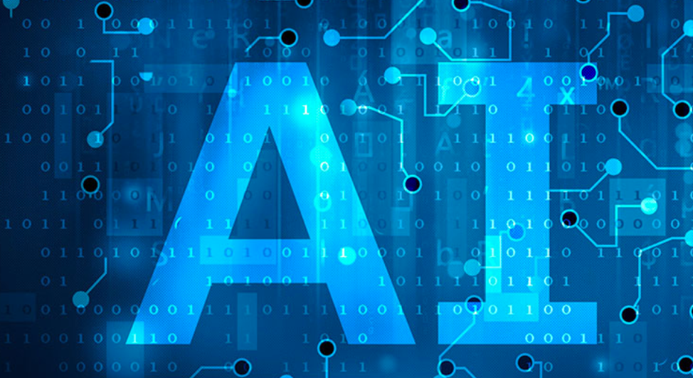

Because hardware, software and staffing costs for AI can be expensive, many vendors are including AI components in their standard offerings, as well as access to Artificial Intelligence as a Service (AIaaS) platforms. AI as a Service allows individuals and companies to experiment with AI for various business purposes and sample multiple platforms before making a commitment. Popular AI cloud offerings include Amazon AI services, IBM Watson Assistant, Microsoft Cognitive Services and Google AI services.

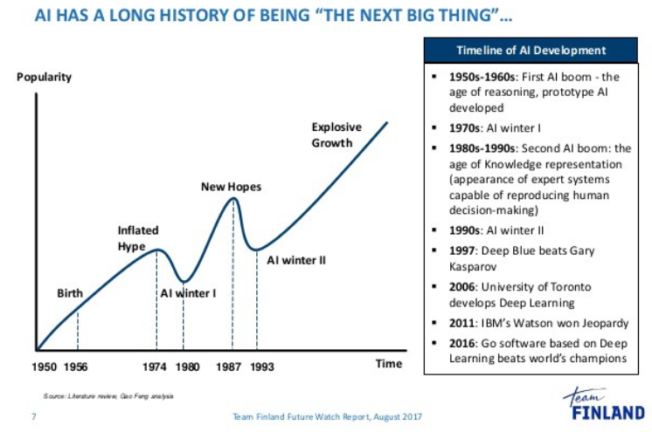

Source: <https://medium.com/@bboynton97/why-isnt-ai-the-buzzword-that-it-used-to-be-ffa3199324fd>

Advances in artificial intelligence (AI) could impact nearly all aspects of society: the labor market, transportation, healthcare, education, and national security. AI’s effects may be profoundly positive, but the technology entails risks and disruptions that warrant attention. While technologists and policymakers have begun to discuss AI and applications of machine learning more frequently, public opinion has not shaped much of these conversations. In the U.S., public sentiments have shaped many policy debates, including those about immigration, free trade, international conflicts, and climate change mitigation. As in these other policy domains, we expect the public to become more influential over time. It is thus vital to have a better understanding of how the public thinks about AI and the governance of AI. Such understanding is essential to crafting informed policy and identifying opportunities to educate the public about AI’s character, benefits, and risks.

