# IST769 Homework Submission #1

## Basic Information

Your Name: Thulasi Ram Ruppa Krishnan   
Your SUID: truppakr  
Your Email: truppakr@syr.edu  
Date Due: 460746269   
Homework #: HW1

## Instructions

For each answer, please include your answer as text, and any screenshot(s) which demonstrate your answer was executed. Most importantly, make sure to include evidence your answer is correct. This will most likely be a screenshot. If you had issues, problems, or had to make assumptions include them in your answer.

## Answers:

1. What would be the command to bring up the redis environment? How is the command different from the mssql environment? How is it the same?
   1. The docker command to bring up the redis environment is same as mssql . The only difference is we need to change the location form which we are running the command in powershell. We will first go to the location where redis image file is available and in this case it is C:\Users\LocalAdmin\adv-db-labs\redis . Also, the docker command to bring up any environment is same as <docker-compose up -d> after navigating to the folder where the image file is available.

The below screen shots show the command to bring up both mssql and redis environment which are essentially the same but the directory location from where execute the command is different.



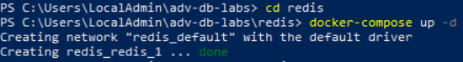

1. Where is the specific configuration information about each environment stored?
   1. Specific configuration about each environment is stored in Dockerfile or docker-compose.yml file. It is not mandatory to have both the files but depending upon the complexity we can have both or just the file with configuration about the environment and image.

A sample Dockerfile and docker-compose.yml file is shown below which contains all the configurations to start a mssql environment.

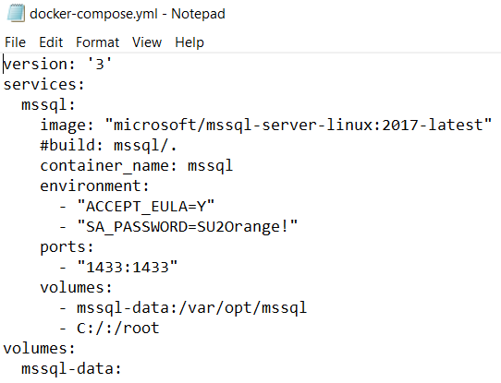

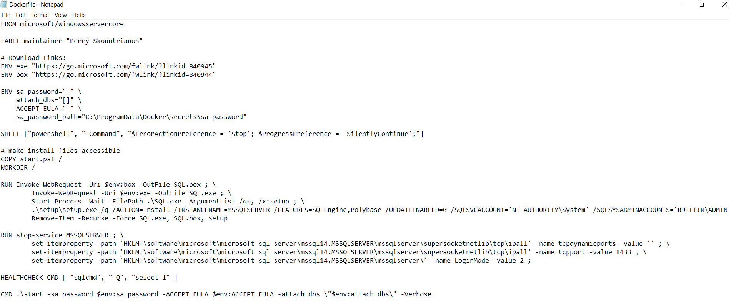

1. Explain the difference between stopping an environment and bringing it down. Elaborate with use-cases for each.
   1. Stopping the environment means to stop running containers, but not to remove them completely.



* 1. Bringing it down also removes the stopped containers, images as well as any networks that were created. You can take down 1 step further and add the -v flag to remove all volumes too. This is great for doing a full-blown reset on your environment by running “docker-compose down -v” as shown in the below figure

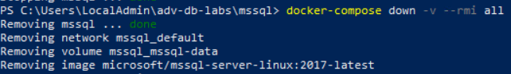

1. What happens when you bring up an environment that is already up?
   1. when you try to bring up and environment that is already up, it will say the environment is up-to-date. For example, if you are trying to bring up the mssql while it is already running, you will receive a message saying “mssql is up-to-date” as shown in the below figure.

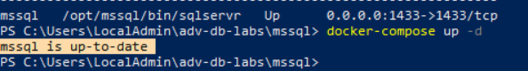

1. What was the most difficult aspect of this lab? What changes could be made to make it less difficult?
   1. The lab steps are straight forward and easy to follow. It will be helpful if we know little more background on the Docker itself like how the image is created and where it is stored on the machine. Also, how the licensing part work when we spun an instance of mssql image file. One more challenge I faced while trying to set up the environment is on my local machine where it is throwing the error saying “ERROR: for mssql Cannot create container for service mssql: status code not OK but 500: {"Message":"Unhandled exception: Drive has not been shared"}”. It will help us if there is a document for FAQ and the known issues and solutions are documented for a local setup.