# IST769 Homework Submission #10

## Basic Information

Your Name: Thulasi Ram Ruppa Krishnan   
Your SUID: 460746269  
Your Email: truppakr@syr.edu  
Date Due: 06-07-2020   
Homework #: HW10

# Exercises

Complete each of the following exercises. If you are unsure how to accomplish the task, please consult the coursework videos where there are explanations and demos.

1. Write KSQL to create a stream named **weblogs** from the JSON keys in the **weblogs** Kafka topic. Make sure to set the TIMESTAMP property to the timestamp from the stream.

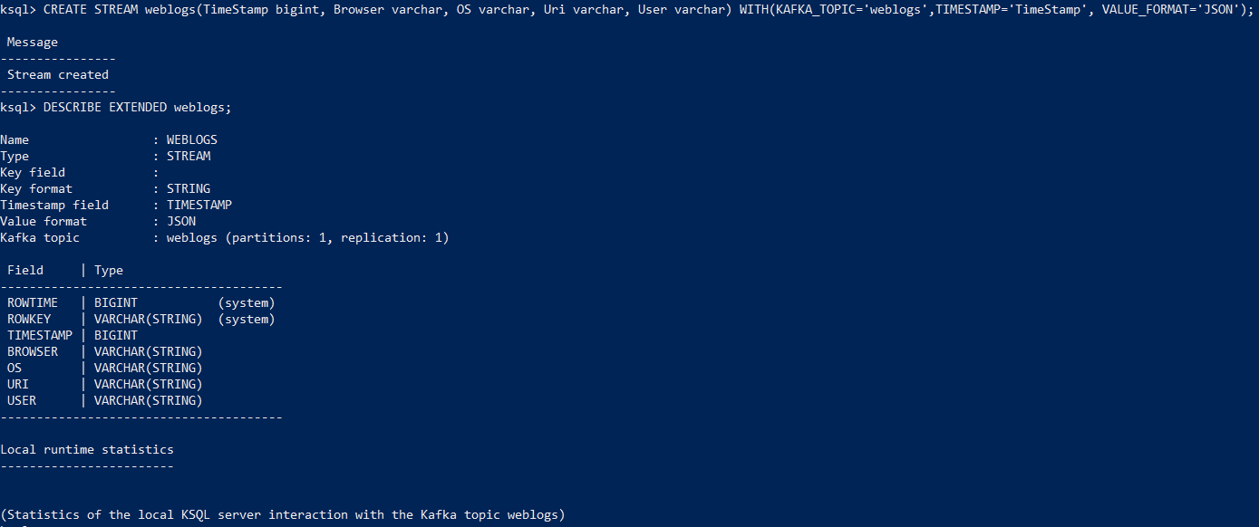

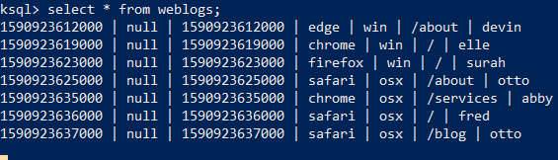

1. Write a KSQL statement create a persistent stream/table called **homepage** which only displays visitors to the root of the website (/). It should display all columns from the **weblogs** stream.

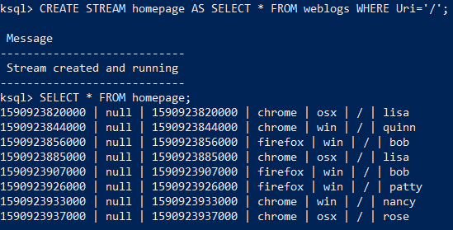

1. Write a KSQL statement to count operating systems users (os) in 60 second windows. After 60 seconds, the counter should reset, and counts should begin again.

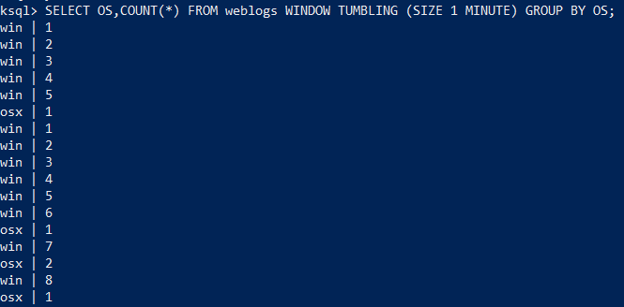

1. Write a KSQL persistent stream/table called **user_activity** which will display a count of user activity on the website within 1-minute sessions.

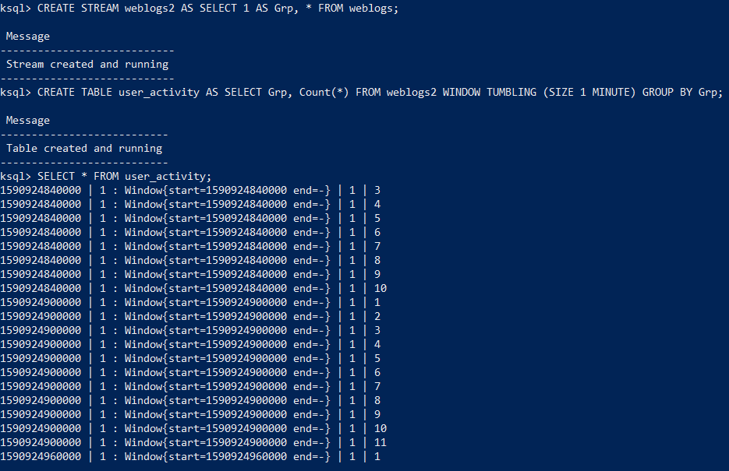

1. Write a KSQL statement to display users who have more than 1 pages of activity in a 1-minute session.

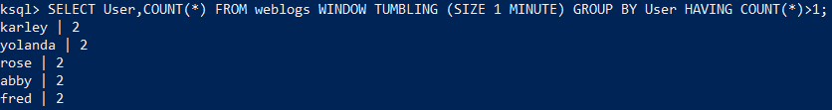

# Tear-Down

When you are finished with the homework you should stop the environment:

1. From the terminal window where you typed docker-compose up -d type in the following:  
   docker-compose stop