# IST769 Homework Submission #8

## Basic Information

Your Name: Thulasi Ram Ruppa Krishnan   
Your SUID: 460746269  
Your Email: truppakr@syr.edu  
Date Due: 05-21-2020   
Homework #: HW8

## Instructions

For each answer, please include your answer as text, and any screenshot(s) which demonstrate your answer was executed. Most importantly, make sure to include evidence your answer is correct. This will most likely be a screenshot. If you had issues, problems, or had to make assumptions include them in your answer.

# Exercises

Complete each of the following exercises. If you are unsure how to accomplish the task, please consult the coursework videos where there are explanations and demos.

1. Write a MongoDB Query to retrieve Country name, population, and capital for all countries in the collection.   
   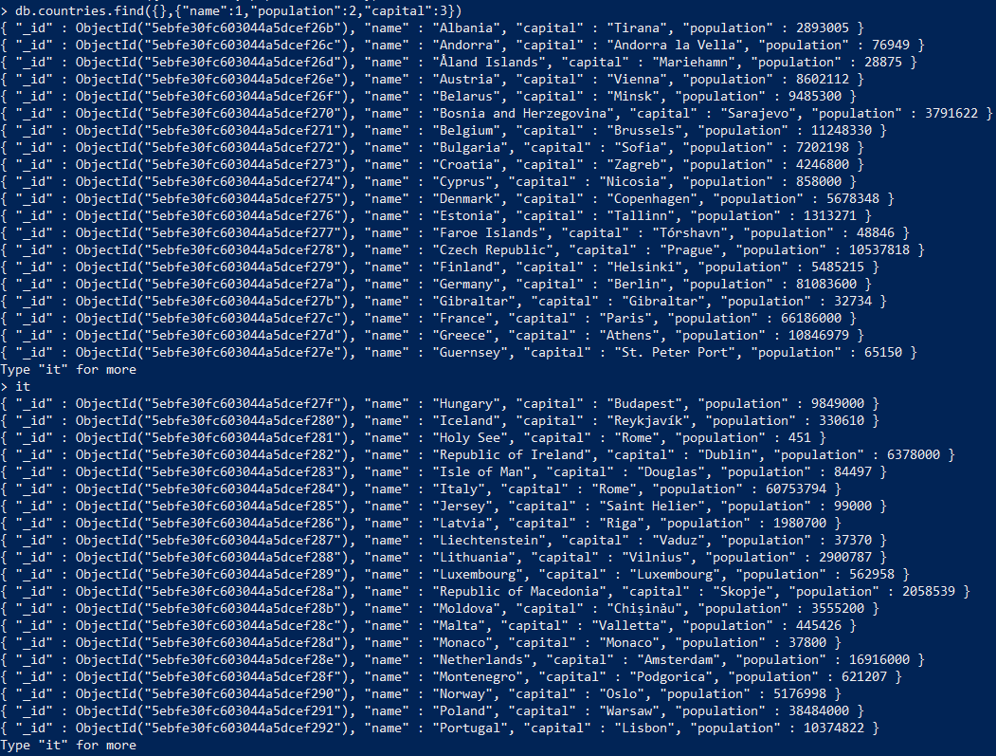
2. Write a MongoDB Query to retrieve Country name, population, and capital for all countries with a population under 500,000 sorted by population.

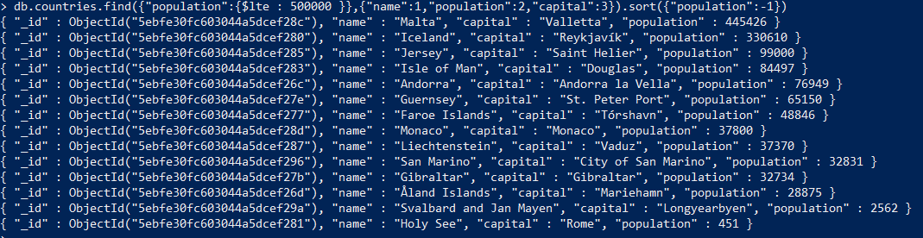

1. Use the**. explain(“executionStats”)** method to analyze the query you wrote in the previous step. Write an index to improve the performance of the query, then perform another explain to demonstrate it worked. Include the code of the index you wrote, the and the relevant output of the execution stats which demonstrate the index is being used.

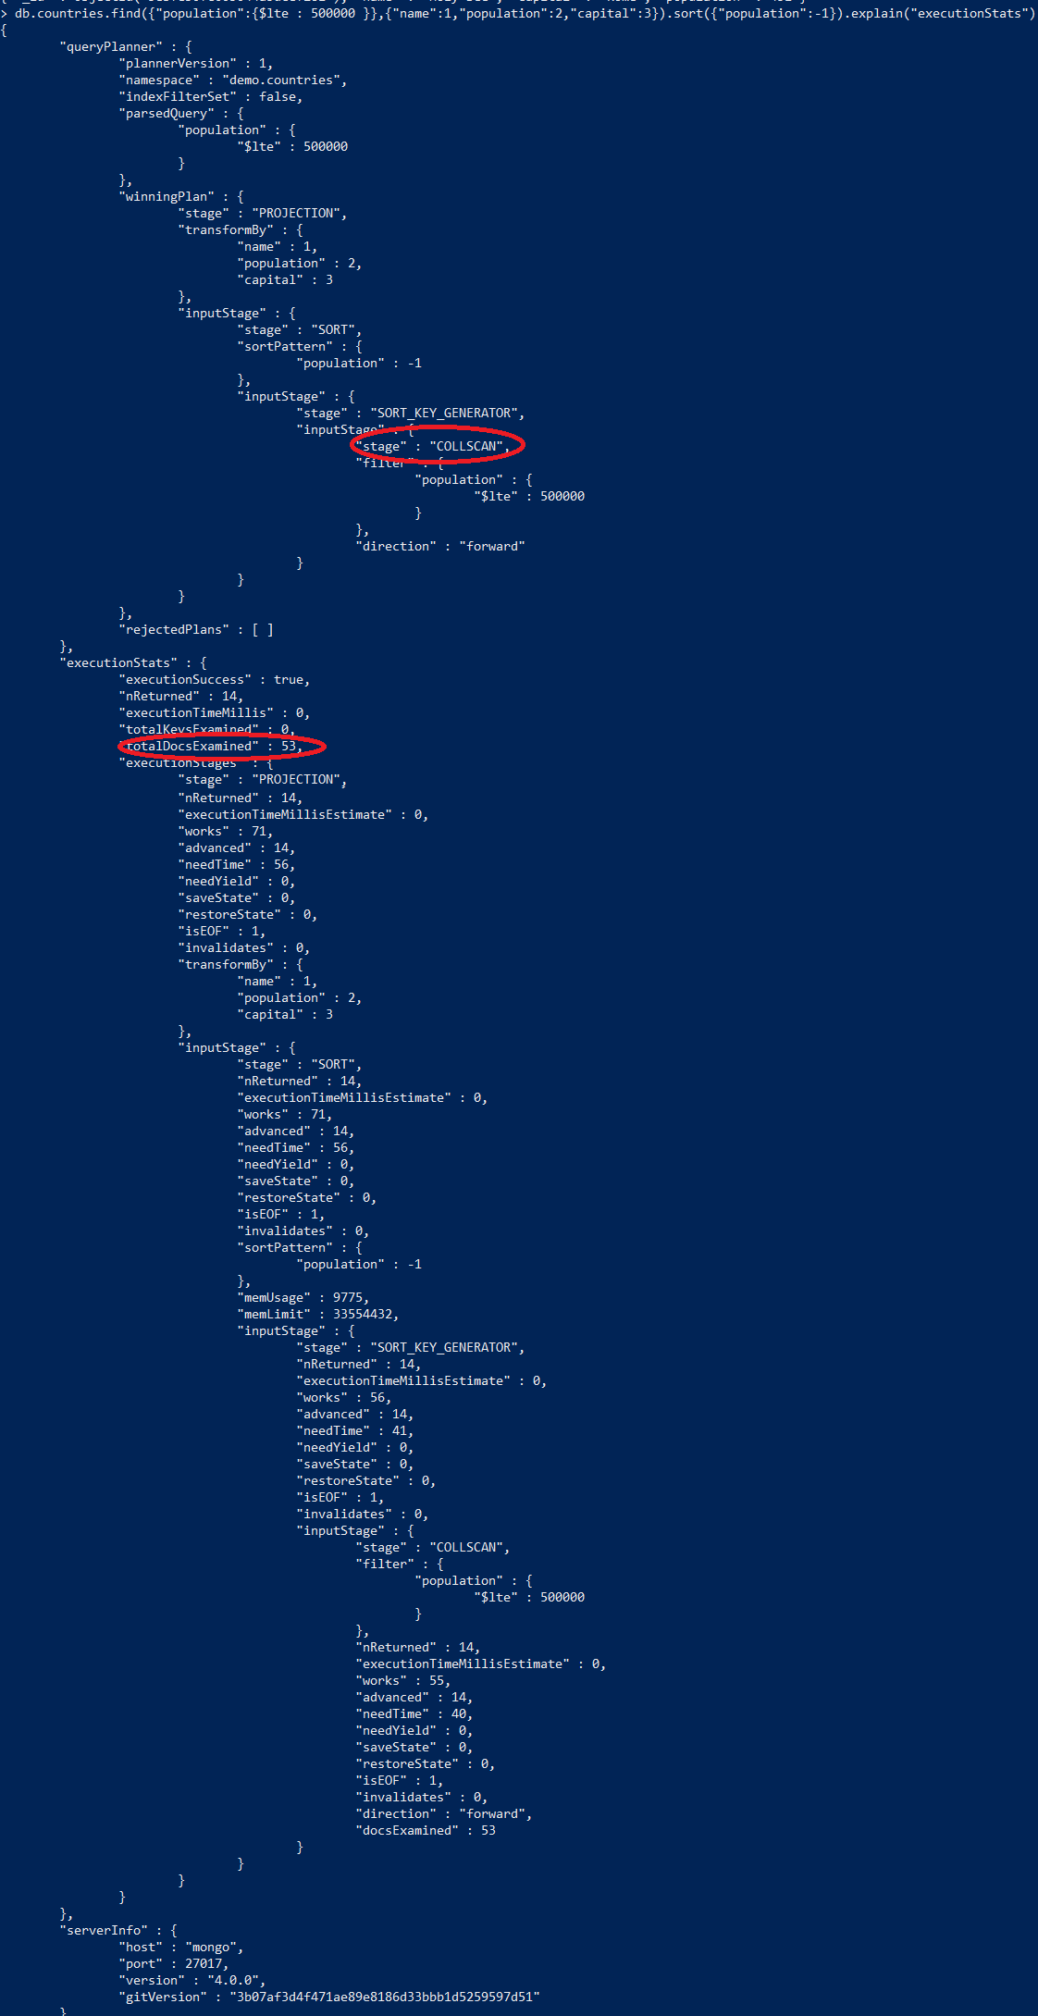

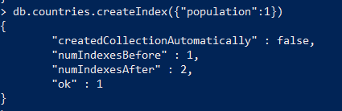

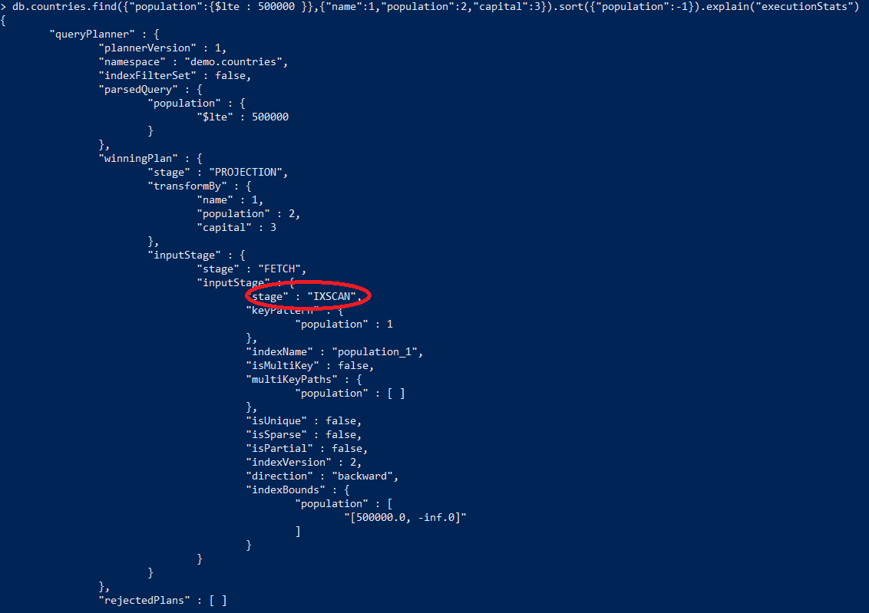

1. Select the most appropriate Redis data structure to store the following information:

|  |  |  |  |
| --- | --- | --- | --- |
| Product ID | Name | Qty On Hand | Unit Price |
| 1 | Apple | 7 | 2.49 |
| 2 | Banana | 12 | 1.99 |
| 3 | Cherry | 9 | 4.99 |

Execute the commands to store this information in Redis. Make sure to namespace your key and each of the fields should be retrievable under the key used.  


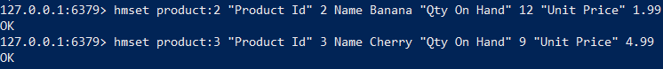

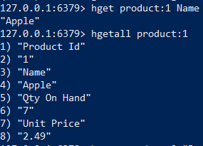

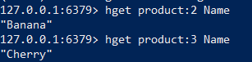

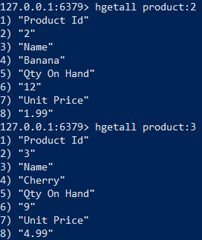

1. Select the most appropriate Redis data structure to store the following information:

The 2018 Golden Snowball Competition for the Upstate NY City with the Highest Snowfall. Scores updated hourly.

|  |  |  |  |
| --- | --- | --- | --- |
| City | Syracuse | Rochester | Buffalo |
| Snowfall Inches | 97 | 68 | 84 |

Execute the commands to store this information in Redis. Make sure to namespace your key and each of the snowfall values should be updatable. For example, you should be able to add 10 inches to Buffalo to make it 94. You should be able to display the information upon request.



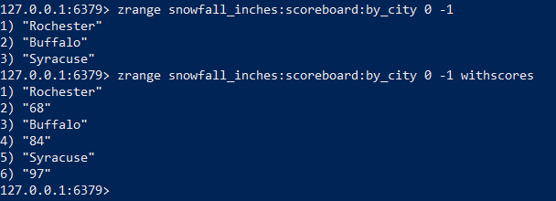

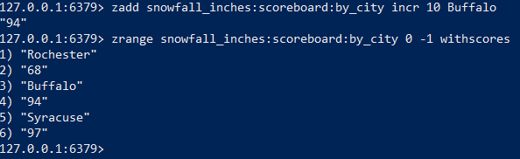

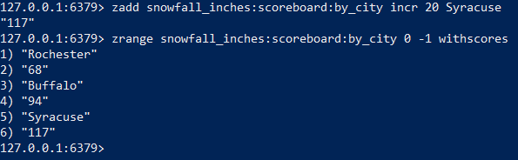

# Turning it in

Take your copy and paste each of the solutions to the exercises into the submission template file included with this assignment. Make sure your name and SU email are at the top and turn in your work through the course learning management system.

# Tear-Down

When you are finished with the homework you should stop the environment:

1. From the terminal window where you typed docker-compose up -d type in the following:  
   docker-compose stop