CSCI 4208 / ADVANCED WEB APPLICATIONS
Live Repertoire Explorer
Implementation, Testing, and Classroom Presentation Guide
A project-specific manual for running the React/Vite application, explaining its local-first architecture, validating it with Vitest, and presenting the design decisions clearly to classmates.
Guide at a glance | Current project
Application | React + Vite single-page application
Analytics | Chart.js with browser-side calculations
Persistence | Versioned localStorage plus optional JSONBin settings
Testing | Vitest 4.1.10; 5 files; 18 unit/service tests
Deployment | GitHub Pages-compatible hash routing and relative assets

Revision note: This edition replaces the original outline. It removes the proposed Express proxy and reframes manual song entry because neither matches the current static-hosted performance-record architecture.

How to use this guide
Use Sections 1-3 to prepare the application, Sections 4-7 to explain the architecture, Sections 8-12 to demonstrate Vitest, and Section 13 as a timed presentation script.
Section | Purpose
1. Project story | Explain the problem, audience, and learning goals.
2. First run | Install dependencies and launch the app.
3. Functional walkthrough | Demonstrate the routes and interactions.
4-7. Architecture | Explain data, classes, state, persistence, and errors.
8-12. Vitest | Run, interpret, target, write, mock, and debug tests.
13. Presentation plan | Deliver a clear seven-minute class walkthrough.
Appendix | Use command and troubleshooting references.

Before class: five-minute readiness check
- Open PowerShell and change to C:\Projects\courses\csci4208\setlist-analytics.
- Run node --version. The locked Vite version requires Node 20.19 or newer, or Node 22.12 or newer.
- Run npm install if this computer has not installed the project dependencies.
- Run npm test and confirm all five test files pass.
- Run npm run dev, open the printed Local URL, and visit Dashboard, Originals, Songs, and Venues.
- Keep this guide and docs/ARCHITECTURE.md open as presentation notes.
Important: Do not add vitest.config.ts just because the original guide mentioned it. The current tests run in Vitest's Node environment and need no configuration file.

1. Project story

1.1 Problem being solved
Musicians often remember individual shows but cannot easily answer questions across months of performances: Which songs dominate the repertoire? How often are original songs played? Which songs have disappeared from rotation? Live Repertoire Explorer turns normalized concert records into those answers.

1.2 Why this qualifies as a thick-client SPA
- React renders all routes and interaction states in the browser.
- The browser loads, validates, filters, sorts, and analyzes performance data.
- Chart.js renders charts from derived analytics rather than server-generated images.
- localStorage supplies versioned offline state and saved preferences.
- HashRouter supports multiple views on static GitHub Pages hosting.

2. First run: exact steps
- Open PowerShell.
- Change to the project directory:
cd C:\Projects\courses\csci4208\setlist-analytics
- Confirm Node and npm are available:
node --version
npm --version
- Install dependencies from package-lock.json:
npm install
- Start the Vite development server:
npm run dev
- Open the Local URL printed by Vite, normally http://localhost:5173/.
- Stop the server when finished by pressing Ctrl+C in the same terminal.

2.1 Production validation
A development server proves the app can run. A production build also proves Vite can bundle every imported module:
npm run build
npm run preview
The build command creates dist/. Preview serves that optimized build locally. The generated folder is intentionally ignored by Git because it can be rebuilt.

3. Functional walkthrough
The fastest way to explain the application is to follow the user journey from data status to filters, analytics, and specialized views.
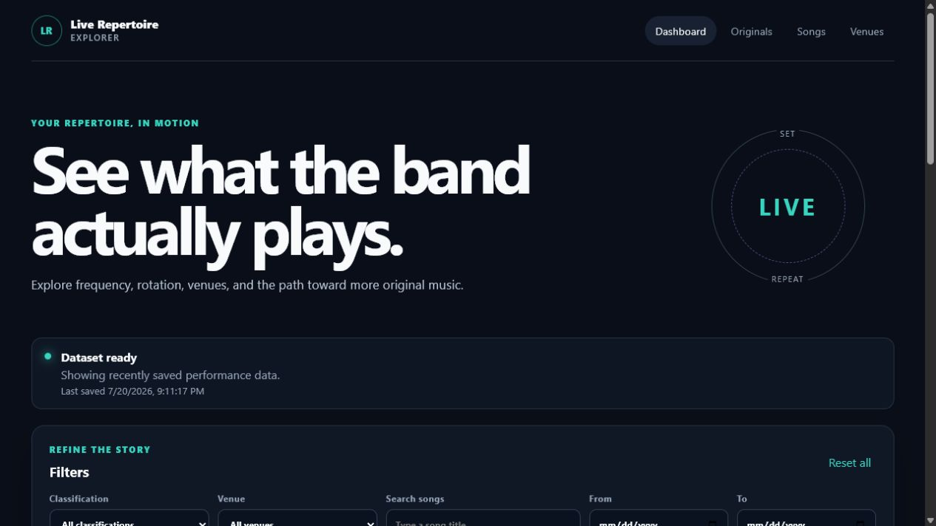
Figure 1. Dashboard: dataset status, filters, summary metrics, and analytics.

3.1 Dashboard demonstration
- Point out the Dataset ready status. Explain that cached records may appear before a refresh.
- Change Classification from All classifications to Originals. Metrics and charts recalculate immediately.
- Search for part of a song title and explain that filtering happens inside PerformanceDataset.
- Reset the filters and identify the top-song bar chart and monthly trend chart.
- Explain that table sorting changes the displayed order without changing the source records.

3.2 Originals and repertoire health
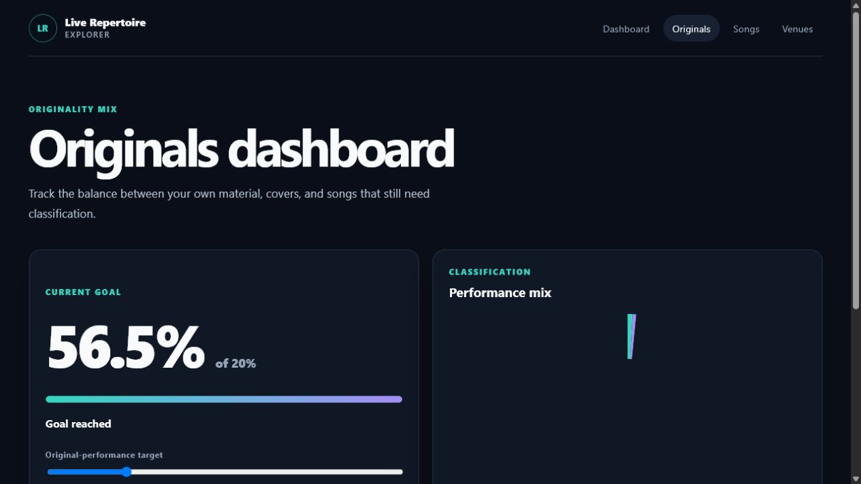
Figure 2. Originals view: classification mix and progress toward an adjustable target.
Move the target slider and explain that the setting is saved locally. The classification percentages come from AnalyticsEngine, so unknown values remain visible instead of being guessed as originals or covers.
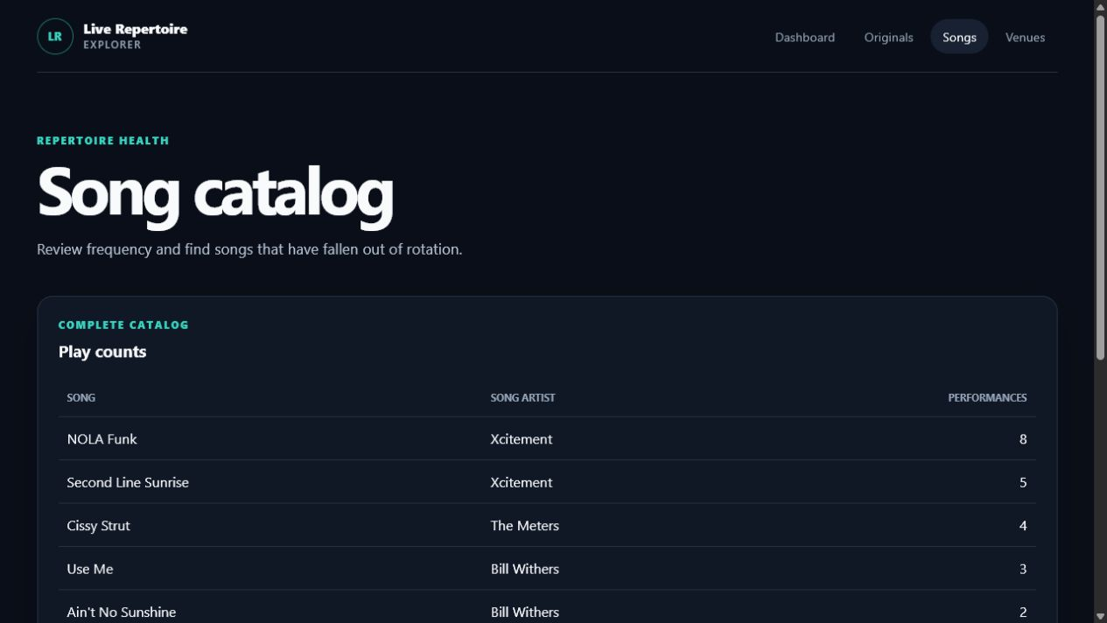
Figure 3. Songs view: ranked frequency and repertoire-rotation review.
The Songs view reports the last performance date relative to the newest gig in the dataset. This is deterministic even when the sample data is historical.

4. Architecture at a glance
Layer | Responsibility | Examples
UI | Routes, filters, tables, charts, messages | views/, components/, charts/
State | Actions, reducer transitions, derived filtered records | state/AppStore.jsx
Domain | Validated records, dataset operations, analytics | models/, analytics/
Services | Fetch, cache, and optional cloud settings | services/
Utilities | CSV parsing and browser downloads | utils/
Configuration | TTL, schema version, URLs, defaults | config/appConfig.js

4.1 Unidirectional data flow
- A user changes a filter.
- FilterPanel dispatches SET_FILTER to AppStore.
- The reducer creates a new state object.
- PerformanceDataset filters the complete normalized record collection.
- AnalyticsEngine calculates metrics from the filtered records.
- React rerenders metric cards, charts, and the song table.
- The persistence effect saves records, filters, settings, and views to localStorage.
Presentation phrase: "The UI does not calculate business rules itself. It asks the domain layer for normalized data and analytics, which keeps the code testable."

5. Core classes and objects
Object | What it owns | What to say in class
PerformanceRecord | Normalization and validation of one performed song | Bad source rows cannot silently enter analytics.
PerformanceDataset | Collection filters, unique values, and date sorting | Filtering returns a new dataset and does not mutate the original.
AnalyticsEngine | Counts, percentages, trends, concentration, stale songs | Pure calculations are easy to test because they have no UI or network dependency.
PerformanceDataSource | Abstract asynchronous loading contract | The UI is independent of JSON, CSV, or a future published sheet.
PublishedDatasetSource | Fetch, timeout, retry, CSV/JSON parsing, row validation | The service returns valid records and reports rejected rows.
StorageService | Versioned localStorage and TTL freshness checks | Old or corrupt cache data fails safely.
CloudSettingsService | Small JSONBin settings artifact | Only non-sensitive settings are shared; performance data remains local/source-driven.
ChartRenderer | Chart.js registration and shared display options | Charts receive already-calculated values.
AppStoreProvider | Controller role: loading, reducer, persistence, derived data | React state replaces a separate DashboardController class.

6. Data model and source replacement
One record means one song performed during one concert:
{
"performanceId": "2026-07-12-3090-nola-funk",
"gigId": "2026-07-12-3090",
"gigDate": "2026-07-12",
"venue": "30/90",
"city": "New Orleans",
"songTitle": "NOLA Funk",
"songArtist": "Xcitement",
"performingArtist": "Xcitement",
"classification": "original",
"setNumber": 2,
"position": 5
}

6.1 Classification rule
Only original, cover, and unknown are valid. Missing or unsupported values become unknown. This prevents a misleading original-versus-cover percentage.

6.2 Why the data source is replaceable
PublishedDatasetSource and XcitementSheetSource must return the same normalized record array. Once the future sheet is mapped to this schema, the store, views, analytics, charts, and tests do not need to know where the data came from.

7. Local-first startup and failure states
- StorageService reads the versioned local cache.
- If usable cached records exist, the app can render immediately.
- The TTL determines whether the published dataset needs refreshing.
- A refresh uses fetch, AbortController, validation, and retry/backoff.
- A successful response replaces the cached source record array.
- If refresh fails and cached data exists, the app remains usable in offline mode.
- If no data exists, the UI shows an error or empty state with an appropriate retry path.
Security boundary: VITE_* values are compiled into browser code. A JSONBin access value used for a classroom demo must be restricted and must never protect sensitive data.

8. Vitest: what is already configured
Vitest is already installed as a development dependency and the project defines two scripts. No additional setup is required after npm install.
"scripts": {
"test": "vitest run",
"test:watch": "vitest"
}
Test file | Tests | Primary coverage
PerformanceRecord.test.js | 4 | Text/date normalization, classification, optional numbers, invalid records
PerformanceDataset.test.js | 3 | Combined filters, non-mutating sorting, unique values
AnalyticsEngine.test.js | 4 | Summary, rankings, percentages, trends, venues, concentration, stale songs
StorageService.test.js | 3 | Save/load, corrupt/version mismatch, TTL freshness
DataServices.test.js | 4 | Abstract source, CSV quoting, valid/invalid rows, failed requests

Current total: 5 test files and 18 tests.

8.1 Run the complete suite once
npm test
Use this before a commit or presentation. The command exits after the suite finishes and returns a nonzero exit code if any test fails.

8.2 Use watch mode while coding
npm run test:watch
Watch mode stays open, reruns affected tests after saved file changes, and provides keyboard shortcuts in the terminal. Press q to quit.

9. Targeting tests instead of running everything
Goal | Command
Run one file | npm test -- tests/AnalyticsEngine.test.js
Match a file/name pattern | npm test -- PerformanceRecord
Run one named test | npm test -- -t "calculates dashboard summary"
Show every test name | npm test -- --reporter=verbose
Update snapshots | npm test -- -u (only if snapshot tests are later added)

How npm arguments work: The first -- tells npm to pass the remaining arguments to Vitest. For example, npm test -- -t "goal progress" passes -t directly to Vitest.

9.1 How to read the result
Test Files 5 passed (5)
Tests 18 passed (18)
Duration ...
- Test Files reports whether each test module loaded and completed.
- Tests reports individual it(...) cases.
- A failed test includes the file, test name, expected value, received value, and source line.
- A startup error occurs before tests run and usually points to configuration, imports, Node version, or dependencies.

9.2 Recommended validation sequence
npm test
npm run build
Tests validate behavior. The build validates module imports, JSX compilation, and production bundling. A strong GitHub pull request should pass both.

10. Anatomy of a project test
This simplified example follows the same Arrange-Act-Assert pattern used by the current suite:
import { describe, expect, it } from "vitest";
import { PerformanceRecord } from "../src/models/PerformanceRecord.js";
describe("PerformanceRecord", () => {
it("uses unknown for an unsupported classification", () => {
// Arrange: create valid input with one unsupported field.
const input = { ...sampleRecord, classification: "traditional" };
// Act: normalize the source object.
const record = new PerformanceRecord(input);
// Assert: the application does not guess.
expect(record.classification).toBe("unknown");
});
});
Part | Purpose
describe | Groups related behavior under the class or function name.
it | States one observable behavior in plain language.
expect | Compares the actual result with the required result.
fixture | Provides small repeatable input shared across tests.
mock/stub | Replaces a browser or network dependency with controlled behavior.

10.1 Add a new unit test
- Choose the behavior, not the implementation detail. Example: invalid dates are rejected.
- Find the matching test file or create one named ClassName.test.js.
- Create the smallest input that demonstrates the behavior.
- Call the public method or constructor.
- Assert the result or expected error.
- Run only that file until it passes.
- Run npm test to check for regressions.
- Run npm run build before committing.

11. Testing browser and network dependencies

11.1 localStorage without a browser
StorageService tests create a small fake localStorage object and install it with vi.stubGlobal. This keeps unit tests fast and avoids requiring jsdom.
const values = new Map();
vi.stubGlobal("localStorage", {
getItem: vi.fn((key) => values.get(key) ?? null),
setItem: vi.fn((key, value) => values.set(key, value)),
});

11.2 fetch without a real network request
DataServices tests replace global fetch with a resolved Response. The test controls the HTTP status and response body, making success and failure repeatable.
vi.stubGlobal(
"fetch",
vi.fn().mockResolvedValue(
new Response(JSON.stringify(records), {
status: 200,
headers: { "Content-Type": "application/json" },
}),
),
);

11.3 When jsdom becomes appropriate
The current suite tests domain and service logic, so Node is enough. Add jsdom, React Testing Library, and vitest.config.js only when testing rendered components such as FilterPanel or SavedViews.
npm install -D jsdom @testing-library/react @testing-library/user-event
Do not install preemptively: Extra test dependencies add maintenance cost. Add them with the first real component interaction test, not as setup with no test using them.

12. Debugging failed tests
Symptom | Likely cause | Response
npm is not recognized | Node/npm is missing or terminal PATH is stale | Install supported Node, then reopen PowerShell.
Unsupported engine | Node is older than the locked Vite requirement | Use Node 20.19+ or 22.12+.
Cannot find package | Dependencies are not installed or lockfile changed | Run npm install in the project directory.
No test files found | Wrong working directory or naming pattern | Confirm pwd and use tests/*.test.js naming.
Expected X, received Y | Behavior or expectation is wrong | Read the smallest failing assertion and reproduce with its fixture.
Tests pass alone but fail together | Leaked global mock or mutable fixture | Restore mocks and create fresh data in each test.
Network test is inconsistent | Test contacted a real service or timer | Mock fetch and use controlled responses/fake timers.
Test hangs | Unresolved promise, timer, or watch mode | Check async/await; press q if intentionally in watch mode.

12.1 A disciplined failure workflow
- Read the first failure, not the last line of the terminal.
- Run only the failing file.
- Run only the failing test name with -t.
- Compare the fixture with the production schema.
- Decide whether the implementation or expectation is wrong.
- Make the smallest correction.
- Rerun the targeted test, then the full suite and production build.

12.2 Coverage is optional, not currently installed
If the course requires a coverage report, install Vitest's V8 coverage provider and then run the coverage command:
npm install -D @vitest/coverage-v8
npm test -- --coverage
Coverage measures executed lines and branches; it does not prove that assertions are meaningful. Keep acceptance behavior more important than a percentage target.

13. Seven-minute classroom presentation plan
Time | Show | Explain
0:00-0:45 | README and title | The repertoire problem, intended Xcitement use, and analytics track.
0:45-1:45 | Dashboard | Cached-first load, public GET, filters, summary metrics, and charts.
1:45-2:30 | Originals view | Original/cover/unknown rule and adjustable goal.
2:30-3:10 | Songs and Venues | Frequency, stale songs, and venue comparison.
3:10-4:10 | Architecture guide | Layers, normalized record contract, and replaceable sources.
4:10-5:30 | Tests in terminal | Run npm test, name the five suites, and target one test.
5:30-6:20 | One test file | Arrange-Act-Assert and mocked localStorage/fetch.
6:20-7:00 | Wrap-up | Local-first benefits, GitHub Pages fit, and next enhancements.

13.1 Suggested narration
"Live Repertoire Explorer is a thick-client React application. It converts individual performed-song records into repertoire analytics entirely in the browser. I separated validation, dataset operations, analytics, services, and React state so each layer can be explained and tested independently."
"The app is local-first: it can render cached data immediately, refresh a published source when needed, and continue offline. The public sample can later be replaced by Xcitement's sheet because both sources return the same normalized PerformanceRecord objects."
"Vitest verifies the rules that would be hardest to trust by looking at the UI alone: date and classification validation, combined filtering, percentages, stale songs, cache versioning, CSV quoting, and failed fetch behavior."

13.2 Likely questions and concise answers
Question | Answer
Why not call setlist.fm directly? | The capstone avoids API coupling and secret exposure; published JSON/CSV is normalized behind a source abstraction.
Why localStorage? | It supports immediate cached rendering, saved filters, offline use, and a demonstrable local-first design.
Why unknown classification? | Missing evidence must not distort original-versus-cover analytics.
Why no backend? | The required analytics and persistence fit a static thick client and GitHub Pages deployment.
Why Vitest? | It shares Vite's module pipeline, supports ES modules, mocks globals cleanly, and requires little configuration.
Are charts tested? | The calculations feeding charts are unit tested. Component/visual tests are a future layer.

Appendix A. Command reference
Task | Command
Enter project folder | cd C:\Projects\courses\csci4208\setlist-analytics
Install dependencies | npm install
Start development | npm run dev
Run all tests once | npm test
Run tests continuously | npm run test:watch
Run one test file | npm test -- tests/AnalyticsEngine.test.js
Run one named test | npm test -- -t "calculates dashboard summary"
Verbose results | npm test -- --reporter=verbose
Production build | npm run build
Preview build | npm run preview

Appendix B. What not to claim
- Do not claim the app currently calls setlist.fm; it loads published JSON or CSV.
- Do not claim an Express proxy is implemented or required for GitHub Pages.
- Do not describe AddSongForm as implemented; manual entry needs a full performance-record design.
- Do not claim jsdom or React Testing Library is installed; current tests are Node-based unit/service tests.
- Do not say a missing classification is automatically a cover or original.
- Do not say a passing build replaces tests; the two checks answer different questions.

Appendix C. Presentation checklist
- The app opens and the sample dataset loads.
- All four routes are visible.
- Filters reset before the demo starts.
- The terminal is already in the project folder.
- npm test has passed on the presentation computer.
- The architecture document and one test file are open.
- No API keys or .env values are visible on screen.
- The final repository status is understood before committing or pushing.

