Software Defined Instrumentation Workshop

Hands-on activity pre-requisites
- ADALM2000 drivers installation
https://github.com/analogdevicesinc/plutosdr-m2k-drivers-win/releases

- Install Scopy software from:
https://github.com/analogdevicesinc/scopy/releases/download/v1.3.0/scopy-v1.3.0-Windows-setup.exe



Hands-on activity

Demo 1

Scope and Signal generator channels – Cascaded LP filters

Materials:
- ADALM2000 Active Learning Module
- Solder-less breadboard, and jumper wire kit
- 2 x 1 KΩ resistors
- 2 x 0.1 uF capacitors (marked 104)

Hardware setup
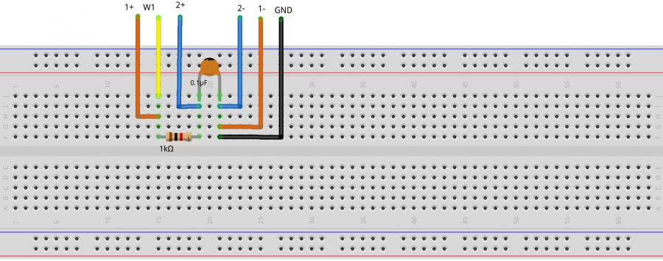
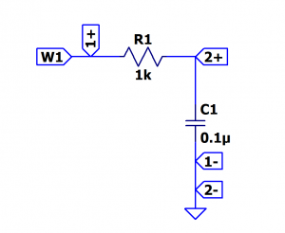

Steps:
- Open Network Analyzer
- Set the sweep to logarithmic
- Set the start frequency to 100Hz and stop to 20kHz
- Set the magnitude axis between -50dB and 10dB
- Set the phase axis between -180 and 90 degrees

Results:
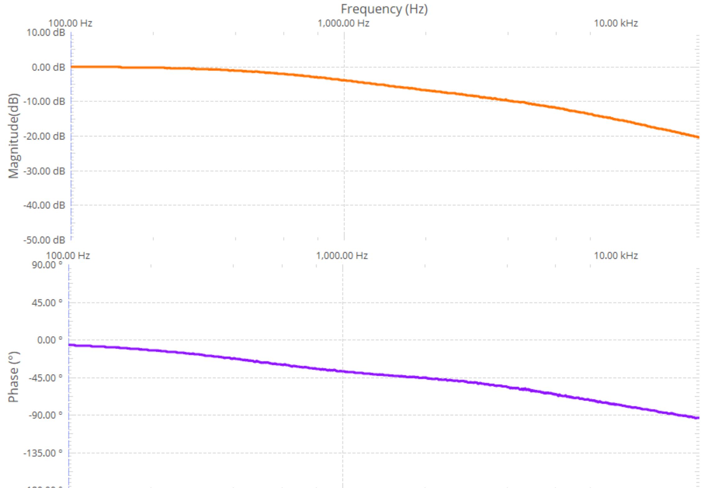

Second stage filter

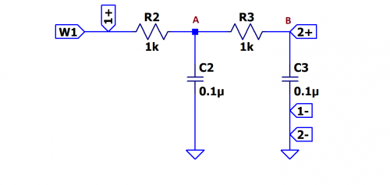
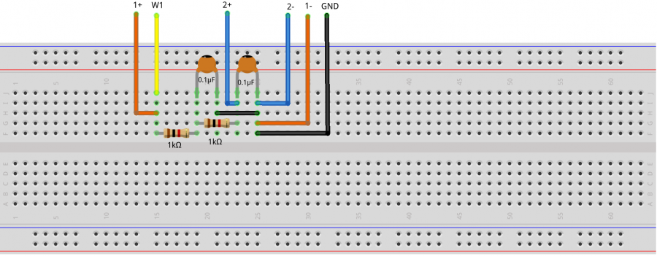

Steps:
- Connect the Scope Channel 2 after the first RC group and do a single sweep
- Take a signal snapshot to preserve the result as a reference
- Connect the Scope Channel 2 after the second RC stage and perform another sweep
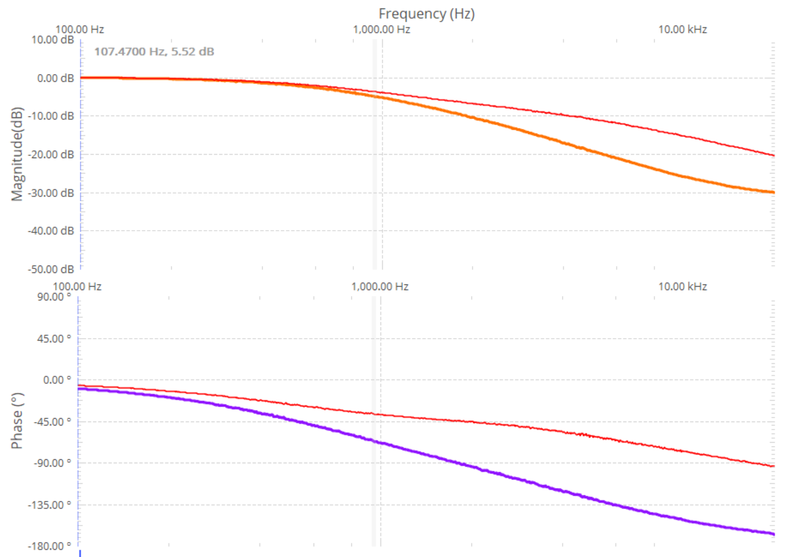

Demo 2

Digital Pattern Generator and Scope – AD5626 component – SPI controlled and analog signal visualized using Scope

Materials used:
- ADALM2000 Active Learning Module
- Solder-less breadboard
- Jumper wires
- 1 - AD5626 12-bit nanoDAC
- 1 x 2.2 KΩ resistor
- 1 x 0.001 uF capacitor(marked 102)
- 1 x 0.1 uF capacitor(marked 104)
- 1 x 10 uF capacitor

Theory of operation
SPI Transfer:
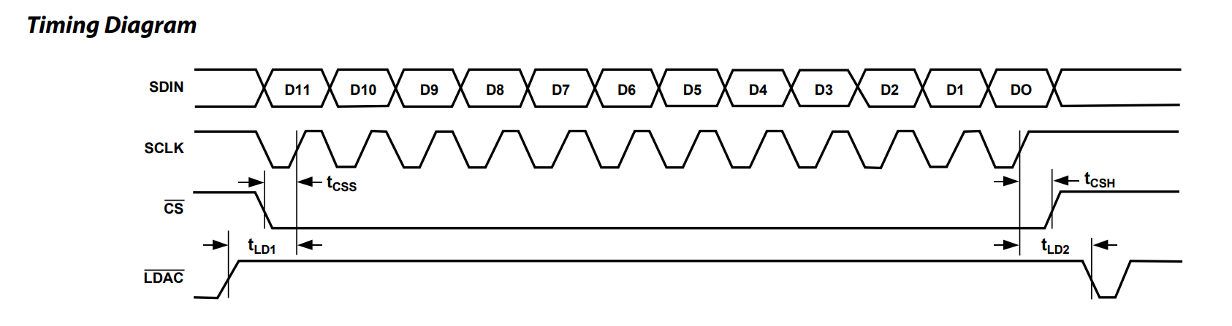
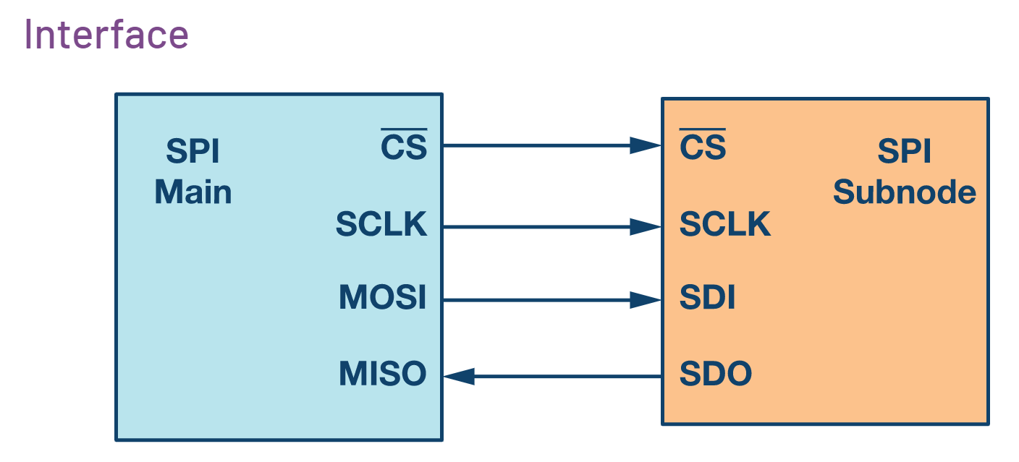

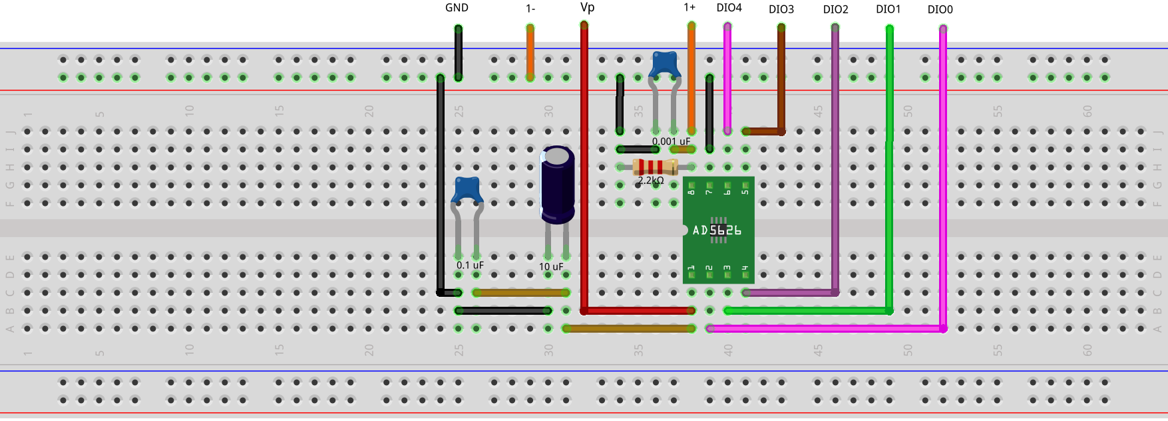
Hardware Setup:
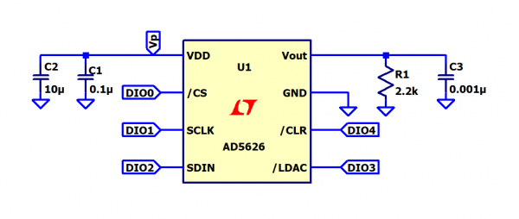

Steps:
- Connect the Vp power supply to the Vdd of the chip, set it to 5V
- Connect the GND pin to the GND of the M2K
- Beware not to connect the supply pins of the chip to the positive power of ADALM2000 and GND in a reversed order!
- Connect the digital pins to the corresponding chip pins as shown in the schematic.
- Configure the SPI interface in pattern generator to match the timing diagram of the AD5626 datasheet.

Pattern generator signals:
- DIO0 - /CS
- DIO1 – SCLK
- DIO2 – SDIN
- DIO3 - /LDAC
- DIO4 - /CLR

Setup:
- According to the time diagram, minimum SPI clock period is 30ns, set the SPI frequency to 1MHz
- Set CLK polarity and Phase to 1
- Set number of bytes per frame to 2
- Configure the /LDAC and /CLR signals:
  - According to the AD5626 datasheet, the shift register contents are updated on the rising edge of /LDAC if /CLR is high.
  - Set the pattern of DIO4 (/CLR) as “Number” and enter the value 1.
  - /LDAC signal(DIO3) should have a rising edge before /CS falling edge and should be high as long as bits are transmitted serially.
  - With respect to the stated conditions, the DIO3 signal needs to be set as pulse type 100kHz frequency, Low number of samples equal to 5, High 75, for the set frequency of the SPI 1MHz.
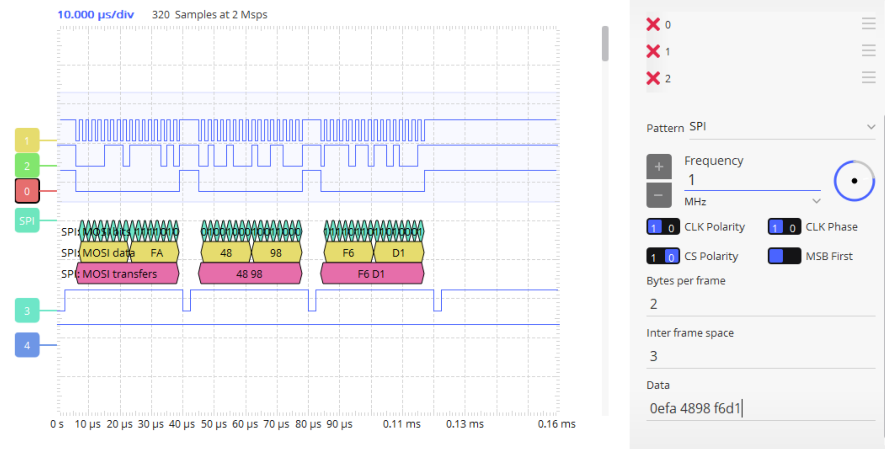
- Open Scope instrument and connect Scope channel 1 to output pin of the AD5626 (pin 8 of the IC)
- Enable the positive 5V Power supply
- Set some values in the Data control of the pattern generator SPI configurator
- Enable Channel 1 measurements to view the analog values
- Change the initially transmitted values
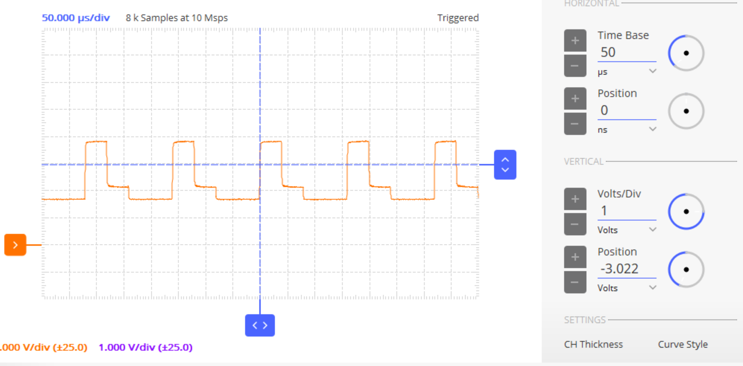

References:

- ADALM2000 Wiki:
  - https://wiki.analog.com/university/tools/m2k
  - https://wiki.analog.com/university/tools/m2k/accessories/bnc
  - https://wiki.analog.com/university/tools/m2k/accessories/power
- ADALM2000 Lab Activities:
  - https://wiki.analog.com/university/courses/electronics/labs
- Virtual classroom:
  - https://ez.analog.com/community/university-program

