Java installation path : C:\Program Files\Java\jdk-17\

Step 01: The Java Platform - An Introduction
Java is platform independent language.
A computer only understands binary code, which are sequences of 0 ʼs and 1 ʼs (called bits). All instructions to a computer should be converted to 0 ʼs and 1 ʼs before execution.

When we wrote our code in JShell, how was it converted to binary code? :
We write our programs in a high-level language, such as Java, as it is easier to learn, remember and maintain.
Who converts it to binary code?
Typically, Compiler is a program which understands the syntax of your programming language and converts it into binary code.
Java designers wanted it to be Platform independent. Compile the code once and run it anywhere.
However, different Operating Systems have different instruction sets - different binary code.

Java provides an interesting solution:
- All Java compilers translate source code to an intermediate representation ( bytecode ).
- There are different JVM's for different operating systems. Windows JVM converts bytecode into Windows executable instructions. Linux JVM converts bytecode into Linux executable instructions.
The Java compiler translates Java source code to bytecode, which is stored as a .class file on the computer.

Step 02: Creating a Java class
a class is a template. Objects are instances of a class .
Syntax : class class_name { } E.g :- class Country { } // syntax for class creation

ClassName objectName = new ClassName() e.g : Country india = new Country(); // syntax for object instace creation.

We can create multiple instances for 1 class.

Writing and Running Java Code
Planet.java
class Planet {
void comingSoon(){
System.out.println("Coming Soon ...");
}
public static void main(String[] args) {
Planet earth = new Planet();
earth.comingSoon();
}
}
The source file name must match the class name it contains. Here, we must name the file Planet.java .
You can compile java code using javac Planet.java . You can see that a new file is created Planet.class . This contains your bytecode .
You can run the class using command java Planet .
The main() method is essential to run code defined within any class .
The definition of main() needs to have this exact synatx: public static void main(String[] args) { /* */ }
A few details:
- void is its return type
- main is its name
- args is its formal argument. Here, it's an array of String .
- `public and static``` are reserved Java keywords. More on these later sections
javac filename // it will create the bytecode file and extention will be _.class file, it will done by JDK
java className // it will run by JVM. Java is platform independent but JVM is platform dependent(windos, mac,).
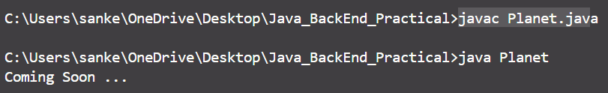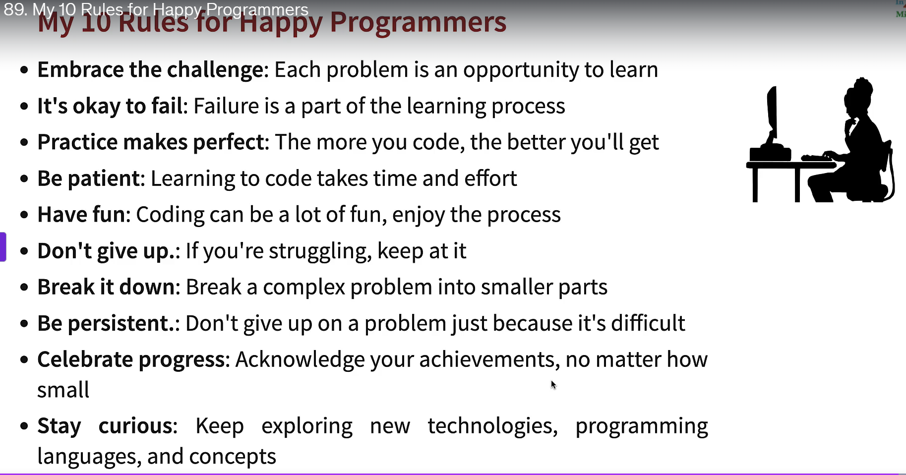

The JVM, JRE And JDK
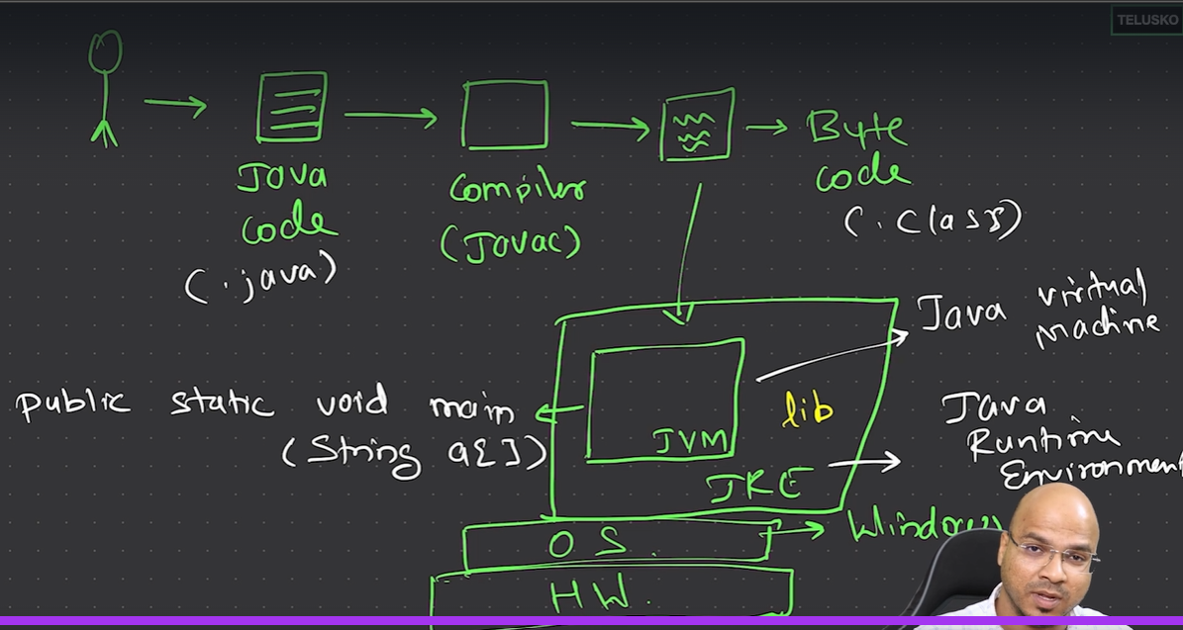
- JDK is needed to Compile and Run Java programs
- JRE is needed to Run Java Programs
- JVM is needed to Run Bytecode generated from Java programs
Let's check a couple of scenarios to test your understanding.
Scenario 1: You give Planet.class file to a friend using a different operating system. What does he need to do to run it? First, install JRE for his operating system. Run using java Planet on the terminal. He does not need to run javac, as he already has the bytecode.
Scenario 2: You gave your friend the source file Planet.java. What does he need to do to run it? Install JDK of a compatible version. Compile code using javac Planet.java. Run java Planet on his terminal.
In summary
Application Developers need ==> JDK
Application Users need ==> JRE
--------------------------------------------- 28 / Jan/ 2026 -------------------------------------------------------
1)What is class and object in java?
2)what is constructor?
Q1).what is object equality in java backend
1️⃣ Reference equality (==)
This checks whether two variables point to the exact same object in memory.
User u1 = new User("Alice");
User u2 = u1;

System.out.println(u1 == u2); // true
But:
User u1 = new User("Alice");
User u2 = new User("Alice");

System.out.println(u1 == u2); // false
2️⃣ Logical (value) equality (equals())
This checks whether two objects should be considered equal based on their content.
u1.equals(u2);
Default behavior
If you don’t override equals(), Java behaves like this:
public boolean equals(Object obj) {
return this == obj;
}
So by default, equals() ≈ ==

🔴 Important
By default, equals() behaves exactly like ==.
So unless you override it:
User a = new User("Alice");
User b = new User("Alice");

a.equals(b); // false
Because they are two different objects in memory.

2️⃣ Then why does equals() exist at all?
Because Java allows polymorphism.
Java lets your class decide what “equality” means.
Example (real-life meaning)
Two users are “equal” if:
- they have the same id
- or same email
Java doesn’t know that — you must teach it by overriding equals().

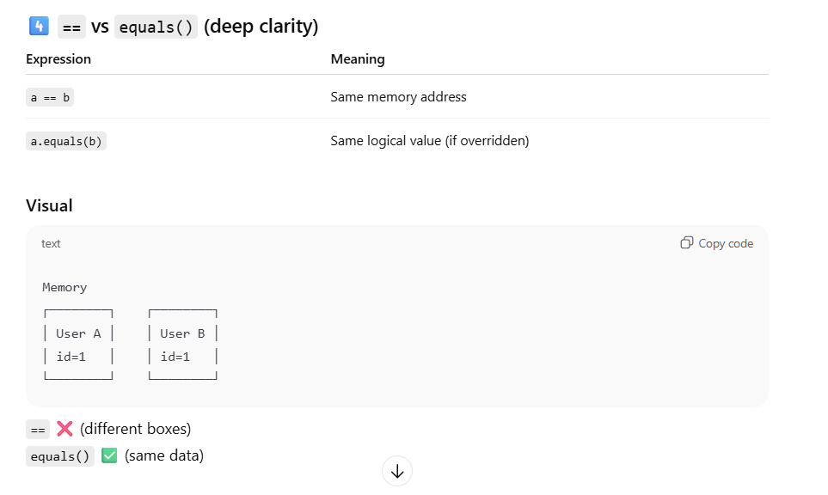

--------------------------------------------- 29 / Jan/ 2026 -------------------------------------------------------
1)local vs Instance vs static vs global
2)heap vs stack vs metaspace
3)various roles of interface in software development
-> contract
-> for multiple inheritance
-> for masking
-> for loose coupling (dynamic binding)
->abstraction
->generalization
4) 4 pillars of oops

--------------------------------------------- 30 / Jan/ 2026 -------------------------------------------------------

--------------------------------------------- 2 / Feb/ 2026 -------------------------------------------------------
--------------------------------------------- 3 / Feb/ 2026 -------------------------------------------------------
--------------------------------------------- 4 / Feb/ 2026 -------------------------------------------------------

