STANDARD OPERATING PROCEDURE
Drug Management System
SharePoint-Based Document Lifecycle & Electronic Signature Workflow
Document No: SOP-DMS-001
Version: 1.0
Effective Date: March 2026
Prepared by: Treta Infotech

Table of Contents
1. System Overview and Purpose
2. SharePoint List Setup and Choice Column Configuration
3. Screen-by-Screen Walkthrough
3.1 Add Document
3.2 Edit Document
3.3 View Document
3.4 CTD Folder Structure
4. Approve / Reject Workflow
5. User Group Roles and Permissions
6. Power Automate Flow 1 — Adobe Sign Implementation
7. Power Automate Flow 2 — Adobe Auto Save Signed Document
8. Troubleshooting and FAQ

1. System Overview and Purpose
The Drug Management System (DMS) is a SharePoint-based web application built using the SharePoint Framework (SPFx). It provides a centralised, controlled environment for managing pharmaceutical regulatory documents across their full lifecycle — from authoring through review, approval, and electronic signature.

1.1 Business Objectives
- Provide a single source of truth for all regulatory and clinical documents.
- Enforce a structured review-and-approval workflow aligned with pharmaceutical quality standards.
- Integrate with Adobe Sign for tamper-evident electronic signatures.
- Restrict access to sensitive documents through SharePoint group-based permissions.
- Maintain a searchable, categorised CTD (Common Technical Document) folder hierarchy.

1.2 Technology Stack
Component | Technology
Frontend Web Part | SharePoint Framework (SPFx) v1.20, React 17
UI Library | Fluent UI / Office UI Fabric React
Data Layer | PnPjs (SharePoint REST API)
Automation | Microsoft Power Automate
Electronic Signature | Adobe Sign (Acrobat Sign)
State Management | Jotai

1.3 Document Lifecycle
A document in the DMS passes through the following states:
- Draft — Initial state when created by an Author.
- Under Review — Submitted to a Reviewer for feedback.
- Pending Approval — Forwarded to an Approver.
- Approved — Cleared by the Approver; eligible for eSignature.
- Rejected — Returned to the Author with comments.
- Signed — Electronically signed via Adobe Sign; PDF auto-saved to SharePoint.

2. SharePoint List Setup and Choice Column Configuration
The DMS is backed by several SharePoint lists. Administrators are responsible for keeping the choice-column data current to ensure that form drop-downs remain accurate.

2.1 Key SharePoint Lists
List Name | Purpose | Primary Columns
Project Documents | Stores all document metadata | Title, Category, Status, Drug, Phase, Author, Approver, Version
eSignature | Queues documents for Adobe Sign | Title, DocumentPath, Status, AgreementID
Categories | Master list of document categories | Name, Group, DocumentCategory, Level, Status
Drugs | Drug/compound master data | Name, GenericName, Indication, Phase, Status
Templates | Reusable document templates | Name, MappingType, CTDFolder, Section, Country, Version

2.2 Adding and Managing Choice Column Options
Choice columns control the values available in drop-down menus throughout the application. To add or edit choices:
- Navigate to your SharePoint site and click the Settings gear icon → Site Contents.
- Locate the target list (e.g., "Project Documents") and click to open it.
- Click the Settings gear → List Settings.
- Under "Columns", click the column you wish to modify (e.g., "Category").
- In the "Type each choice on a separate line" text area, add, remove, or reorder values.
- Click OK to save. Changes take effect immediately in the DMS application.

Important: Removing a choice that is already used by existing items will leave those items with an invalid value. Always rename rather than delete choices when items already reference them.

2.3 Status Column Values
Value | Meaning | Transitions To
Draft | Author is still working on the document | Under Review
Under Review | Reviewer is providing feedback | Pending Approval, Draft
Pending Approval | Approver is reviewing | Approved, Rejected
Approved | Document cleared; sent to Adobe Sign | Signed
Rejected | Returned to Author for revision | Draft
Signed | Electronic signature captured | —

3. Screen-by-Screen Walkthrough

3.1 Add Document
The Add Document form allows authorized Authors to upload a new document and populate its metadata.

Steps to Add a Document
- Log in to the SharePoint site hosting the DMS web part.
- On the Documents dashboard, click the "Add Document" (+ Add) button in the toolbar.
- The Add Document panel slides in from the right side of the screen.
- Complete all required fields marked with an asterisk (*):
  - Document Title — Enter a descriptive name (e.g., "Aspirin Module 2 Clinical Study").
  - Category — Select from the configured choice column (e.g., Clinical, Quality, Nonclinical).
  - Drug / Compound — Select from the Drugs master list.
  - Phase — Select the development phase (e.g., Phase I, Phase III, Marketed).
  - Version — Enter the document version number (e.g., 1.0).
  - Upload File — Click "Browse" and select the .docx, .pdf, or .xlsx file from your computer.
- Click "Save" to create the list item and upload the file to the "Shared Documents/Project Documents" library.
- A success toast notification confirms that the document was added.

Note: Only users in the Author or Admin SharePoint groups can access the Add Document button. Users in the User group have read-only access.

3.2 Edit Document
Authors and Administrators may update document metadata at any time (except when a document is in "Pending Approval" or "Signed" state).
- In the Documents list, locate the document you wish to edit.
- Click the pencil (Edit) icon in the Actions column.
- The Edit Document panel opens with all current values pre-populated.
- Modify the required fields.
- To replace the attached file, click "Replace File" and upload the new version.
- Click "Save" to commit the changes. The version field should be incremented manually.

3.3 View Document
Any authenticated user may view document metadata. Only authorized users may open the file.
- Click the eye (View) icon next to any document in the list.
- The View Document panel opens showing all metadata fields in read-only mode.
- Click "Open Document" to open the file in the browser or download it.
- Click "X" or click outside the panel to close.

3.4 CTD Folder Structure
The CTD (Common Technical Document) view presents documents in an eCTD-compliant module hierarchy.
Module | Section | Description
Module 1 | 1.1, 1.2 | Administrative — Comprehensive TOC, Investigator Brochure
Module 2 | 2.4, 2.5 | Summaries — Nonclinical & Clinical Overviews
Module 3 | 3.2.A, 3.2.P | Quality — Facilities & Drug Product
Module 4 | 4.2.1, 4.2.2 | Nonclinical — Pharmacology & Toxicology
Module 5 | 5.3.1, 5.3.5 | Clinical — Study Reports & Efficacy Reports
To navigate the CTD view, click on any module in the tree panel on the left. The right pane displays documents belonging to that section. Clicking a document opens the View Document panel.

4. Approve / Reject Workflow
The DMS enforces a structured multi-stage workflow to ensure quality oversight before a document is signed.

4.1 Workflow Stages
Stage | Actor | Actions Available
Draft | Author | Edit, Submit for Review, Delete
Under Review | Reviewer | Provide comments, Forward to Approver, Return to Author
Pending Approval | Approver | Approve, Reject with comments
Approved | System / Admin | Trigger Adobe Sign via eSignature list
Rejected | Author | View rejection comments, Edit, Resubmit
Signed | Read-only | View, Download signed PDF

4.2 Approver Steps — Approving a Document
- Log in as a user in the Approver SharePoint group.
- Navigate to the "Pending Approval" tab on the dashboard or filter the document list by Status = "Pending Approval".
- Click the eye icon to open the document and review its content.
- Click "Approve" in the action panel.
- Optionally add an approval comment.
- Confirm the action. The document status updates to "Approved".
- The system (or Admin) then adds an entry to the eSignature list to trigger Adobe Sign.

4.3 Approver Steps — Rejecting a Document
- Open the document from the "Pending Approval" list.
- Click "Reject".
- Enter mandatory rejection comments explaining the reason.
- Confirm the action. The status reverts to "Rejected" and the Author is notified.
- The Author should review the comments, revise the document, and resubmit.

5. User Group Roles and Permissions
Access to DMS features is controlled by three SharePoint Groups. Group membership is managed by the SharePoint Site Administrator.

5.1 Group Overview
Group Name | SharePoint Permission Level | DMS Role
DMS-Admin | Full Control | Administrator
DMS-HR | Contribute | HR / Author
DMS-User | Read | Read-Only User

5.2 Administrator (DMS-Admin)
Administrators have unrestricted access across the entire system.
- Manage list choice-column data (Category, Status, Phase, etc.).
- Add, edit, and delete any document regardless of status.
- Manage user group membership via SharePoint.
- Configure site settings, columns, and views.
- Trigger eSignature workflows and view all Power Automate flow run history.
- Access all SharePoint library contents including Signed Documents.

5.3 HR / Author (DMS-HR)
HR users can create and manage documents they own.
- Add new documents and upload files.
- Edit documents they authored (when in Draft or Rejected state).
- Submit documents for review.
- View all documents in the list (read-only for others).
- Cannot approve, reject, or modify choice-column metadata.

5.4 User (DMS-User)
Standard users have view-only access.
- Browse and search the document list.
- View document metadata panels.
- Open and download approved documents (subject to file-level permissions).
- Cannot add, edit, delete, approve, or reject documents.

5.5 Managing Group Membership
- Navigate to your SharePoint site → Settings → Site Permissions.
- Click the group you wish to manage (e.g., DMS-HR).
- Click "New" → "Add Users" and enter the user's email address.
- Click "Share" to confirm. The user gains DMS access within minutes.

6. Power Automate Flow 1 — Adobe Sign Implementation
This flow sends a document for electronic signature via Adobe Sign (Acrobat Sign) whenever a new item is created in the eSignature SharePoint list.

6.1 Flow Overview
Flow Name: Adobe Sign Implementation
Trigger: When an item is created in the eSignature SharePoint list
Environment: Treta Infotech Private Limited — Power Automate

6.2 Step-by-Step Flow Description

Step 1: Trigger — When an item is created
The flow is triggered automatically when a new item is added to the eSignature SharePoint list.
Site Address: https://treta.sharepoint.com/sites/ReddApps/KrunalData
List Name: eSignature

Step 2: Get file content using path
Retrieves the binary content of the document file stored in the SharePoint document library.
Site Address: https://treta.sharepoint.com/sites/ReddApps/KrunalData
File Path: /Shared Documents/Surbhi-Godhani-20242411101242.docx (dynamic — uses list item file path)

Step 3: Create an agreement and send for signature
This is the core step that calls the Adobe Sign connector.
Field | Value
Agreement Name | Title (from the eSignature list item)
File Name 1 | Dynamic filename from the list item
File Content 1 | Body (file binary from Step 2)
Signature Type | ESIGN
Participant Member 1 (Email) | surbhi.godhan@tretainfotech.com
Participant Order 1 | 1
Participant Role 1 | APPROVER
Participant Member 2 (Email) | surbhi.godhan@tretainfotech.com
Participant Order 2 | 2
Participant Role 2 | SIGNER

Participant Roles: The APPROVER (Order 1) reviews the document first. After approval, the SIGNER (Order 2) applies the electronic signature. Both steps are sequential.

6.3 Connector Setup
- In Power Automate, click "Connections" in the left navigation.
- Click "+ New connection" and search for "Adobe Acrobat Sign".
- Sign in with the Adobe Sign account credentials supplied by your administrator.
- Confirm the connection. It will appear in the connections list as "Adobe Acrobat Sign".
- Return to the flow and ensure the "Create an agreement" step uses this connection.

Flow Diagram — Adobe Sign Implementation
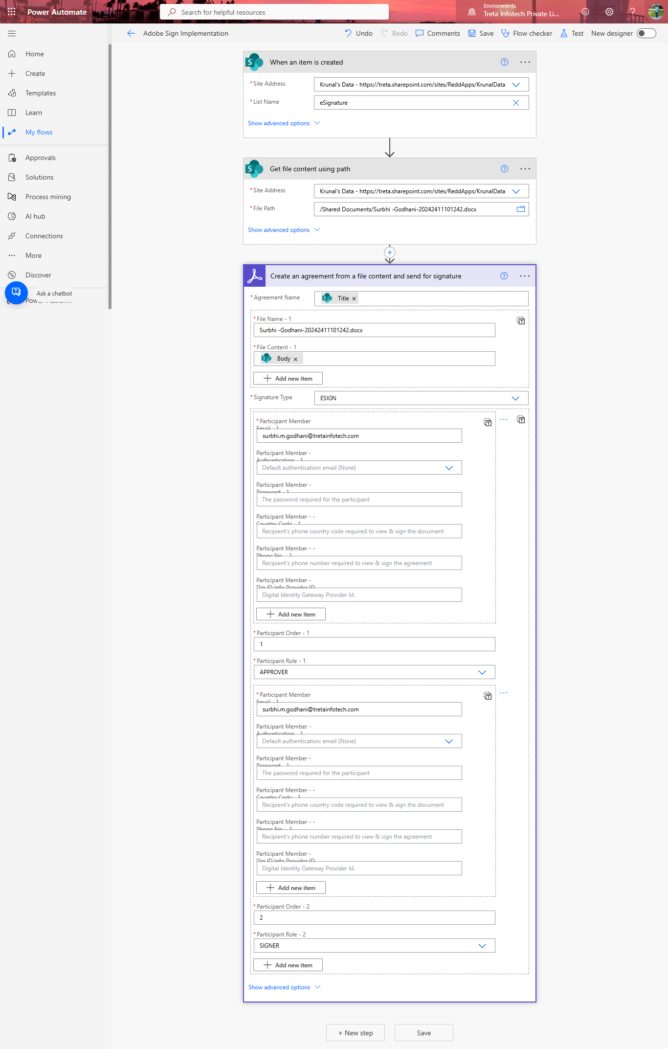

7. Power Automate Flow 2 — Adobe Auto Save Signed Document
This flow monitors Adobe Sign for agreements that reach the SIGNED state and automatically saves the completed PDF to a designated SharePoint library.

7.1 Flow Overview
Flow Name: Adobe Auto Save Signed Document
Trigger: When the state of an agreement changes (Adobe Sign connector)
Environment: Treta Infotech Private Limited — Power Automate

7.2 Step-by-Step Flow Description

Step 1: Trigger — When the state of an agreement changes
The Adobe Sign connector polls for agreement state changes.
Name: Get Signed document
Scope: Any agreement in my account
Events: When a participant completes their action

Step 2: Compose
Extracts the agreement.id dynamic value from the trigger output for use in downstream steps.
Inputs: agreement.id (dynamic value from trigger)

Step 3: Initialize variable
Stores the agreement status in a string variable for use in the condition.
Name: AgreementStatus
Type: String
Value: agreement.status (dynamic value from trigger)

Step 4: Condition — Check if agreement is SIGNED
Evaluates whether the AgreementStatus variable equals "SIGNED".
- If Yes → proceed to retrieve and save the signed PDF.
- If No → do nothing (empty branch).

Step 5 (If Yes): Get Signed Document
Calls the Adobe Sign "Get a PDF of a signed agreement" action.
Agreement ID: agreement.id (from Compose step)

Step 6 (If Yes): Create file in SharePoint
Saves the signed PDF to the SharePoint Shared Documents library.
Field | Value
Site Address | https://treta.sharepoint.com/sites/ReddApps/KrunalData (Krunal's Data)
Folder Path | /Shared Documents/Signed Document
File Name | Signed_[agreement.name]_[utcNow()].pdf
File Content | Body (PDF binary from Get Signed Document step)

Folder: Ensure the "Signed Document" folder exists in the "Shared Documents" library before enabling the flow. The flow will fail if the folder is missing.

7.3 Connector Setup
- In Power Automate, open Connections and verify that the "Adobe Acrobat Sign" connection is active (established in Flow 1 setup).
- Also verify the "SharePoint" connection is present and authenticated with an account that has Contribute rights to the target site.
- Open the flow and confirm each action references the correct connection.
- Click "Save" and then "Test" → "Manually" to validate the end-to-end process.

Flow Diagram — Adobe Auto Save Signed Document
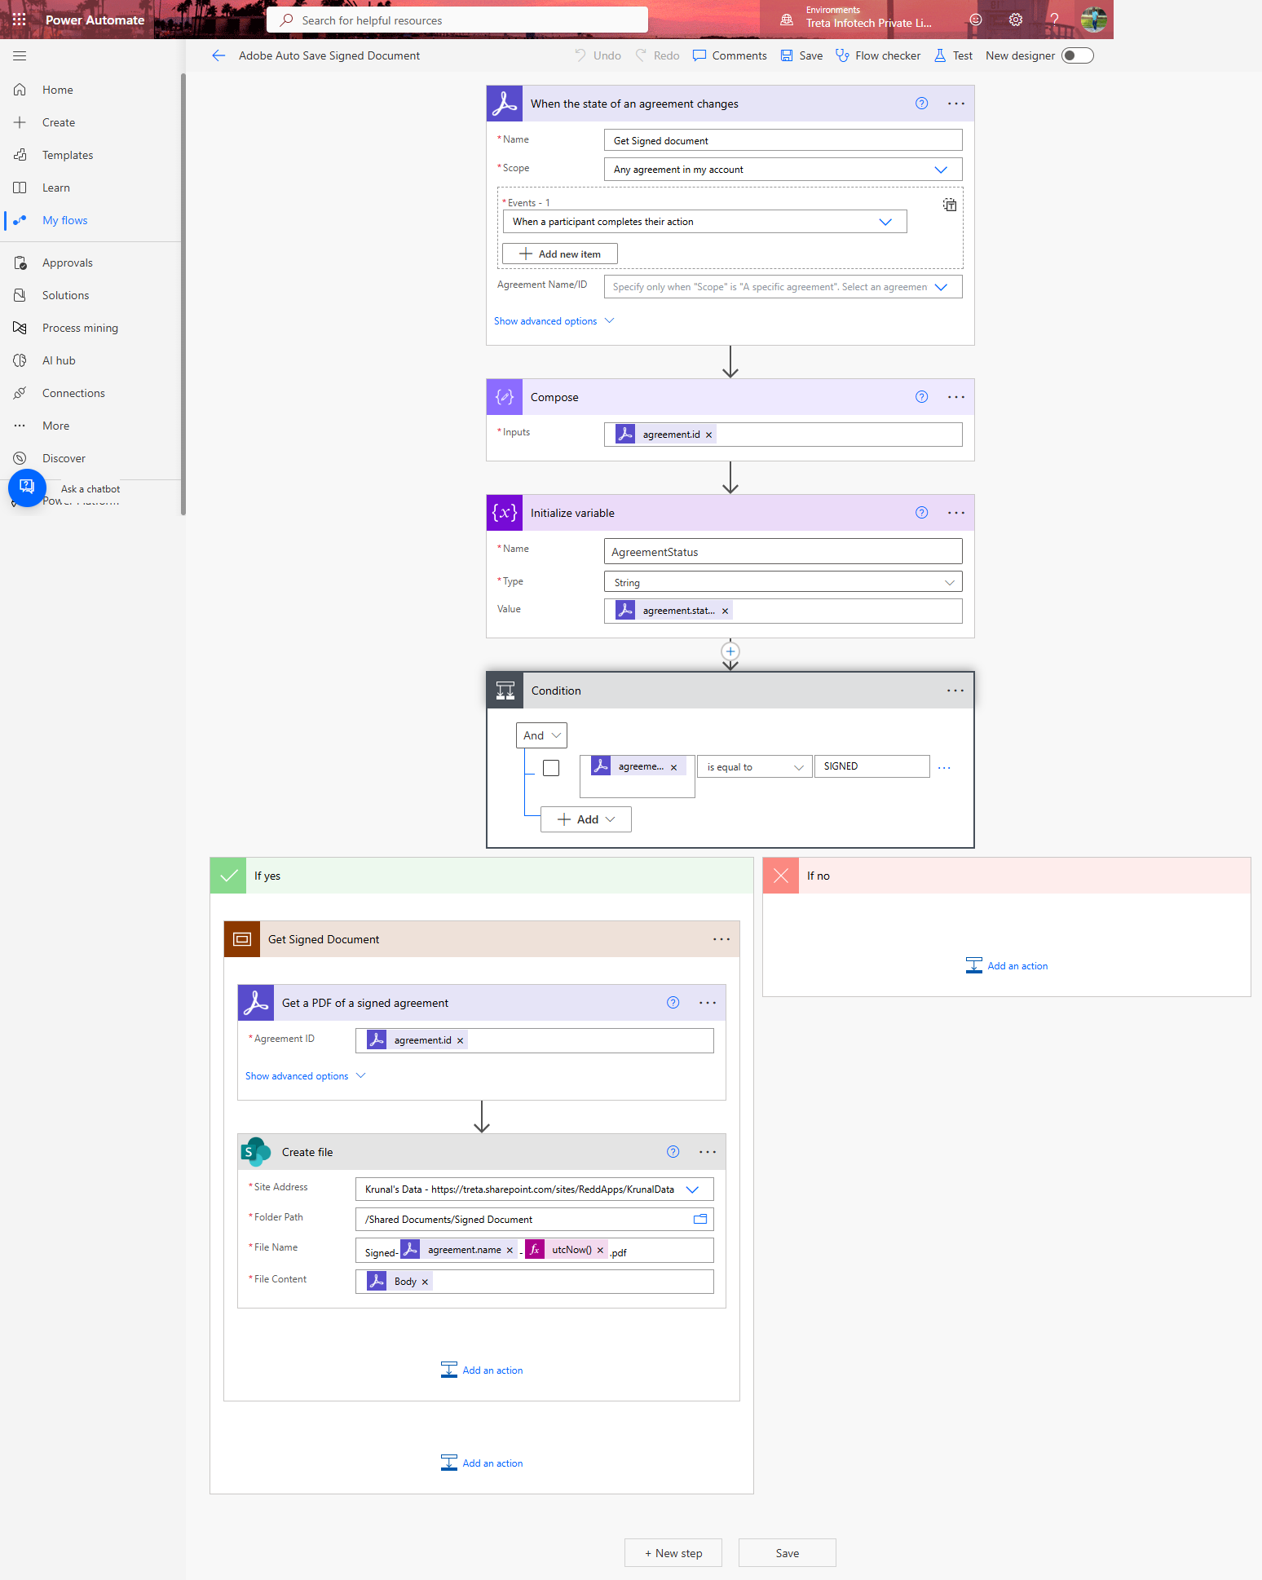

8. Troubleshooting and FAQ
Issue | Likely Cause | Resolution
Cannot see the "Add Document" button | User is in DMS-User group (read-only) | Request Admin to move you to DMS-HR group
Document status is stuck on "Pending Approval" | Approver has not acted | Contact the assigned Approver or Admin
Adobe Sign email not received | Adobe Sign connector uses wrong email | Check Participant Member email in Flow 1
Signed PDF not saved to SharePoint | "Signed Document" folder does not exist | Create the folder in Shared Documents library
Flow fails with "Unauthorized" | Adobe Sign connection has expired | Re-authenticate the Adobe Sign connection in Power Automate
Choice column value missing from dropdown | Value not added to column settings | Admin must add the value via List Settings → Column

For further assistance, contact your SharePoint Administrator or Power Platform support team.

