**ASP.NET MVC5 ADO.NET**

[**https://www.youtube.com/watch?v=3pEax-5wXG8&t=3276s**](https://www.youtube.com/watch?v=3pEax-5wXG8&t=3276s)

1. Create project with MVC
2. Database: Right click on App_Data 🡪 Add 🡪 New Item

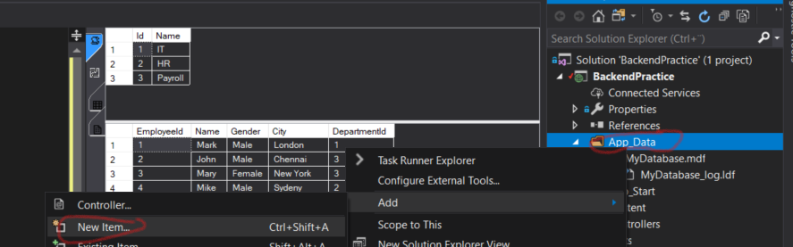

Select SQL Server Database with name MyDatabase.mdf

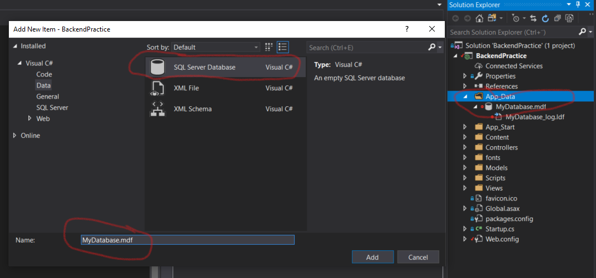

Create tables

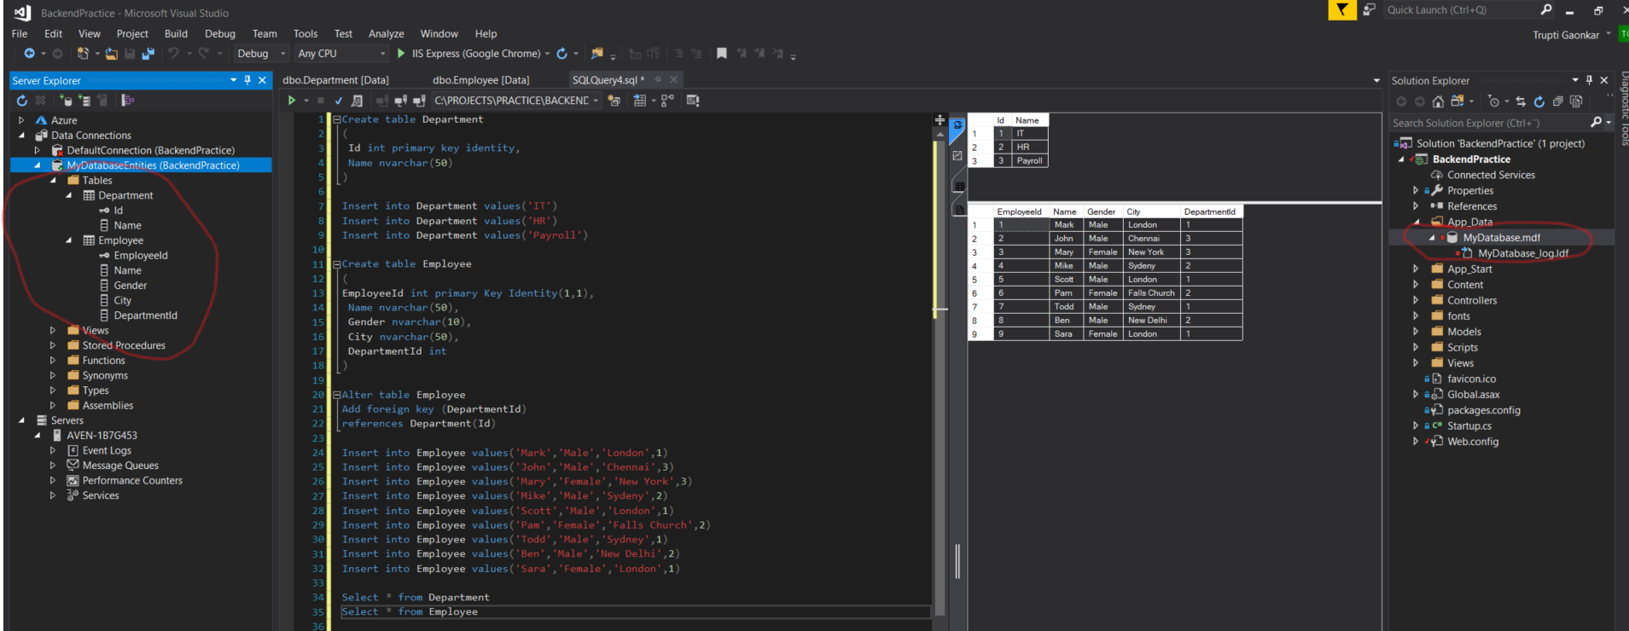

Right click on Table and click new query and execute the query as follows:

Create table Department

(

Id int primary key identity,

Name nvarchar(50)

)

Insert into Department values('IT')

Insert into Department values('HR')

Insert into Department values('Payroll')

Create table Employee

(

EmployeeId int primary Key Identity(1,1),

Name nvarchar(50),

Gender nvarchar(10),

City nvarchar(50),

DepartmentId int

)

Alter table Employee

Add foreign key (DepartmentId)

references Department(Id)

Insert into Employee values('Mark','Male','London',1)

Insert into Employee values('John','Male','Chennai',3)

Insert into Employee values('Mary','Female','New York',3)

Insert into Employee values('Mike','Male','Sydeny',2)

Insert into Employee values('Scott','Male','London',1)

Insert into Employee values('Pam','Female','Falls Church',2)

Insert into Employee values('Todd','Male','Sydney',1)

Insert into Employee values('Ben','Male','New Delhi',2)

Insert into Employee values('Sara','Female','London',1)

Select * from Department

Select * from Employee

1. Add entity data **model**:

Right click on Models 🡪 Add 🡪 New Item 🡪 Select Data and ADO.NET Entity Data Model 🡪 provide Name as MyDataModel 🡪 Add

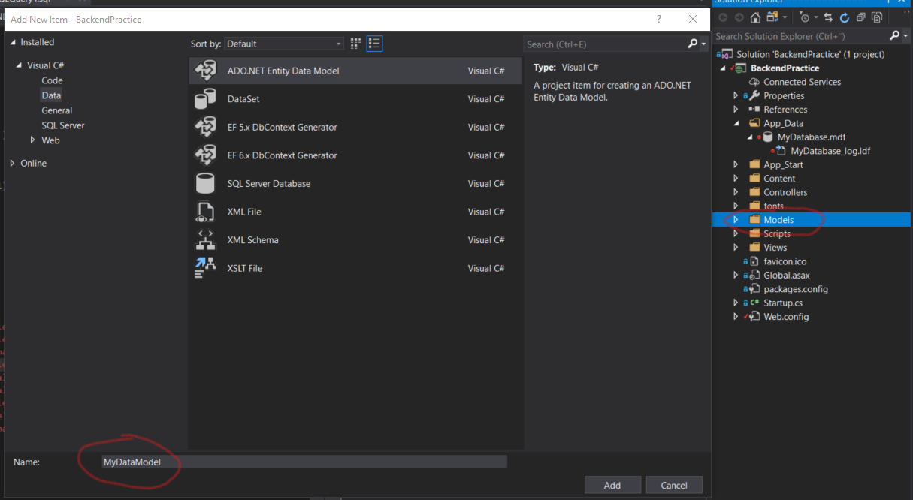

Select following and click Next:

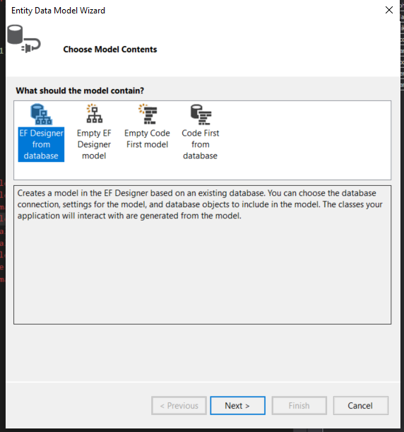

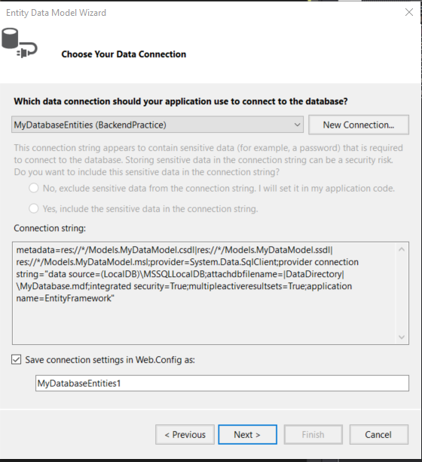

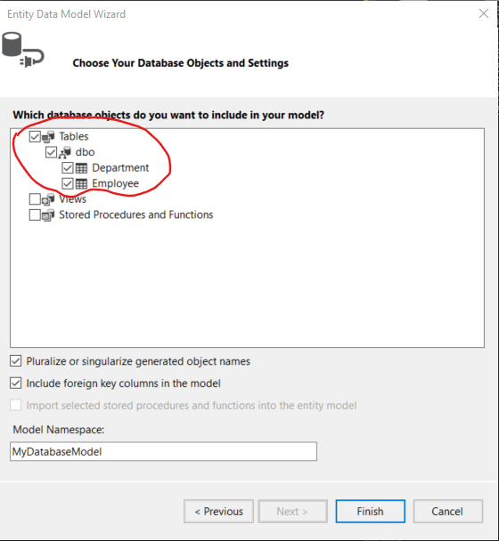

It will create model inside Models folder:

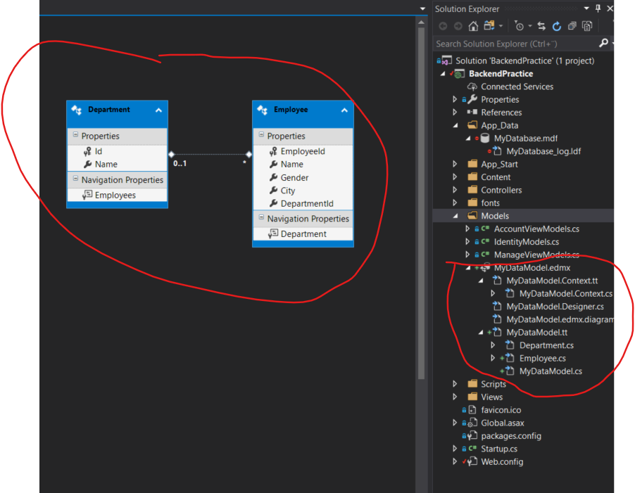

1. **Controller:** Create new controllers i.e. Employees and Departments with models provided

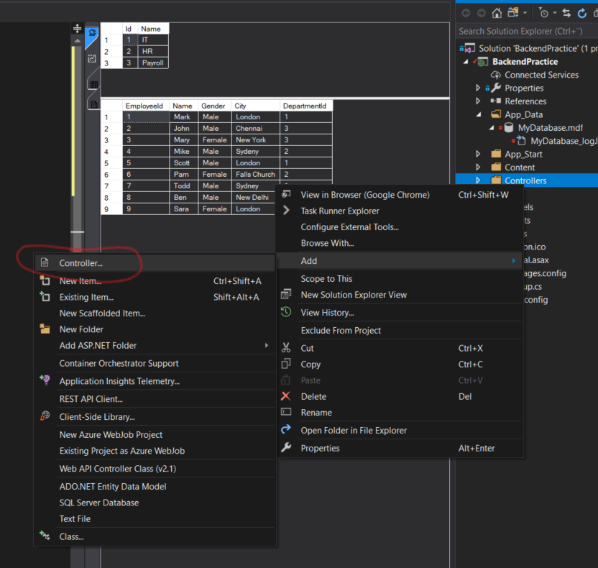

With following scaffold:

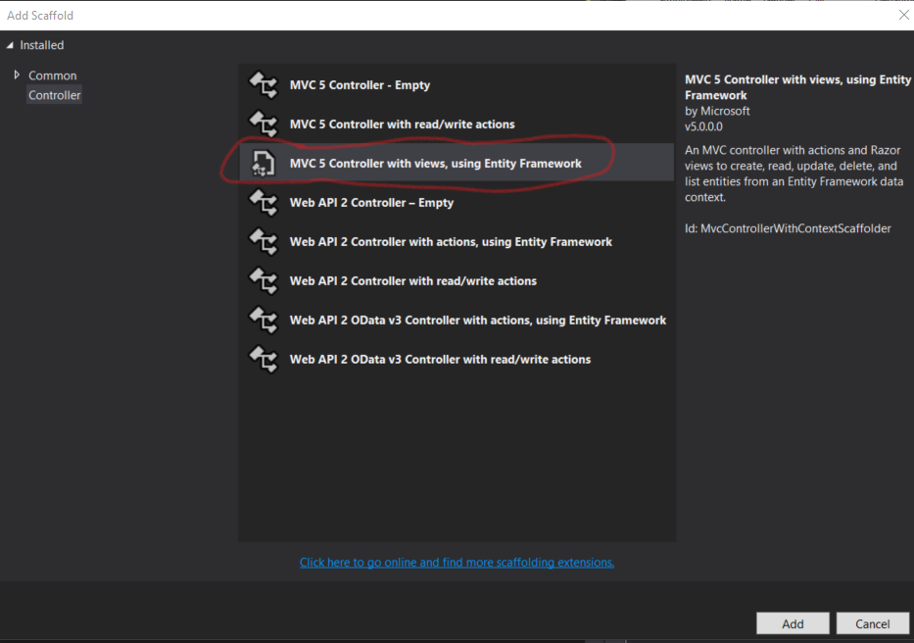

Employee controller

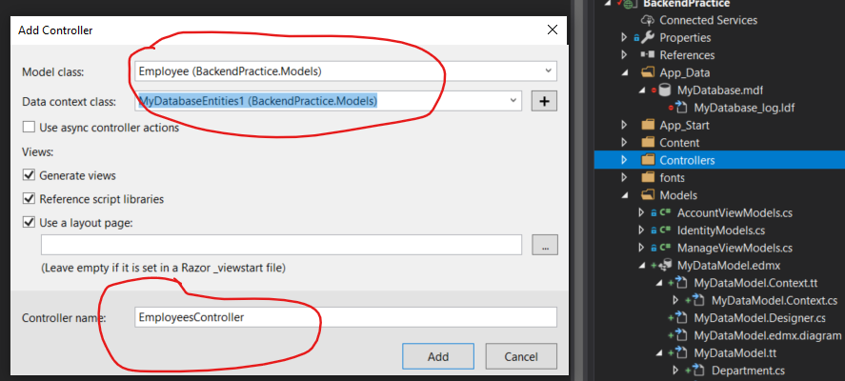

Department Controller

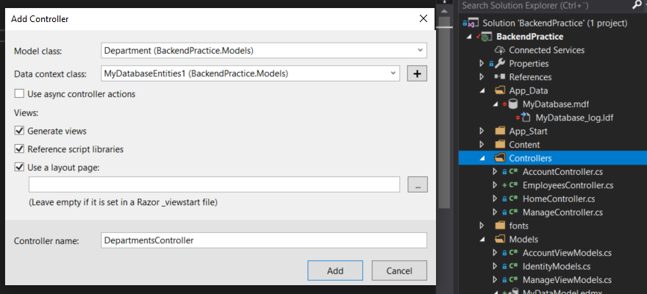

**ASP.NET MVC5 Entity framework Code first**

<https://www.youtube.com/watch?v=p9GdkmFzoPw>

1. Create new project

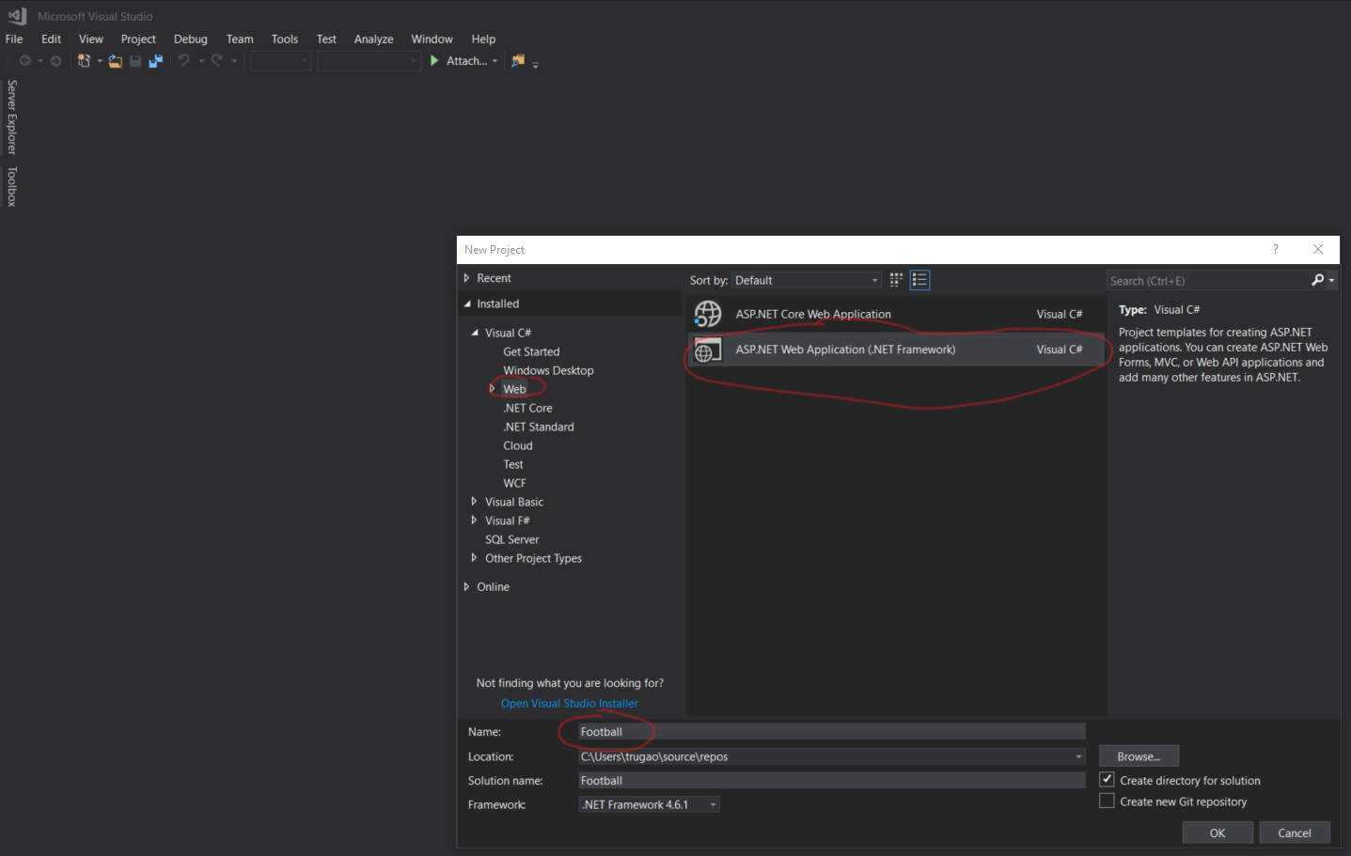

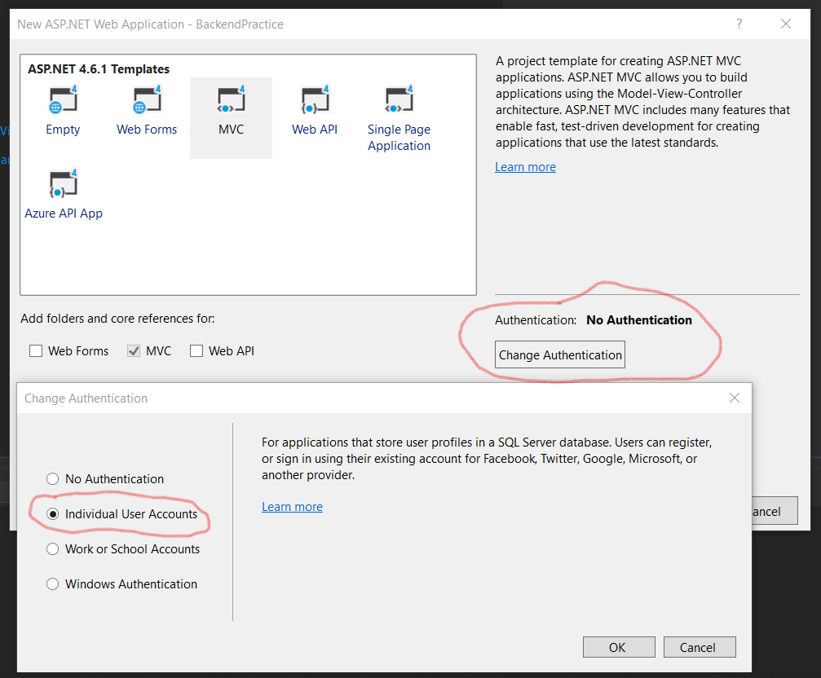

1. Create folder **football** in the model and create following 2 classes, and context class

|  |  |
| --- | --- |
| **Team.cs** | **Player.cs** |
| using System;  using System.Collections.Generic;  using System.ComponentModel.DataAnnotations;  using System.Linq;  using System.Web;  namespace Football.Models.football  {  public class Team  {  [Key]  [MaxLength(30)]  public string TeamName { get; set; }  public string City { get; set; }  public string Province { get; set; }  public List<Player> Players { get; set; }  }  } | using System;  using System.Collections.Generic;  using System.Linq;  using System.Web;  namespace Football.Models.football  {  public class Player  {  public int PlayerId { get; set; }  public string Name { get; set; }  public string Position { get; set; }  public string TeamName { get; set; }  public Team Team { get; set; }  }  } |

**FootballContext.cs**

using Football.Models.football;

using System;

using System.Collections.Generic;

using System.Data.Entity;

using System.Linq;

using System.Web;

namespace Football.Data

{

public class FootballContext: DbContext

{

public FootballContext(): base("DefaultConnection")

{ }

public DbSet<Team> Teams { get; set; }

public DbSet<Player> Player { get; set; }

}

}

1. Open Tools -> NuGet Package Manager 🡪 Package Manager Console

PM> Enable-Migrations -ContextTypeName FootballContext -MigrationsDirectory Migrations\Football

PM> add-migration -ConfigurationTypeName Football.Migrations.Football.Configuration "InitialCreate"