Mandatory Exercise 2 - HTML / CSS (flexbox and media queries .)

<https://www.youtube.com/watch?v=pBUZ_it-8zM>

<https://www.youtube.com/watch?v=IKu0zh2yrBI>

1. Create a new repository on GitHub called **mandatory-htmlcss2 (**Login in <https://github.com> ([truptigaonkar/trups11.trupti@gmail.com/vicky2878](mailto:truptigaonkar/trups11.trupti@gmail.com/vicky2878) **)**

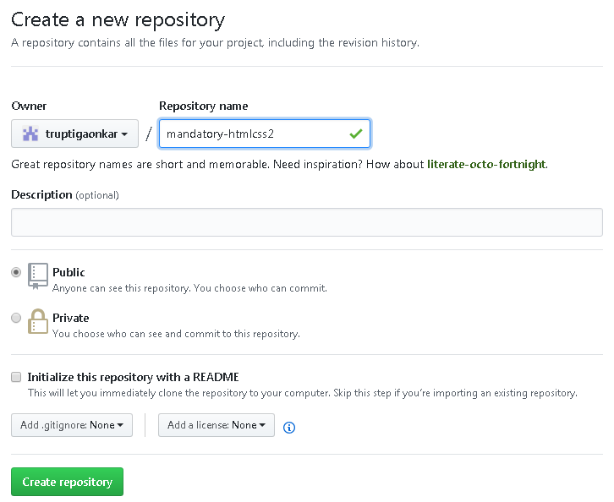

1. Follow the instructions that GitHub gives you; Create a local repository by cloning the newly created repository in the folder where you have to keep it.
2. RH click and select gitbash on folder where you have to clone the directory.

hariom@hariom-PC MINGW32 /d/lab projects (master)

$ git clone git@github.com:truptigaonkar/mandatory-htmlcss2.git

Cloning into 'mandatory-htmlcss2'...

warning: You appear to have cloned an empty repository.

1. Go inside the directory using cd

hariom@hariom-PC MINGW32 /d/lab projects (master)

$ cd mandatory-htmlcss2/

hariom@hariom-PC MINGW32 /d/lab projects/mandatory-htmlcss2 (master)

$ pwd

/d/lab projects/mandatory-htmlcss2

1. Perform all the below steps inside that folder only

hariom@hariom-PC MINGW32 /d/lab projects/mandatory-htmlcss2 (master)

$ echo "# mandatory-htmlcss2" >> README.md

hariom@hariom-PC MINGW32 /d/lab projects/mandatory-htmlcss2 (master)

$ git init

Reinitialized existing Git repository in D:/lab projects/mandatory-htmlcss2/.git/

hariom@hariom-PC MINGW32 /d/lab projects/mandatory-htmlcss2 (master)

$ git add README.md

warning: LF will be replaced by CRLF in README.md.

The file will have its original line endings in your working directory.

hariom@hariom-PC MINGW32 /d/lab projects/mandatory-htmlcss2 (master)

$ git status

On branch master

No commits yet

Changes to be committed:

(use "git rm --cached <file>..." to unstage)

new file: README.md

hariom@hariom-PC MINGW32 /d/lab projects/mandatory-htmlcss2 (master)

$ git commit -m "First commit"

[master (root-commit) 7604440] First commit

1 file changed, 1 insertion(+)

create mode 100644 README.md

hariom@hariom-PC MINGW32 /d/lab projects/mandatory-htmlcss2 (master)

$ git remote add origin git@github.com:truptigaonkar/mandatory-htmlcss2.git

fatal: remote origin already exists.

hariom@hariom-PC MINGW32 /d/lab projects/mandatory-htmlcss2 (master)

$ git push -u origin master

Enumerating objects: 3, done.

Counting objects: 100% (3/3), done.

Writing objects: 100% (3/3), 236 bytes | 236.00 KiB/s, done.

Total 3 (delta 0), reused 0 (delta 0)

remote:

remote: Create a pull request for 'master' on GitHub by visiting:

remote: https://github.com/truptigaonkar/mandatory-htmlcss2/pull/new/maste

remote:

To github.com:truptigaonkar/mandatory-htmlcss2.git

* [new branch] master -> master

Branch 'master' set up to track remote branch 'master' from 'origin'.

hariom@hariom-PC MINGW32 /d/lab projects/mandatory-htmlcss2 (master)

$ git status

On branch master

Your branch is up to date with 'origin/master'.

nothing to commit, working tree clean