**RR-Properties (PHP)**

Website URL - <https://rr-properties.com>

Admin Login URL - <https://rr-properties.com/wp-login.php>

Username - **nsarda**

Password - **Epicomm@123**

**Changes Done –**

Go to 🡪 Appearance 🡪 Theme Editor 🡪 functions.php (find at right side of page)

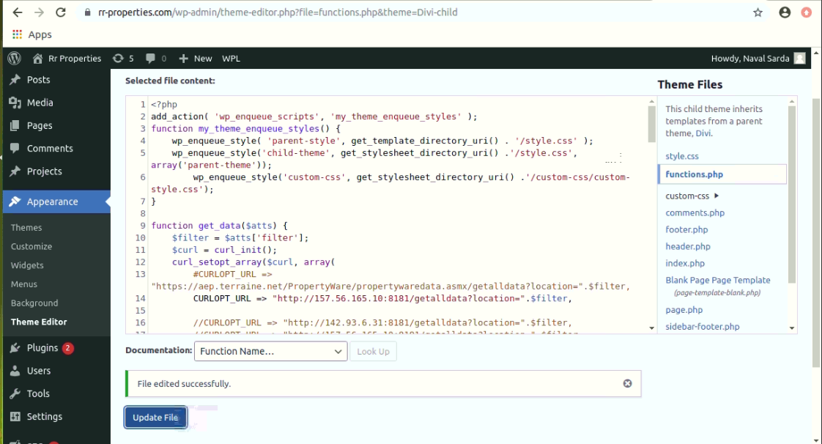

URL => "http://157.56.165.10:8181/getalldata?location=".$filter -----This is url from which getting api response for commercial property units.

Currently changes are done for showing ‘property units’ only when status is ‘Vacant’ and also displayed ‘advertised lease rate’ in table.

**To See Changes –**

Go To 🡪 <https://rr-properties.com> 🡪 Click on ‘Commercial’ 🡪 Scroll down and Click on any property like WALNUT, WOODLANDS..

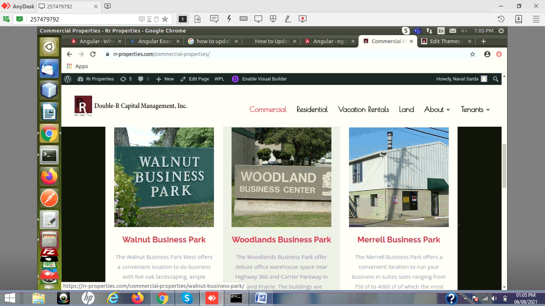

After clicking on any property we will find table with heading ‘Units for Lease’ which shows data we receive from api response only when status is ‘Vacant’ as shown below -

