Q1.
You are working for a health research organization, and you're analysing the cholesterol levels of two groups of patients, Group X and Group Y. You create box plots to visualize the cholesterol data. Which group has a larger interquartile range (IQR)?
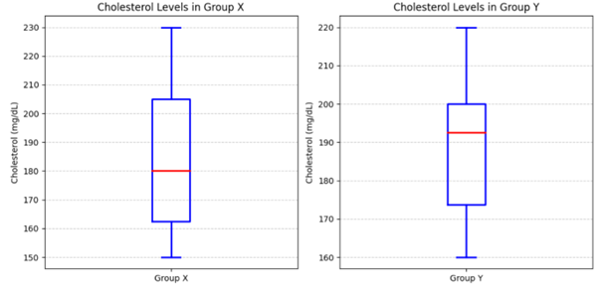
- Group Y
- Group X
- Both Groups have equal IQR
- None
Q2.
What is the range of a dataset?
- The area where the dataset goes on vacation
- The average value in the dataset
- The difference between the maximum and minimum values in the dataset
- The standard deviation of the dataset
Q3.
In a box plot, what do the whiskers represent?
- The median of the data
- Mischievous Data Points
- The first and third quartiles
- The lowest and highest values within the non-outlier range
Q4.
Which measure of spread (range or IQR) is generally less sensitive to outliers in a dataset?
- Range
- IQR
- Both are equally sensitive to outliers
- None of the above
Q5.
What is another term for Quantile 2?
- Odd One Out
- Mean
- Median
- All of the above
Q6.
Which of the following terms are commonly referred to as "Measures of Dispersion"?
- Mean and Median
- Heads and Tails
- Mode and Standard Deviation
- Range and IQR
Q7.
How can you identify outliers in a dataset using the IQR method?
- Any data point that is outside the range of [Q1 - 1.5 IQR, Q3 + 1.5 IQR]
- Any data point that is within the range of [Q1 - 1.5 IQR, Q3 + 1.5 IQR]
- Any data point that is exactly equal to the IQR
- Any data point that is exactly equal to the mean of the data
Q8.
In a box plot, the box represents which part of the data?
- The range of the data
- The middle 50% of the data
- The maximum value in the data
- The data points that ate all the cookies and refuses to share.
Q9.
If the interquartile range (IQR) of a dataset is 10 and the third quartile (Q3) is 45, what is the value of the first quartile (Q1)?
- 35
- 20
- 10
- 15

