**SQ1:-**

package oops_que;

public class Employee {

static String companyName = "Tech Solutions";

static int employeeCount;

int id;

String name;

static {

System.out.println("Welcome to Tech Solutions");

}

public Employee(int id, String name) {

this.id= id;

this.name= name;

employeeCount++;

}

public Employee(int id) {

this.id= id;

this.name= "Unknown";

}

public void displayInfo() {

System.out.println("ID: "+id);

System.out.println("Name: "+name);

System.out.println("Company Name: "+companyName);

}

public static void displayEmployeeCount() {

System.out.println("No of Employee: "+ employeeCount);

}

}

public class Main {

public static void main(String[] args) {

Employee e1 = new Employee(316, "Truptiranjan");

Employee e2 = new Employee(228, "Satya");

Employee e3 = new Employee(300);

e1.displayInfo();

e2.displayInfo();

e3.displayInfo();

Employee.displayEmployeeCount();

}

}

OUTPUT:-

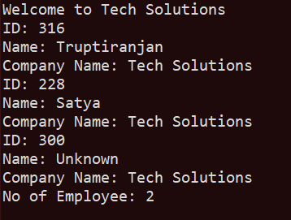

**Q2:-**

**package oops_que;**

**public class Stud {**

**int rollno;**

**String name;**

**static String college = "SOA";**

**static int count;**

**public Stud(int rollno, String name) {**

**this.rollno=rollno;**

**this.name=name;**

**count++;**

**}**

**public void printInfo() {**

**System.out.println("Name: "+name);**

**System.out.println("Roll.no: "+rollno);**

**System.out.println("College: "+college);**

**}**

**static void Count() {**

**System.out.println("No of Stud: "+count);**

**}**

**}**

**public class Main {**

**public static void main(String[] args) {**

**Stud s1 = new Stud(316, "Truptiranjan");**

**Stud s2 = new Stud(228, "Satya");**

**Stud s3 = new Stud(300, "Sudhanshu");**

**s1.printInfo();**

**System.out.println();**

**s2.printInfo();**

**System.out.println();**

**s3.printInfo();**

**System.out.println();**

**Stud.Count();**

**}**

**}**

**OUTPUT:**

