Project Report
On
Hospital Patient Analysis System
Name – Trupti D Yadav.
Project Title – Hospital Patient Analysis System
Date of Submission – 30/12/2025
Technology Used – Python
Library -
- Pandas
- NumPy
- Matplotlib

Introduction
Hospital Patient Analysis System is a data analysis project developed using Python. This system analyzes hospital patient data to understand patient admissions, disease patterns, revenue generation, and service quality. It helps hospital management take data-driven decisions.

Aim of the Project
The aim of this project is to analyze hospital patient records using Python and extract meaningful insights such as patient trends, revenue contribution, and department performance.

Objectives
• To analyze patient admission data.
• To identify most common diseases.
• To calculate revenue generated from patients.
• To analyze patient satisfaction ratings.
• To visualize insights using graphs.

Methodology
• Loading hospital patient dataset using pandas.
• Cleaning data by removing duplicates and handling missing values.
• Performing analysis using NumPy and pandas.
• Visualizing results using matplotlib and seaborn.

1. Patient Admission Analysis
This analysis helps understand how many patients are admitted over time and identifies peak admission periods.

2. Disease-wise Patient Analysis
This feature analyzes which diseases are most common among patients and helps hospitals plan resources.

3. Revenue Analysis
Revenue generated from different diseases and departments is calculated to identify high-income areas.

4. Department-wise Performance
This analysis compares departments based on patient count, revenue, and satisfaction ratings.

5. Patient Satisfaction Analysis code
Average patient ratings are analyzed to measure quality of hospital services.

Code
STEP 1: Import Required Libraries
import numpy as np
import pandas as pd
import matplotlib.pyplot as plt
import seaborn as sns
STEP 2: Load Dataset (MOST IMPORTANT)
df = pd.read_csv("hospital_patients.csv")
STEP 3: Understand the Data
print(df.info())
print(df.describe())
- <class 'pandas.core.frame.DataFrame'>
- RangeIndex: 12 entries, 0 to 11
- Data columns (total 8 columns):
- # Column Non-Null Count Dtype
- --- ------ -------------- -----
- 0 Patient_Name 12 non-null object
- 1 Age 12 non-null int64
- 2 Gender 12 non-null object
- 3 Disease 12 non-null object
- 4 Department 12 non-null object
- 5 Bill_Amount 12 non-null int64
- 6 Rating 12 non-null float64
- 7 Admission_Date 12 non-null object
- dtypes: float64(1), int64(2), object(5)
- memory usage: 900.0+ bytes
- None
- Age Bill_Amount Rating
- count 12.000000 12.000000 12.000000
- mean 42.833333 41250.000000 4.283333
- std 13.092908 33352.456636 0.332575
- min 25.000000 5000.000000 3.800000
- 25% 32.250000 7750.000000 4.000000
- 50% 42.500000 42500.000000 4.250000
- 75% 51.250000 67500.000000 4.525000
- max 65.000000 90000.000000 4.800000

STEP 4: Data Cleaning
print(df.isnull().sum())
df.drop_duplicates(inplace=True)
df['Admission_Date'] = pd.to_datetime(df['Admission_Date'])
- Patient_Name 0
- Age 0
- Gender 0
- Disease 0
- Department 0
- Bill_Amount 0
- Rating 0
- Admission_Date 0
- dtype: int64

STEP 5: NumPy Calculations
print("Average Bill Amount:", np.mean(df['Bill_Amount']))
print("Maximum Bill Amount:", np.max(df['Bill_Amount']))
print("Minimum Bill Amount:", np.min(df['Bill_Amount']))
- Average Bill Amount: 41250.0
- Maximum Bill Amount: 90000
- Minimum Bill Amount: 5000

STEP 6: Disease-wise Analysis
print(df['Disease'].value_counts())
disease_revenue = df.groupby('Disease')['Bill_Amount'].sum()
print(disease_revenue)
- Disease
- Heart 3
- Fever 3
- Diabetes 2
- Infection 2
- Orthopedic 2
- Name: count, dtype: int64
- Disease
- Diabetes 85000
- Fever 18000
- Heart 250000
- Infection 17000
- Orthopedic 125000
- Name: Bill_Amount, dtype: int64

STEP 7: Time-Based Patient Analysis
df['Month'] = df['Admission_Date'].dt.month
monthly_patients = df.groupby('Month').size()
print(monthly_patients)
Month
1 2
2 2
3 2
4 2
5 2
6 2
dtype: int64

STEP 8: Visualization
1.Disease-Wise Patient Count(Bar Chart)
df['Disease'].value_counts().plot(kind='bar')
plt.title("Disease-wise Patient Count")
plt.xlabel("Disease")
plt.ylabel("Number of Patients")
plt.show()
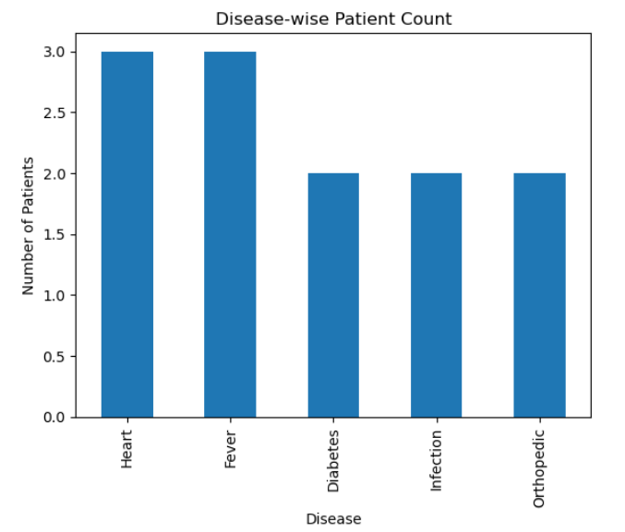

2.Monthly Patient Admission Trend
df.groupby('Month').size().plot(marker='o')
plt.title("Monthly Patient Admission Trend")
plt.xlabel("Month")
plt.ylabel("Number of Patients")
plt.show()
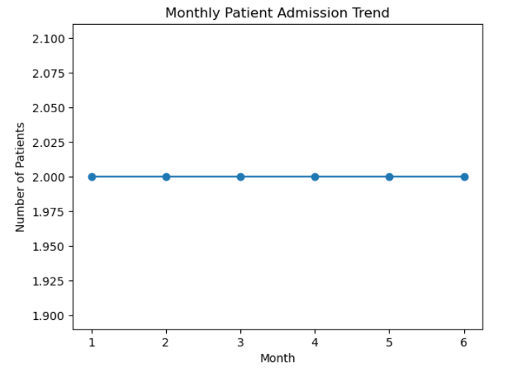
sns.barplot(x=disease_revenue.index, y=disease_revenue.values)
plt.title("Revenue by Disease")
plt.xlabel("Disease")
plt.ylabel("Revenue")
plt.show()
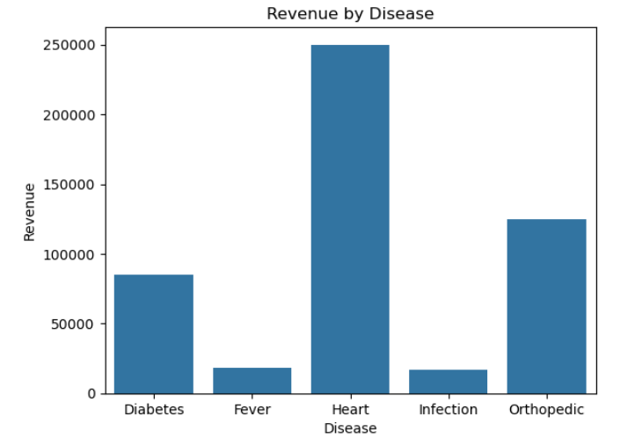
Gender-wise Analysis
gender_count = df['Gender'].value_counts()
gender_count.plot(kind='pie', autopct='%1.1f%%')
plt.title("Gender-wise Patient Distribution")
plt.ylabel("")
plt.show()
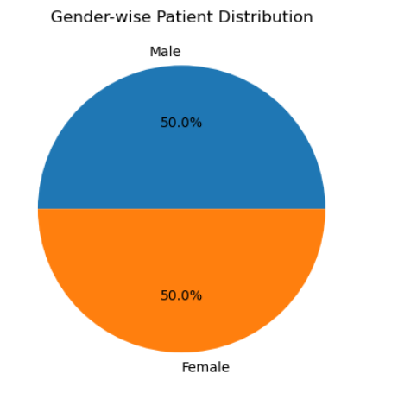
Age Group Analysis
bins = [0, 18, 35, 50, 100]
labels = ['Child', 'Young Adult', 'Adult', 'Senior']
df['Age_Group'] = pd.cut(df['Age'], bins=bins, labels=labels)
sns.barplot(
x=df['Age_Group'].value_counts().index,
y=df['Age_Group'].value_counts().values
)
plt.title("Age Group-wise Patients")
plt.xlabel("Age Group")
plt.ylabel("Number of Patients")
plt.show()
- Age_Group
- Young Adult 5
- Adult 4
- Senior 3
- Child 0
- Name: count, dtype: int64
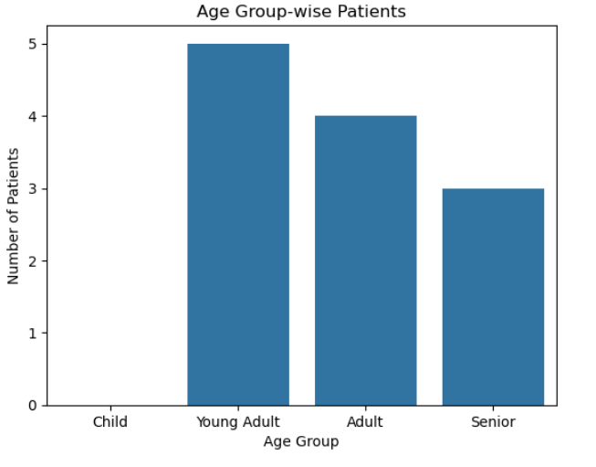
Department-wise Analysis
department_revenue = df.groupby('Department')['Bill_Amount'].sum()
print(department_revenue)
- Department
- General 5
- Cardiology 3
- Endocrinology 2
- Orthopedic 2
- Name: count, dtype: int64
- Department
- Cardiology 250000
- Endocrinology 85000
- General 35000
- Orthopedic 125000
- Name: Bill_Amount, dtype: int64

Patient Rating Analysis
avg_rating = df.groupby('Department')['Rating'].mean()
sns.barplot(x=avg_rating.index, y=avg_rating.values)
plt.title("Average Patient Rating by Department")
plt.xlabel("Department")
plt.ylabel("Average Rating")
plt.show()
- Department
- Cardiology 4.666667
- Endocrinology 4.250000
- General 3.960000
- Orthopedic 4.550000
Name: Rating, dtype: float64
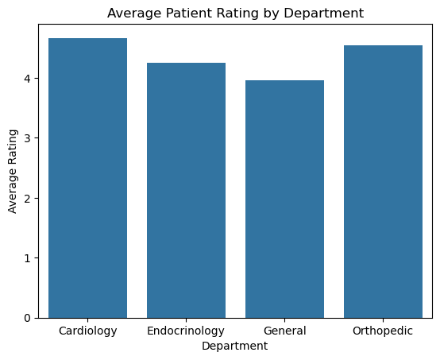
High-Value Patients
avg_bill = df['Bill_Amount'].mean()
high_value_patients = df[df['Bill_Amount'] > avg_bill]
print(high_value_patients[['Patient_Name', 'Disease', 'Bill_Amount']])

Patient Name Disease Bill Amount
0 Amit Sharma Heart 75000
4 Rohit Singh Orthopaedic 60000
6 Karan Mehta Heart 90000
7 Anita Deshmukh Diabetes 45000
8 Suresh Rao Heart 85000
10 Vikas Gupta Orthopaedic 65000

Advantages
• Helps in better hospital decision making.
• Reduces manual analysis work.
• Provides accurate and clear insights.
• Improves service quality monitoring.

Scope of the Project
This project helps students understand real-world healthcare data analysis. It can be further extended with live databases, dashboards, and predictive analytics.

Conclusion
Hospital Patient Analysis System demonstrates how Python can be used for healthcare data analysis. It is simple, effective, and useful for beginners to understand data analysis concepts and real-world applications.

