Project Report
On
Smart City Performance Analysis using Power BI

Name – Trupti D Yadav
Project Title – Smart City Performance Analysis Dashboard
Date of Submission – 28/01/2026
Tool Used – Microsoft Power BI

Introduction
Smart City Performance Analysis Dashboard is a data visualization project developed using Microsoft Power BI. This project focuses on analyzing city-level data such as Budget, Crime Rate, Population, Energy Consumption, and Transport usage to derive meaningful insights.

Aim of the Project
To analyze smart city data using Power BI and present insights through interactive dashboards for better decision-making.

Objectives
• Analyze city-wise budget and utilization
• Study crime rate and crime types
• Visualize population distribution
• Analyze energy consumption patterns
• Compare public and private transport usage

Dataset Description
City details, Budget data, Crime data, Energy consumption data, Transport usage data, and Date table.

Methodology
• Data imported into Power BI
• Data cleaned using Power Query
• Relationships created
• DAX measures developed
• Dashboards designed

Dashboard Analysis
KPI analysis, Crime analysis, Population analysis, Budget analysis, Energy analysis, Transport analysis with slicers and drill-through.

DAX Measures Used
• Total Budget
• Used Budget
• Budget Utilization %
• Total Crimes
• Total Population
• Energy Consumption

Dashboard Screenshots

Figure 1: Smart City Performance Overview Dashboard
This dashboard provides a comprehensive overview of smart city performance. It highlights key KPIs such as Total Budget, Crime Rate, Total Population, and Budget Utilization Percentage. The dashboard also includes city-wise crime analysis, population distribution, energy consumption by city, and public vs private transport usage, enabling high-level comparison across cities.
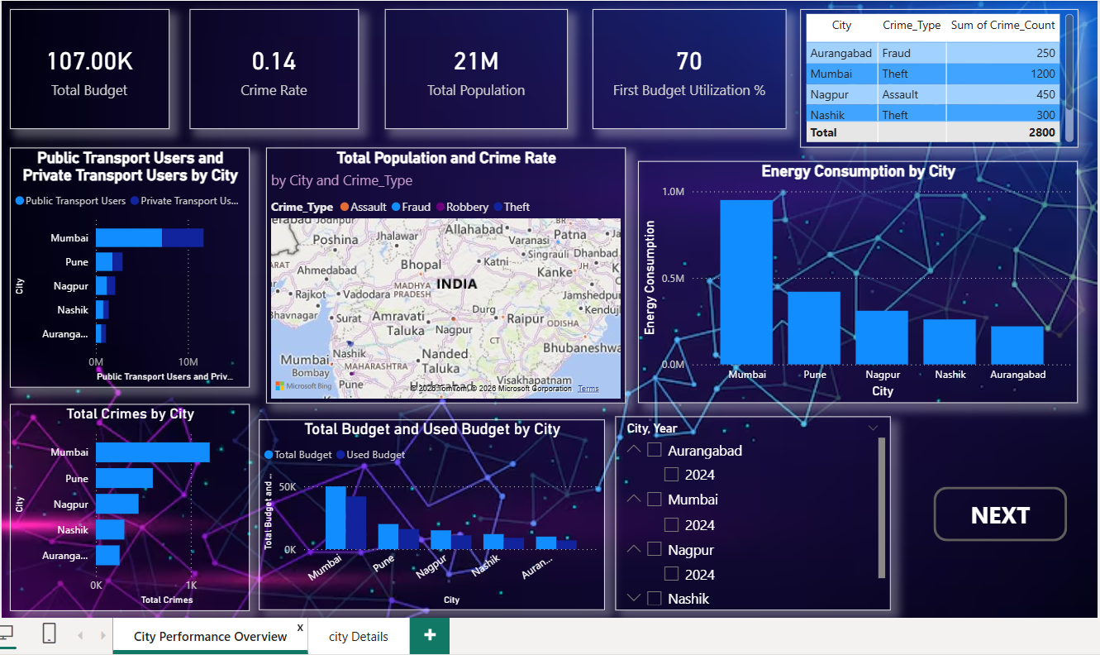

Figure 2: City Details and Year-wise Analysis Dashboard
This dashboard presents detailed city-level information using drill-through functionality. It includes city-wise population details, total crimes by year, budget utilization percentage, and year-wise energy consumption. This page helps in performing in-depth analysis for a selected city and year.
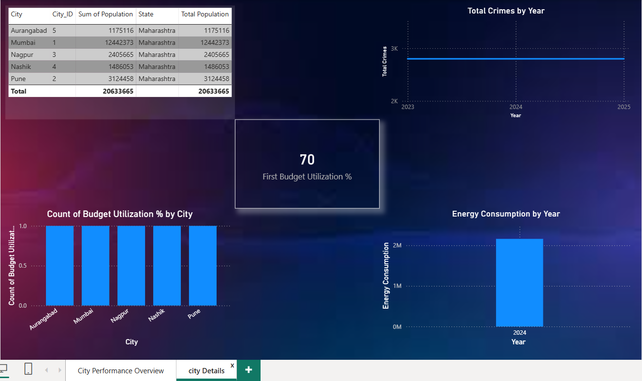
Advantages
• Interactive dashboards
• Easy comparisons
• Quick decision-making
• Real-world application

Scope
Project can be enhanced with real-time data and predictive analytics.

Conclusion
This Smart City Power BI project demonstrates effective data visualization and analysis for smart city planning and management.

