**CsvActorHandler plugin**

To use the plugin we need create an object of a UCsvMovementController class:

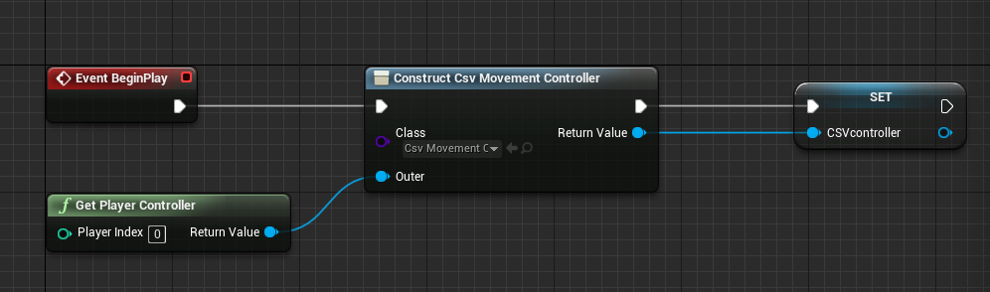

**Note!** It requires a UObject that has a pointer to UWorld as an Outer (I set First Player Controller).

The next step is initialization the controller:

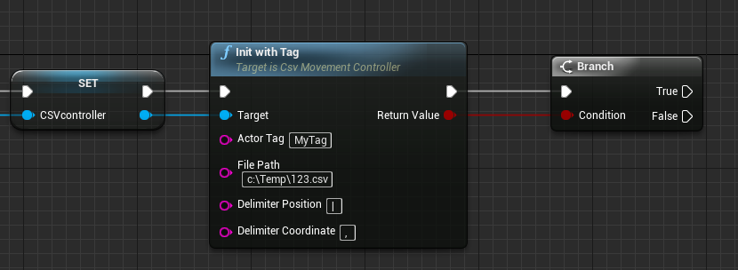

You may do it either with InitWithActor function ot InitWithTag giving a movable actor or its tag respectively. FilePath points to a CSV file with coordinates, Delimiter Position and Delimiter Coordinate separate blocks of coordinates from each other (point1, point2) and coordinates (x, y, z). If all went fine the function returns true, otherwise you may see in logs a message



Probably there is no an actor in the scene with the tag or a CSV file doesn’t exist.

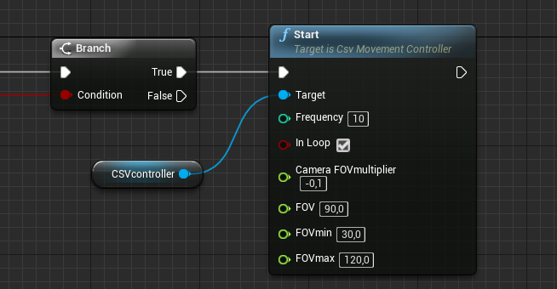The last step is to make the actor moving:

There are some options:

- Frequency describes how many times per second the actor changes its position;

- if InLoop set to false the actor moves just once;

- CameraFOVmultiplier sets how fast FOV changes (its value times a delta of X coordinate of the actor’s displacement adds to the current FOV);

- start FOV value

- FOVmin and FOVmax set border values

Also there are fucntions to pause\un-pause and stop the actor’s movement.

Good luck!