

**COLLEGE OF TECHNOLOGY**

**ADITYA SILVER OAK INSTITUTE OF TECHNOLOGY**

# DEPARTMENT OF COMPUTER ENGINEERING

A Report on

**Food Entrepreneurship**

**Surplus milk and Dairy Waste**

DIGITAL TRANSFORMATION OF WORKFORCE MANAGEMENT FOR ORGANIZATIONAL EFFICIENCY

Under Subject of

# PROBLEM BASED LEARNING - II

Semester - VI

***Submitted by***

Ansh Butani

Gautami Koradiya

Trush Isamaliya

**Faculty Name HOD Name**

Prof. Dhenu Patel Prof. Jay Dave

**Aditya silver oak institute of technology**

Department of Computer Engineering

## CERTIFICATE

This is to certify that the project entitled “**Food Entrepreneurship**” has been carried out by **“Ansh Butani”, “Gautami Koradiya”, “Trush Isamaliya”** under my guidance in fulfillment of the Problem Based Learning-II (1010003392) Subject of Bachelor of Engineering in **Computer**

**Engineering** – 6th Semester of Silver Oak University, Ahmedabad during the academic year 2024- 2025.

**Faculty Name HOD Name**

Prof. Dhenu Patel Prof. Jay Dave

## ACKNOWLEDGEMENT

We are heartily thankful to our supervisor, **Prof. Dhenu Patel,** whose encouragement, supervision and support from the preliminary to the concluding level enabled me to develop an understanding of the subject. At the end, we offer my regards and blessings to all of those who supported us in any respect during the completion of the project and to our college for providing a resources and materials.

We would like to extend my gratitude to **Prof. Jay Dave** head of Computer

Engineering Department, Silver Oak college of Engineering and Technology, Ahmedabad, for his continuous encouragement and motivation.

Last but not the least we would like to mention here that we are greatly indebted to each and everybody who has been associated with our project at any stage but whose name does not find a place in this acknowledgement.

Yours Sincerely

Gautami Koradiya

Butani Ansh

Trush Isamaliya

### ABSTRACT

The Surplus Milk Management System is a strategic digital and operational framework aimed at addressing the issue of excess milk production in dairy supply chains. The project focuses on the

timely identification, collection, and transformation of surplus milk into high-value, long shelf-life

dairy products such as milk powder, cheese, butter, and UHT milk. This system integrates digital tracking, inventory monitoring, and processing workflows to minimize wastage, enhance

profitability, and ensure sustainability.

By utilizing technologies such as cloud computing, IoT sensors, and data analytics, the system provides real-time insights into milk production trends and surplus levels. The solution also

promotes efficient logistics coordination, better demand forecasting, and streamlined conversion

processes. The ultimate goal is to stabilize market prices, reduce environmental impact, and create economic opportunities by adding value to surplus milk through product diversification.

## LIST OF FIGURES

|  |  |  |
| --- | --- | --- |
| **Figure No** | **Figure Name** | **Page No.** |
| **1.** | **System Workflow Diagram** | **10** |
| **2.** | **Surplus Milk Lifecycle Chart** | **11** |
| **4.** | **Timeline Chart** | **15** |

**TABLE OF CONTENT**

|  |  |  |
| --- | --- | --- |
| **Chapter No.** | **Title** | **Page No** |
|  | **ACKNOWLEDGEMENT** | **3** |
|  | **ABSTRACT** | **4** |
|  | **LIST OF FIGURES** | **5** |
| **1** | **INTRODUCTION**  **Project Summary**  **Purpose**  **Scope**  **Technical and Literature Review** | **7** |
| **2** | **SYSTEM REQUIREMENT STUDY**  **User Characteristics**  **Hardware and Software Characteristics**  Hardware Requirements  Software Requirements | **8** |
| **3** | **SYSTEM ANALYSIS**  **Study of Current System**  **Problems in Existing Systems**  **Requirement of New System**  Functional Requirement  Non-functional Requirement  **Feasibility Study** | **9** |
| **4** | **SYSTEM DESIGN**  **Flow charts** | **10** |
| **5** | **LIMITATION AND FUTURE ENHANCEMENT** | **15** |
| **6** | **TIMELINE CHART** | **15** |
| **7** | **CONCLUSION** | **16** |
| **8** | **REFERENCE** | **16** |
|  |  |  |

### 1. INTRODUCTION

* **Project Summary**

The Surplus Milk Management System is designed to tackle the seasonal and regional oversupply of milk by enabling its conversion into durable dairy products. Through timely data collection, intelligent routing, and product processing, it aims to prevent spoilage and economic loss. The system supports real-time monitoring of surplus levels, integrates with local dairy plants, and enables strategic product diversification, ultimately strengthening food security and rural incomes.

* **Purpose**

To provide a sustainable, technology-driven solution for managing excess milk by converting it into value-added, shelf-stable dairy products. This reduces wastage, supports dairy farmers, and promotes circular agricultural practices.

* **Scope**
  + Track surplus milk production across farms and dairy centers.
  + Enable automated alerts for excess milk detection.
  + Connect with processing units for product conversion (e.g., milk powder, ghee, cheese).
  + Support cold-chain and storage management.
* **Technical and Literature Review**

**Technical Overview:**

* + - **Frontend: ReactJS / Android Mobile App**
    - **Backend: Node.js / Laravel**
    - **Database: MySQL / Firebase**
    - **IoT: Milk volume and quality sensors**
    - **Cloud Storage: AWS / Google Cloud**

**Literature Review Highlights:**

* + - Studies (2020–2024) from FAO and NDDB show that over 10% of milk produced goes to waste due to lack of cold storage and market linkage.
    - Converting surplus to dairy products reduces spoilage and increases farmer income by up to 25%.
    - Countries like New Zealand and the Netherlands successfully implement surplus milk drying and export strategies

**2. SYSTEM REQUIREMENT STUDY**

**User Characteristics**

* **Farmers:** Need simple interfaces to report milk volumes.
* **Dairy Cooperatives:** Monitor intake and coordinate transport to plants.
* **Processing Plants:** Receive alerts and production instructions.
* **Administrators:** Oversee system-wide logistics and analytics.

**Hardware Requirements**

* IoT milk sensors
* Mobile/tablet for field entries
* Servers with cloud backup
* Milk processing machinery (dryers, fermenters, packaging units)

**Software Requirements**

* **Frontend:** ReactJS / Flutter • **Backend:** Laravel / Node.js
* **Database:** MySQL or MongoDB.
* **Security:** SSL/TLS, role-based access

### 3. SYSTEM ANALYSIS

**Study of Current System:**

* Manual tracking of milk production leads to uncoordinated supply.
* Lack of real-time updates causes delays in processing surplus milk.
* Limited options to preserve or transport excess milk efficiently.

**Problems in Existing Systems:**

* Spoilage during peak production times.
* Income loss for farmers due to non-collection • Wastage due to underutilized dairy capacity.

**Requirement of New System:**

* Real-time surplus alerts from dairy collection points.
* Automated scheduling for milk diversion to processing units.
* Historical data to plan for conversion into long shelf-life products.

**Non-Functional Requirements:**

* High availability
* Secure and scalable cloud system
* Mobile and desktop access
* Integration with logistics and storage platforms

**Functional Requirement:**

* Surplus Detection Module
* Transport & Processing Coordination
* Product Conversion Tracker
* Reporting & Forecasting Tools

**Feasibility Study:**

* **Operational:** Ease of adoption with farmer cooperatives and local dairy units.
* **Technical:** Supported by IoT and existing dairy tech infrastructure.
* **Economic:** Savings from reduced spoilage, new income via product sales.

### 4. SYSTEM DESIGN

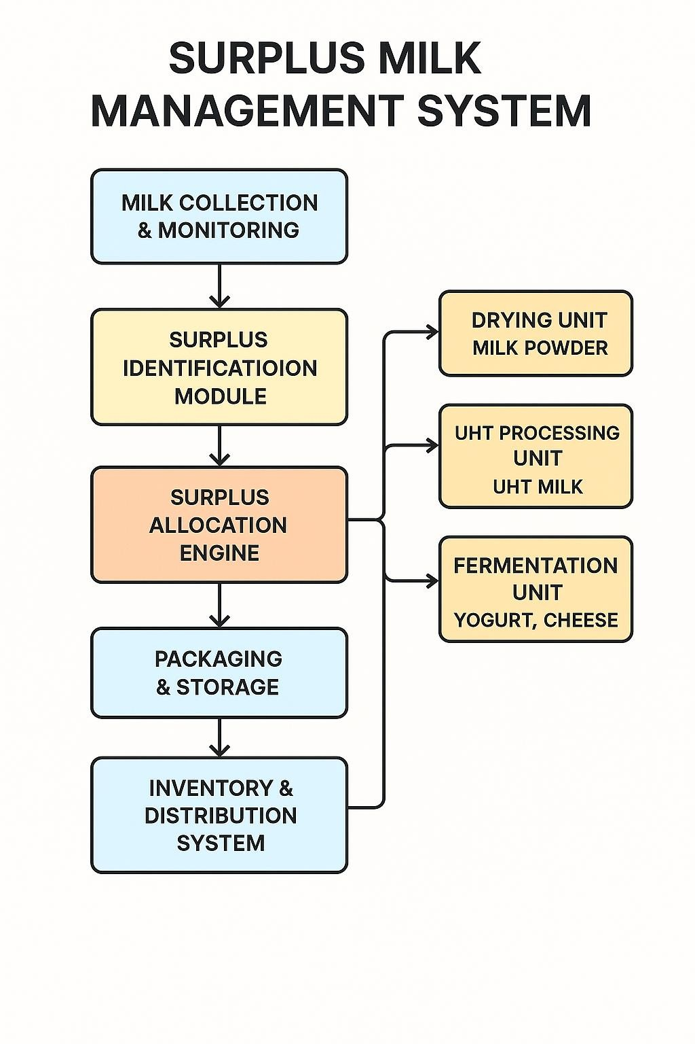

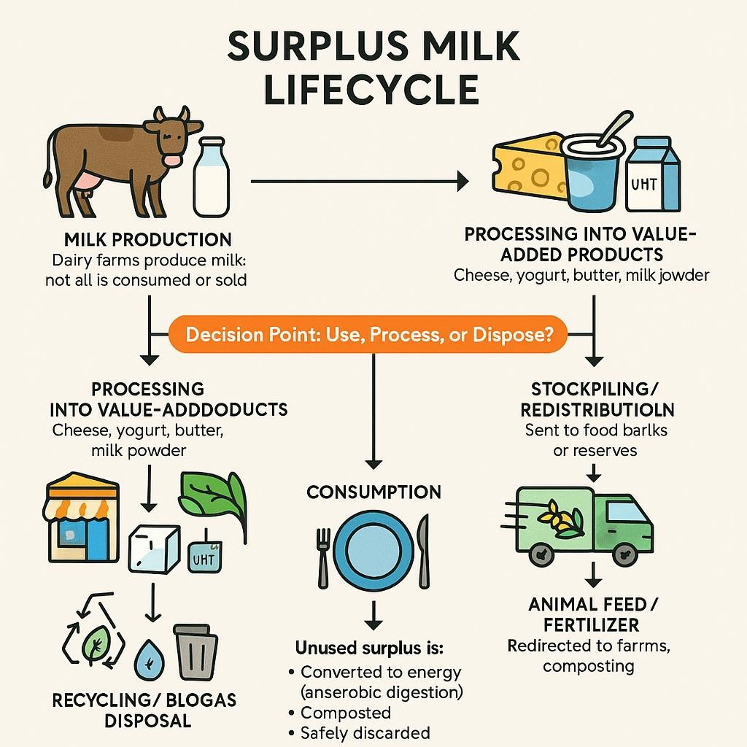

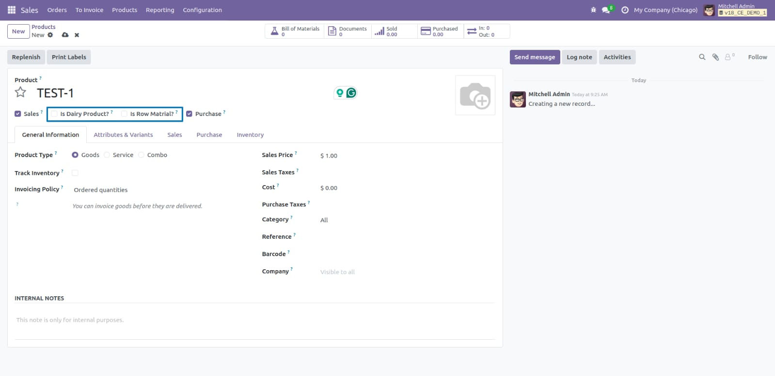

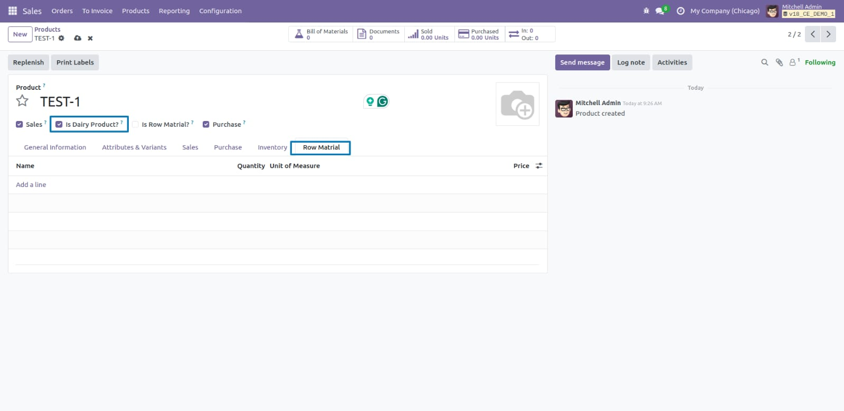

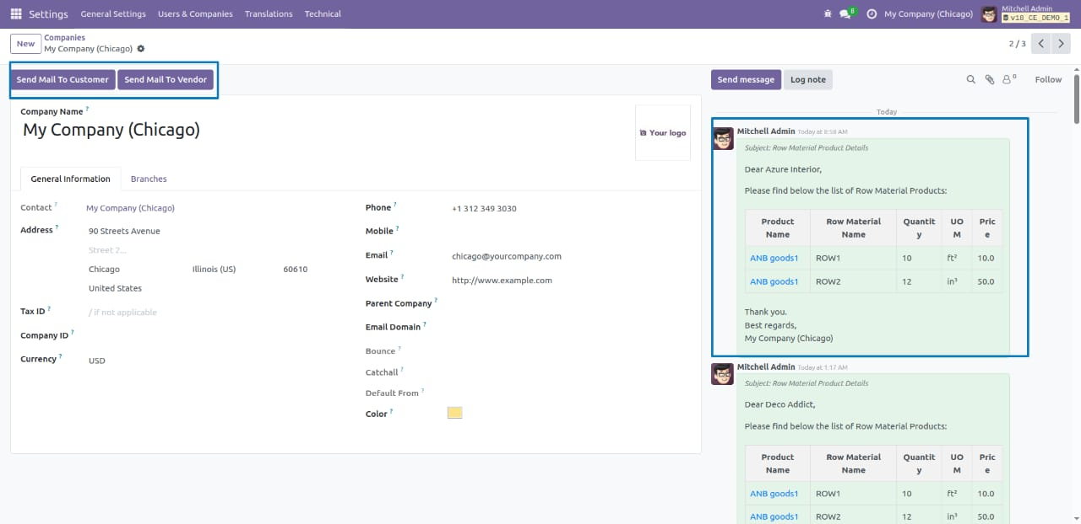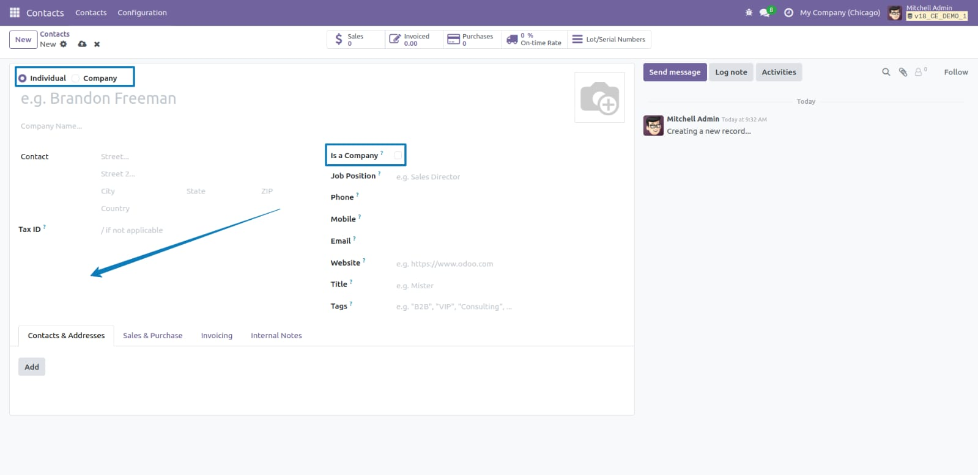

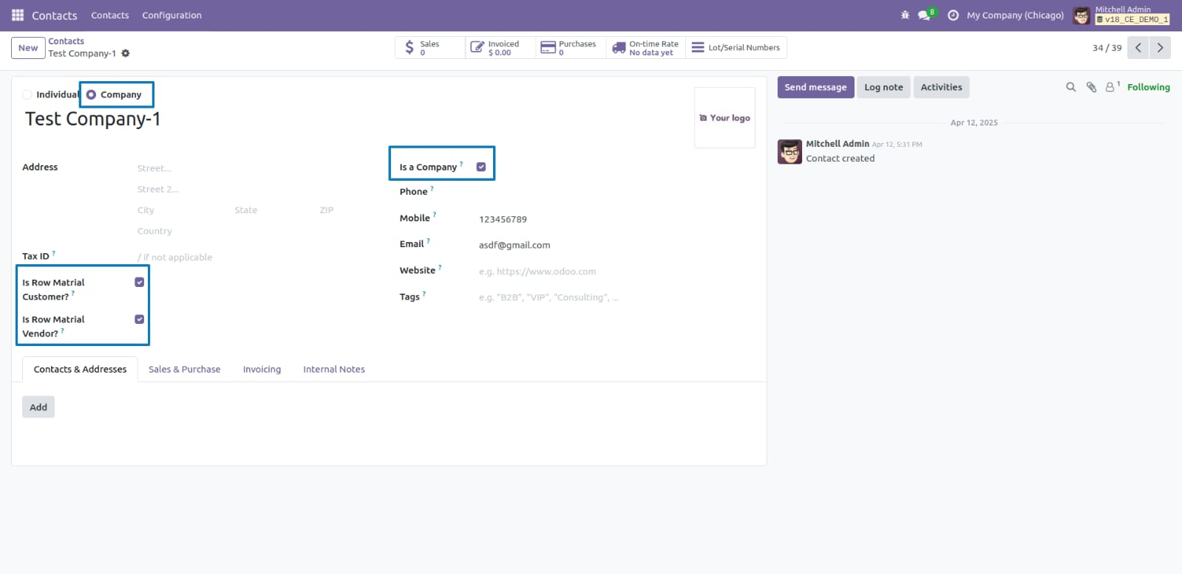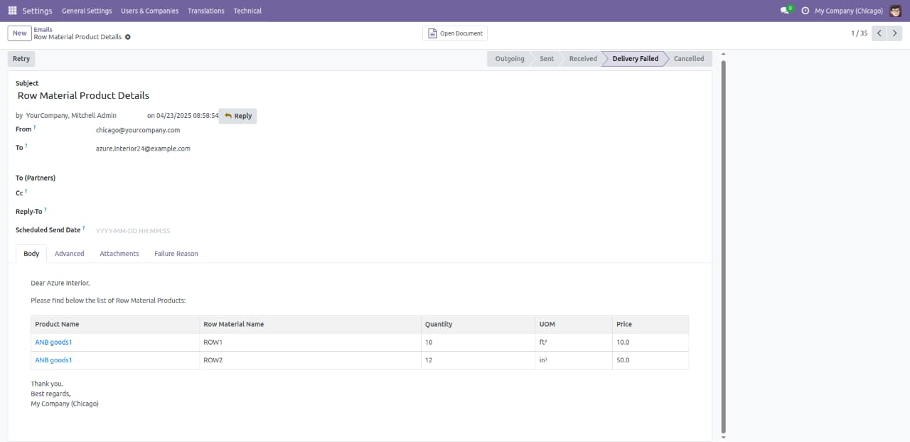

### 5. LIMITATION AND FUTURE ENHANCEMENT

**Limitations:**

* Dependence on internet connectivity for rural areas.
* Initial investment in IoT devices and processing units.
* Need for consistent training for cooperative staff.

**Future Enhancements:**

* AI-based demand and surplus prediction
* Integration with cold chain logistics
* Blockchain for traceability in dairy products
* Expansion to include waste-to-energy options for spoiled milk
* Voice Command Integration
* Export support features for powdered milk and cheese

#### 6. TIMELINE CHART

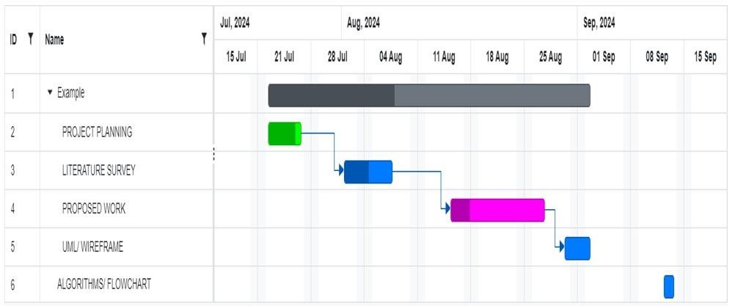

#### 7. CONCLUSION

The Surplus Milk Management System offers a practical and scalable solution to a recurring problem in dairy farming. By enabling the conversion of excess milk into long shelf-life dairy products, the system not only reduces wastage but also improves profitability for

producers and processors alike. Its adoption will lead to enhanced food security, reduced environmental impact, and a more resilient dairy supply chain.

#### 8. REFERENCE

* FAO. “Milk Waste and Sustainability in the Dairy Industry.” 2023. <https://www.fao.org/dairy-waste>
* NDDB. “Annual Report on Indian Dairy Sector.” 2024. <https://www.nddb.coop/reports>
* Gupta, Priya. “IoT and Dairy: The Future of Milk Management.” Journal of Agricultural Tech, 2024.
* Singh, Rohit. “Dairy Processing for Shelf Stability.” DairyTech Review, Jan 2025.