PREFACE

In today's fast-growing world, every business is moving towards digitalization. The medical field is also not an exception. In a small city like Sihor, people still have to stand in long queues at medical stores to get medicines, which is very time-consuming and difficult, especially for old and ill people.

To solve this problem, we have developed "MediTrack - A Pharmacy Management System". It is a web-based application designed for online medicine ordering and pharmacy management.

The main objective of this project is to provide medicines at the customer's doorstep with just one click. Our system provides many modern facilities like Voice Search (Mic Search), Prescription Upload, Online Payment, Real-time Order Tracking, and Automatic Expiry & Stock Alert.

This system is beneficial for both customers and medical store owners. Customers get 24x7 service and home delivery, while the owner can manage stock, bills, and orders digitally without any paperwork.

We have used PHP, MySQL, HTML, CSS, JavaScript and Web Speech API to develop this system.

We are very thankful to our project guide and our college for giving us guidance and support to complete this project successfully.

We hope this system will be very useful for the people of Sihor city and will give a new digital direction to the local medical business.
ACKNOWLEDGMENT

We take this opportunity to express our deep sense of gratitude to all those who have helped us in completing our project titled "MediTrack - Pharmacy Management System" successfully.

First and foremost, we would like to express our sincere thanks to our project guide Prof. Nilesh Parghi for his valuable guidance, constant encouragement, and expert suggestions throughout our project work. His guidance has been a great source of inspiration for us.

We are very thankful to the Head of Department and all the faculty members of Computer Department, Kamani Science College & Prataprai Arts College, Amreli, for providing us with all the necessary facilities and support.

We are also thankful to our respected Principal for giving us this opportunity to work on this project and for providing the required resources in the college.

We would like to extend our heartfelt thanks to our parents and friends for their continuous moral support and motivation.

Last but not the least, we are thankful to all the medical store owners and customers of Sihor for their valuable co-operation during system study.

Thank you all.
ABSTRACT

The MediTrack Pharmacy Management System is a Web Portal in which Admin and Users interact with each other. In this platform, a user can search and order medicines online and admin can manage stock, users, billing and orders efficiently. In this way the user gets medicines at doorstep and the system can be managed digitally by admin.

This project aims to develop a pharmacy management system where not only a user can order medicines but also can upload prescription, use voice search facility and track his order. Admin can manage all medicines, get auto alert for low stock and expiry medicines, and manage all orders and users.

Admin and User both can be benefited from this system. Users who wish to order medicines can save their time and get 24x7 home delivery service, resulting in work being done fast and efficiently and also given access to secure online payment and have the ability to get medicines from their homes rather than visiting a store.

INTRODUCTION

MediTrack is a trusted online pharmacy management system that provides good quality medicines for daily use. The system was developed to meet the medical needs of homes, offices, and small communities. We offer a variety of medicines such as tablets, syrups, drop, cream and other useful healthcare products, all at one place through online ordering.

At MediTrack, we believe in honest work and customer satisfaction. We always try to give genuine medicines at reasonable prices and help users choose the right medicines according to their needs. Admin manages stock, expiry and orders. Quality service, fair dealing, and user trust are the main values of our system. Features like voice search and prescription upload make it user-friendly.

Our aim is to build long-term relationships with users by providing reliable medicines and friendly service. MediTrack is committed to serving the community with dedicated service and continues to grow with the support and trust of its users, providing 24x7 home delivery and secure payment.

Timeline chart

PROFILE PAGE

Field Details
Project Name: MediTrack Pharmacy Management System
Developed By: Desai Twinsi R.
Garniya Trusha J.
Front End Tool: HTML, CSS, PHP
Back End Tool: PHP
Database: MySQL
Operating System: Microsoft Windows 7 & Microsoft Windows 10
Computer System: Pentium-IV or higher, RAM: 2GB
Project Details: MediTrack Pharmacy Management System is a web-based pharmacy system. The system provides online medicine ordering, voice search, prescription upload and doorstep delivery for daily household and medical use.
Completion Time: 3.5 Month
Guided By: Prof. Nilesh Parghi
Submitted By: Saurashtra University, Rajkot

HARDWARE AND SOFTWARE REQUIREMENT

HARDWARE

Hardware refers to the physical components of a computer. Computer hardware is any part of the computer that we can touch these parts. These are the primary electronic devices used to build up the computer.
- 8GB of RAM (Minimum 2GB as per Project Profile)
2.Multimedia keyboards and mouse
3. 1.0+ GHz processor (Pentium-IV or higher)
4. 500 GB Hard Disk or SSD
5. Monitor 1024x768 resolution

SOFTWARE:

Software is a collection of instruction procedures, documentation that performs different tasks on a computer system, we can say also computer software is a programming code executed on a computer processor. That code can be machine level code or the code written for an operating system.
1. Operating System: Microsoft Windows 7 & Microsoft Windows 10
2. Front End Tool: HTML, CSS, PHP
3. Back End Tool: PHP
4. Database: MySQL
5. Server: XAMPP/WAMP Server
6. Browser: Chrome, Firefox, Edge
7. Editor: Visual Studio Code, Sublime Text

PROJECT PLANNING & SCHEDULING

Project planning is an aspect of Project Management, which comprises of various processes. The aim of these processes is to ensure that various Project tasks are well coordinated and they meet the various project objectives including timely completion of the project. Project Planning is an aspect of Project Management that focuses a lot on Project Integration. The project plan reflects the current status of all project activities and is used to monitor and control the project.

Project planning tasks ensure that various elements of the MediTrack system are coordinated to guide project execution. Project Scheduling is one of the most important, yet difficult, tasks. In a web-based project like MediTrack, the frontend (HTML/CSS) and backend (PHP/MySQL) development may happen in parallel, but their work remains highly interdependent.

Meditrack Pharmacy Management System, the Administrator centrally manages all medicine categories, required prescription, inventory, and user data through the Admin Panel. When users (patients or pharmacists) place orders, the data is synchronized and displayed on the admin side. The admin panel provides full privileges, including the ability to manage user accounts, update medicine inventories, and delete user data or orders as required.

SDLC

The software development life Cycle is the Cost-effictive and time efficient. Process that development teams use to design and build high-quality software.

when the system. approach is applied to the development of information system a multistep cycle emerges. This multistep cycle known as system Development life cycle.

SDLC is classically through of as the set of I activities that analytics designers and users. carry out to develop and implement an information System.

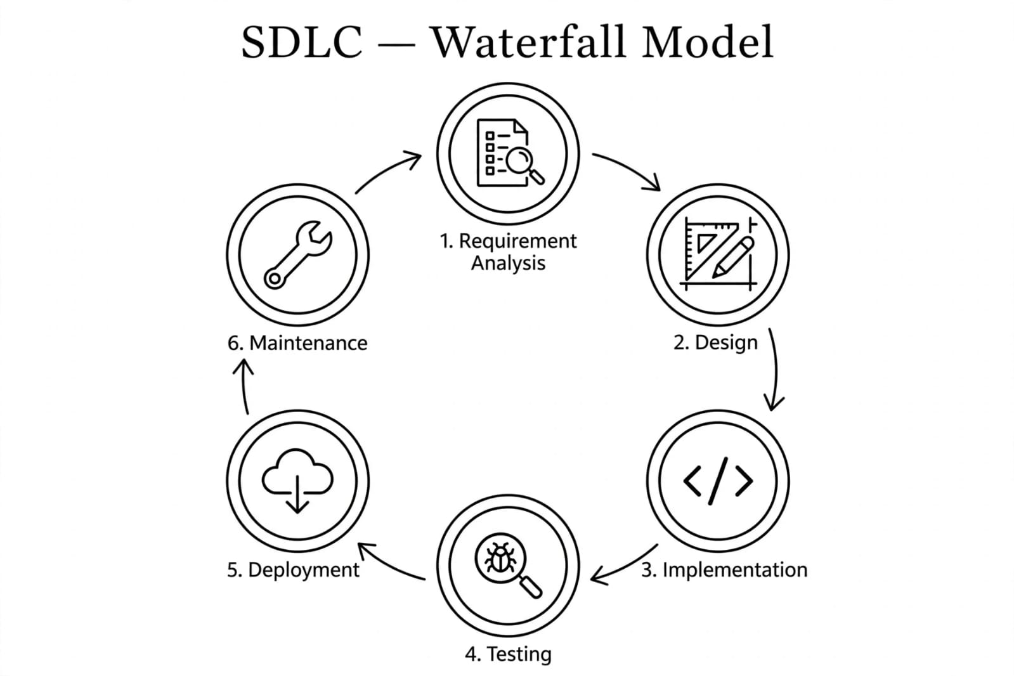

SYSTEM ANALYSIS

System analysis is the process of identification of objectives and requirements, evaluation of alternative solutions and recommendation for a more feasible solution. In other words, system analysis is the step-by-step process of gathering, recording and interpreting facts. The main aim of analysis is to determine problem areas and to take solutions to reduce or eliminate them.
➤ System analysis itself breaks into two stages:

1. Preliminary analysis:
2. Detailed analysis:

During analysis, data are collected from the available files, decision points and transactions of the systems using various tools like Data Flow Diagram (DFD).
PROBLEM DEFINATION

In the existing manual pharmacy system, all work is done manually. The pharmacist has to maintain all records of medicines, stock, expiry dates, customer details and billing in registers or books. This manual system is very time consuming, requires more manpower and there are high chances of errors.

The main problems in existing system are: No online medicine search facility, customer has to visit pharmacy physically, no stock and expiry alert system, difficult to find medicines quickly, no prescription upload facility, no order tracking system, and maintaining sales reports is difficult.

So, to overcome these problems, we have proposed 'MediTrack -Pharmacy Management System'. It is a web-based system with two modules Admin and User. Admin can manage medicines, stock, expiry alerts, users, prescriptions and orders. User can search medicine with voice search, upload prescription, add to cart, place order, track order and make payment online. This system saves time, reduces Manual work and provides 24x7 service.

OBJECTIVE OF PROJECT

The main objective of the MediTrack Pharmacy Management System is to develop a computerized system that helps manage the daily operations of the pharmacy in an efficient and organized manner. The system aims to store and manage medicine information, stock records, expiry dates, and user details in a digital format instead of manual registers.

Another objective of this project is to improve inventory management by allowing the admin to easily add, update, and check medicine stock. This helps prevent problems such as stock shortages, expiry loss, or incorrect medicine records, with auto alerts for low stock and expiry.

The project also aims to simplify the ordering and billing process by generating accurate bills and maintaining proper transaction records. By doing this, the system reduces human errors and saves time during daily pharmacy operations. Users can order online, upload prescription and use voice search.

In addition, the system is designed to provide a simple and user-friendly interface so that the admin and user can easily operate it without requiring advanced technical knowledge. It provides 24x7 home delivery tracking and secure payment.

Overall, the objective of the MediTrack Pharmacy Project is to make pharmacy management faster, more accurate, and more organized through the use of a digital management system for both admin and users.

FEASIBILITY STUDY

A purpose of feasibility study is to check out the possibility of a computerized solution to the organization's observed problem before very much money that has been spent on.
A feasibility study is carried out to select the best system that meets performance requirements. Only by spending the time to evaluate the feasibility do I reduce the chances for extreme embarrassment at later stage of the system project.
For the complete feasibility study I need to concentrate on following area:
➤ They are three types of feasibility Study:
1. Technical
2. Operational
3. Economical
Technical:
This checks whether required technology and resources are available.
The shop has computer systems, internet connection, billing software, and supplier network, so it is technically feasible.
Operational:
This checks whether daily operations can run smoothly. Dhara Enterprise manages stock, billing system, customer service, and supplier coordination properly, so operations are manageable.
Economical:
This checks whether the business is profitable. If monthly income from mobile and accessories sales is more than expenses (rent, stock purchase, electricity, salary), then the shop is economically feasible.

REQUIREMENT SPECIFICATION

Question/Answers.
Q-1 what is the name of pharmacy?
Ans: Belief medimart

Q-2 What is the purpose of this system?
Ans: to sell medicines online and manage Pharm-ary inventory and billing.

Q-3 Which companies medicine do you sell?
Ans: medicine from different pharmaceutical companies such as apollo Pharma. adrovent Pharma,

Q-4 who use this system?
Ans: Admin
Pharmacist
Customer.

Q-5 what categories of medicine do you sell?
Ans: Tablet
Syrup
cream

Q-6 how is medicine Quantity measured?
Ans: in strips
bottles.
Boxes
Drops

Q-7 should batch Number be maintained?
Ans: yes, every medicine must have a batch Number for tracking

Q-8 can customer’s order. Prescription medicine online?
Ans: yes, by uploading Prescription and selecting medicine quantity

Q-9 what customer details core required?
Ans: Name
Phone Number
Email
Address

Q-10 How can customer Pay?
Ans: UPI
COD-cash on Delivery.

Q-11 should expiry dates be tracked?
Ans: yes, the system should monitor expiry dates and provide alerts.

Q-12 can medicines be searched easily?
Ans: by Name,
by category
by disease

Q-13 How is the selling Price determined?
Ans: MRP
Discount
GIST

Q-14 what reports core generated?
Ans: sales report
Purchase report
Medicine

Q-15 What is the minimum and maximum onder quantity?
Ans: minimum - 1 strip/box
maximum as Per Stock

Q-16 Do you keep ready stock of medicines?
Ans: yes, Fust moving medicines core always available.

Q-17 Does the system maintain customer Purchase history!
Ans: yes, admin and Pharmacist can view Past orders.

Q-18 which product is sold the most?
Ans: diabetes & bp medicine

Q-19 what security features are Required?
Ans: Password Protection, login authentication. and better customer service.

Q-20
Ans:

REQUIREMENT GATHERING

- User Requirements (Patients/Customers)

· User registration and login.
· View and search medicines by name, category, or manufacturer.
· Check medicine availability, dosage form (tablet, syrup, capsule), and
pack size.
· Upload prescription (if required) and add medicines to cart and place orders.
· Make payment through UPI, Card, or COD.
· View order status and purchase history.

2. Admin Requirements (Pharmacist/Admin)
· Admin login.
· Manage medicines, categories, and suppliers.
· Manage price, batch number, expiry date, and stock levels.
· Manage customer orders and verify uploaded prescriptions.
· Generate bills, invoices, and reports (sales, low stock, expiring soon).

3. System Requirements
· MySQL database for storing data (users, medicines, orders, prescriptions).
· PHP for processing.
· HTML, CSS and JavaScript for interface.
· XAMPP server for running the system.
· Simple and user-friendly interface.

