
Meditrack Pharmacy System

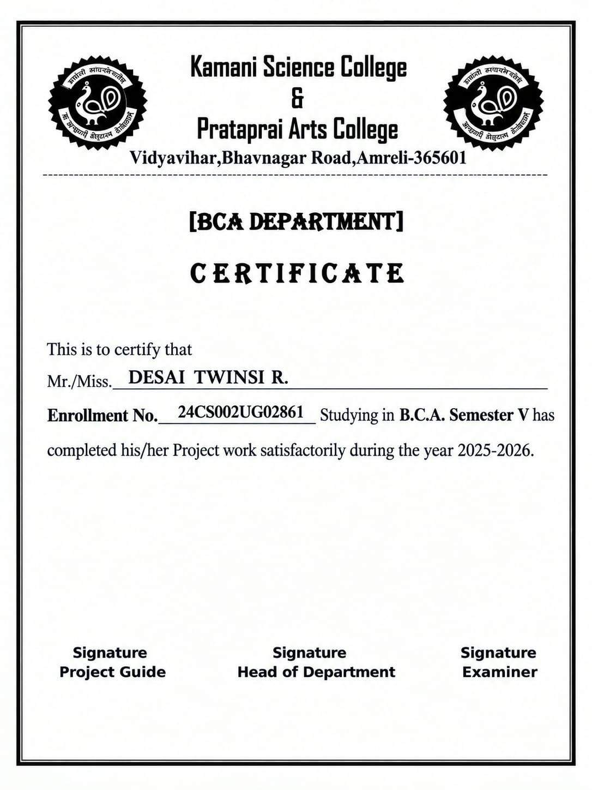

INDEX
No | Title | Page no
1 | Preface | 1
2 | Acknowledgement | 2
3 | Abstract | 3
4 | Introduction | 4
5 | Time Line Chart | 5
6 | Profile Page | 6
7 | Hardware Requirements | 7
8 | Software Requirements | 7
9 | Project Planning & scheduling | 8
10 | SDLC | 9
11 | System Analysis | 11
12 | Problem Definition | 12
13 | Objective of Project | 13
14 | Feasibility Study | 14
15 | Requirement specification | 15
16 | Requirement gathering | 19
17 | Project Page Structure | 21
18 | Data Dictionary | 24
19 | Data Flow Diagram | 29
20 | ER Diagram | 33
21 | UML Diagram | 35
22 | Usecase Diagram | 36
23 | Activity Diagram | 37
24 | Coding | 24
25 | Testing | 25
26 | Advantages | 26
27 | Limitation | 27
28 | Screenshot | 28
29 | biodli

