PREFACE

In today's fast-growing world, every business is moving towards digitalization. The medical field is also not an exception. In a small city like Sihor, people still have to stand in long queues at medical stores to get medicines, which is very time-consuming and difficult, especially for old and ill people.

To solve this problem, we have developed "MediTrack - A Pharmacy Management System". It is a web-based application designed for online medicine ordering and pharmacy management.

The main objective of this project is to provide medicines at the customer's doorstep with just one click. Our system provides many modern facilities like Voice Search (Mic Search), Prescription Upload, Online Payment, Real-time Order Tracking, and Automatic Expiry & Stock Alert. This system is beneficial for both customers and medical store owners. Customers get 24x7 service and home delivery, while the owner can manage stock, bills, and orders digitally without any paperwork.

We have used PHP, MySQL, HTML, CSS, JavaScript and Web Speech API to develop this system. we are very thankful to our project guide and our college for giving us guidance and support to complete this project successfully.

ACKNOWLEDGMENT

We take this opportunity to express our deep sense of gratitude to all those who have helped us in completing our project titled "Meditrack - Pharmacy Management System" successfully.

First and foremost, we would like to express our sincere thanks to our project guide Prof. Nilesh Parghi for his valuable guidance, constant encouragement, and expert suggestions throughout our project work. His guidance has been a great source of inspiration for us.

We are very thankful to the Head of Department and all the faculty members of Computer Department, Kamani Science College & Prataprai Arts College, Amreli, for providing us with all the necessary facilities and support.

We are also thankful to our respected Principal for giving us this opportunity to work on this project and for providing the required resources in the college.

We would like to extend our heartfelt thanks to our parents and friends for their continuous moral support and motivation.

Last but not the least, we are thankful to all the medical store owners and customers of Sihor for their valuable co-operation during system study.

Thank you all.
ABSTRACT

The Meditrack Pharmacy Management System is a Web Portal in which Admin and Users interact with each other. In this platform, a user can search and order medicines online and admin can manage stock, users, billing and orders efficiently. In this way the user gets medicines at doorstep and the system can be managed digitally by admin.

This project aims to develop a pharmacy management system where not only a user can order medicines but also can upload prescription, use voice search facility and track his order. Admin can manage all medicines, get auto alert for low stock and expiry medicines, and manage all orders and users.

Admin and User both can be benefited from this system. Users who wish to order medicines can save their time and get 24x7 home delivery service, resulting in work being done fast and efficiently and also given access to secure online payment and have the ability to get medicines from their homes rather than visiting a store.

INTRODUCTION

Meditrack is a trusted online pharmacy management system that provides good quality medicines for daily use. The system was developed to meet the medical needs of homes, offices, and small communities. We offer a variety of medicines such as tablets, syrups, drop, cream and other useful healthcare products, all at one place through online ordering.

At Meditrack, we believe in honest work and customer satisfaction. We always try to give genuine medicines at reasonable prices and help users choose the right medicines according to their needs. Admin manages stock, expiry and orders. Quality service, fair dealing, and user trust are the main values of our system. Features like voice search and prescription upload make it user-friendly.

Our aim is to build long-term relationships with users by providing reliable medicines and friendly service. Meditrack is committed to serving the community with dedicated service and continues to grow with the support and trust of its users, providing 24x7 home delivery and secure payment.

TIMELINE CHART

Preliminary Investigation 5 Days
System Analysis 5 Days
System Design 7 Days
Coding 15 Days
Testing 7 Days
Implementation 5 Days
Maintenance 10 Days
PROFILE PAGE

Filed | Detail
Project Name | MediTrack Pharmacy Management System
Developed By | Desai Twinsi R.  Garniya Trusha J.
Front End Tool | HTML, CSS, PHP
Back End Tool | PHP
Database | MySQL
Operating System | Microsoft Windows 7 & Microsoft Windows 10
Computer System | Pentium-IV or higher, RAM: 2GB
Project Details | Meditrack Pharmacy Management System is a web-based pharmacy system. The system provides online medicine ordering, voice search, prescription upload and doorstep delivery for daily household and medical use.
Completion Time | 3.5 Month
Guided By | Prof. Nilesh Parghi
Submitted By | Saurashtra University, Rajkot

HARDWARE AND SOFTWARE REQUIREMENT

- HARDWARE
- 8GB of RAM (Minimum 2GB as per Project Profile)
- Multimedia keyboards and mouse
- 1.0+ GHz processor (Pentium-IV or higher)
- 500 GB Hard Disk or SSD
- Monitor 1024x768 resolution

- SOFTWARE:
      - Operating System: Microsoft Windows 7 & Microsoft Windows10
      - Front End Tool: HTML, CSS, PHP
      - Back End Tool: PHP
      - Database: MySQL
      - Server: XAMPP/WAMP Server
      - Browser: Chrome, Firefox, Edge
      - Editor: Visual Studio Code, Sublime Text

PROJECT PLANNING & SCHEDULING

Project planning is an aspect of Project Management, which comprises of various processes. The aim of these processes is to ensure that various Project tasks are well coordinated and they meet the various project objectives including timely completion of the project. Project Planning is an aspect of Project Management that focuses a lot on Project Integration. The project plan reflects the current status of all project activities and is used to monitor and control the project.

Project planning tasks ensure that various elements of the Meditrack system are coordinated to guide project execution. Project Scheduling is one of the most important, yet difficult, tasks. In a web-based project like Meditrack, the frontend (HTML/CSS) and backend (PHP/MySQL) development may happen in parallel, but their work remains highly interdependent.

Meditrack Pharmacy Management System, the Administrator centrally manages all medicine categories, required prescription, inventory, and user data through the Admin Panel. When users (patients or pharmacists) place orders, the data is synchronized and displayed on the admin side. The admin panel provides full privileges, including the ability to manage user accounts, update medicine inventories, and delete user data or orders as required.

SDLC

The software development life Cycle is the Cost-effective and time efficient. Process that development teams use to design and build high-quality software.

when the system. approach is applied to the development of information system a multistep cycle emerges. This multistep cycle known as system Development life cycle.

SDLC is classically through of as the set of I activities that analytics designers and users. carry out to develop and implement an information System.

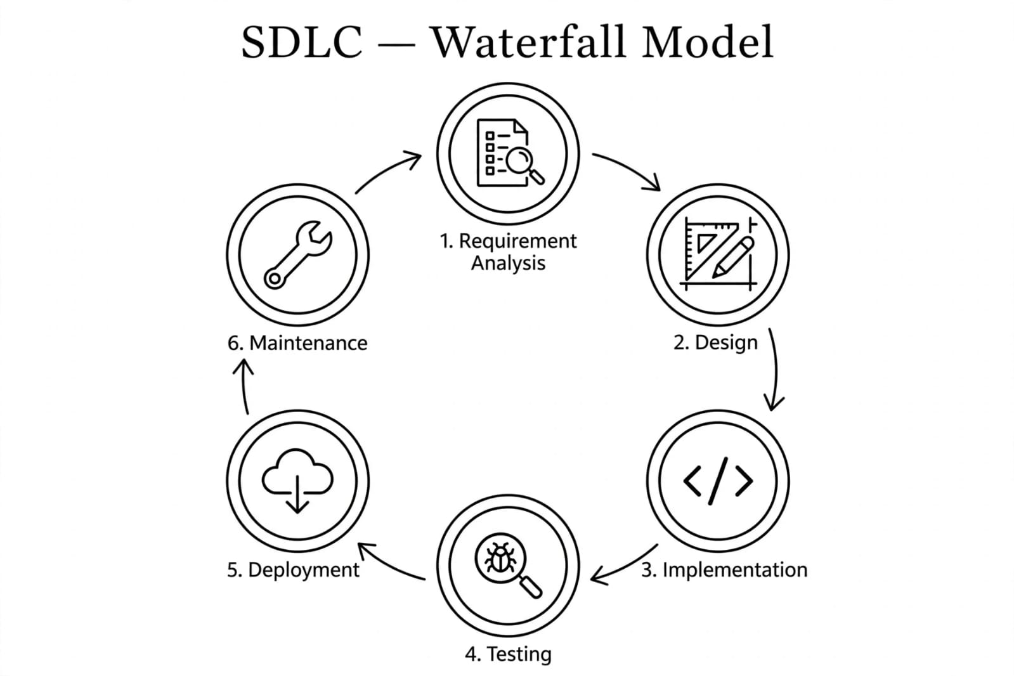

SYSTEM ANALYSIS

System analysis is the process of identification of objectives and requirements, evaluation of alternative solutions and recommendation for a more feasible solution. In other words, system analysis is the step-by-step process of gathering, recording and interpreting facts. The main aim of analysis is to determine problem areas and to take solutions to reduce or eliminate them.
➤ System analysis itself breaks into two stages:

1. Preliminary analysis:
2. Detailed analysis:

During analysis, data are collected from the available files, decision points and transactions of the systems using various tools like (DFD).
PROBLEM DEFINATION

In the existing manual pharmacy system, all work is done manually. The pharmacist has to maintain all records of medicines, stock, expiry dates, customer details and billing in registers or books. This manual system is very time consuming, requires more manpower and there are high chances of errors.

The main problems in existing system are: No online medicine search facility, customer has to visit pharmacy physically, no stock and expiry alert system, difficult to find medicines quickly, no prescription upload facility, no order tracking system, and maintaining sales reports is difficult.

So, to overcome these problems, we have proposed 'Meditrack -Pharmacy Management System'. It is a web-based system with two modules Admin and User. Admin can manage medicines, stock, expiry alerts, users, prescriptions and orders. User can search medicine with voice search, upload prescription, add to cart, place order, track order and make payment online. This system saves time, reduces Manual work and provides 24x7 service.

OBJECTIVE OF PROJECT

- To maintain accurate records of medicines, customers, and prescriptions.

- To automate the pharmacy management process and reduce manual work.

- To provide fast and error-free billing and payment processing.

- To send alerts for low stock and expired medicines.

- To improve data security and ensure safe storage of pharmacy records.

- To save time, reduce operational costs, and increase productivity.

- To improve customer satisfaction by providing quick, convenient, and reliable pharmacy services.

- To ensure 24x7 business availability, business analysis and growth, and data backup and data security are included

FEASIBILITYSTUDY

The feasibility study is done before starting the project to check if the proposed system can be built, operated, and is profitable. It avoids risk and future failure.
For the complete feasibility study, I need to concentrate on following area:
➤ They are three types of feasibility Study:
1. Technical
2. Operational
3. Economical
Technical:
It checks if required technology is available. For Meditrack Pharmacy, PHP, MySQL, Apache Server, Computer, Internet, Billing System and Prescription Upload features are easily available. So, it is technically feasible.
Operational:
It checks if daily work can run smoothly. The system manages medicine stock, expiry alerts, billing, online orders, and home delivery efficiently. Staff and users can operate it easily. So it is operationally feasible.
Economical:
It checks if the system is profitable. Income from medicine sales is more than expenses like rent, stock, electricity and salary. It also saves time and reduces manual work. So it is economically feasible
REQUIREMENT SPECIFICATION

Q-1. what is the name of pharmacy?
Ans: Belief Medimart

Q-2. What is the purpose of this system?
Ans: to sell medicines online and manage Pharmacy inventory and billing.

Q-3. Which companies’ medicine do you sell?
Ans: medicine from different pharmaceutical companies such as adrovent Pharma Apollo Pharma.

Q-4. who use this system?
Ans: Admin
Pharmacist
Customer.

Q-5. what categories of medicine do you sell?
Ans: Tablet
Syrup
Cream

Q-6. how is medicine Quantity measured?
Ans: in strips
bottles.
Boxes
Drops

Q-7. should batch Number be maintained?
Ans: yes, every medicine must have a batch Number for tracking

Q-8. can customer’s order Prescription medicine online?
Ans: yes, by uploading Prescription and selecting medicine quantity

Q-9. what customer details core required?
Ans: Name
Phone Number
Email
Address

Q-10. How can customer Pay?
Ans: UPI
COD-cash on Delivery.

Q-11. should expiry dates be tracked?
Ans: yes, the system should monitor expiry dates and provide alerts.

Q-12. can medicines be searched easily?
Ans: by Name,
by category
by disease

Q-13. How is the selling Price determined?
Ans: MRP
Discount
GIST

Q-14. what reports core generated?
Ans: sales report
Purchase report
Medicine

Q-15. What is the minimum and maximum onder quantity?
Ans: minimum - 1 strip/box
maximum as Per Stock

Q-16. do you keep ready stock of medicines?
Ans: yes, Fust moving medicines core always available.
Q-17. Does the system maintain customer Purchase history!
Ans: yes, admin and Pharmacist can view Past orders.

Q-18. which product is sold the most?
Ans: diabetes & bp medicine

Q-19. what security features are Required?
Ans: Password Protection, login authentication. and better customer service.

REQUIREMENT GATHERING

- User Requirements (Patients/Customers)
- User registration and login.
- View and search medicines by name, category, or manufacturer.
  - Check medicine availability, dosage form (tablet, syrup, capsule), and pack size.
  - Upload prescription (if required) and add medicines to cart and place orders.
- Make payment through UPI, Card, or COD.
- View order status and purchase history.

2. Admin Requirements (Pharmacist/Admin)
- Admin login.
- Manage medicines, categories, and suppliers.
- Manage price, batch number, expiry date, and stock levels.
- Manage customer orders and verify uploaded prescriptions.
- Generate bills, invoices, and reports (sales, low stock, expiring soon).

3. System Requirements
- MySQL database for storing data (users, medicines, orders, prescriptions).
- PHP for processing.
- HTML, CSS and JavaScript for interface.
- XAMPP server for running the system.
- Simple and user-friendly interface.
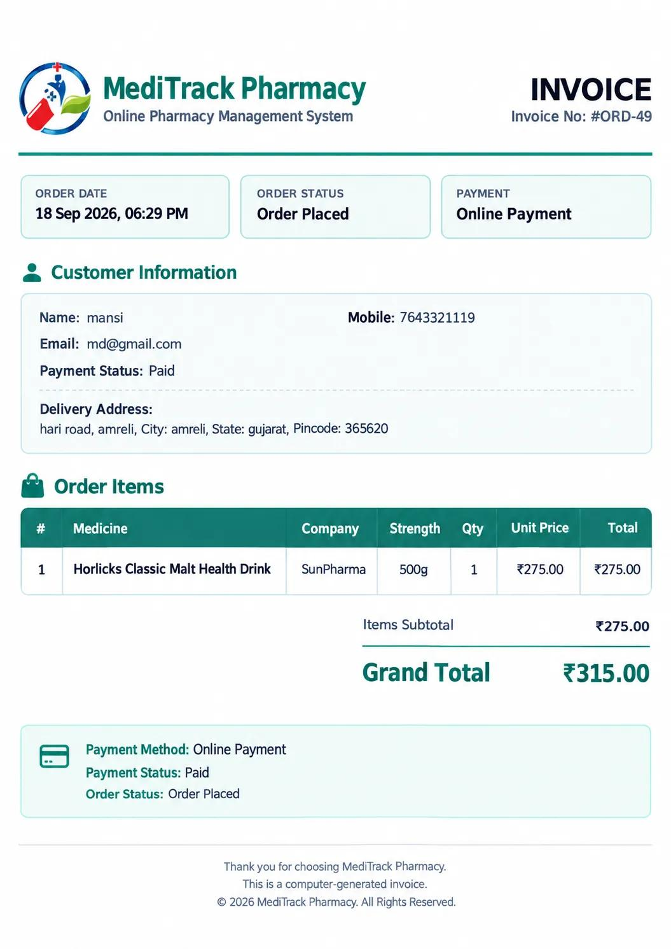
PROJECT PAGE STRUCTURE

- Admin Side:
- Login Home
- Dashboard
- Manage Medicine
- Category
- Medicine list
- Stock and expiry
- Purchases
- Prescription
- Customer Order
- Sales &Billing
- Registered Users
- Review
- Report
- CMS
- View Site
- Logout

- User Side:
- View Site
- About Us
- Contact Us
- Medicine Store
- Cart / buy now
- Registration / Login
- Checkout
- Required Prescription
- Payment
- Invoice
- Track Order
- Review
- Logout
- Admin Side

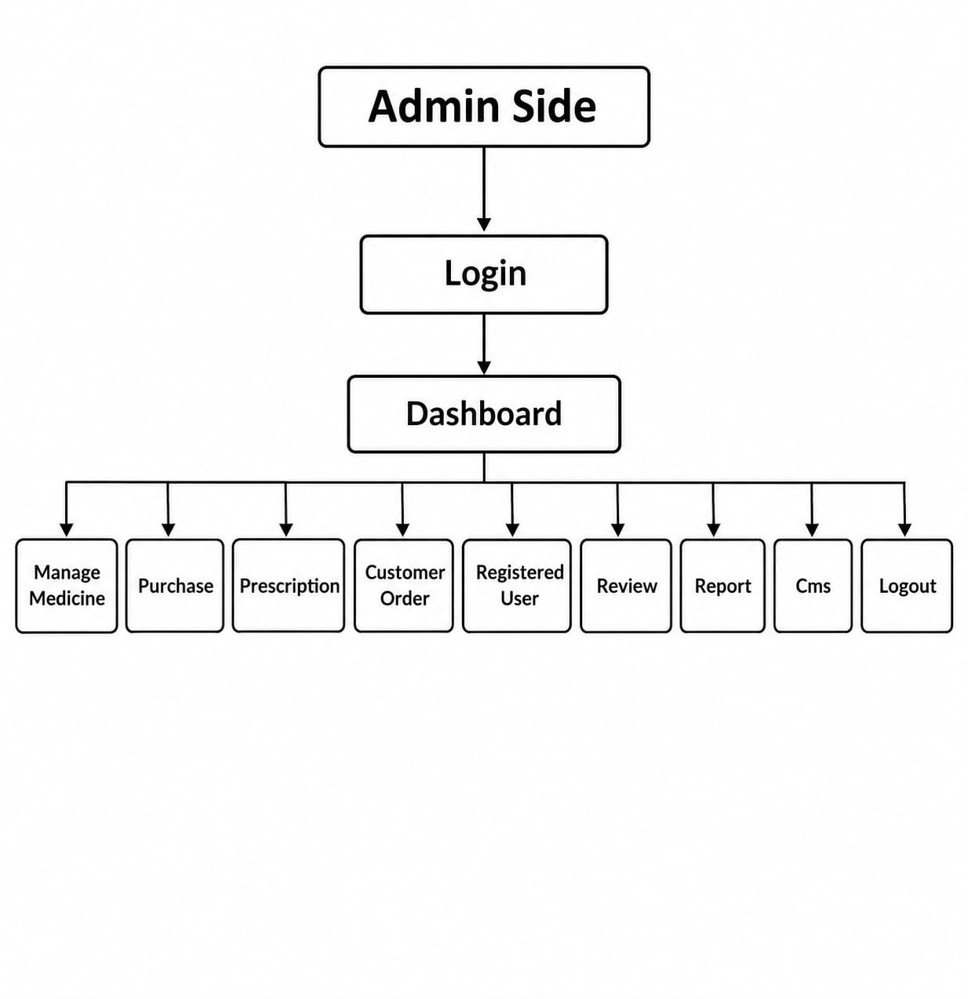

- User Side
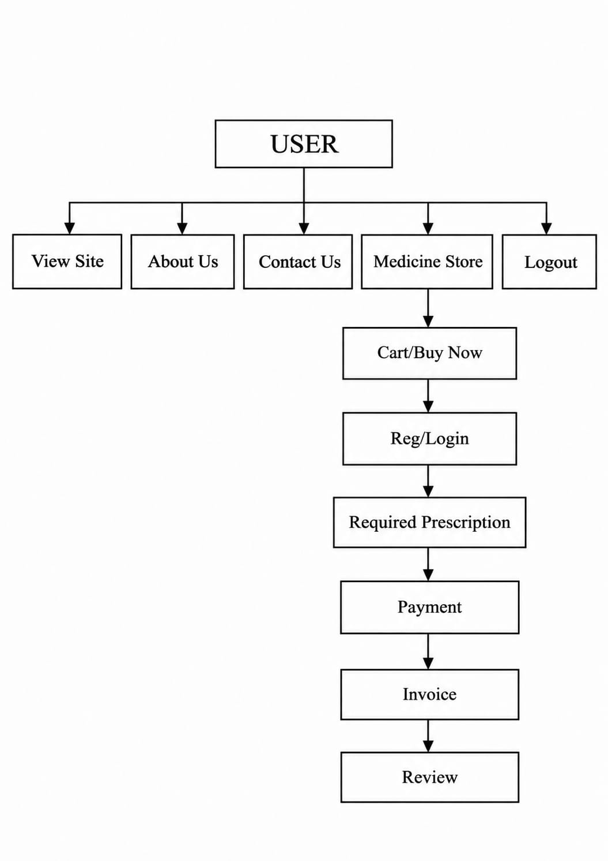

DATA DICTIONARY

The data Dictionary is a set of tables. MySQL uses it to maintain information about this own database.
➤ Data dictionary contains the following information:
- Name of the table of database.
- User information such as privileges.
- Name and data-type of all columns in database table.

- Database Name: Belief

- User
This table is used to store users and admin information.

Column Name | Data Type | Constraints
id | Integer (11) | Primary key
name | Varchar (100) | Not null
mobile_no | Varchar (15) | Not null
email | Varchar (100) | Not null, unique
password | Varchar (255) | Not null
user_type | enum (`user`,`admin`) | Not null(default: `user`)

2. Categories
This table is used to organize medicines into category

Column Name | Data Type | Constraints
id | Integer (11) | Primary key
category_name | Varchar (100) | Not null

3. Medicines
This table is used to store medicine information like cream.

Column Name | Data Type | Constraints
Id | Integer (11) | Primary key
medicine_name | Varchar (100) | Not null
Symptoms | Varchar (255) | Nullable
company_name | Varchar (100) | Not null
Category | Varchar (50) | Not null
category_id | Integer (11) | Foreign key
Strength | Varchar (50) | Not null
Price | Decimal (10,2) | Not null
Stock | Integer (11) | Not null(default:0)
expiry_date | Date | Not null(default:0)
Image | Varchar (255) | Primary key
is_popular | Integer (11) | Foreign key
requires_presciption | Integer (11) | Foreign key

4. Cart
This table is storing selected medicine.

Column Name | Data Type | Constraints
Id | Integer (11) | Primary key
user_id | Integer (11) | Foreign key
medicine_id | Integer (11) | Foreign key
Quantity | Integer (11) | Not null

5. Prescriptions
This table contains all medication orders prescribed by doctors.

Column Name | Data Type | Constraints
id | Integer (11) | Primary key
order_id | Integer (11) | Foreign key
user_id | Integer (11) | Foreign key
file_name | Varchar (255) | Not null
uploaded_at | Timestamp | Not null
status | Varchar (20) | Not null

6. Orders
This table is storing order details and work by place and track customer order.

Column Name | Data Type | Constraints
id | Integer (11) | Primary key
user_id | Integer (11) | Foreign key
counter_customer_name | Varchar (100) | Nullable
counter_customer_moblile | Varchar (15) | Nullable
total_amount | Decimal (10,2) | Not null
payment_method | Varchar (50) | Not null
payment_status | Varchar (20) | Not null
address | Text | Not null
order_date | Timestamp | Not null
status | Varchar (20) | Not null

7. Order_items
This table is storing medicine linked to an order, used for invoicing and stock deduction

Column Name | Data Type | Constraints
id | Integer (11) | Primary key
order_id | Integer (11) | Foreign key
medicine_id | Integer (11) | Foreign key
quantity | Integer (11) | Not null
price | Decimal (10,2) | Not null

8. Reviews
This table is working by save ratings and review and use customer review.

Column Name | Data Type | Constraints
id | Integer (11) | Primary key
order_id | Integer (11) | Foreign key
user_id | Integer (11) | Foreign key
rating | Integer (11) | Not null
comment | Text | Nullable
created_at | Timestamp | Not null

9. Contact_messages
This table is stores queries and messages submitted by users through the website contact form.

Column Name | Data Type | Constraints
id | Integer (11) | Primary key
name | Varchar (100) | Not null
email | Varchar (100) | Not null
phone | Varchar (20) | Not null
subject | Varchar (255) | Not null
message | Text | Not null
created_at | Timestamp | Not null

10. Purchases
This table is used for inventory updates, accounts payable and purchase analysis.

Column Name | Data Type | Constraints
id | Integer (11) | Primary key
medicine_id | Integer (11) | Foreign key
quantity | Integer (11) | Not null
purchase_price | Decimal (10,2) | Not null
purchase_date | Timestamp | Not null

DATA FLOW DIAGRAM

The DFD gives brief idea on how the designed system is working. It also suggests to us the type of users who using this system and the process involved in the system.

Represent dataflow

Represent an Entity

Represent a processing

Represent a data table

- Context level

Meditrack Pharmacy
Management System

User
Admin

- level 1 DFD (user side)

1.1
1.2
1.3
1.4
1.5
1.6
1.7
1.8

- level 2 DFD (admin side)

1.1
1.2
1.3
1.4
1.5
1.6
1.7
1.8

ER DIAGRAM

The Entity-Relationship Model (ER Model) is a conceptual model for designing a database. This model represents the logical structure of a database, including entities, their attributes and relationships between them.

Entity

Relationship

Attribute

UML DIAGRAM

UML (Unified Modeling Language) is a standard visual language used to design and represent the structure and behavior of a software system
I. Use case Diagram
A Use Case Diagram shows the interaction between users (actors) and the system. It represents what functions the system provides.

Actors

Usecase

System boundary

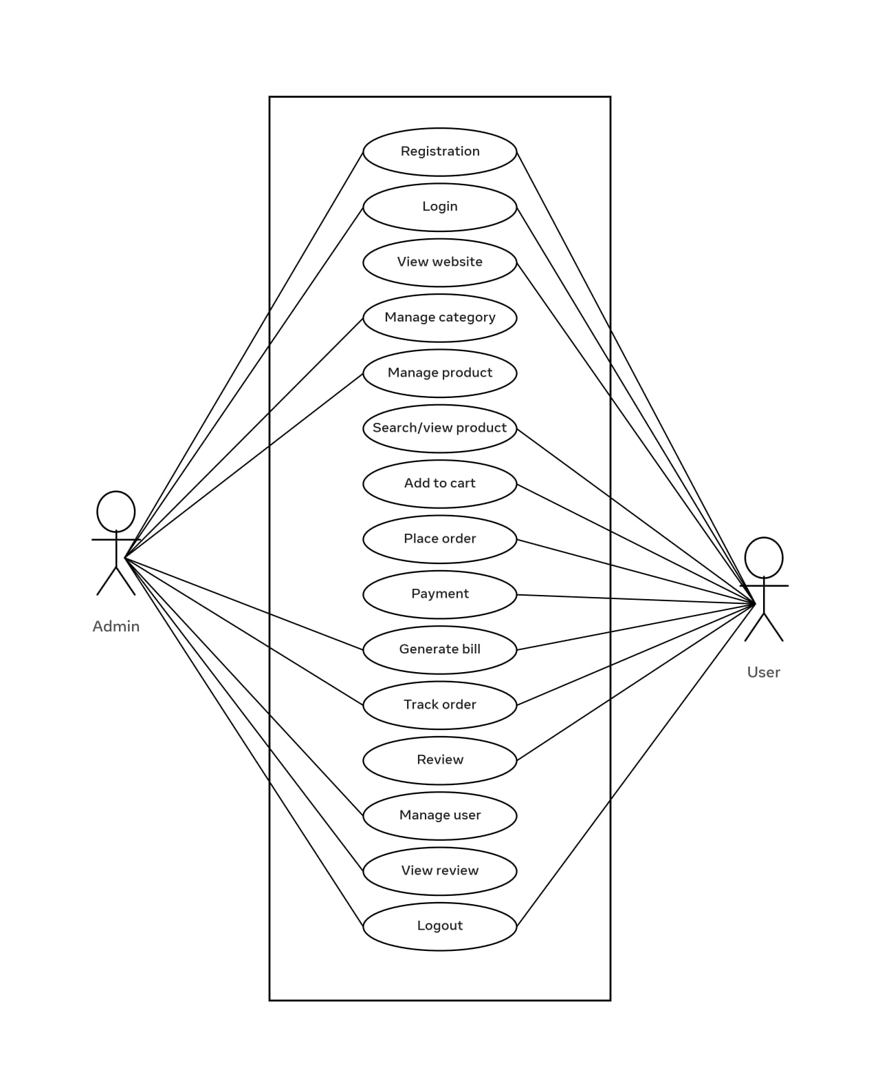

II. Activity Diagram

An Activity Diagram shows the step-by-step workflow or process of a system. It represents how an activity starts, proceeds through different steps, and ends.

Initial state

Activity state

Control flow

Decision node

Fork

Join

Final state
- Admin side
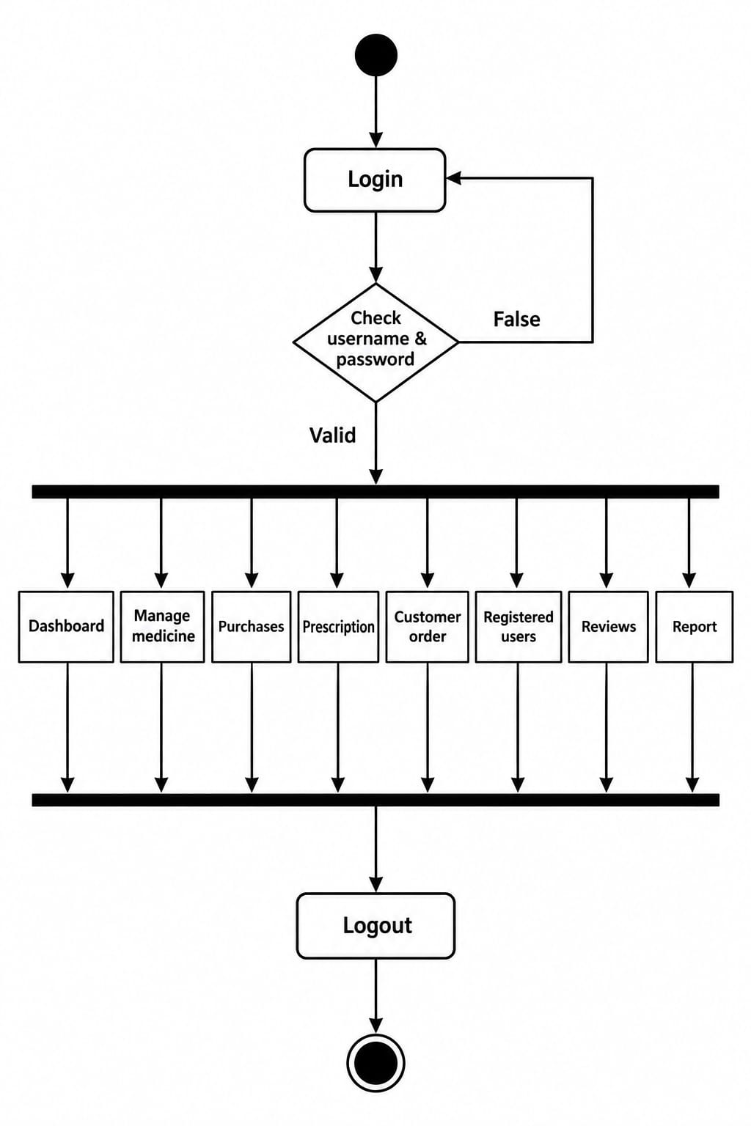
- User side
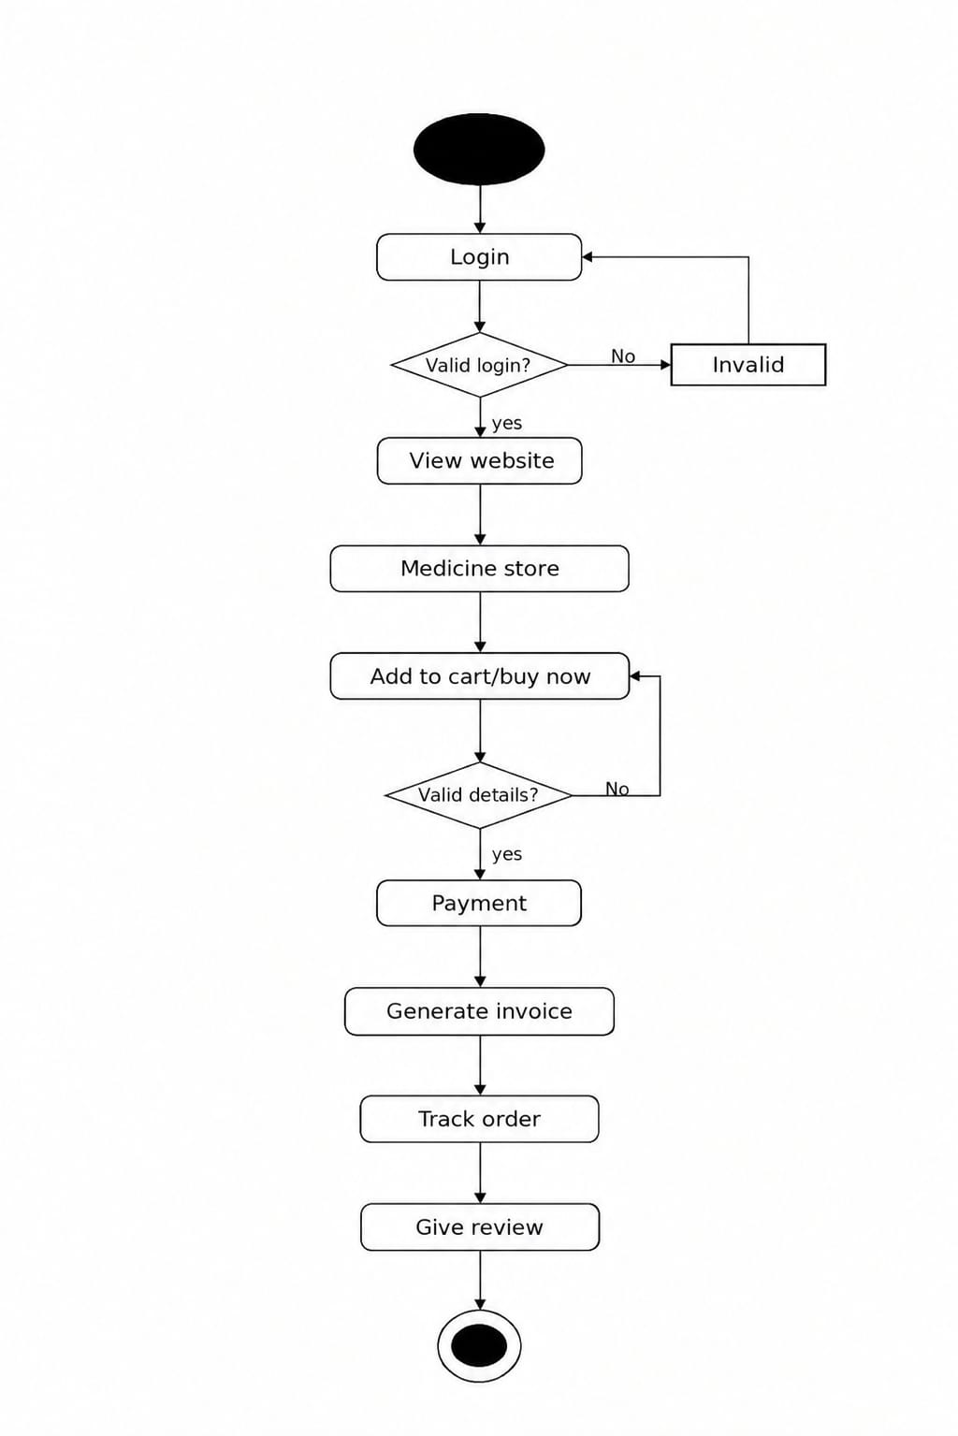
SCREEN LAYOUT FOR CODING [ADMIN SIDE]

SCREENSHOTS
Home page
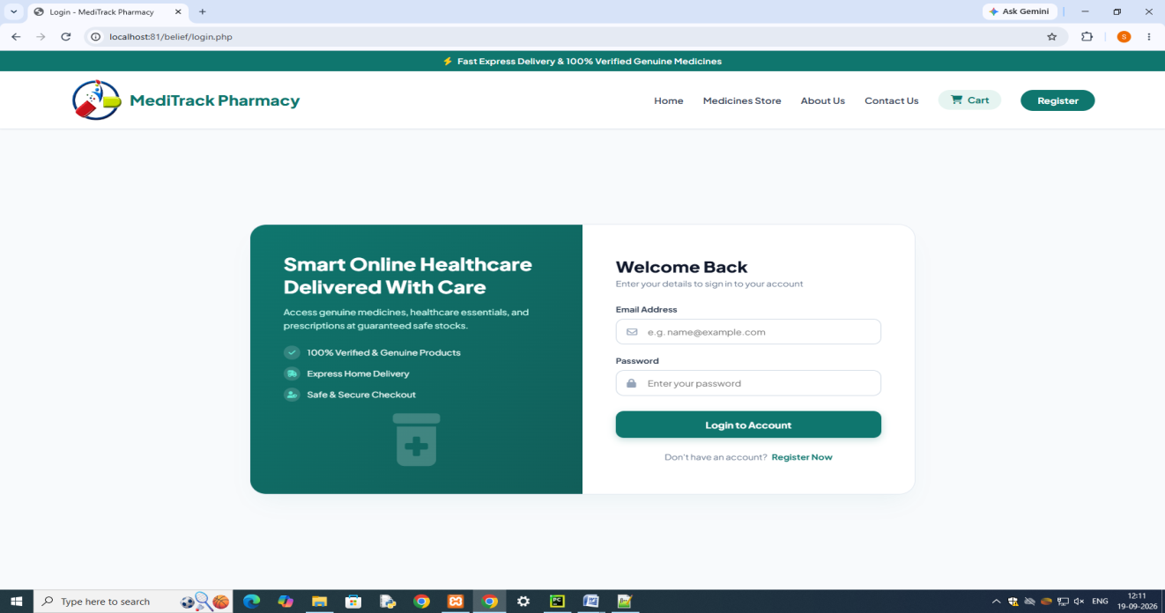
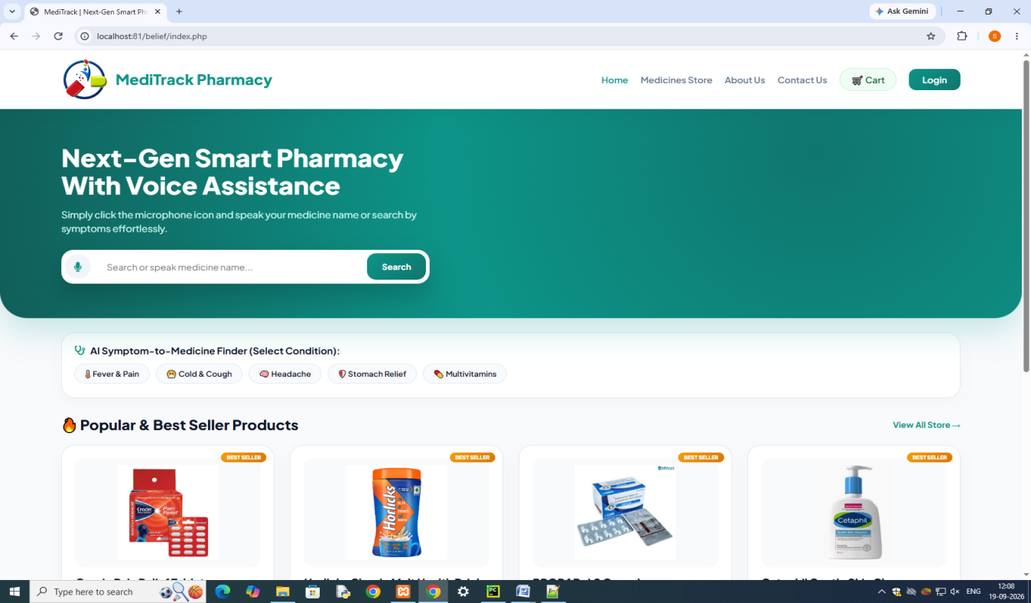
Login page

Registration Page
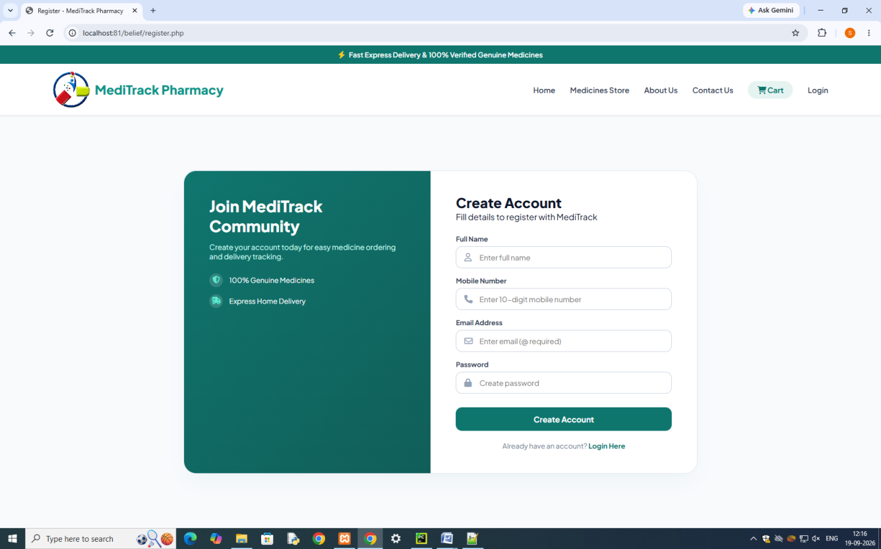
Medicine Store
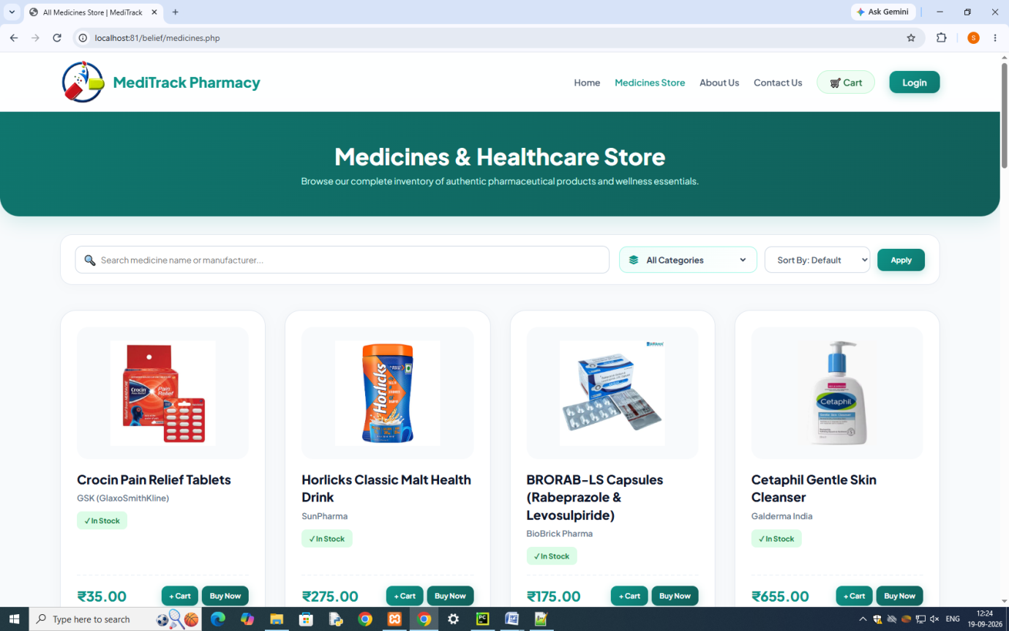

About Us
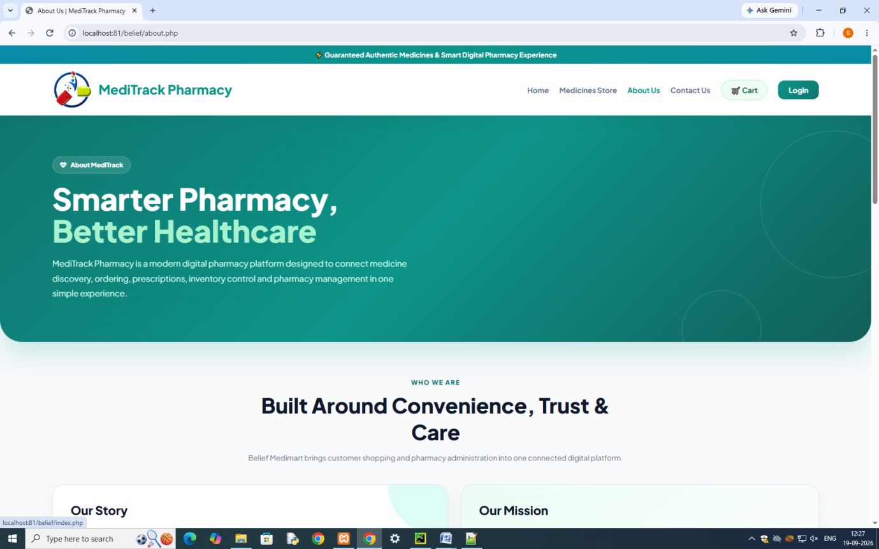

Contact Us
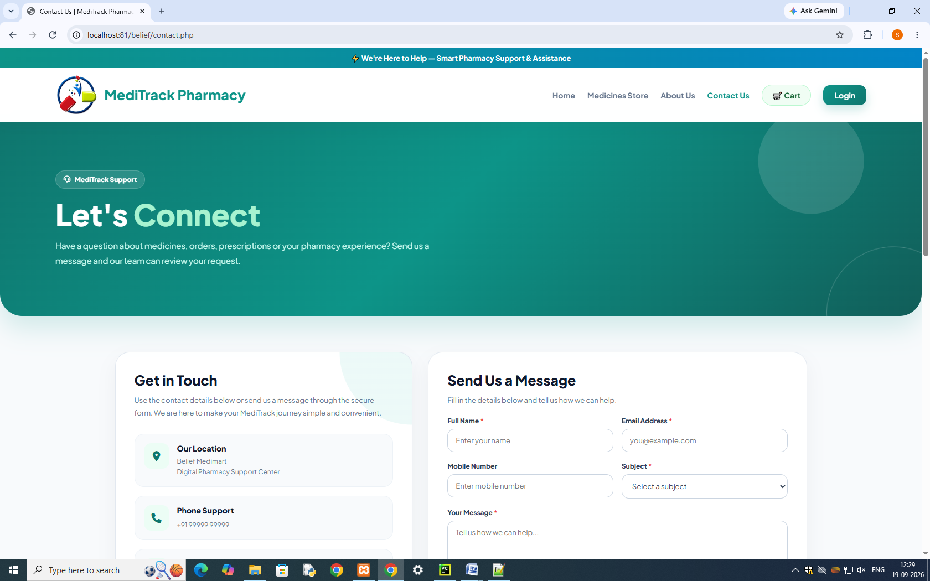

Cart
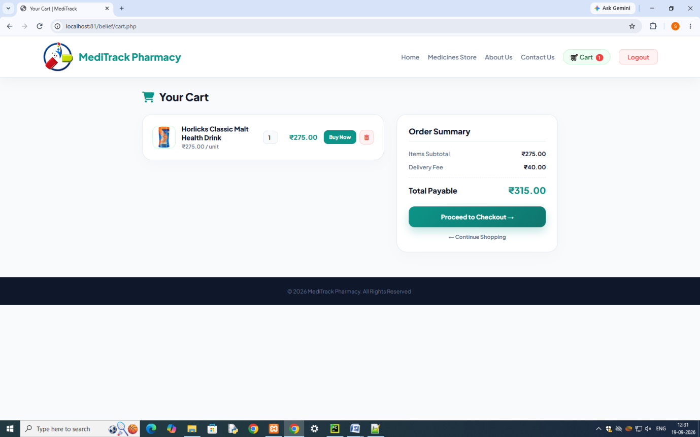

Check out
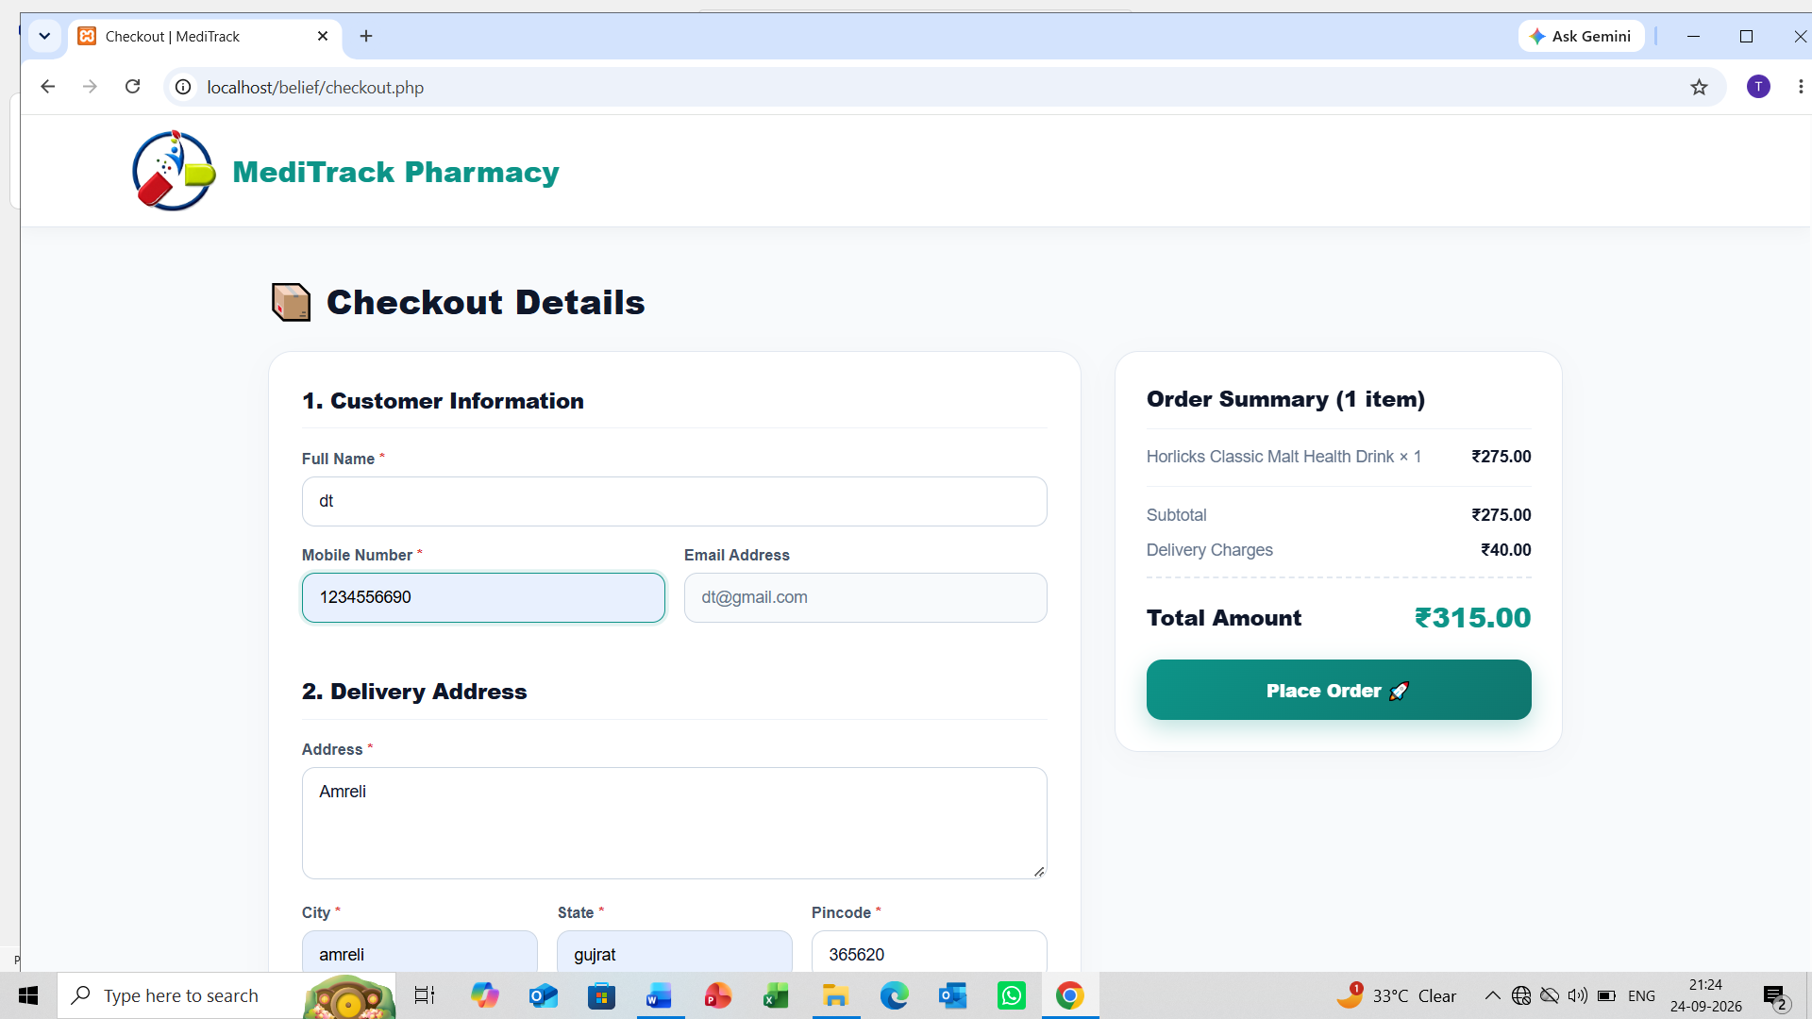
Place order

TESTING

What is testing?

Testing is the process of evaluating and verifying that a software product or application. does what it is supposed to do.

Types of testing: -
Manual testing
Automation testing

Manual testing:

Types Of Testing Methods

Black Box White Box Grey Box
Testing Testing Testing

+ =

(Unknown Internal (Known Internal (Internal Code
Code Structure) Code Structure) Partially Known)

- White Box Testing: -

It is Software testing technique that involves testing the internal structure and workings of a software application.

- Black Box Testing: -

A form of testing that is performed with no knowledge of a system.

- Gray Box Testing: -

In Gray box testing, the tester is not required to design test case.

TEST CASE
- Login form
Test Case Id | Test Step | Input Data | Expected Results | Actual Results | Execution Status
TC01 | Open the login page | Login page URL | Login form with email password and Login button should appear. | Login page displayed correctly | Pass
TC02 | Enter valid Email and password and click Login | Valid Email, Valid Password | User should login successfully and redirect to home page | Login successful and redirected to home page | Pass
TC03 | Enter invalid Email or password | Invalid Email / Password | Error message should appear | Error message displayed | Pass
TC04 | Click Login without entering any data | Empty fields | System should show required field validation | Validation message displayed | Pass
TC05 | Access protected page then login | Valid Email, Valid Password | User should be redirected to requested page after login | Redirect works correctly | Pass
TC06 | Click Register link | Click Register | User should open registration page | Registration page opened | Pass

PROS AND CONS FOR SYSTEM

Advantages:
Time saving & convenient.
24x7 availability.
Stock management easy.
online Payment facility CUPI ID).
Prescription upload facility.
home delivery with tracking.
voice-based medicine search.
secure & Paperless, with fust work.
automatic generate invoice...

Limitation:
Internet dependency.
No Return / No Refund.
single admin system.
NO OTP verification for registration.
NO barcode Scanner integration.
only single language support
No discount Cupon system

BIBLIOGRAPHY

Bibliography means take reference to prepare any project. Here I concern website which takes reference is as under.

Reference Websites: -
https://www.google.com/
W3Schools Online Web Tutorials
Our staffs

