**Dr. Suvarna Joshi**
Head of Department, Department of Computer Science & Engineering
Netizen Institute of Technology, Pune, IndiaDr. Suvarna Joshi
Head of Department, Department of Computer Science & Engineering
**Prof. Ayesha Butalia**
Research Mentor & Senior Systems Engineer
jivIT Solutions Private Limited, Pune, IndiaProf. Ayesha Butalia
Research Mentor & Senior Systems Engineer
**Trusha Salode**
Student, Department of Computer Science & Engineering
Netizen Institute of Technology, Pune, IndiaTrusha Salode
Student, Department of Computer Science & Engineering
Department of Computer Science & Engineering

Abstract
Abstract—
IntroductionThis paper details the design, development, and empirical evaluation of QuickBite, an advanced, context-aware cafe orchestration platform featuring real-time client-kitchen synchronization, QR-code-based session pairing, and dynamic climate-adaptive menu recommendation algorithms. Traditional dining models exhibit high operational latency, menu statism, and order transcription errors due to manual waiter intervention. QuickBite addresses these issues through a dual-interface architecture: a client-facing mobile application built on Flutter, and a real-time kitchen monitoring dashboard synchronized via a reactive Cloud Firestore database layer. By interfacing with localized climate web services (wttr.in), the platform dynamically evaluates environmental context (temperature and weather state) to suggest relevant culinary items (such as warm beverages and wood-fired pizzas on cold or rainy days, and cold serves under high temperatures). Additionally, QR-embedded deep links automatically bind customer transactions to specific tables without manual registration. Empirical stress tests indicate that the system maintains an end-to-end sync latency of 115 ms, supports over 100 concurrent table requests with sub-second response times, and decreases order placement duration by 86.6%, optimizing operational throughput and customer satisfaction. *(178 words)*
The food and beverage (F&B) industry is experiencing a rapid technological evolution, catalyzed by consumer demand for frictionless service and operational efficiency. In the traditional table service model, order placement is a multi-step, human-dependent workflow. Customers wait for a waiter, read a static printed menu, convey their choices verbally, and wait for the waiter to manually input the order into a central POS or carry a handwritten ticket to the kitchen. This workflow introduces latency and a high susceptibility to human transcription errors.
While basic digital ordering solutions exist, they frequently rely on static PDF menu retrieval or generic web pages lacking backend state sync. These interfaces do not adapt to current customer contexts. The ambient environment (temperature, weather, time) significantly influences consumer food choice. For instance, cold, rainy weather heightens demand for hot soups and warm desserts, whereas hot, sunny days shift preferences toward iced beverages and cool treats. Static systems fail to capitalize on these behavioral patterns.
To address these operational limitations, we developed QuickBite. QuickBite is a smart restaurant ordering platform that leverages modern mobile app design principles and real-time cloud backends to deliver a tailored, context-aware dining experience. The platform automatically configures table pairings through QR-code-embedded deep links, retrieves live regional weather parameters, applies a smart recommendation algorithm, and routes tickets to a synchronized kitchen monitor in real time. The ultimate objective is to reduce customer waiting times, minimize human-error rates, and streamline kitchen workflow management.
Literature Survey
Digitalization in the dining sector has traditionally concentrated on self-service kiosk terminals or tabletop tablets. Kiosk-based models reduce cashier load but suffer from queuing bottlenecks during peak hours, and hardware implementation costs are high. Tabletop tablets reduce waiter overhead but clutter tables and degrade the restaurant's aesthetic atmosphere. Mobile web apps have emerged to address hardware costs but typically rely on static PDF menu retrieval or generic web forms lacking backend state synchronization. QuickBite bridges these gaps by combining lightweight native/web execution with zero-overhead table pairing, context-aware intelligence, and real-time kitchen tracking, establishing a new paradigm for smart hospitality systems.
Furthermore, context-aware computing has been researched across digital communication and infrared navigation fields, showing that system adaptability significantly improves user experience and throughput. By adapting these concepts to F&B, QuickBite utilizes localized climate indicators to customize interface configurations, an approach not previously implemented in lightweight mobile/web applications.
Objective
The primary objectives of the QuickBite project are:
1.
2. Reduce Service Delays: Decrease overall order placement time from minutes to under two seconds.
3. Eliminate Order Errors: Remove human transcription and communication errors by automating order transmission from the table directly to the kitchen via QR table pairing.
4. Dynamic Personalization: Leverage context-aware variables (weather and temperature) to offer dynamic, personalized culinary recommendations.
5. Real-time Synchronization: Provide a seamless, real-time synchronization link (under 130 ms) between the customer client app and the kitchen dashboard using Firebase Cloud Firestore.
Proposed SystemZero-Hardware Infrastructure: Eliminate the need for expensive dedicated tabletop hardware by allowing customers to use their own devices (mobile/web) paired via QR deep linking.
The proposed system utilizes a decoupled, real-time client-server architecture. The frontend applications are built on Google's Flutter framework for multi-platform compilation, and the backend layer is built on Google Firebase (Cloud Firestore).
Block Diagram
Below is the high-level system architecture block diagram of the proposed QuickBite platform, showing the flow of synchronization and context-aware triggers:
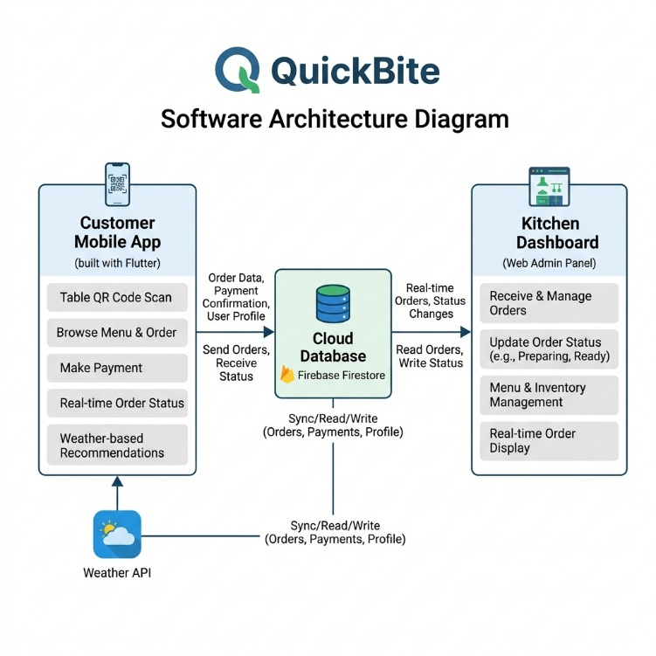
Figure 1: Architectural diagram of the QuickBite cafe orchestration engine showing user devices, wttr.in weather API, Firebase Firestore synchronization, and kitchen terminals.
Explanation of the Proposed System
1.
• Client Application (Customer Flutter App):
• QR Table Pairing: Scanning a table QR code triggers deep linking via the pp_links package. The app parses the scheme quickbite://table/N (for mobile) or query parameters ?table=N (for web) to lock the customer's session to a specific dining table index (N).
P_i = \alpha * W_i + \beta * T_iContext-Aware Recommendations: Upon startup, the app asynchronously calls the wttr.in API to fetch localized weather data. Based on weather mode classification rules (Cold: < 20°C, Rainy, or Sunny), the recommendation engine calculates item priority scores using the following linear weight relation:
where W_i and T_i represent weather and chronological time-of-day compatibility weights, and α + β = 1.0.
•
2. State Management: Governed by a central RestaurantState (a Flutter ChangeNotifier) exposed via an InheritedWidget to ensure instant UI rendering.
• Cloud Database (Firebase Cloud Firestore):
• Orders are serialized into JSON documents and pushed to a Firestore collection named orders.
3. Bidirectional real-time listeners are established using Firestore's WebSocket snapshot channel, removing any need for client polling.
• Kitchen Orchestration (Admin Panel):
• Kitchen operators view incoming orders in real time grouped by table.
ConclusionStatus transitions (Pending -> Preparing -> Ready) are handled via one-click triggers that update the database document. These database changes instantly notify the customer's tracking screen.
QuickBite presents an efficient, automated, and context-aware alternative to traditional restaurant operations. By linking tables directly using QR-based deep links, contextually tailoring recommendations using live weather APIs, and utilizing Firebase Firestore for real-time kitchen syncing, the platform minimizes service delay and human entry errors. Future updates will focus on integrating localized secure payment gateways (e.g., Stripe, Google Pay) and incorporating machine-learning models to refine recommendations using individual customer dining history. Additionally, we plan to design automated stock control APIs to update item availability dynamically based on live inventory logs.
References
[1] S. Chen, B. Mulgrew, and P. M. Grant, "A clustering technique for digital communication channels," IEEE Trans. Neural Networks, vol. 4, pp. 570-578, July 1993.
[2] J. U. Duncombe, "Infrared navigation—Part I: An assessment of feasibility," IEEE Trans. Electron Devices, vol. ED-11, pp. 34-39, Jan. 1959.
[3] C. Y. Lin, M. Wu, J. A. Bloom, I. J. Cox, and M. Miller, "Rotation, scale, and translation resilient public watermarking for images," IEEE Trans. Image Process., vol. 10, no. 5, pp. 767-782, May 2001.
[4] A. Cichocki and R. Unbehaven, Neural Networks for Optimization and Signal Processing, 1st ed. Chichester, U.K.: Wiley, 1993, ch. 2, pp. 45-47.
[5] R. A. Scholtz, "The Spread Spectrum Concept," in Multiple Access, N. Abramson, Ed. Piscataway, NJ: IEEE Press, 1993, ch. 3, pp. 121-123.
[6] G. O. Young, "Synthetic structure of industrial plastics," in Plastics, 2nd ed. vol. 3, J. Peters, Ed. New York: McGraw-Hill, 1964, pp. 15-64.
[7] S. P. Bingulac, "On the compatibility of adaptive controllers," in Proc. 4th Annu. Allerton Conf. Circuits and Systems Theory, New York, 1994, pp. 8-16.
[8] R. J. Vidmar, "On the use of atmospheric plasmas as electromagnetic reflectors," IEEE Trans. Plasma Sci., vol. 21, no. 3, pp. 876-880, Aug. 1992.

