1. Real-World Devices Using SMPS and UPS

Devices Using SMPS (Switched Mode Power Supply)
Device | Why it Uses SMPS
Desktop Computer | Converts AC power into stable DC voltages for the motherboard, CPU, and other components.
Laptop Charger | Converts mains AC into low-voltage DC to charge the laptop battery safely.
LED TV | Provides efficient and regulated DC power to the television's internal circuits.

Devices Using UPS (Uninterruptible Power Supply)
Device | Why it Uses UPS
Desktop Computer | Prevents data loss and allows safe shutdown during power outages.
Wi-Fi Router | Keeps the internet connection running during short power cuts.

2. Diagram of a Typical Desktop PC SMPS
AC Mains Input (230V AC)
│
▼
+------------------+
| AC Input & |
| Filter |
+------------------+
│
▼
+------------------+
| Rectifier |
| (AC → DC Output) |
+------------------+
│
▼
+------------------+
| High-Frequency |
| Switching |
| Circuit (PWM) |
+------------------+
│
▼
+------------------+
| Transformer |
| (Voltage Change) |
+------------------+
│
▼
+------------------+
| Rectifier & |
| Output Filter |
+------------------+
│
▼
+------------------+
| DC Outputs |
| +3.3V |
| +5V |
| +12V |
+------------------+

3. Power Connectors Used in a Desktop PC
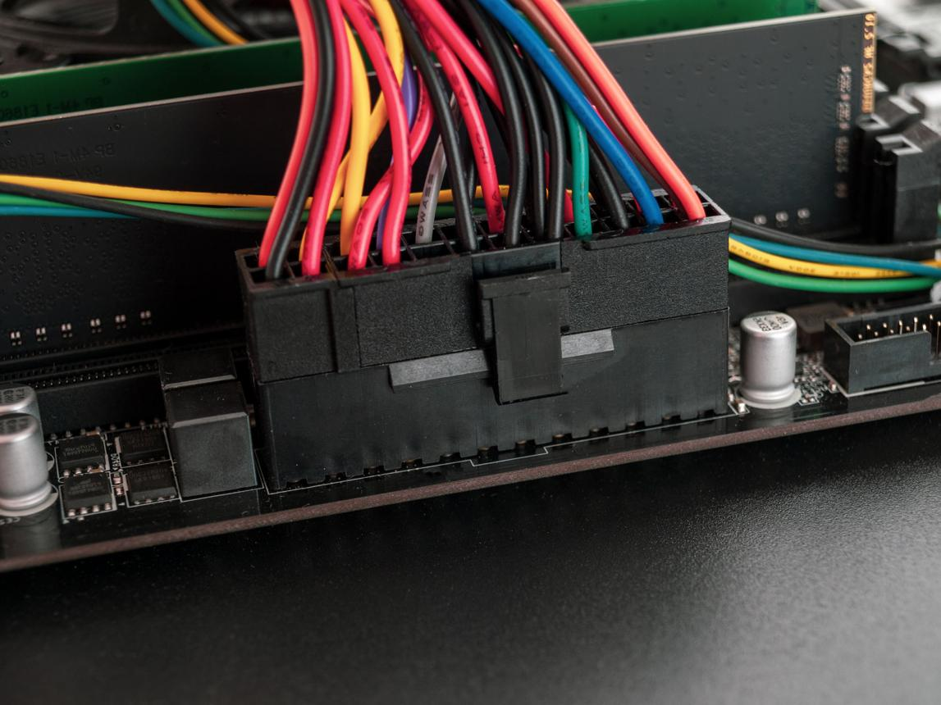
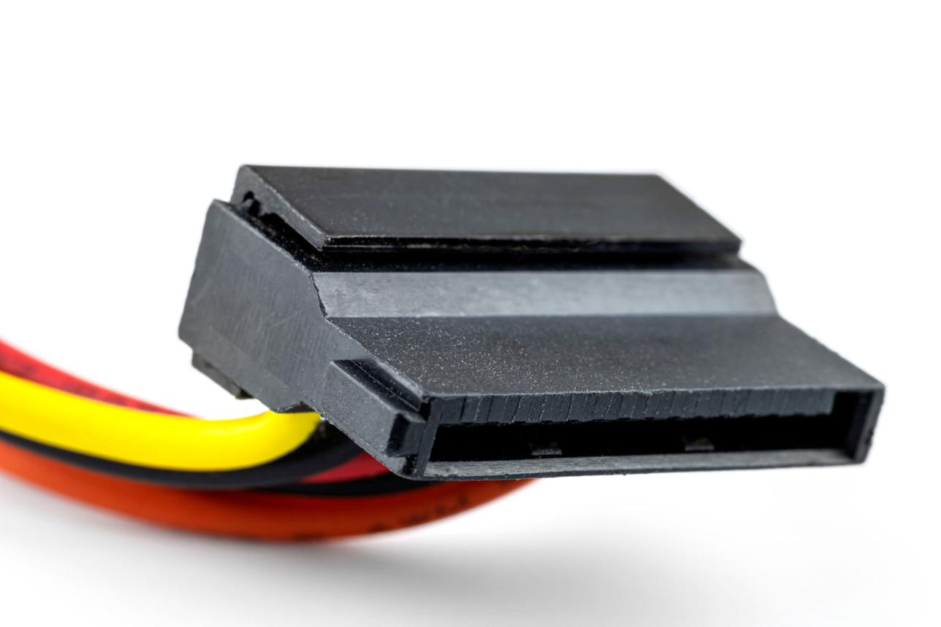
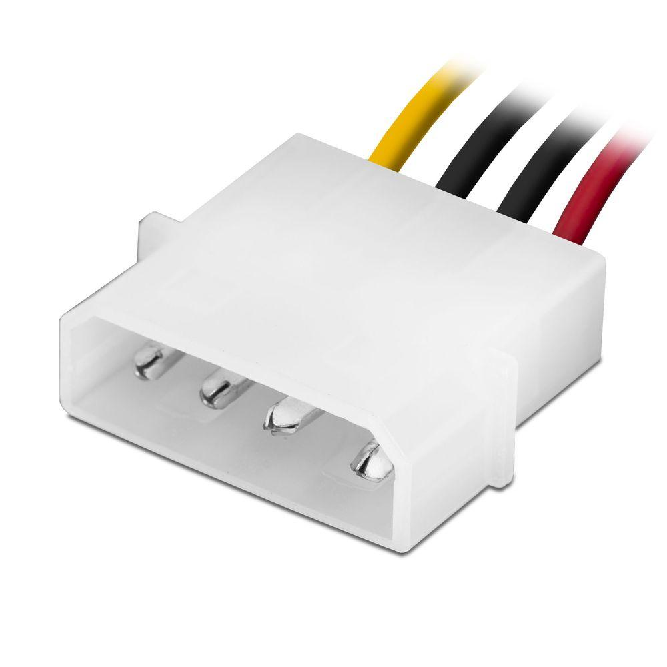
5
Connector | Devices it Powers | Safety Tip
ATX 24-pin Motherboard Connector | Motherboard | Turn off and unplug the PC before connecting or removing the connector.
SATA Power Connector | SSDs, HDDs, DVD/Blu-ray drives | Insert gently in the correct orientation; never force it.
Molex Connector (4-pin) | Older hard drives, optical drives, fans | Hold the connector by its plastic housing when unplugging.
PCIe 6/8-pin Connector | Graphics Card (GPU) | Ensure the connector clicks into place before powering on the PC.

4. Steps to Connect an SMPS in a New Gaming PC
- Install the SMPS
  - Place the SMPS inside the computer case.
  - Secure it using the four mounting screws.
- Connect Power to the Motherboard
  - Use the 24-pin ATX power connector.
  - Plug it into the motherboard until the locking clip clicks.
- Connect CPU Power
  - Use the 4+4-pin (8-pin) EPS CPU power connector.
  - Connect it to the CPU power socket near the processor.
- Connect the Graphics Card
  - Install the graphics card into the PCIe x16 slot.
  - Connect the required PCIe 6-pin or 8-pin power cable from the SMPS to the graphics card.
- Connect Storage Devices
  - Use SATA power connectors to connect SSDs, HDDs, or optical drives.
  - Also connect a SATA data cable from each storage device to the motherboard.
- Connect Additional Devices
  - Connect case fans, RGB controllers, or other accessories using SATA or Molex connectors if required.
- Check All Connections
  - Ensure every connector is fully inserted and locked.
  - Organize cables using cable ties to improve airflow.
- Power On and Test
  - Connect the AC power cable to the SMPS.
  - Turn on the SMPS switch.
  - Start the PC and verify that the motherboard, graphics card, and storage devices are detected correctly.

