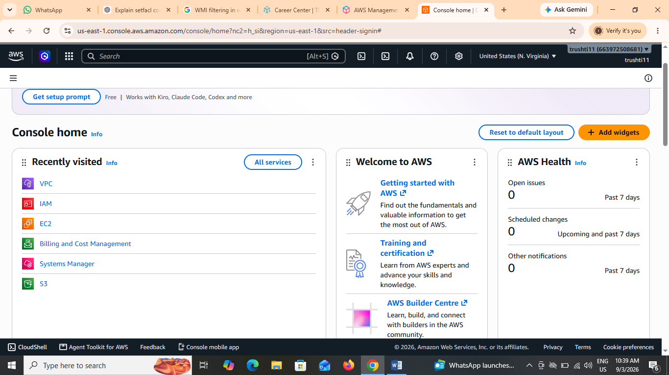

2. Five Key Cloud Services
Service | What it does | Real app that could use it
EC2 (Compute) | Provides virtual servers to run applications and websites. | Zomato can use EC2 to run its website and backend.
S3 (Storage) | Stores files such as images, videos, documents, and backups. | Instagram can use S3 to store uploaded photos and videos.
RDS (Database) | Provides managed databases for storing and retrieving application data. | Flipkart can use RDS to store product and customer information.
VPC (Networking) | Creates a private and secure network for cloud resources. | Paytm can use VPC to securely connect its application servers and databases.
CloudWatch (Monitoring/Analytics) | Monitors applications and resources and provides performance information and alerts. | BookMyShow can use CloudWatch to monitor its servers during high-traffic periods.

3. Finding S3 Using the AWS Console Search Bar
Steps I followed:
- I logged in to the AWS Management Console.
- I clicked on the Search bar at the top of the console.
- I typed S3 or Amazon S3 in the search bar.
- I selected S3 from the search results to open the Amazon S3 service.
How Spotify could use S3:
A music app like Spotify could use S3 to store user-uploaded audio files, album artwork, and other media files. S3 provides scalable storage, so the app can store a large amount of music and access the files whenever users stream or download them.

4. Characteristic of Cloud Computing — Rapid Elasticity
Rapid elasticity means cloud resources can quickly increase or decrease according to demand.
For example, BookMyShow may receive a sudden huge number of users when tickets for a popular movie or event go on sale. Cloud computing can automatically provide additional resources during the traffic spike and reduce them when the traffic goes back to normal. This helps the app remain available and avoids paying for unnecessary resources during normal usage.

