Cloud Computing Assignment – Zomato Smart Group Order Feature

1. New Feature Description
Chosen App: Zomato
Feature: Smart Group Order & Live Party Cart
This feature allows friends or family to join one shared food cart using a link or QR code. Everyone can add items from different devices, see updates in real time, split the bill automatically, and place one combined order. Because many users may join the same cart during festivals or cricket matches, the feature needs cloud hosting and automatic scaling to support thousands of simultaneous users.

2. Basic Cloud Architecture Diagram
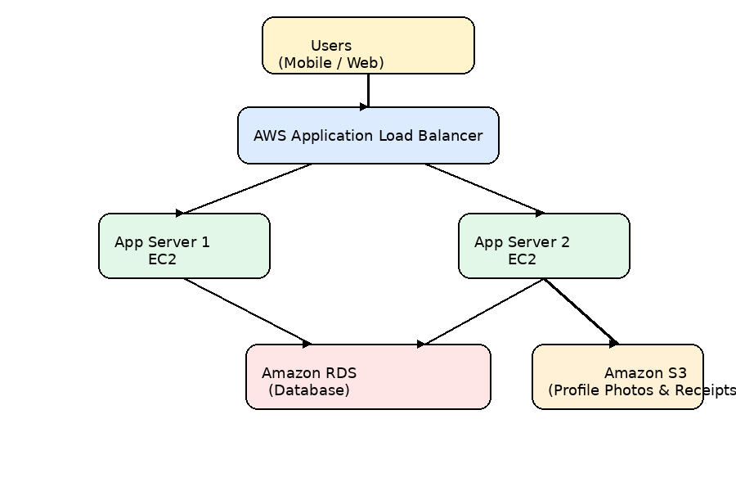
Components: Users → AWS Application Load Balancer → Two EC2 App Servers → Amazon RDS Database → Amazon S3 Storage.

3. Security Measures
Security Measure | How It Helps
HTTPS (SSL/TLS) | Encrypts data between users and the application so passwords and payment information remain secure.
Security Groups & Network ACLs | Allow only required ports like 80, 443, and database traffic while blocking unauthorized access.
User Authentication (OTP/JWT Login) | Verifies user identity before accessing shared carts or account information.

4. How the Architecture Handles a Sudden Spike in Users (200–300 words)
During a big event such as the IPL finals, thousands of users may open Zomato at the same time to place food orders. The architecture is designed to handle this traffic without slowing down or crashing. All user requests first reach the AWS Application Load Balancer, which distributes traffic evenly across multiple EC2 application servers. Instead of sending all requests to one server, the load balancer shares the workload so the application remains responsive.
If traffic suddenly increases, Auto Scaling automatically launches additional EC2 app servers based on CPU usage or the number of requests. When demand becomes normal again, extra servers are removed, helping reduce cloud costs.
Amazon RDS stores user accounts, restaurant information, orders, and payment details. RDS can be scaled by increasing database capacity or using read replicas for read-heavy workloads. This helps the database continue serving many users during peak traffic.
Amazon S3 stores images, digital receipts, and other static files. S3 is highly scalable and can serve millions of files without affecting application servers. Since static content is stored separately, EC2 instances can focus on processing orders and user requests.
This cloud architecture provides high availability, better performance, and automatic scalability. Even if one application server fails, the load balancer sends traffic to healthy servers, ensuring users can continue placing orders without interruption.

5. Feedback from Friend or Family Member
Feedback/Question:
"Why do we need two app servers instead of just one?"
My Response:
Two app servers improve reliability and performance. The load balancer sends traffic to both servers. If one server becomes busy or fails, the other server continues handling user requests, so the application stays available.

