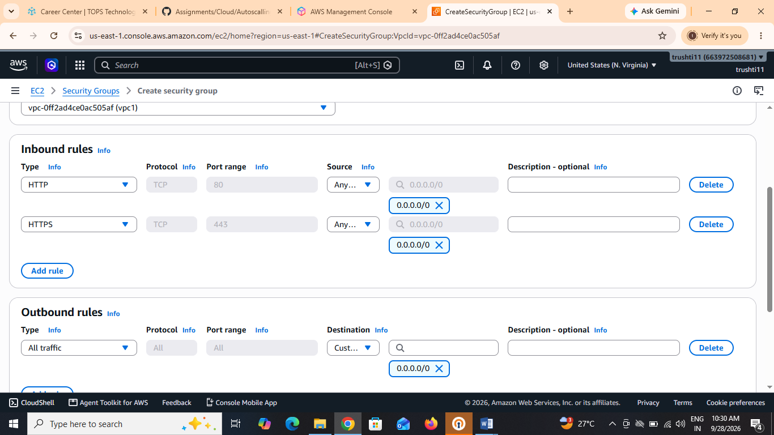
For a Flipkart-like AWS cloud application, here are two key differences between Security Groups and Network ACLs:
Security Group | Network ACL (NACL)
1. Stateful: If incoming traffic is allowed, the response traffic is automatically allowed. | 1. Stateless: Incoming and outgoing traffic must be allowed separately with rules.
2. Applied at Instance Level: It is attached directly to EC2 instances (such as Flipkart web servers or application servers). | 2. Applied at Subnet Level: It controls traffic for the entire subnet containing multiple EC2 instances.

Easy example (Flipkart application)
- Security Group: Allow customers to access the Flipkart website on HTTP (80) and HTTPS (443) for the web server EC2 instance.
- Network ACL: Allow HTTP/HTTPS traffic for the public subnet and block unwanted ports for all instances in that subnet.

