Intravital imaging and 4D quantification of tumor growth and the tumor vasculature. Poster B2

By: Marta Alabrudzinska

# Background to my data

To understand the processes of tumor growth and tumor vascularization we have isolated non-hyperplastic pancreatic islets from the pancreatic neuroendocrine tumor mouse model; RIP-Tag (RT2) mice, and transplanted them into anterior chamber of the mouse eye. The RT2 engrafted onto the iris and recruited blood vessels where after they initiated tumor development and growth. The tumors were repeatedly imaged using reflected light, and the tumor vasculature was visualized by a Texas Red conjugated dextran. The tumor acquired a complex 3D vasculature network, which was analyzed by extracting the numerous parameters: length, tortuosity, width, number of branch points etc. We have challanged the model by including the VEGFB overexpressing (RipVEGFB) islets and expecting the decrease in vascularization.

|  |  |  |
| --- | --- | --- |
| Main outcome | Predictors | Research hypothesis |
| Length of the vasculature | Genotype | Development of vasculature depends on overexpression of VEGFB |

# Table 1: Baseline characteristics

tab1 <- CreateTableOne(vars = c("diffLength", "diffLengthVolume"), strata ="Genotype", data = datawide, test=F, includeNA=TRUE)  
kable(print(tab1), align = "r")

## Stratified by Genotype  
## RipVEGFB RT2 RT2.RipVEGFB  
## n 16 19 25   
## diffLength (mean (sd)) 1.87 (0.63) 3.31 (1.30) 2.80 (1.34)   
## diffLengthVolume (mean (sd)) 1.52 (0.68) 1.49 (0.91) 1.37 (0.85)   
## Stratified by Genotype  
## wt   
## n 18   
## diffLength (mean (sd)) 1.46 (0.59)  
## diffLengthVolume (mean (sd)) 1.45 (0.70)

|  |  |  |  |  |
| --- | --- | --- | --- | --- |
|  | RipVEGFB | RT2 | RT2.RipVEGFB | wt |
| n | 16 | 19 | 25 | 18 |
| diffLength (mean (sd)) | 1.87 (0.63) | 3.31 (1.30) | 2.80 (1.34) | 1.46 (0.59) |
| diffLengthVolume (mean (sd)) | 1.52 (0.68) | 1.49 (0.91) | 1.37 (0.85) | 1.45 (0.70) |

## Figure 1:

par(mfrow=c(2,2), mar=c(2,3,1.5,0.5), oma=c(0,0,2,0))  
for(g in gen){  
 n=length(datawide$Genotype[datawide$Genotype==g])  
 colors<-palette(rainbow(n)); c=1  
 for (a in (1:total)){  
 if (datawide$Genotype[a]==g){  
 vector<-c(datawide$Dendrite_Length.W1[a], datawide$Dendrite_Length.W2[a], datawide$Dendrite_Length.W3[a], datawide$Dendrite_Length.W4[a])  
 if(sum(is.na(vector))==0){  
 plot(vector, col=colors[c], type="l", ylim=c(0,maxvalue), axes=F, xlab="", ylab="", main=g)  
 par(new=T); c=c+1  
 } } }  
 axis(1, at=c(1, 2, 3, 4), labels=c("W1", "W2", "W3", "W4"), cex.axis=0.8)  
 axis(2, las=2, cex.axis=0.8)  
 }  
mtext("Change in length of the islet vasculature", outer = T, side = 3, cex =1.5, font =2)

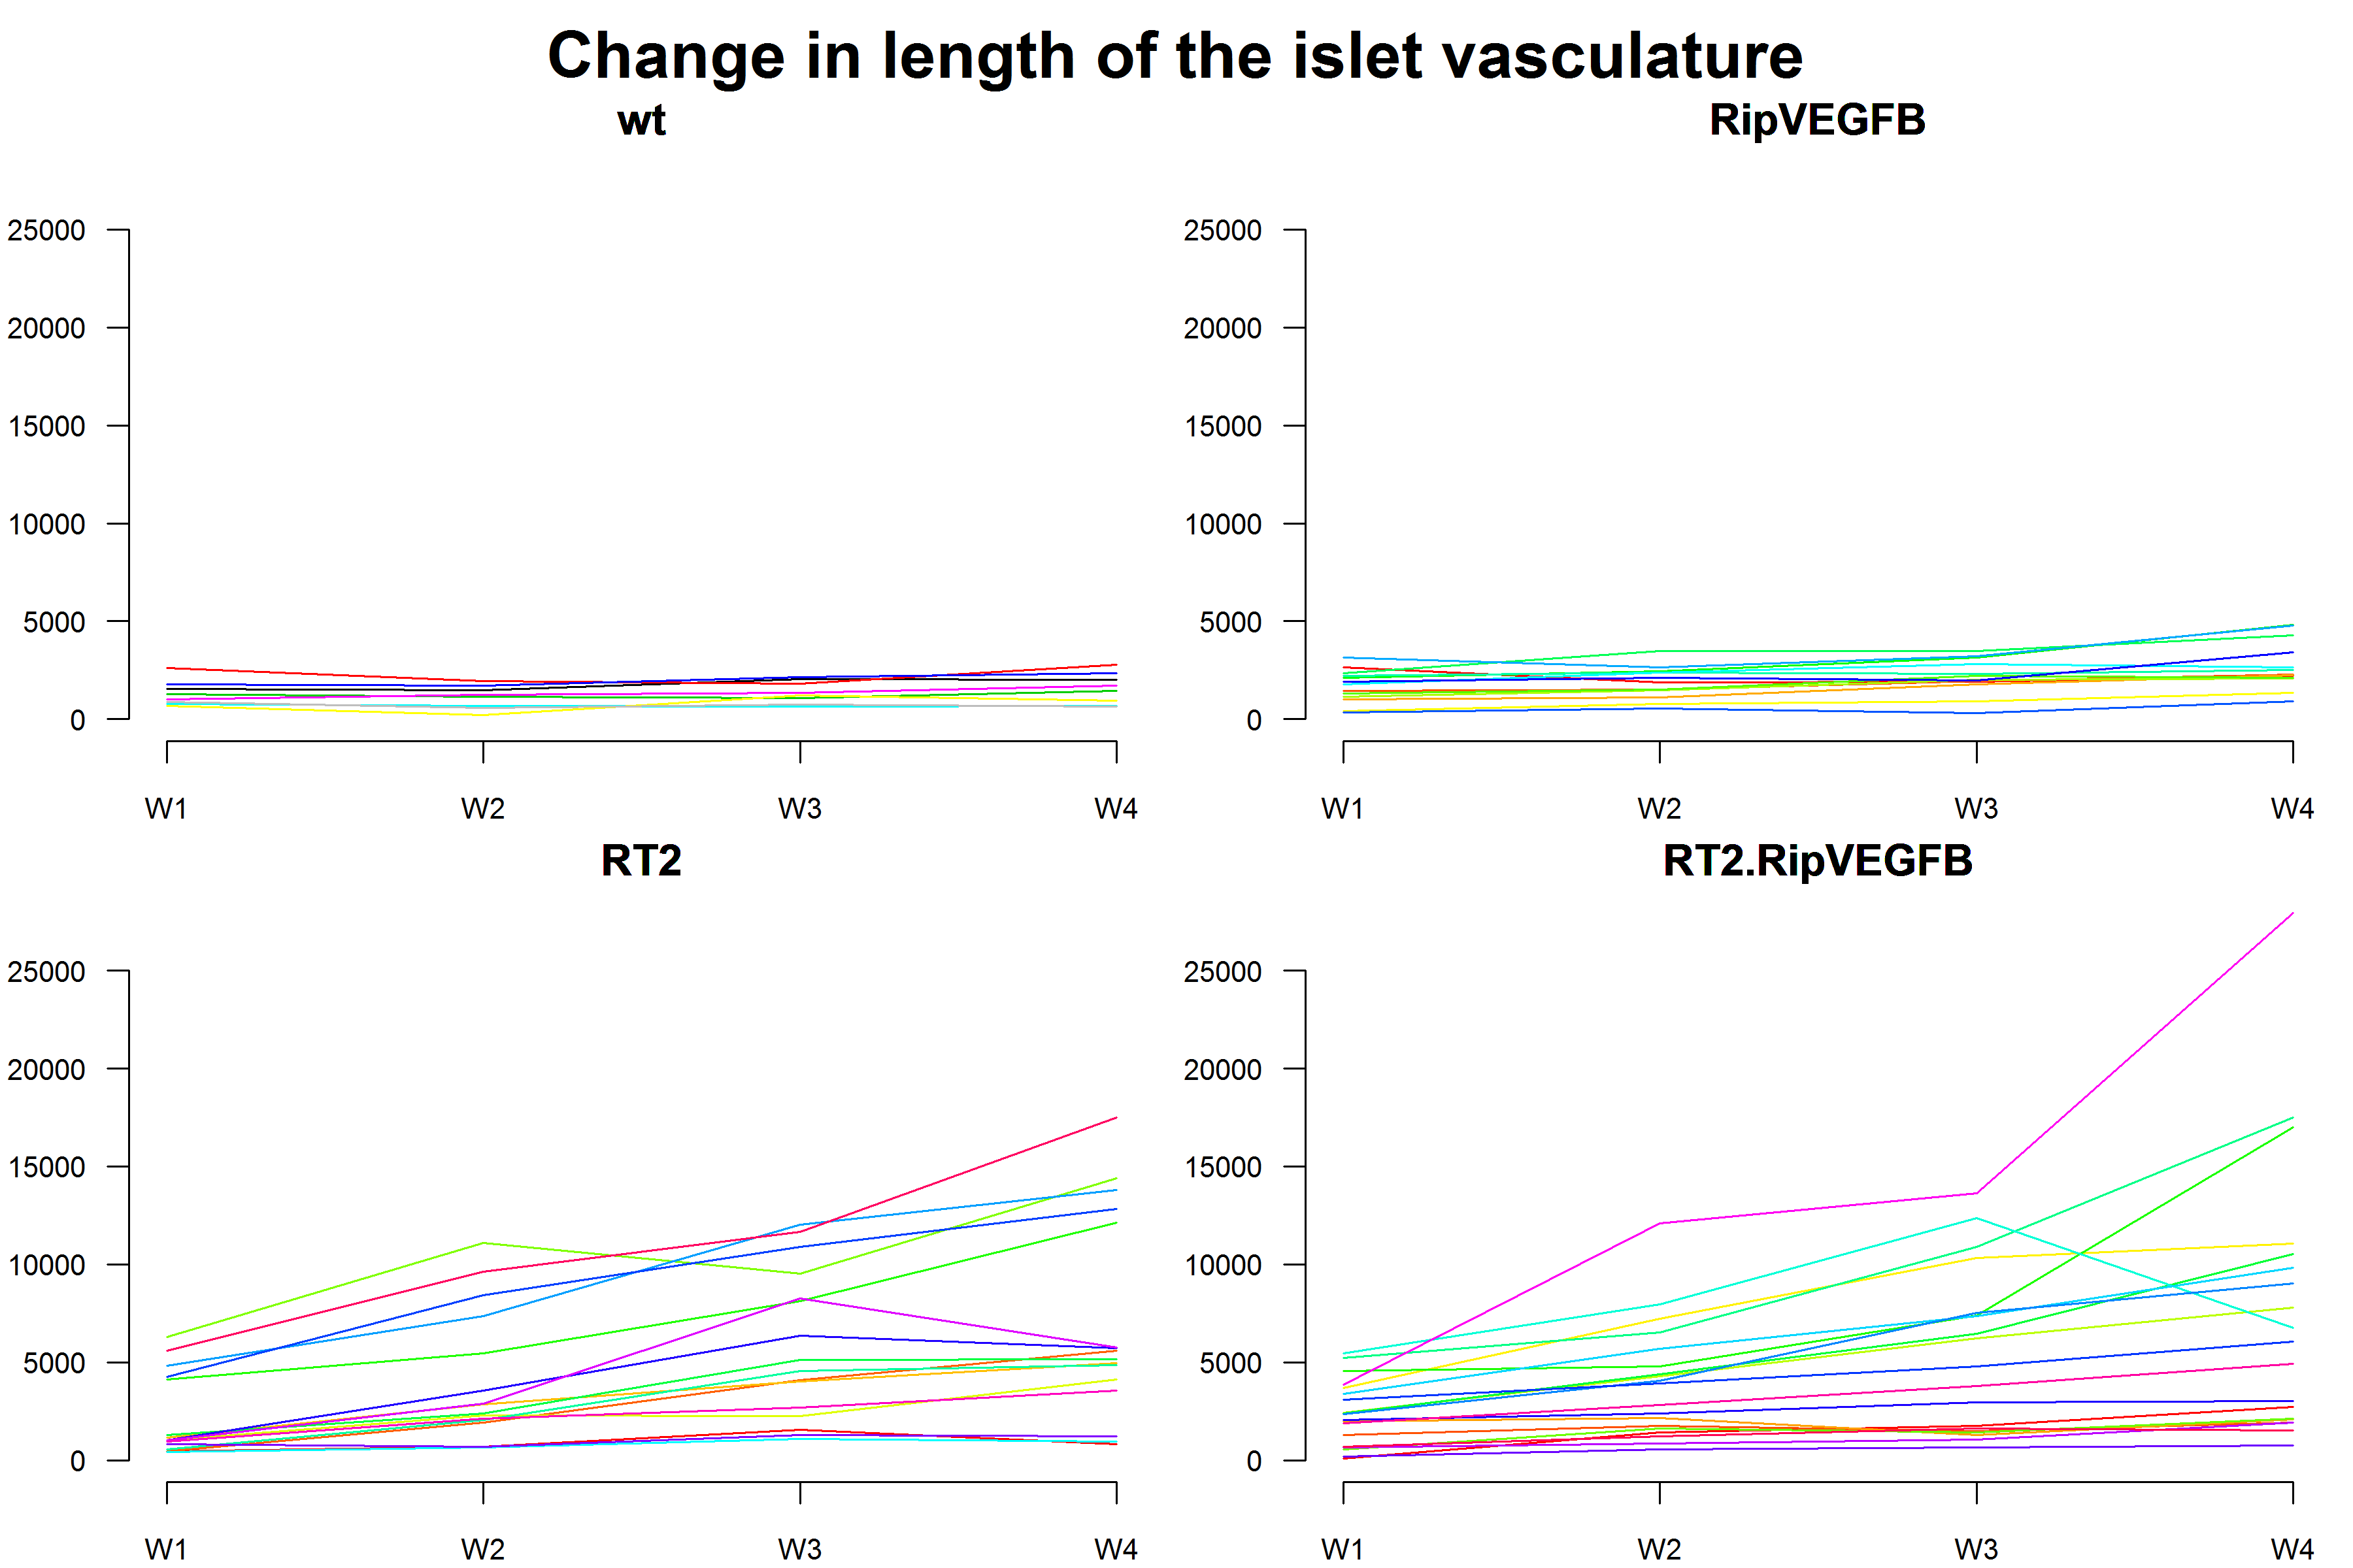

## Figure 2:

par(mfrow=c(1,2))  
par(oma=c(0,0,0,0))  
par(mar=c(2,3,4,0.5))  
  
datawide$diffLength[datawide$diffLength>8]=NA  
boxplot(datawide$diffLength ~ datawide$Genotype, at=c(2,3,4,1), cex.axis=0.9, col=c(1:4),   
 main="Difference in length of vasculature \n between after 4 weeks", ylab="ratio")  
  
datawide$diffLengthVolume[datawide$diffLengthVolume>5]=NA  
boxplot(datawide$diffLengthVolume ~ datawide$Genotype, at=c(2,3,4,1), cex.axis=0.9, col=c(1:4),  
 main="Difference in length\n of vasculature/volume \nbetween after 4 weeks")

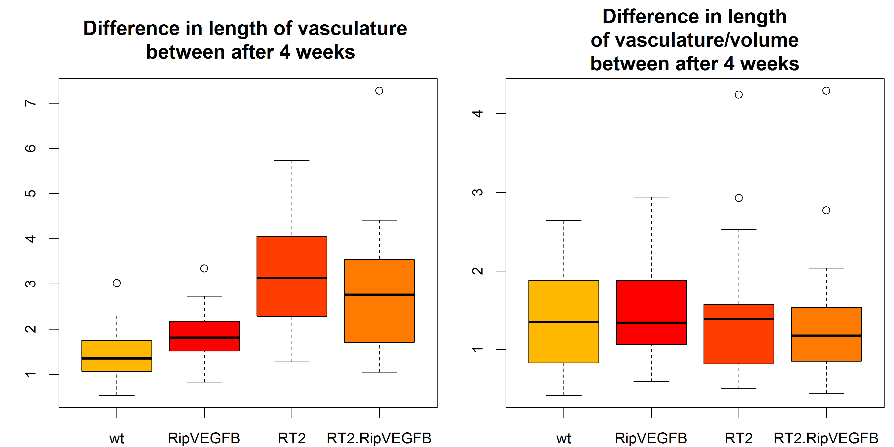 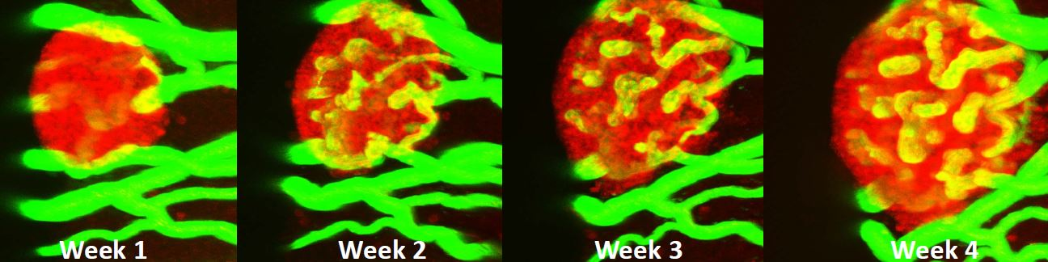

## Analysis of the data - Length of vasculature/islet

tt1<-t.test(datawide$diffLength[datawide$Genotype=="wt"],datawide$diffLength[datawide$Genotype=="RT2"],var.equal = TRUE)  
tt2<-t.test(datawide$diffLength[datawide$Genotype=="wt"],datawide$diffLength[datawide$Genotype=="RipVEGFB"],var.equal = TRUE)  
tt3<-t.test(datawide$diffLength[datawide$Genotype=="RT2"],datawide$diffLength[datawide$Genotype=="RT2.RipVEGFB"],var.equal = TRUE)  
r1 <- rbind(c(tt1[1:3])); r1 <- cbind(test="wt - RT2", r1)  
r2 <-rbind(c(tt2[1:3])); r2 <- cbind(test="wt - RipVEGFB", r2)  
r3 <-rbind(c(tt3[1:3])); r3 <- cbind(test="RT2 - RT2.RipVEGFB", r3)  
kable(rbind(r1,r2,r3), digits=3, col.names = c("test", "t-value", "df", "p-value"),caption="Length of vasculature/islet")

Length of vasculature/islet

|  |  |  |  |
| --- | --- | --- | --- |
| test | t-value | df | p-value |
| wt - RT2 | -5.45935 | 33 | 4.753777e-06 |
| wt - RipVEGFB | -1.88464 | 30 | 0.06919965 |
| RT2 - RT2.RipVEGFB | 1.213257 | 39 | 0.232329 |
|  |  |  |  |

Length of vasculature/volume

|  |  |  |  |
| --- | --- | --- | --- |
| test | t-value | df | p-value |
| wt - RT2 | -0.1431258 | 35 | 0.8870117 |
| wt - RipVEGFB | -0.2812075 | 30 | 0.7804817 |
| RT2 - RT2.RipVEGFB | 0.4088427 | 39 | 0.6848915 |

# Conclusion

The data suggest that there is a significant difference between length of the vasculature per islet between the wt islets and tumour islets, however it is probably caused by the bigger size of tumur islets - there is no difference after normalization to the volume of the islet.