A small example of markdown 'poster'

*Eva Hagel*

## Warning: package 'Epi' was built under R version 3.3.3

##   
## Attaching package: 'Epi'

## The following object is masked from 'package:base':  
##   
## merge.data.frame

## Warning: package 'tableone' was built under R version 3.3.3

##### This is a page break

# Background to my data

Write a short description of your research, dataset and hypothesis. The description should not be more than a couple of lines but include a specification of your outcome variable, predictors and the expected relation between them.

## Main outcome

BMI

## Predictors

Type of job and the amount of fibre (g/day) the person consumes

# Research hypothesis

Average BMI is different depending on job type and the amount of fibre

## Table 1: Baseline characteristics

tab1 <- CreateTableOne(vars = c("BMI", "fibre"), strata = c("job"),   
 data = diet, test=F, includeNA=TRUE)  
  
kable(print(tab1))

## Stratified by job  
## Driver Conductor Bank worker   
## n 102 84 151   
## BMI (mean (sd)) 24.57 (3.45) 22.90 (3.17) 24.51 (2.89)  
## fibre (mean (sd)) 1.64 (0.52) 1.60 (0.50) 1.83 (0.60)

|  |  |  |  |
| --- | --- | --- | --- |
|  | Driver | Conductor | Bank worker |
| n | 102 | 84 | 151 |
| BMI (mean (sd)) | 24.57 (3.45) | 22.90 (3.17) | 24.51 (2.89) |
| fibre (mean (sd)) | 1.64 (0.52) | 1.60 (0.50) | 1.83 (0.60) |

## Figure 1:

par(mfrow=c(1,2), mar=c(4.1,4.1,2.1,2.1))  
boxplot(diet$BMI~diet$job, border="grey40", range=F, ylab="BMI", main="BMI depending on job title", cex=0.8)  
  
points(as.numeric(diet$job)+rnorm(length(diet$job), 0, 0.1), diet$BMI, pch=16, cex=as.numeric(diet$fibre)/3)  
  
  
plot(diet$BMI~log(diet$fibre), col=as.numeric(diet$job), pch=16, xlab="log fibre", ylab="BMI", las=1, cex=0.8)  
abline(lm(diet$BMI~log(diet$fibre)), lty=2, lwd=2)  
corr <- cor(diet$BMI, log(diet$fibre), use="pairwise.complete.obs")  
text(par("usr")[2], 29, paste("r=", round(corr, 2)) , xpd=T, pos=2, cex=0.8)  
  
legend("top", inset=c(0, -0.1), c(names(table(diet$job))), pch=c(16),   
 col=1:3, horiz = T, xpd=T, bty = "n")

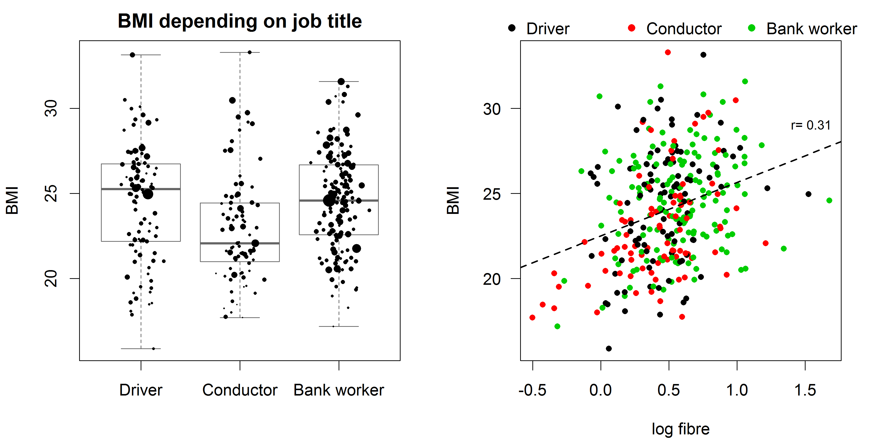

## Analysis of the data

mod1 <- lm(BMI~job+fibre, data=diet)  
  
outs <- summary(mod1)$coefficients  
cis <- confint(mod1)  
  
kable(cbind(outs, cis), digits=3, col.names = c("Estimate", "Std.Error", "t-value",   
 "p-value", "Lower 95", "Upper 95"))

|  |  |  |  |  |  |  |
| --- | --- | --- | --- | --- | --- | --- |
|  | Estimate | Std.Error | t-value | p-value | Lower 95 | Upper 95 |
| (Intercept) | 22.174 | 0.583 | 38.056 | 0.000 | 21.028 | 23.321 |
| jobConductor | -1.444 | 0.451 | -3.203 | 0.001 | -2.332 | -0.557 |
| jobBank worker | -0.174 | 0.399 | -0.436 | 0.663 | -0.959 | 0.611 |
| fibre | 1.356 | 0.302 | 4.487 | 0.000 | 0.761 | 1.950 |

## Conclusion

The data suggest that BMI may depend on the amount of fiber a person consumes, even though the relationship is weak (r = 0.31 and estimate = 1.36, p = 0.000). There is also a dependency between job title and BMI which shows that the group "Conductor" have statistically significant lower values of BMI compared to "Driver" adjusted for the amount of fiber they consume on average dialy basis (est= -1.44 and p= 0.001). There was no statistically significant difference between "Bank workers" and "Drivers".