**TCM-FM2L Manual**

1. Download and install Ubuntu 18.04 desktop version.

2. For the example, the ID is ‘tfarm’ and Password is ‘12345’.

3. Select this option to install automatically.

4. After executing ‘sudo nano /etc/sudoers’, add the following comment: ‘tfarm ALL=NOPASSWD: ALL’ in ‘suders’ file.

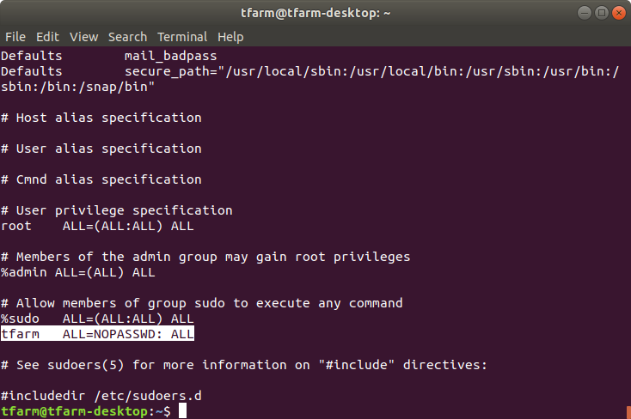

5. If you can’t log in automatically, do the following.

(1) After pressing ‘WINDOW KEY’, input ‘SETTINGS’ on ‘SEARCH’ bar. Click ‘SETTINGS’ application icon.

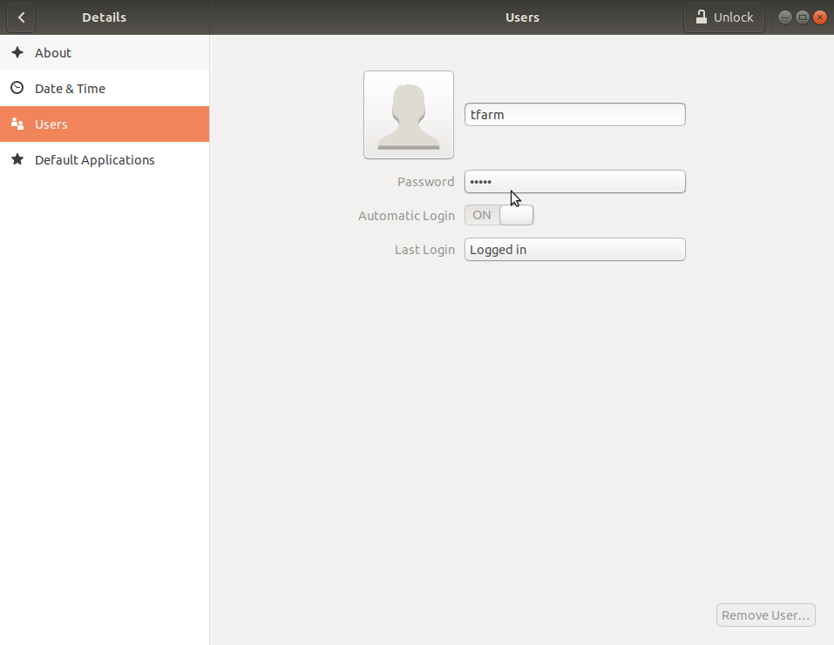

(2) After clicking DETAILS menu, click “Users’ and then click the ‘USERS UNLOCK’ menu on the upper right corner.

(3) set up ‘ON’ of ‘Automatic Login’

6. Unzip the provided minor program..

(1) unzip dckec.zip

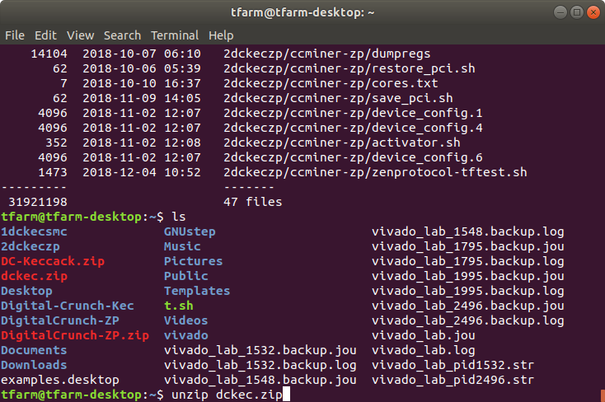

(2) You can mine Smart Cash, Max Coin and Creative Coin in the ‘1dckecsmc’ directory.

(3) You can mine Zen Protocol in the ‘2dckeczp’ directory

7. How to check if the server is normally connected with the boards

(1) cd 1dckecsmc/ccminer

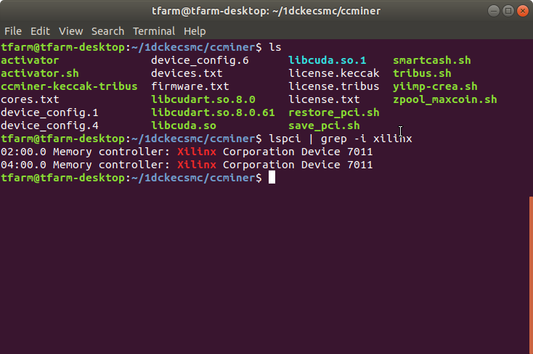

(2) Execute this command: ‘lspci | grep -i xilinx’

For example, slot 2 and slot 4 are connected.

8. Edit device.txt in order to set up ‘ccminer program’ to recognize the FPGA boards

(1) nano devices.txt

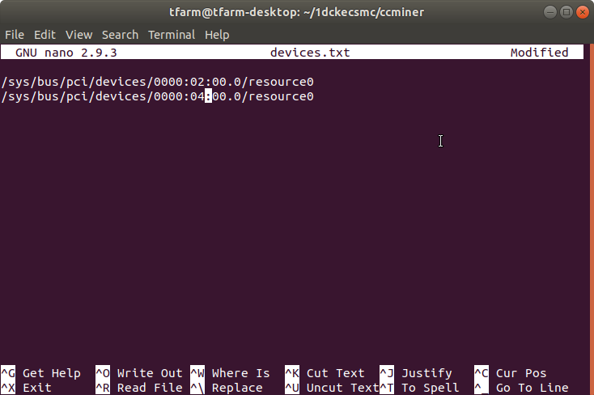

(2) setting example for slot 2 and slot 4

/sys/bus/pci/devices/0000:02:00.0/resource0

/sys/bus/pci/devices/0000:04:00.0/resource0

9. How to execute ‘Smart Cash’ program

(1) Set up and verify Wallet

-- Wallet address can be created in ‘smartcash.cc’

After running ‘nano smartcash.sh’, edit like the below example for being enable of ‘pcidevice’. Next, set the wallet address (see: orange color) and the worker name (for example: ‘tfm2ml’). And then save and exit.

If the slot 2 and slot 4 are connected, the below two comment lines must be included:

/sys/bus/pci/devices/0000:02:00.0/enable

/sys/bus/pci/devices/0000:04:00.0/enable

However, the below comment line is not matter if they are in ‘smartcash.sh’.

/sys/bus/pci/devices/0000:01:00.0/enable /sys/bus/pci/devices/0000:06:00.0/enable

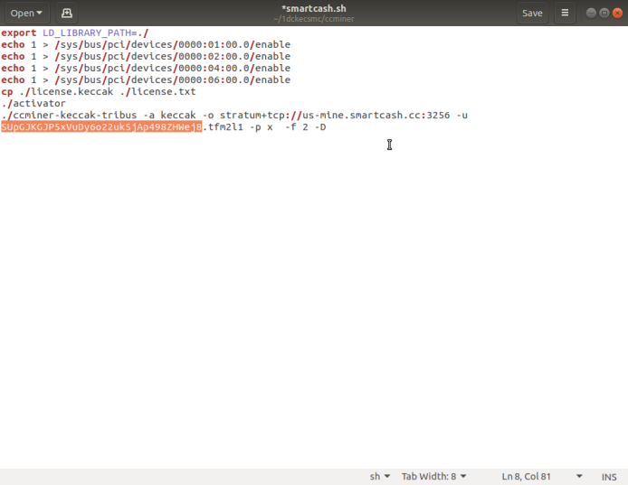

1. Run Smart Cash shell

sudo ./smartcash.sh

1. After confirming the running, it is possible to check the 2.5gh in the pool after 30 minutes. You can search for ‘workers stats’ on the left of Smart Cash URL: https://us-mine.smartcash.cc/

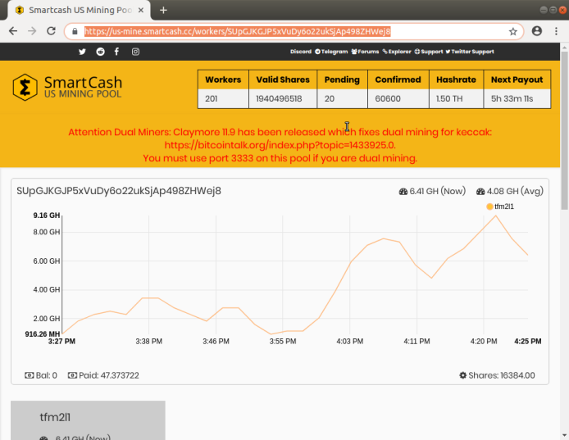

For example, you can access you wallet URL of Smart Cash like <https://us-mine.smartcash.cc/workers/SUpxxxxxxx>. ‘SUpxxxxxxx’ means your wallet address.

10. How to make it run automatically when you start your computer

(1) Create ‘start.sh’ shell file in any directory and make it run automatically when the computer restarts.

(2) Example of creating start.sh under ‘/home/tfarm’

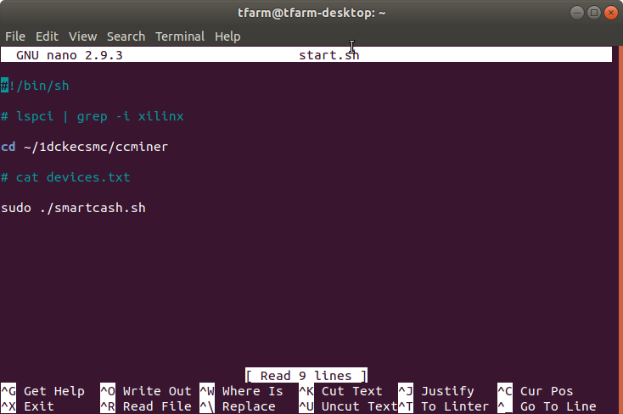

Run ‘nano start.sh’ and insert the following executable script.

cd /home/tfarm/1dckecsmc/ccminer

sudo ./smartcash.sh

(3) Register ‘start.sh’ above to be executed automatically when login to account.

After pushing button ‘window key’ and finding ‘startup application’ of Search bar,

click 'add' button and run ‘Startup Application Preference’. Next, type 'gnome-terminal - /home/tfarm/start.sh' in ‘command’ of ‘Startup Application Preference’ window and then restart after saving.

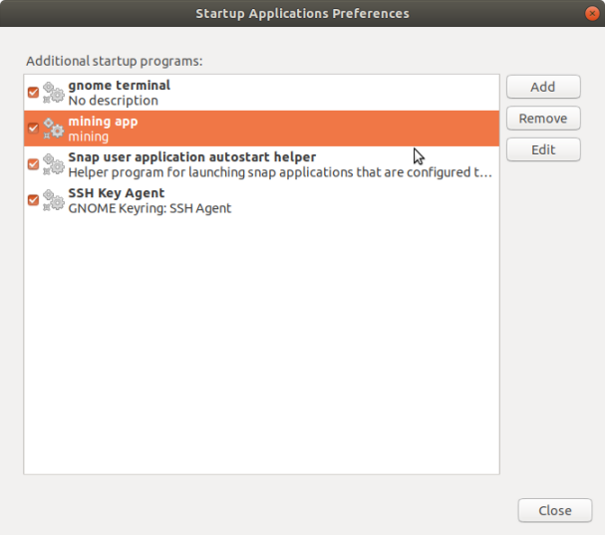

11. Run Vivado_lab

(1) After running 'Vivado_lab', click 'Open Hardware Manager' and the following screen will be displayed. At this time, click 'Auto Connect' icon for connecting a Board.

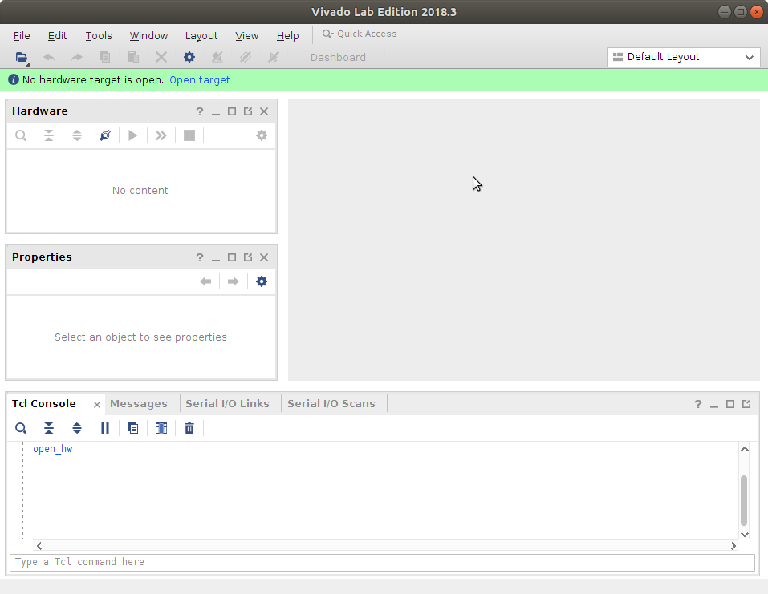

(2) When the FPGA board is properly connected, the following screen appears.

If not, the platform driver is not recognized by Ubuntu.

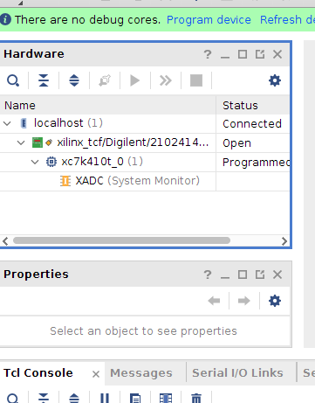

(3) If the FPGA board is not properly connected, reinstall the platform cable driver in Ubuntu.

'cd /tool/Xilinx/Vivado_lab/2018.3/data/xicom/cable_drivers/lin64/install_script/install_drivers/'

'sudo ./install_drivers'

The driver will be installed as shown below.

