**TCM-FM2L Install Guide**

1. **Install inside PC**

Same install as PC-VGA card, or PCI-e card.

Connect 6Pin or 8Pin VGA (or PCI-e) Power Connector to FM2L.

FM2L uses main power from 8Pin VGA Power Connector.  
No power consume from PCI-socket, just use data signals.

1. **Install outside PC , and Use External PC ATX Power**

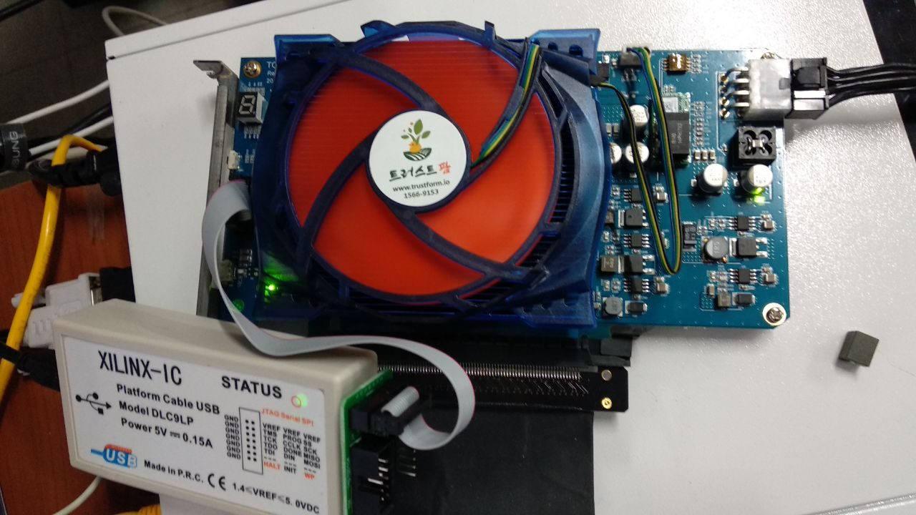

As above photo, use PCI-E Extend Reiser with PC Motherboard.

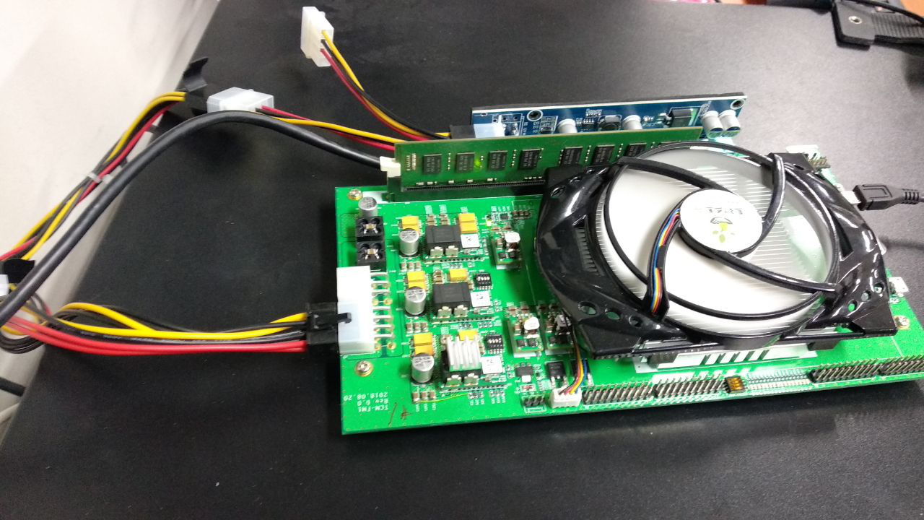

If you don’t have FULL PCI-E 16x Reiser, You can use PCI-E 1X Reiser.

And then PCI-E max speed is limited 1x 6Gbps.

And, You add jumper 4 and 7 pin for mother board power. Then FM2 is work independently regardless of Your PC power On/Off.

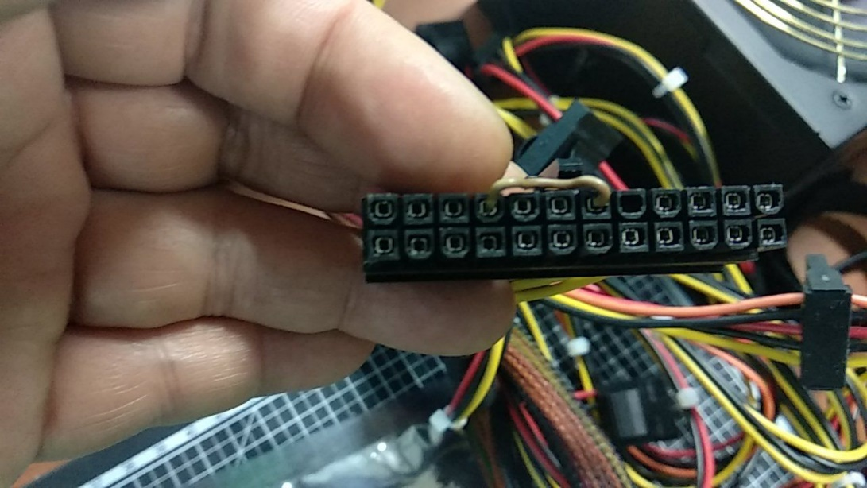

**4**

**7**